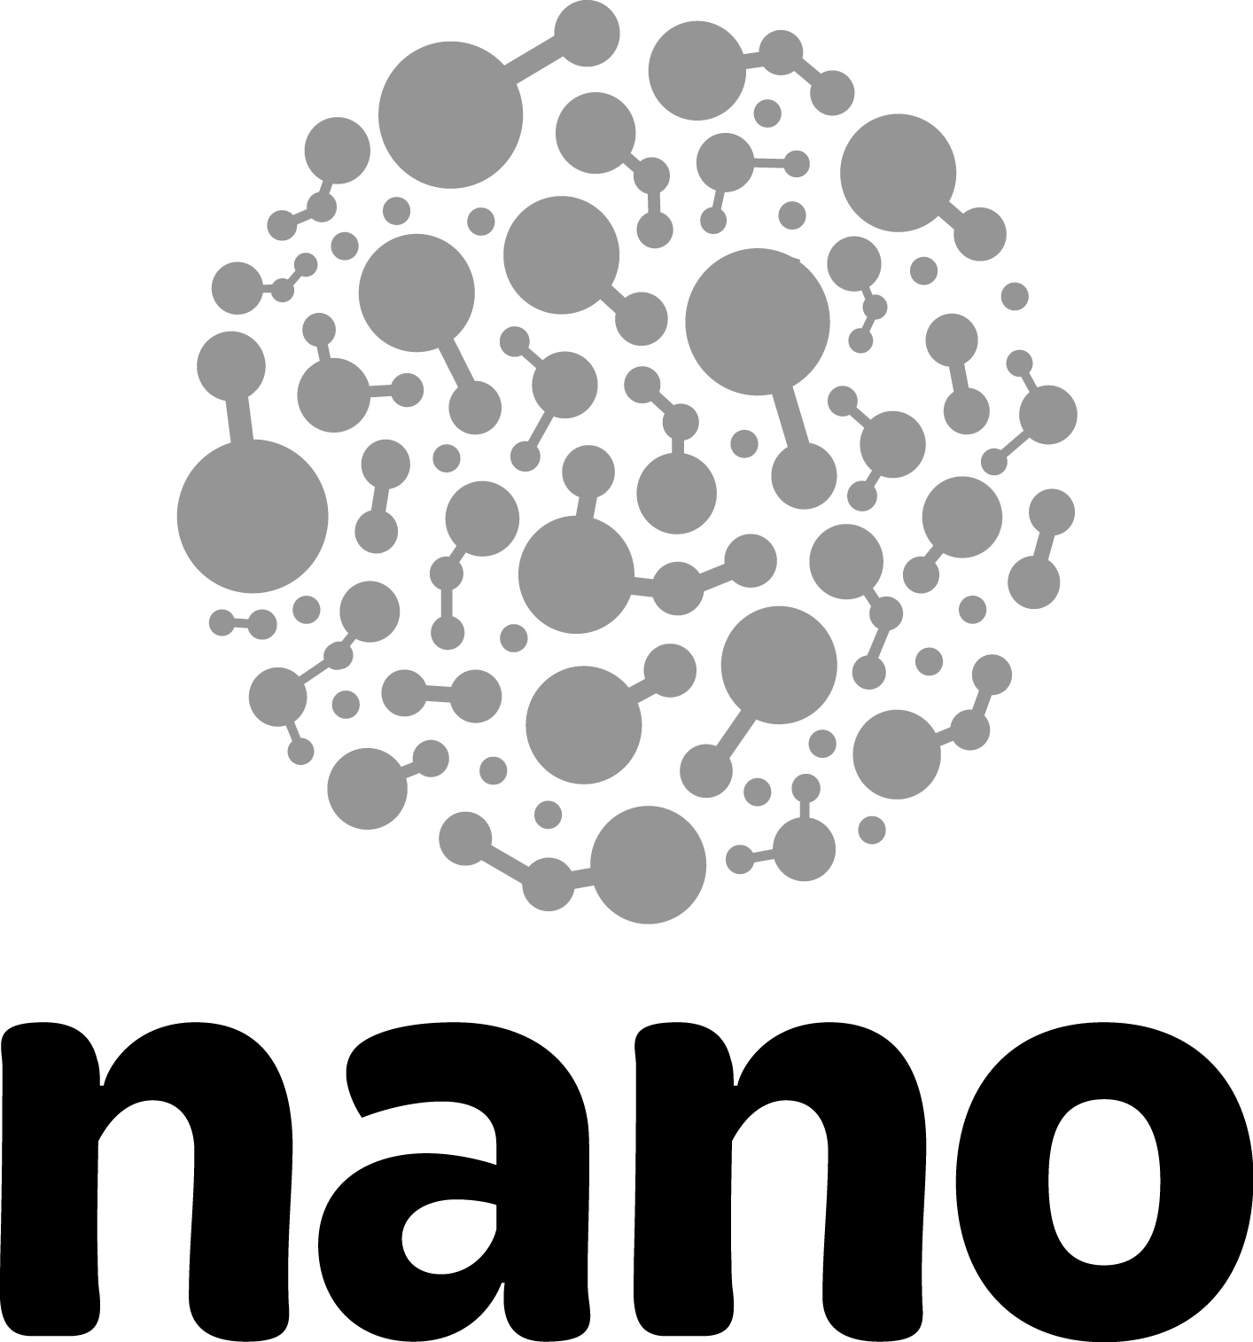

Nano & Society—Visitor Conversation Log Guide

The Visitor Conversation Log is meant to help museum educators reflect on effective ways to engage visitors in conversations about nano and society. The log is not a way to assess or “grade” other educators, but rather a way to help both the facilitator and the observer identify effective facilitation strategies.
For further background on nano and society content and on strategies and tips for engaging visitors in conversations, see these documents
- Big Ideas
- Conversation “Cheat Sheet”
- Tips for Visitor Conversations

To use the Conversation Log as an observation tool
- One person should act as facilitator (interacting with a visitor group) and one person should act as observer.
- Together, complete the top box before starting a conversation. Indicate the date of the interaction, who will be facilitating, and who will be observing. Mark which nano and society activity you'll be trying with visitors. Choose a “conversation goal” to focus on, and then add indicators for that goal from the Conversation “Cheat Sheet” document. In addition, identify at least one or two strategies you’d like to practice.
- During the interaction, the observer makes notes about the overall composition of the visitor group, such as the number of children and adults, visitor genders and ages, or the type of visitor group (e.g., a family group or a school group).
- After the interaction, the observer describes the overall conversation between the museum educator and the visitor group. Who contributed to the conversation and how? Who led or dominated the conversation? How did the group interact with one another? Was everyone engaged to the same extent? What was said?
- Next, the observer marks down specific strategies that the facilitator used. As much as possible capture what worked and what didn’t work to foster visitor engagement related to the chosen goals and indicators.
- You can list any additional observations or suggestions for future conversations on the back of the log.

Review your notes together and discuss. You can collect several logs and use the data reflection resources provided to more formally analyze these interactions.

Tip
- If you aren’t able to have both an observer and a facilitator on the floor at the same time, you can still use this log to reflect on your own practice. Simply complete the form yourself after a visitor conversation.
- If at all possible go through the data reflection process with at least one other person who can help find themes and interpret their meanings.

