

“Light Switch” Training Guide

During the “Light Switch” training activity, staff collaboratively draw out the systems and people that are required in order for a light to turn on and off at the flick of a switch. This facilitated discussion helps participants reflect on the ways that technologies are embedded in bigger systems.
Time  15 minutes  Materials  - Working light switch  - Whiteboard and markers  - Assistant to draw (optional)  Overview  - Group discussion (10-15 minutes)  - Review the “big idea” (5 minutes) | 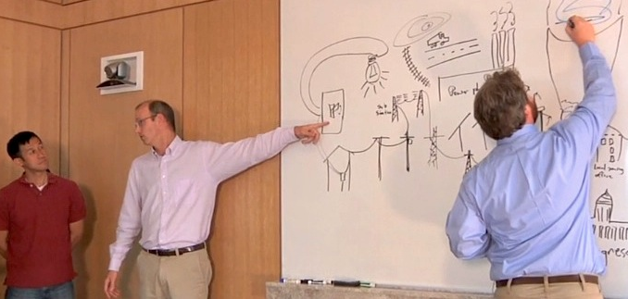

Group Discussion
During this discussion, the group will create a drawing that maps out some of the many people and things that are involved when we turn on a light switch. The role of the facilitator is to ask questions that help participants to identify and reflect on the various elements of the system.

Each time the activity is done, the drawing and discussion will be different. Not all elements of the system need to be (or can be) identified in a given discussion, but facilitators should encourage participants to think about the system from different perspectives, including its technological, commercial, environment, government, and social aspects.

Begin by turning the light off and then back on. Below are some questions you might use during the conversation, with possible answers. Choose questions that require the participants to think at deeper levels as the conversation progresses.

What just happened?

The light came on.

What made the light turn on? What happened behind the switch?

A circuit was completed, bringing energy to the light bulb.

Where did the energy come from?

The power plant, or alternative sources of energy like solar cells.

How does the power plant make energy?

Coal, hydroelectric, wind.

How does the energy get from the power plant to the building?

Power lines.

Can you just go ahead and build a power plant or install a solar panel?

No. Local government needs to be involved. There might be zoning issues or incentives.

Where do you get a solar panel?

They’re built in factories. You need materials and people to build them.

How do we get a solar panel set up at our home?

We need to transport it, using infrastructure like roads. Then we need workers to install them.

Are they any other people we should think about, in addition to workers?

Government officials, lobbyists, and citizens who are involved in legislation.
Wrap Up
After several different aspects of the system have been discussed, look at the drawing as a whole and reflect on its meaning. Below are some suggested talking points.

What can we learn from a light switch?

A light switch is so much a part of our everyday lives that we don’t think about it. Now that we’ve thought about it, we can see that there’s an enormous system that goes into our ability to turn on and off the light.

This activity help us to see that in order to really understand a technology, we need to think about the system that makes it work. The bigger system includes things like:
- Physical infrastructure
- Governments
- People
- Environment

Big Idea
This training activity explores Nano & Society Big Idea 3:
Technologies work because they are part of systems
- Technologies are part of larger systems that include technological, political, social, and environmental components.
- Many people and groups are involved in the development and adoption of new technologies.
- We affect the development and use of technologies through our actions and choices (as consumers, citizens, voters, workers, parents).
- In order to understand the role that technologies play and the effects they have, we need to think about the ways they’re connected to systems and people.

 | This project was supported by the National Science Foundation under Award Nos. 0940143 and 0937591. Any opinions, findings, and conclusions or recommendations expressed in this document are those of the author and do not necessarily reflect the views of the Foundation.

Copyright 2012, Sciencenter, Ithaca, NY.

