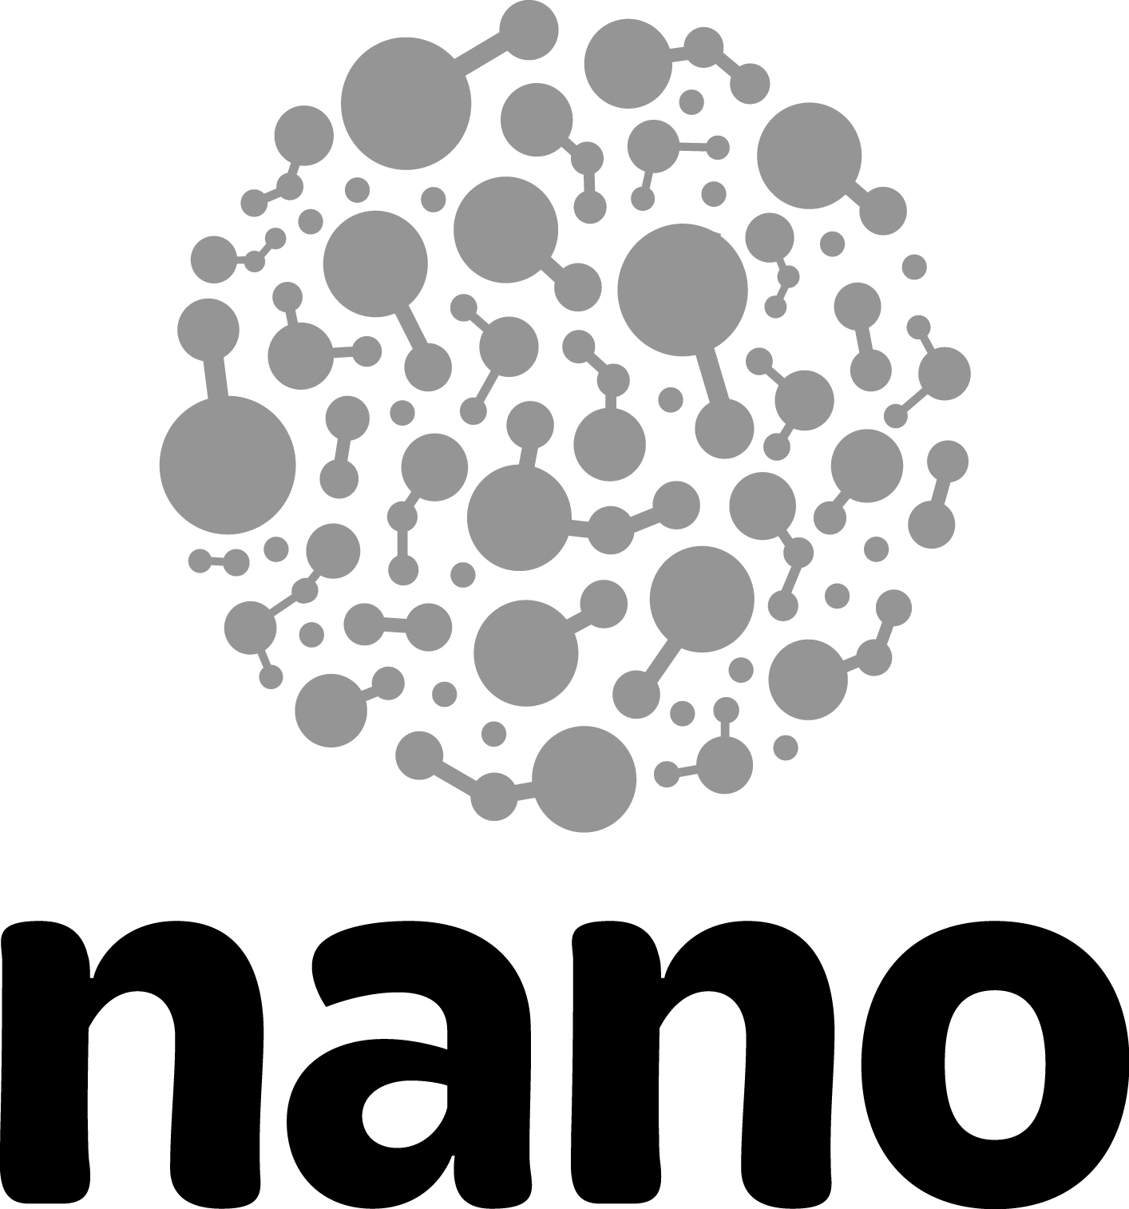

Nano & Society–Visitor Experiences

The Nano & Society Workshop includes a variety of programs and activities to share with your visitors. Most of the materials you need to do these activities are included in your workshop kit.

Values shape technologies

Nano & Society—You Decide!
- Hands-on activity for general public audiences
- Materials are included in the Nano & Society Workshop kits

Nano Around the World
- Program for visitor groups (middle school and up) or staff training
- Materials are included in the Nano & Society Workshop kits

Technologies affect social relationships

Nano & Society—Invisibility Cloak
- Hands-on activity for general public audiences
- Materials are included in the Nano & Society Workshop kits

Technologies work because they’re part of systems

Nano & Society—Flying Cars
- Hands-on activity for general public audiences
- Materials are included in the Nano & Society Workshop kits

Values, relationships, and systems

Nano & Society—Space Elevator
- Hands-on activity for general public audiences
- Materials are included in the Nano & Society Workshop kits

Nano & Society—Tippy Table
- Pocket science for general public audiences, related to “Balance our Nano Future” component of the Nano exhibit
- Materials are included in the Nano & Society Workshop kits

Nano Exhibit Worksheet
- Student group worksheet to be used when exploring the Nano exhibit
- Digital teacher version also provided

Robots & People!
- Program for general public audiences
- Materials are included in the Nano & Society Workshop kits

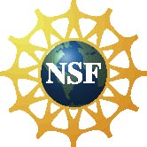 | This project was supported by the National Science Foundation under Award Nos. 0940143 and 0937591.  Any opinions, findings, and conclusions or recommendations expressed in this document are those of the author and do not necessarily reflect the views of the Foundation.

Copyright 2012, Sciencenter, Ithaca, NY.

