

Exploring Fabrication—Electroplating

Try this!  - Wearing safety goggles, connect the nickel coin to the negative side of the battery (using one alligator clip) and the copper bar to the positive side (using the second alligator clip).  - Dip both the nickel and the copper bar into the salt solution. (Make sure they do not touch each other!) What do you notice?  - Now take the coin and the copper out of the salt solution. What changed? | 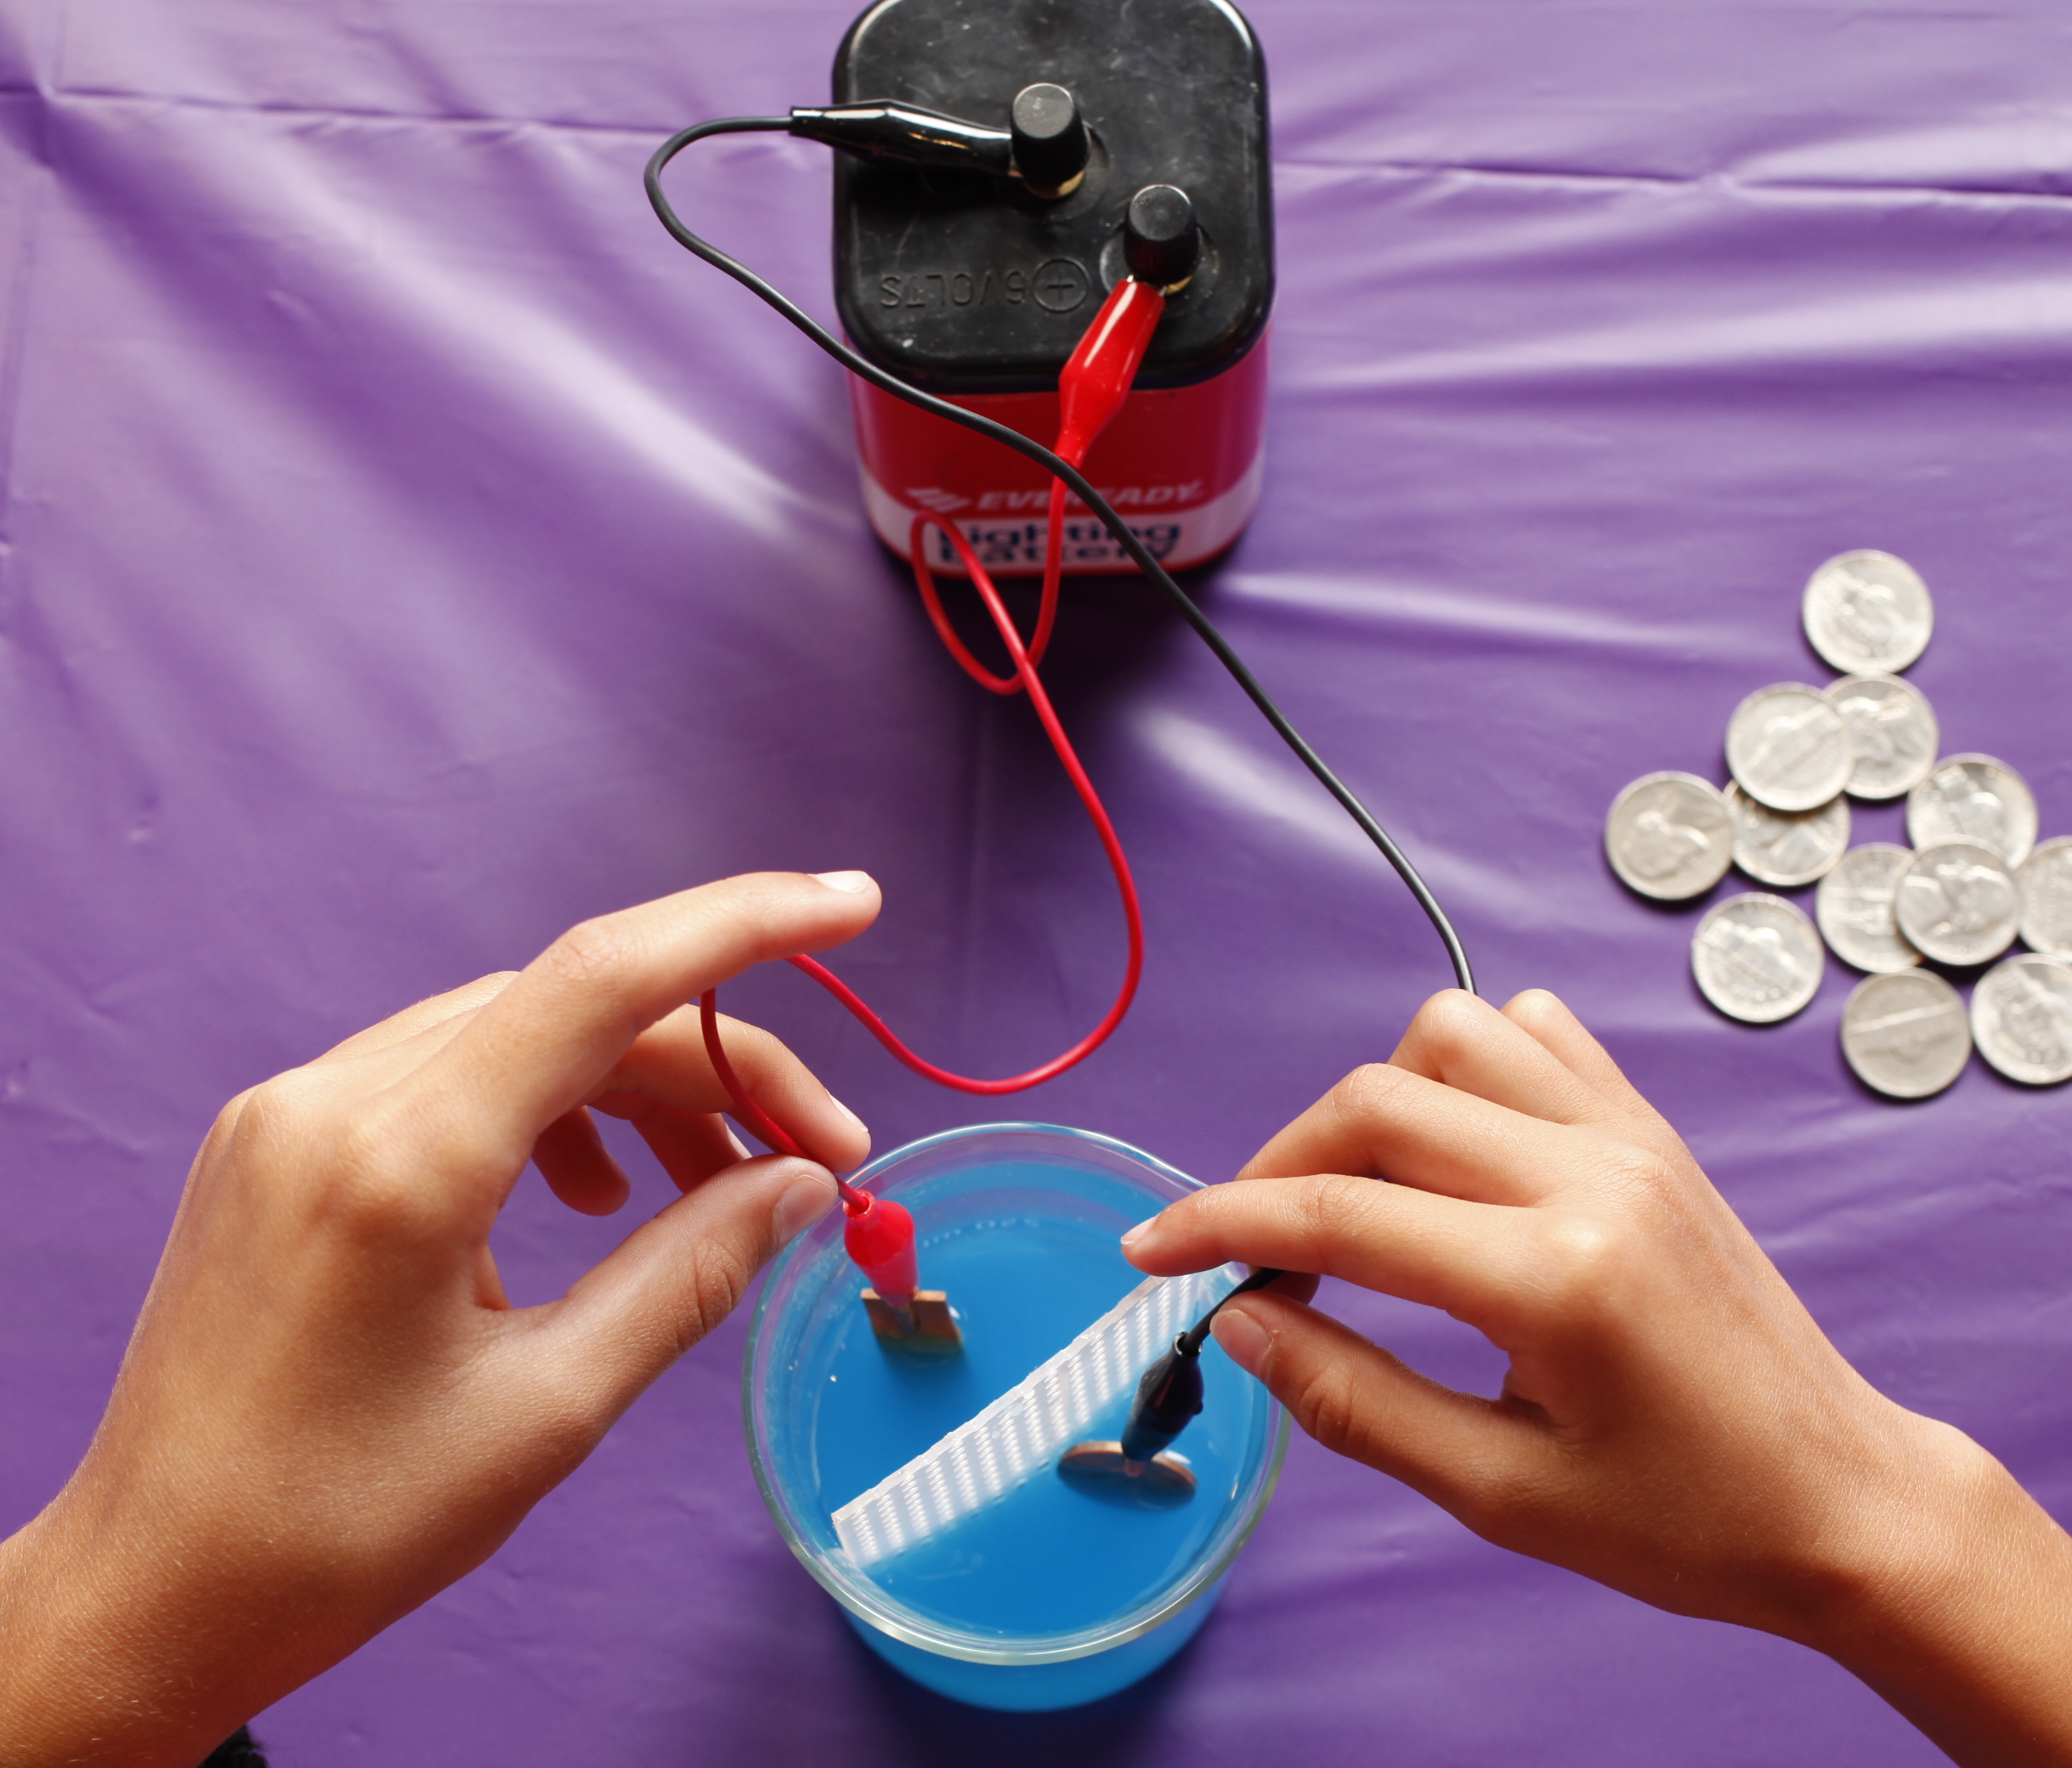
What’s going on?
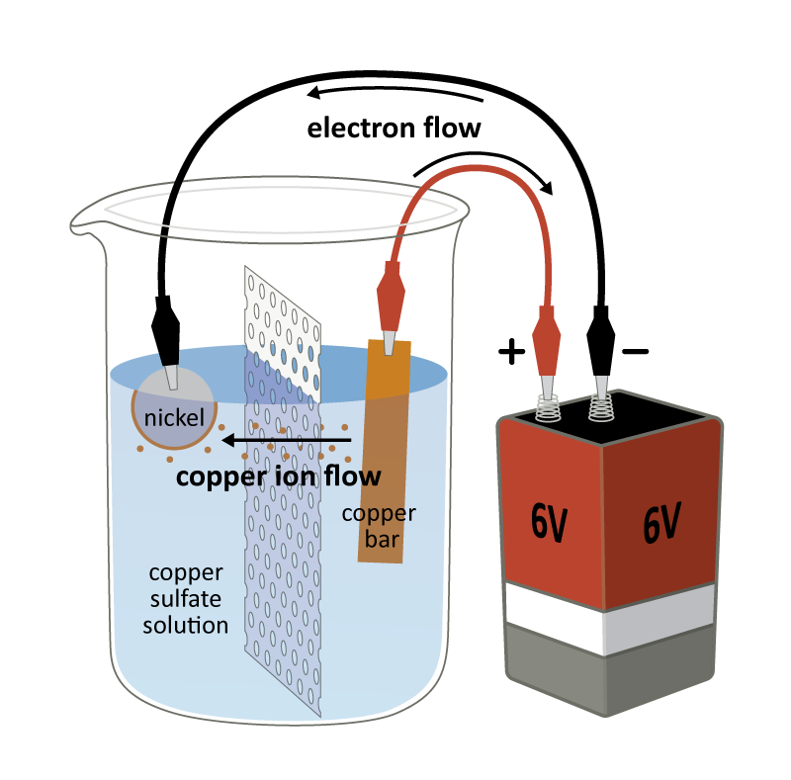  Copper electroplating | The nickel coin changed color because it now has a thin layer of copper on it. When the copper bar and nickel coin are connected to the battery and placed in the salt solution, you complete an electrical circuit. The electricity from the battery removes copper from the surface of the copper bar and deposits it onto the surface of the nickel. This process is called electroplating. The longer you keep the circuit connected, the thicker the layer will be.  The blue solution is copper sulfate (CuSO₄) in water. When solid copper sulfate is dissolved in water it breaks up into two ions, Cu²⁺ and SO₄²⁻. These ions allow electric current to flow through the liquid.  When the current is flowing from the battery, the reaction at the copper bar converts copper metal (Cu), which has no electric charge, to copper ions (Cu²⁺), which have a positive charge.

These copper ions travel through the solution to the coin connected to the negative side of the battery. The copper ions turn back to metallic copper and bond onto the coin. The copper ions present in the copper sulfate solution plate onto the coin, and the reaction at the copper bar continually replaces the copper ions in the solution allowing the plating to continue as long as the circuit is connected and there is still copper available.

Copper is just one of many metals used for electroplating. Other examples include zinc, gold, silver, and platinum. Electroplating is used for a variety of reasons such as making thin protective layers on cars or planes or coating jewelry with precious metals like gold.

How is this nano?
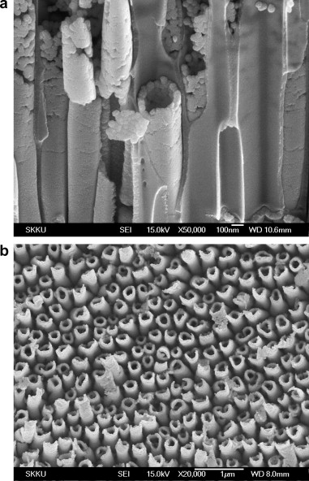  Electroplated nanotubes | Scientists use special tools and equipment to work on the nanoscale. The electroplating process can deposit nanometer-thin layers of material. (A nanometer is a billionth of a meter.) Researchers can reliably control how thick the electroplated layer is by carefully controlling the current flowing through the circuit.  Electroplating is a simple, low-cost process scientists can use to create thin films, coating, nanowires, and other nanoscale structures.

Learning objective
- Scientists use special tools and equipment to work on the nanoscale.

Materials

- Safety goggles
- Glass beaker
- Plastic divider
- Battery
- Alligator clips
- Copper bar
- Nickel coins
- Sponge (with scouring pad)

- Copper sulfate solution (see below for preparation instructions)

Notes to the presenter
Before doing this activity, prepare the copper sulfate solution:
- Fill the bottle containing 125g copper sulfate pentahydrate (CuSO₄•5H₂O) with distilled water (approx. 1 liter). Mix well.
SAFETY: At this concentration, the copper sulfate solution is safe to use with visitors. Refer to Materials Safety Data Sheet for specific safety info on the copper sulfate solution. Supervise visitors at all times while doing this activity. Safety goggles should be worn. Do not allow visitors to drink the solution. Some of the objects in this activity could present a choking hazard to young children.
Tips: To demonstrate that electroplating requires electricity, you can dip the coin and copper bar in the salt solution without first connecting them to the battery.
Be sure that you connect the coin and copper to the correct terminals of the battery. The copper should always be connected to the positive side of the battery and the coin to the negative side.
The plastic divider is meant to separate the coin and copper bar. Be sure that the coin and copper bar do not touch while they’re connected to the battery. This will short-circuit the battery and drain it quickly.
For a good coating, the coin and copper bar should have a clean surface. The copper bar sometimes develops a brownish-greenish oxidation layer, which can usually be wiped off with the sponge. To clean the coins you can use a non-scratching scouring pad. For dirtier coins you may want to soak them in vinegar.
If the copper coating is not very noticeable, wait a little longer before removing the coin and copper bar.
Cleanup: The copper sulfate solution can be reused indefinitely. After use, return the solution to a sealed bottle and store in a cool, dry place. Do not pour down the sink unless allowed by federal, state and local regulations. For more detailed disposal information contact your local waste disposal facility.
Related educational resources
The NISE Network online catalog (www.nisenet.org/catalog) contains additional resources to introduce visitors to nanotechnology and the tools researchers use to study and make things that are too small to see:
- Public programs include Colors at the Nanoscale: Butterflies, Beetles and Opals and Liquid Crystals.
- NanoDays activities include Exploring Products—Liquid Crystal Displays, Exploring Materials—Liquid Crystals, Exploring Products—Memory Metal, and Exploring Materials—Thin Films.

Credits and rights
Illustration of copper electroplating cell by Emily Maletz for the NISE Network.

 | This project was supported by the National Science Foundation under Award No. 0940143. Any opinions, findings, and conclusions or recommendations expressed in this program are those of the author and do not necessarily reflect the views of the Foundation.
Copyright 2013, Sciencenter, Ithaca, NY. Published under a Creative Commons Attribution-Noncommercial-ShareAlike license: http://creativecommons.org/licenses/by-nc-sa/3.0.

