
Exploring Materials—Oobleck
Try this!  - Move the Oobleck around in the plastic bag.  - Now, try tapping or squeezing the Oobleck. What do you think, is it a solid or a liquid?  What’s going on?  When you quickly apply a lot of pressure to Oobleck, like tapping or squeezing, it firms up like a solid. When no pressure is applied, it flows like a liquid. Oobleck is actually a simple mixture made of corn starch and water that has some very surprising properties. | 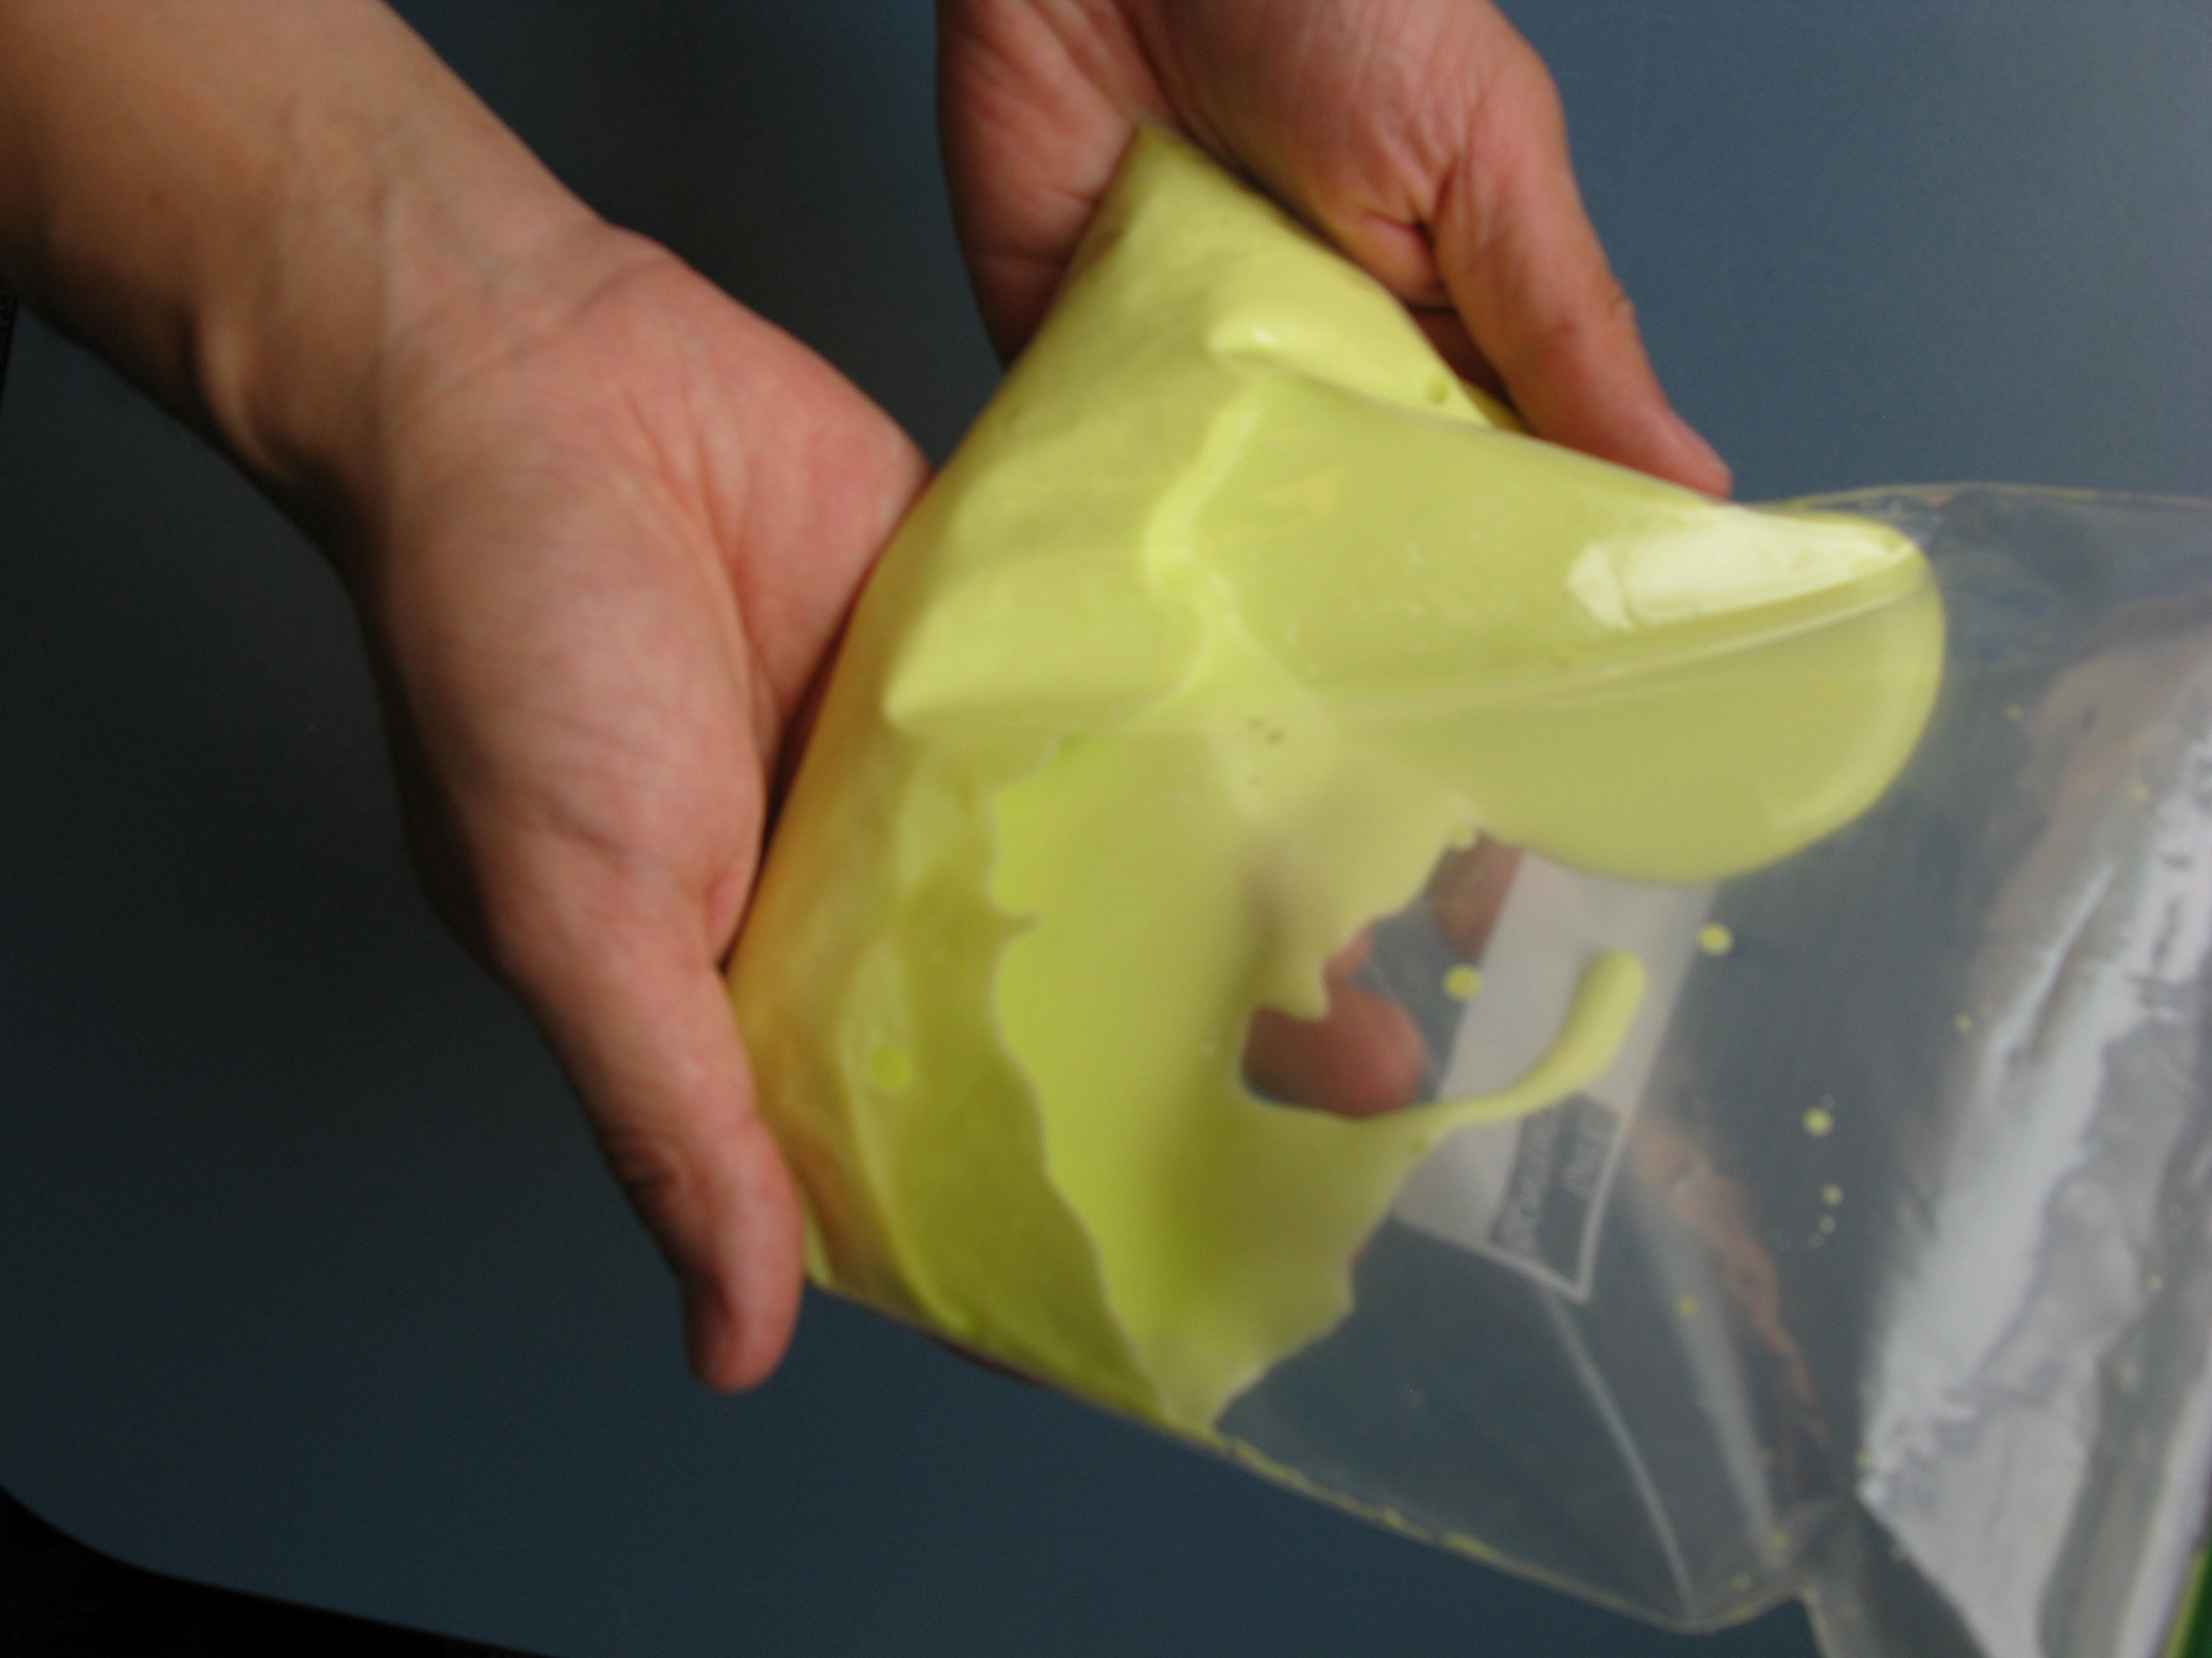  Oobleck
Oobleck is one of many materials called non-Newtonian fluids. Non-Newtonian fluids are fluids that do not follow Newton’s 3rd law of motion, “every action has an equal and opposite reaction”. For example, most fluids move faster when they are pushed harder. Oobleck moves slower when more force or pressure is applied. Some other non-Newtonian fluids are ketchup, toothpaste, and paint. In a regular Newtonian fluid, viscosity (resistance to motion) is a constant and only changes if the temperature is changed. Oobleck responds to how fast and how hard a force is applied. Pressure affects Oobleck’s viscosity because it changes the way the cornstarch and water interact. When you slowly stir the Oobleck it behaves like a liquid. The same force applied quickly makes it act more like a solid.

Now try this!  - Place a plastic egg into a small bag, and then put that bag into one of the large bags of Oobleck.  - Hold the large bag and an unprotected plastic egg about 2.5 feet (or roughly chest height) off the ground.  - At the same time, drop the bag and the egg. What happens?  What’s going on?  The Oobleck protects the egg. When it hits the ground, a quick direct force is applied to the Oobleck. | 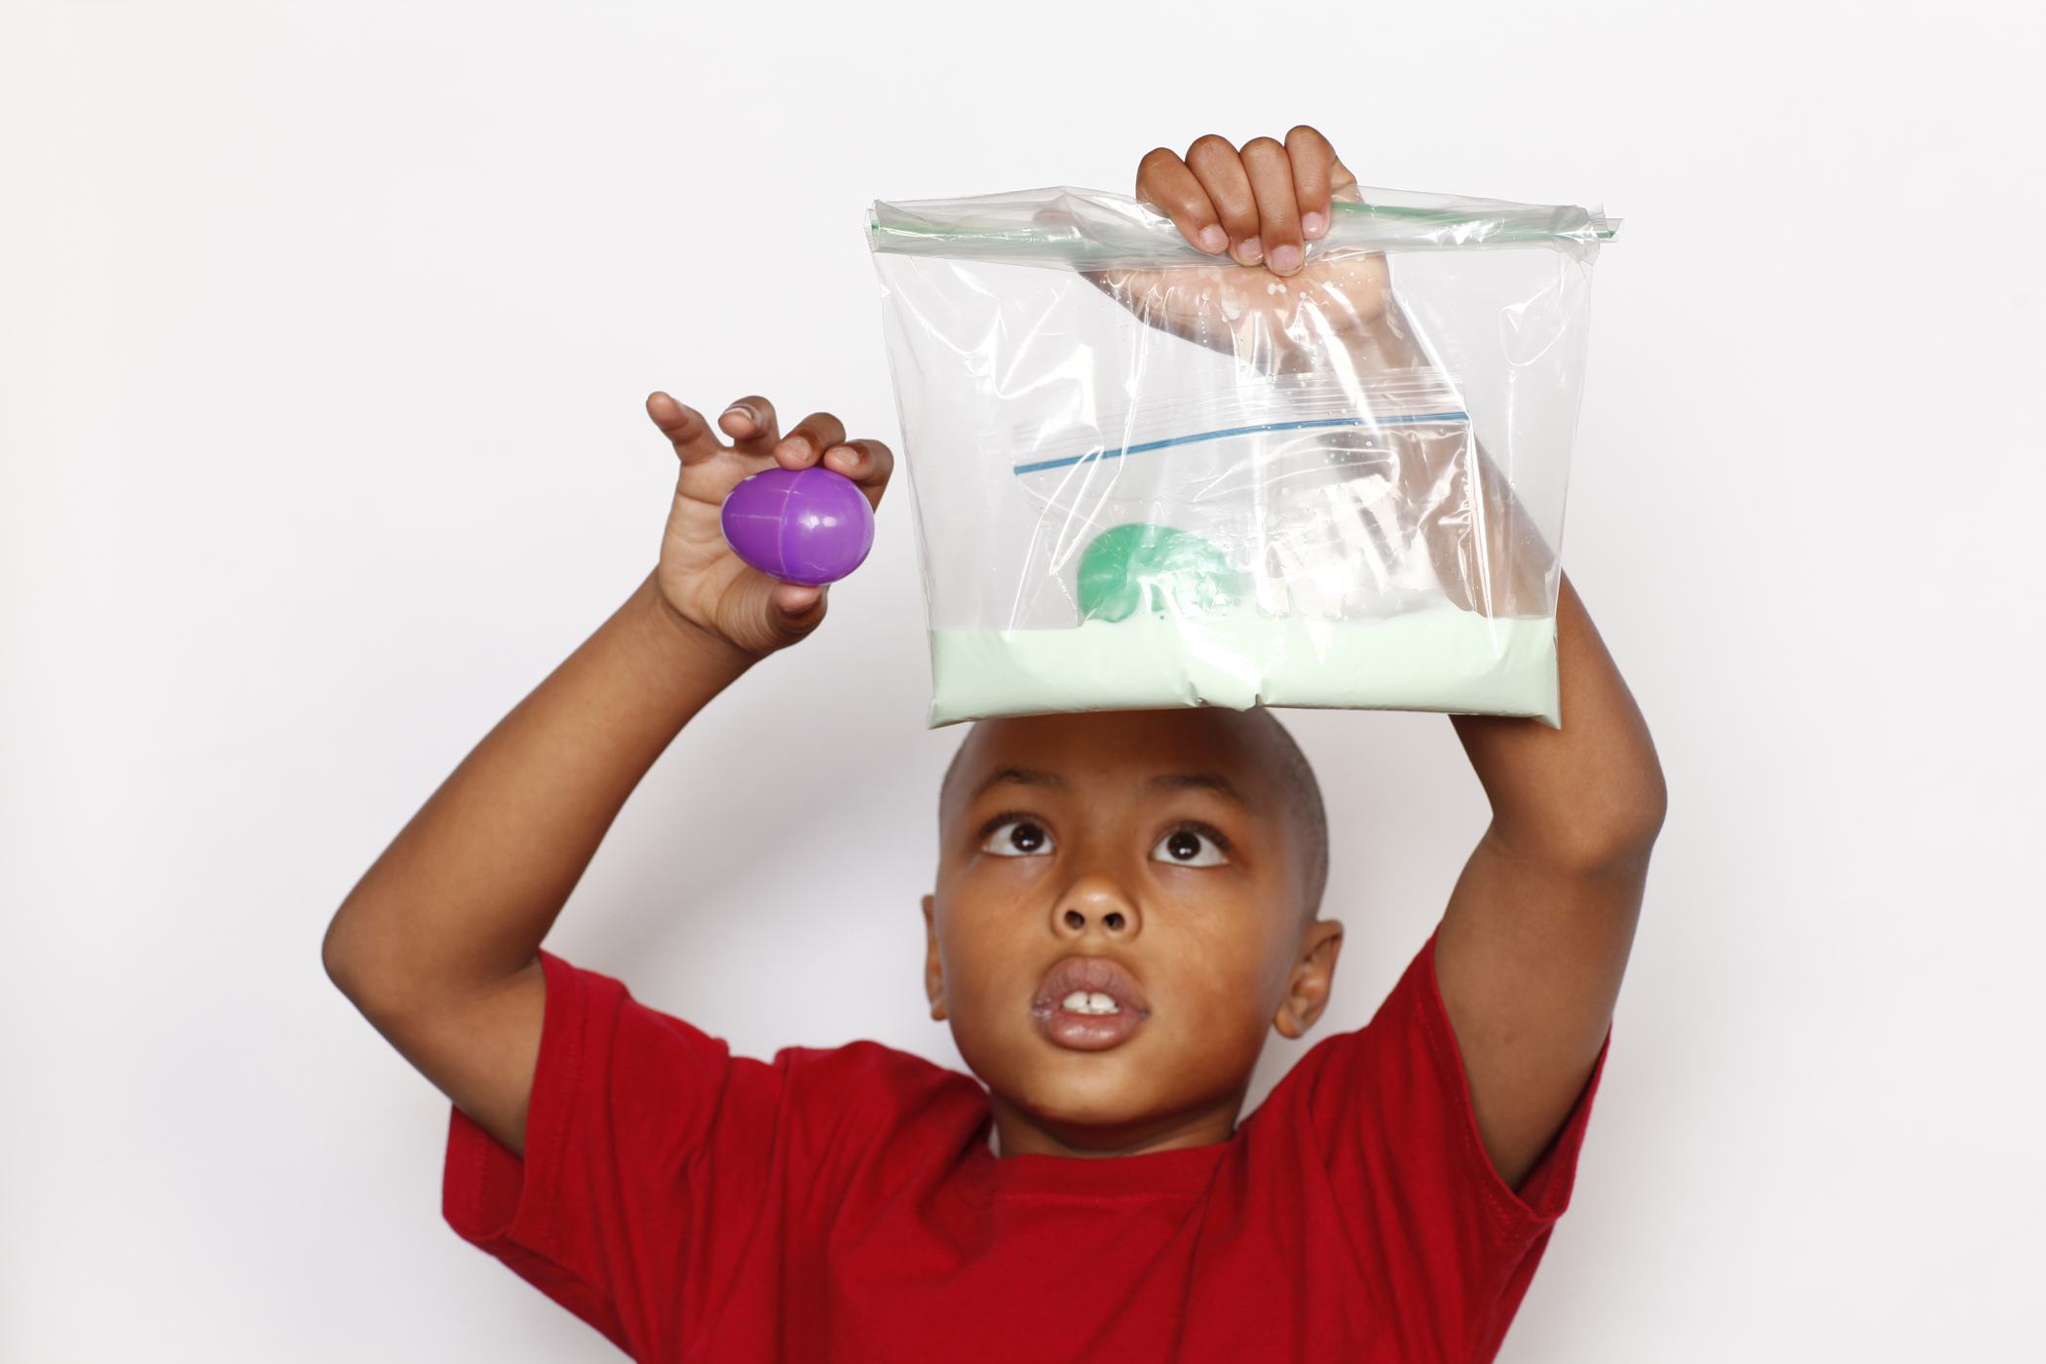  Oobleck experiment
The cornstarch clumps together and hardens like a solid, absorbing the impact and protecting the plastic egg. The Oobleck quickly goes back to acting like a liquid. Researchers are using sheer-thickening fluids (STFs) that behave a lot like Oobleck to make new gels and fabrics. These fabrics are flexible and comfortable when no force is applied, but when struck quickly they harden and provide solid protection.

How is this nano?
  STFs make a winter hat more like a helmet | The way a material behaves on the macroscale is affected by its structure on the nanoscale. Changes to a material’s molecular structure are too small to see directly, but we can sometimes observe corresponding changes in a material’s properties.  Nanotechnology takes advantage of properties at the nanoscale to create new materials. Fabrics made with sheer-thickening fluids (STFs) that contain nano-sized particles are used in a variety of technologies, from flexible body armor to protective (and fashionable) winter hats.

Learning Objectives
- The way a material behaves on the macroscale is affected by its structure on the nanoscale.
- Nanotechnology takes advantage of special properties at the nanoscale to create new materials.

Materials

- Oobleck
- 2 Large plastic bags
- Small plastic bag
- 2 Plastic eggs
- Liquid Body Armor image sheet

Notes to the presenter

Before doing this activity, prepare the Oobleck in each large bag:
- 1 cups cornstarch
- Half a cup water
- 2-3 drops food coloring (optional)
Mix until you reach the desired consistency. You may need to adjust the amount of water. The Oobleck solution should harden when pressure is applied, but otherwise will flow like a liquid. Prepare two bags of Oobleck; one for handling and one for the egg drop experiment. Be sure to not get the mixture in the bag’s zipper as it can prevent the bag from sealing. The Oobleck can be mixed in a bowl and then poured into the bag or mixed directly in the bag. To mix in the plastic bag allow some air in the bag and tilt the mixture from side to side.
SAFETY: Although nontoxic, visitors should be careful handling these materials. Visitors should not consume the Oobleck.
Tips: Perform the egg drop experiment on a hard surface. If done on carpet, the unprotected egg may not break. If the unprotected egg does not break on the first try, repeat the experiment from a higher starting point. Also, try to orient the eggs so they land on their sides. They tend to break more reliably if the seam hits the ground.
Cleanup: If visitors do get messy with the Oobleck, advise them to dunk their hands into a tub of water before washing in a sink. Empty all Oobleck directly into the trashcan, NOT the sink. Oobleck can clog a sink if too much is put down the drain. If saved for more than a few days Oobleck can begin to smell, so throw it out promptly.
Name: Oobleck gets its name from the Dr. Seuss book Bartholomew and the Oobleck where a gooey green substance, Oobleck, fell from the sky and wreaked havoc in the kingdom.

Related educational resources
The NISE Network online catalog (www.nisenet.org/catalog) contains additional resources to introduce visitors to the fundamentals of nanoscale science and technology:
- Public programs include Robots & People, Would You Buy That?, and Horton Hears a Who! Storytime
- NanoDays activities include Exploring Materials—Ferrofluid, Exploring Materials—Memory Metal, Exploring Properties—Invisibility, and Exploring Properties—Surface Area.
- Media include the Intro to Nanotechnology video, the Mr. O video series, and the Nano and Me video series.
- Exhibits include the Nano mini-exhibition.

Credits and rights
STF treated Kevlar images courtesy of Norman J. Wagner, University of Delaware.

This activity was adapted from Liquid Body Armor, developed by the Children’s Museum of Houston for the NISE Network. The original program is available at www.nisenet.org/catalog.

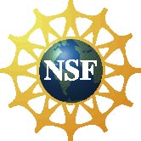 | This project was supported by the National Science Foundation under Award No. 0940143. Any opinions, findings, and conclusions or recommendations expressed in this program are those of the author and do not necessarily reflect the views of the Foundation.
Copyright 2013, Sciencenter, Ithaca, NY. Published under a Creative Commons Attribution-Noncommercial-ShareAlike license: http://creativecommons.org/licenses/by-nc-sa/3.0.

