

Exploring Properties—Capillary Action

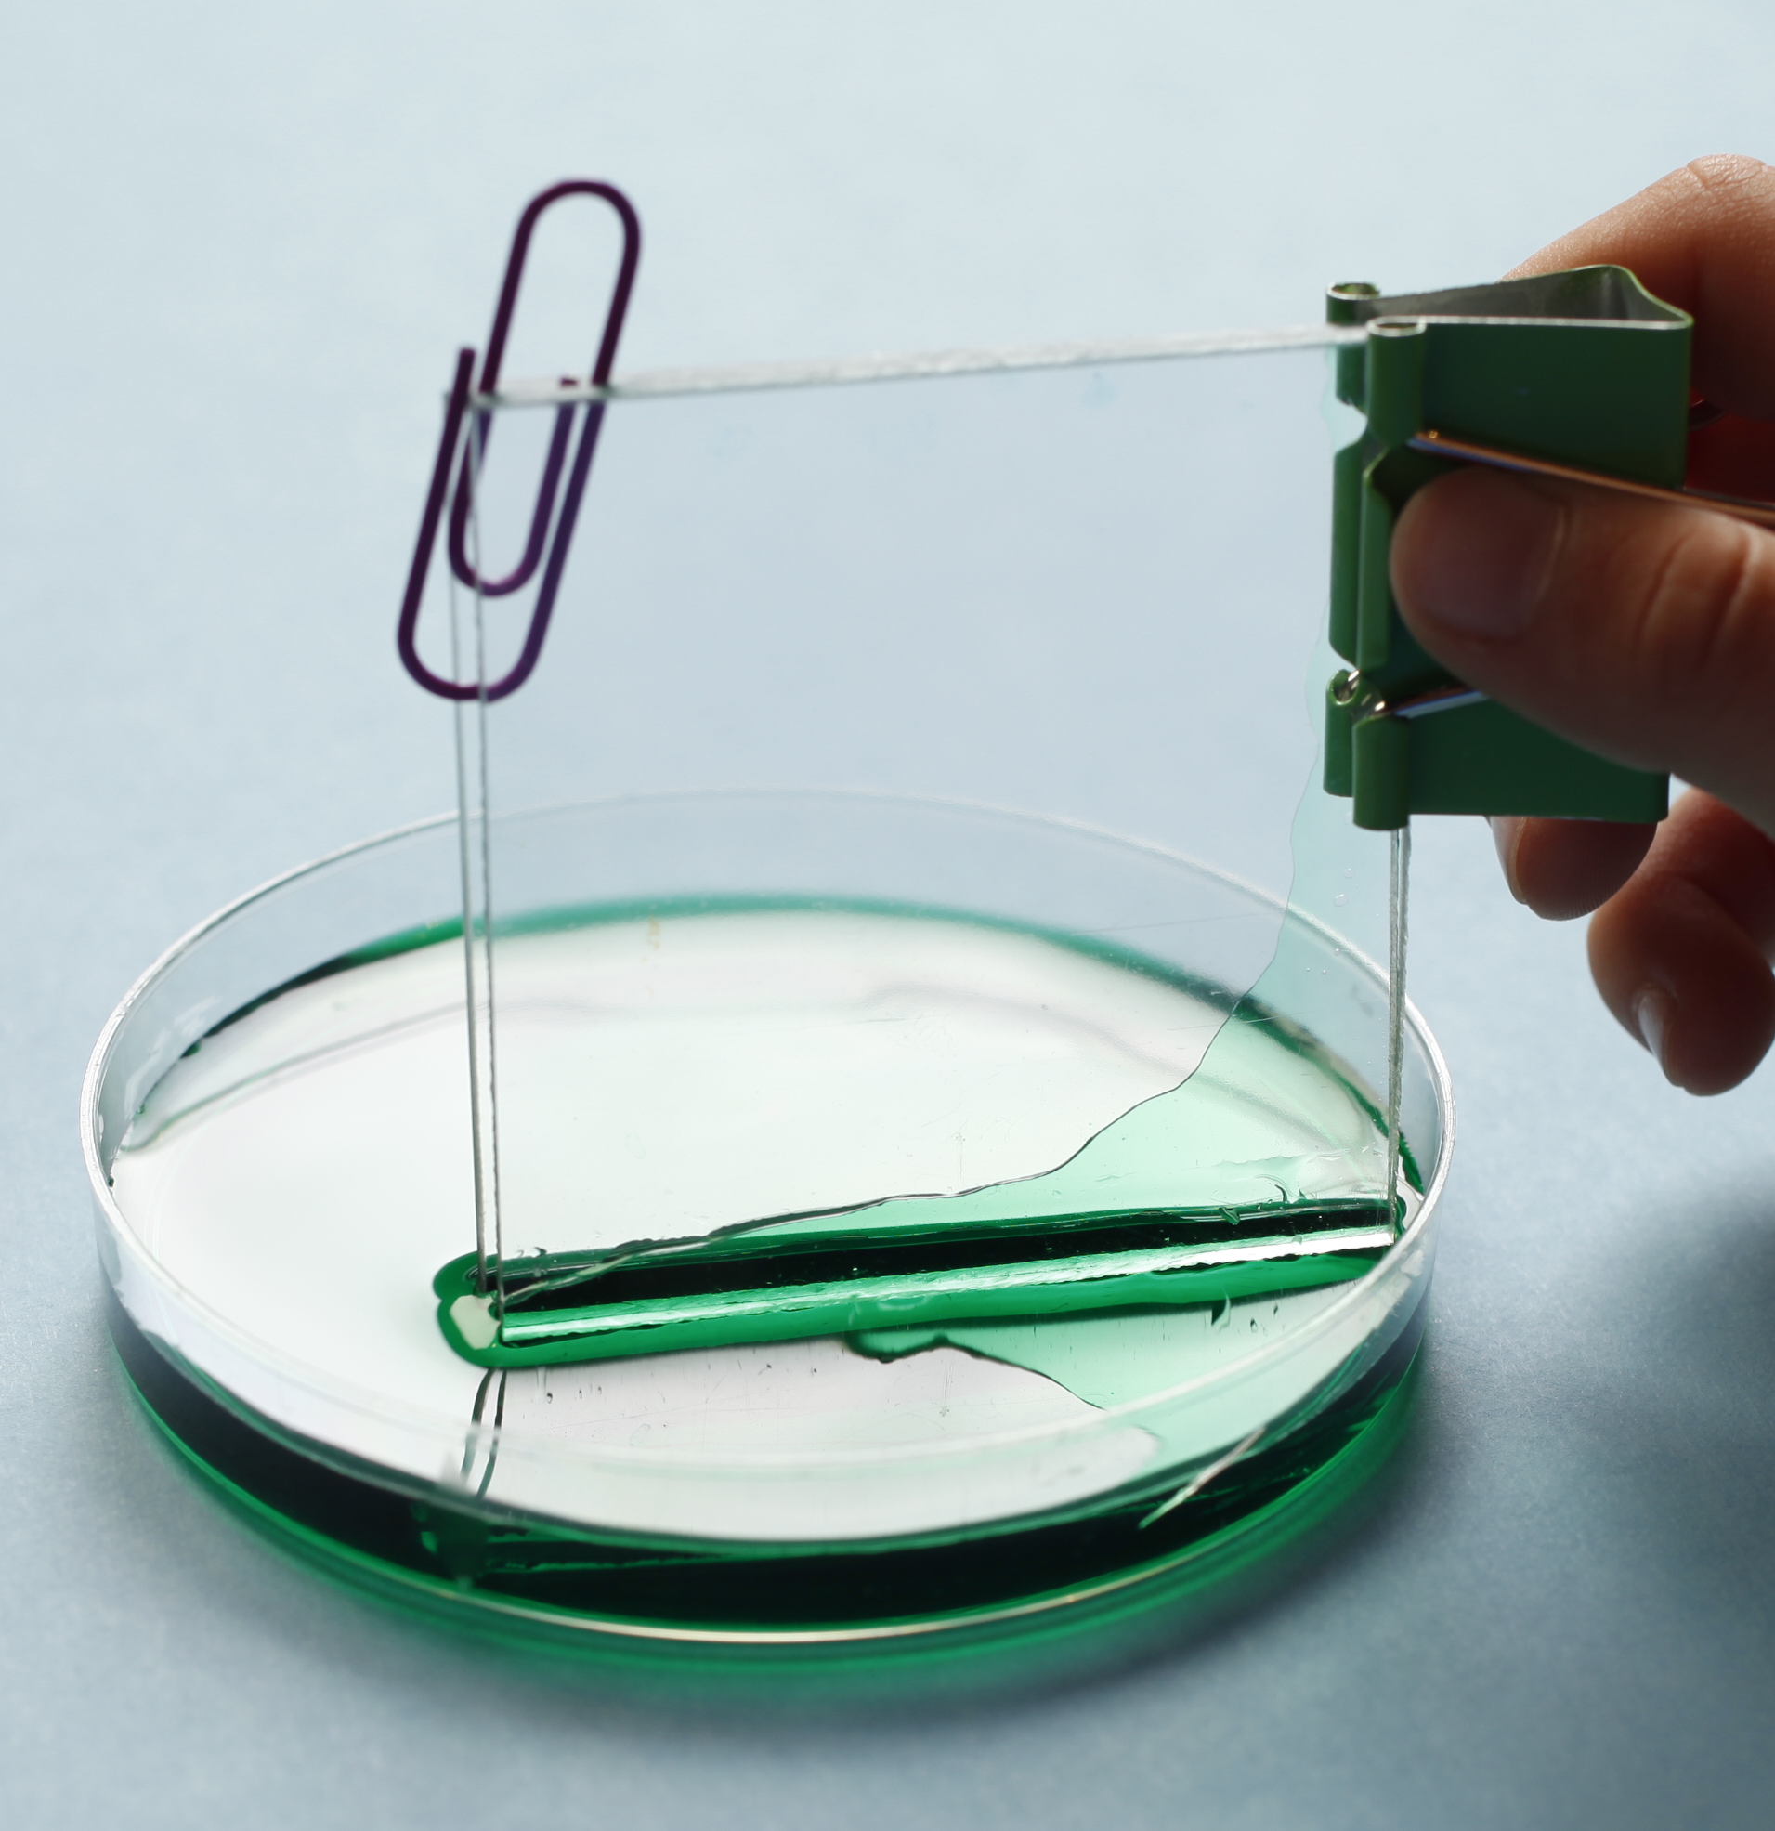
Try this!
- Hold an acrylic setup in a small amount of colored water.
- Observe the water level between the two pieces of acrylic. What happens? Is the water level the same across the setup?

What’s going on?
The water level between the two acrylic pieces rose as a result of capillary action. Capillary action is the ability of a liquid to flow in narrow spaces—even against gravity. The water level was higher where the pieces were closer together and the space was narrower. As capillary spaces get smaller and smaller, liquids can move farther and faster.

Now try this!
- Use water-based markers to draw on a coffee filter.
- Add several drops of water to the coffee filter.
- Now hold the paper up vertically and watch the water move. What do you notice?

What’s going on?
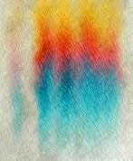  Color moving on paper | The ink pigment dissolves in the water because it is water-soluble. As the water travels up the paper by capillary action, it carries the pigment along with it. How fast each pigment travels depends on the size of the pigment molecule and on how strongly the pigment is attracted to the paper. The spaces between the fibers in the paper act as capillary tubes.  This technique is called chromatography and was originally used for separating pigments that made up plant dyes. There are many different types of chromatography. In all of them, a liquid (like the water) or a gas flows through a stationary substance (like the paper). Chromatography can determine the chemical makeup of a flavor or scent, the components of pollutants, and can separate blood proteins.

How is this nano?
When things get small they can behave in surprising ways. Different physical forces dominate when things get very, very small. For example, gravity is very important to us on the macroscale, but it’s hardly noticeable at the nanoscale.  Researchers at Harvard University are making special patterned paper that wicks small volumes of fluid by capillary action. The fluid is tested and analyzed through different sensors printed right onto the paper. The result is a flexible, disposable test that can check a tiny amount of urine or blood for evidence of infectious diseases or chronic conditions. Currently, paper diagnostics use microtechnologies, but nanoscale features may make them even more useful and accurate. | 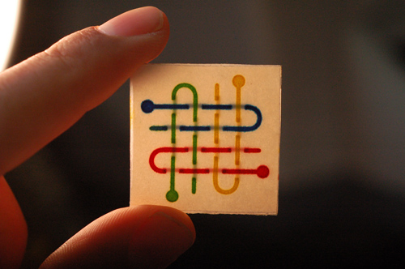  Paper diagnostics
Learning objectives
- At the nanoscale things behave in surprising ways.
- Technologies and society influence each other.

Materials

- Coffee filters
- Water-soluble markers
- Squeeze bottle of water
- Lab-on-a-chip & paper diagnostics sheet

- Acrylic capillary action setup (two acrylic squares, binder clip, paper clip, petri dish, food coloring)
- Paper towels (optional for clean up)

Notes to the presenter
SAFETY: Although nontoxic, visitors should be careful handling these materials. Visitors should not drink the dyed water.

Before doing this activity:
Prepare the capillary action setup: You may need to peel the brown paper backing off the acrylic. Hold the two acrylic squares together with the binder clip along one edge. Insert the paper clip on the opposite edge to make a small wedge. Fill the petri dish halfway with colored water. Tips: You’ll want to use a high concentration of food coloring (3 or more drops) in order to see the water wick up between the plastic squares. The kit includes two sets of the capillary action setup. Alternate between the two sets to allow for drying and resetting.

Timing: It may take a few moments for the liquid to rise up between the acrylic squares. Do the coffee filter activity first and come back to the demo afterwards to see how much the water moved.

Knowing your visitors: The filter paper activity is an opportunity for visitors to explore and experiment with capillary action. Young visitors can draw freely and choose how much water to add. Make it a more controlled experiment for older children or adults by drawing a line on one edge of the filter and holding the paper vertically to watch the water rise up against gravity.

Conversations: This activity is based on a demonstration of capillary action, but it provides an opportunity to engage visitors in conversation about potential new nanotechnologies, like a lab-on-a-chip and paper diagnostics, and ways that these technologies can both influence and be influenced by society.

Related educational resources
The NISE Network online catalog (www.nisenet.org/catalog) contains additional resources to introduce visitors to the fundamentals of nanoscale science and technology:
- Public programs include Robots & People, Would You Buy That?, and Wheel of the Future.
- NanoDays activities include Exploring Forces—Gravity, Exploring Properties—Surface Area, Exploring Forces—Static Electricity, Exploring Materials—Nano Gold, Exploring Nano & Society—You Decide, and Exploring Nano & Society—Space Elevator.
- Media include the Intro to Nanotechnology video, the Mr. O video series, the Nano and Me video series, the Societal and Ethical Implications Posters, and the Wonders and Worries of Nanotechnology video series.
- Exhibits include the Nano mini-exhibition, At the Nanoscale and Unexpected Properties.

Credits and rights
Images of paper diagnostic tools provided by Whitesides Research Group, Harvard University.
Image of lab-on-a-chip courtesy of Agilent.

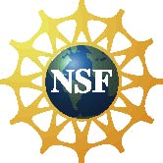 | This project was supported by the National Science Foundation under Award No. 0940143. Any opinions, findings, and conclusions or recommendations expressed in this program are those of the author and do not necessarily reflect the views of the Foundation.
Copyright 2013, Sciencenter, Ithaca, NY. Published under a Creative Commons Attribution-Noncommercial-ShareAlike license: http://creativecommons.org/licenses/by-nc-sa/3.0.

