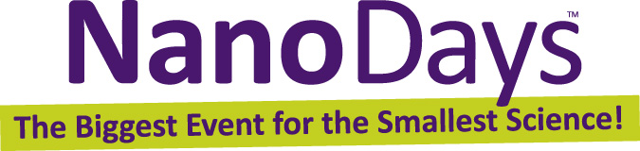

Exploring Properties—Surface Area

Try this!  - Pour 20 ml of colored water from the pitcher into each measuring cup.  - Remove two antacid tablets from their wrapper. Break one in half, and drop it into a cylinder. Break the other tablet into many small pieces, and put it in the other cylinder.  - At the same time, pour the water from each cup into a cylinder.  - Which fizzes up faster, the tablet you broke in half or the tablet you broke into lots of pieces?  What’s going on?  The crushed tablet fizzes faster than the halved tablet. That’s because it has a greater surface area to volume ratio. For the same amount of antacid, the crushed tablet has more surface—or exterior—to react with the water. Because the water can reach more of the antacid immediately, the chemical reaction (fizzing) happens faster. | 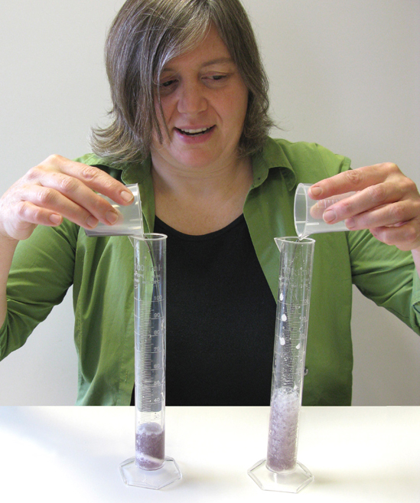

Small things have more surface area for their volume than larger things do. Some things that aren’t reactive at all in big pieces are very reactive when they’re tiny. Steel wool catches fire, but you can’t easily light a lump of metal on fire!

How is this nano?
  Nano adhesives stick graphics  onto cardboard boxes | A material can act differently when it’s nanometer-sized. Things on the nanoscale have a lot of surface area, so they react much more easily and quickly than they would if they were larger.  Nanotechnology takes advantage of different material properties at the nanoscale—such as increased surface area—to make new materials and tiny devices. For example, an extra-sticky, eco-friendly glue can be made from starch molecules that are only 100 nanometers in size.  Nanotechnology allows scientists and engineers to make other things like smaller, faster computer chips and new medicines to treat diseases like cancer.

Learning objectives
- A material can act differently when it’s nanometer-sized.
- Things on the nanoscale have a lot of surface area, so they react much more easily and quickly than they would if they were larger.

Materials
- 100 ml graduated cylinders (2)
- Small plastic measuring cups (2)
- Pitcher
- Effervescent antacid tablets
- Food coloring

Notes to the presenter
SAFETY: The antacid tablets contain medication. Visitors should be supervised when doing this activity, and should not be allowed to consume the tablets or the water they’re dissolved in. You may choose to perform this as a demonstration, rather than allowing visitors to do it as a hands-on activity.

Before beginning this activity, fill the pitcher with water and add food coloring.

You’ll need a place to dump wastewater. If there isn’t a sink near your activity area, you can dump wastewater into a bucket and dispose of it periodically.

Between demonstrations, give the cylinders a good shake to remove excess water.

Related educational resources
The NISE Network online catalog (www.nisenet.org/catalog) contains additional resources to introduce visitors to the fundamentals of nanoscale science and technology:
- Public programs include Intro to Nano, Nano Dreams and Nano Nightmares, Surface Area and Wheel of the Future.
- NanoDays activities include Exploring Forces—Gravity and Exploring Forces—Static Electricity.
- Media include the Intro to Nanotechnology video.
- Exhibits include At the Nanoscale and Unexpected Properties.

Credits and rights
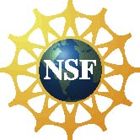 | This project was supported by the National Science Foundation under Award No. ESI-0532536. Any opinions, findings, and conclusions or recommendations expressed in this program are those of the author and do not necessarily reflect the views of the Foundation.

Copyright 2010, Sciencenter, Ithaca, NY. Published under a Creative Commons Attribution-Noncommercial-ShareAlike license: http://creativecommons.org/licenses/by-nc-sa/3.0/us/

