Piezoelectricity


Organization: Oregon Museum of Science and Industry

Contact person: Anders Liljeholm

Contact information: 503-797-4606, aliljeholm@omsi.edu

General Description

Demonstration

This cart demo is about piezoelectricity - how some crystals produce electricity when you squeeze them. Visitors learn about the history of piezoelectricity, how it's used, and how it's applied in nanotechnology. They make electric sparks, handle models and listen to cheesy music.

Program Objectives

Big idea:
Certain crystals do the "electric squeeze", making electricity when squeezed.

Learning goals:
The nanostructure of a material determines its properties. Small changes in structure can mean big changes in property.
Piezoelectricity is a property of crystals with a certain shape. Squeeze them and they generate electricity. Apply a current to them and they change shape.
Scientists use piezoelectricity to explore and transform the nanoscale world.

NISE Main Messages covered:
[ X ] 1. Nanoscale effects occur in many places. Some are natural, everyday occurrences; others are the result of cutting-edge research.
[ X ] 2. Many materials exhibit startling properties at the nanoscale.
[ X ] 3. Nanotechnology means working at small size scales, manipulating materials to exhibit new properties and create new devices.
[ X ] 4. Nanoscale research is a people story.
[ ] 5. No one knows what nanoscale research may discover, or how it may be applied.
[ ] 6. How will nano affect you?

Piezoelectricity

Table of Contents
General Description 1
Program Objectives 1
Time Required 1
Table of Contents 2
Background Information 3
Materials 4
Set Up 5
Step 1: 5
Program Delivery 5
Safety: 5
Procedure and Discussion: 6
Tips and Troubleshooting: 7
Common Visitor Questions 8
Going Further… 8
Clean Up 9
Universal Design 9

NOTICE: You're welcome to alter this program to suit your needs. In fact, we encourage it! Change it around, and if you find something that works let us know. Post your revisions on www.nisenet.org.

Time Required

Set-up Program Clean Up
5 minutes 15 minutes 5 minutes

Background Information

Definition of terms

Nano is the scientific term meaning one-billionth. (1/1,000,000,000) It comes from a Greek word meaning “dwarf.”
A nanometer is one one-billionth of a meter. One inch equals 25.4 million nanometers. A sheet of paper is about 100,000 nanometers thick. A human hair measures roughly 50,000 to 100,000 nanometers across. Your fingernails grow one nanometer every second.
(Other units can also be divided by one billion. A single blink of an eye is about one-billionth of a year. An eyeblink is to a year what a nanometer is to a yardstick.)
Nanoscale refers to measurements of 1 – 100 nanometers. A virus is about 70 nm long. A cell membrane is about 9 nm thick. Ten hydrogen atoms are about 1 nm.

At the nanoscale, many common materials exhibit unusual properties, such as remarkably lower resistance to electricity, or faster chemical reactions.
Nanotechnology is the manipulation of material at the nanoscale to take advantage of these properties. This often means working with individual molecules.
Nanoscience, nanoengineering and other such terms refer to those activities applied to the nanoscale. “Nano,” by itself, is often used as short-hand to refer to any or all of these activities.

Materials
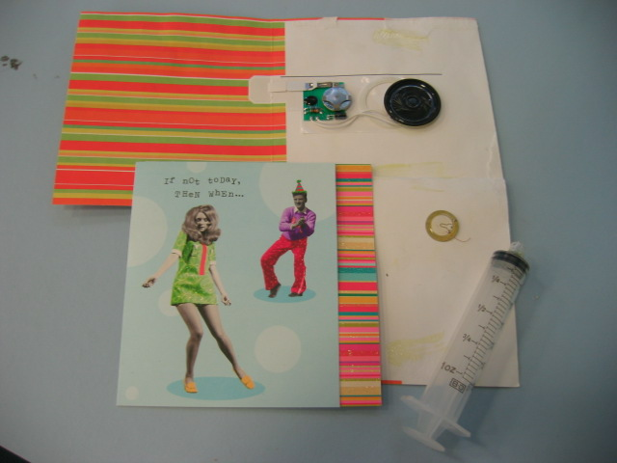
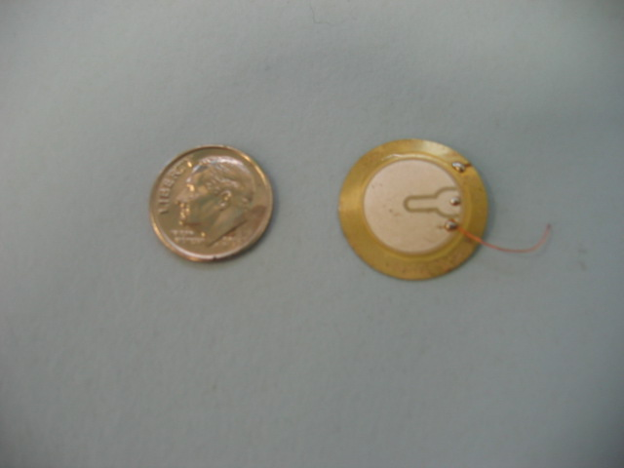
Musical greeting card
Piezo transducer
Quartz crystal

Crystal models (Available at www.indigo.com. Note: The buckyball kit can be made into a nanotube or graphite, but not a diamond. Only the diamond kit models carbon bonding accurately enough to make a diamond structure.)
One diamond kit
One quartz model
Two buckyball kits

http://www.indigo.com/models/gphmodel/diamond-model-M.html
http://www.indigo.com/models/gphmodel/buckyball-model-M.html
http://www.indigo.com/models/gphmodel/quartz-model-M.html

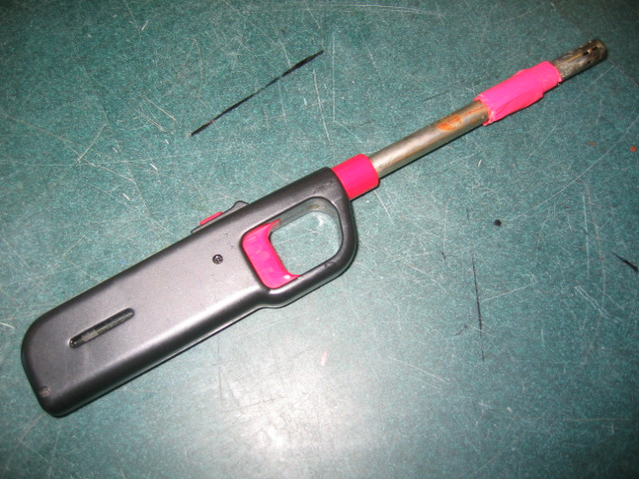
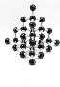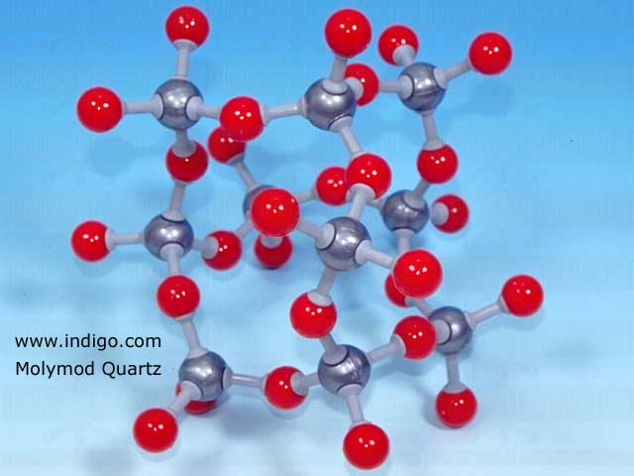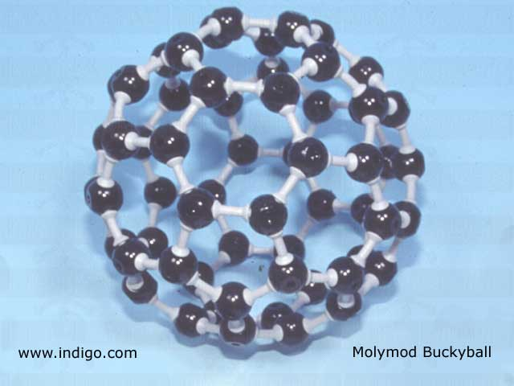

Barbecue lighter

Powerpoint or printed pictures (AFM images, applications of piezoelectricity, faces of pioneers)

Syringe
Bucket
Water (You can add food coloring to make it look like ink)

Black tube with sparker

Set Up

Time: 5 minutes

Step 1:
Set out all supplies.

The very first time you do the demo, you will have to assemble your molecular models, which will take about 30 minutes.

Program Delivery

Time: 15 minutes

Safety:
Don’t use the piezo sparker around any flammable material.

The molecular models are a potential choke hazard for small children.

Procedure and Discussion:

Everything is made of tiny bits of matter called atoms. The way the atoms line up determines how a substance acts.

[Show the 3 carbon models.] These models represent three different substances. Each is made of the same kinds of atoms--carbon--but the carbon atoms are arranged in different ways.

For example, here’s graphite and here’s diamond. Both are pure carbon. One is soft and black, while the other is clear and the hardest stuff on Earth. In diamonds, the carbon atoms form crystals with a very regular pattern, but in graphite the atoms slide around in big sheets. Pencil lead and diamonds are made of the same stuff, but arranged in different ways. Feel how the model of the diamond crystal is strong—it doesn’t jiggle much--but the graphite model slides around. [Let visitors feel diamond and graphite models.]

This model represents a molecule called a Buckyball. It’s also made entirely of carbon atoms, arranged it a sphere. It’s very smooth.

Now, if I take a sheet of graphite molecules and roll them into a tiny tube, they take on a new property, something we call The Electric Squeeze. The tube makes electricity when we squeeze it. Scientists call this property piezoelectricity, but I like “The Electric Squeeze” better. Pierre Curie discovered The Electric Squeeze back in 1880.

Lots of different atoms can do The Electric Squeeze, not just carbon. It depends on how the atoms are arranged. [Show the quartz and quartz model.] This is a quartz crystal. And this is a model of the crystal. Quartz is made of silicon and oxygen. It also does The Electric Squeeze. If you squeeze quartz, it makes electricity. To see why, watch what happens when I squeeze the model. You can see the atoms bunch up on one side. If you hook up a wire to a piece of quartz and squeeze it, it would release the electrons from all those bunched-up atoms and create an electric current.

In this black tube, we have a quartz crystal that you can squeeze, and you can see the electricity. Try it! [Let the visitors press on the sparker button, then show them the grill lighter.] This lighter uses the same type of crystal to make electricity. When you squeeze on it, it makes a spark.

The Electric Squeeze also works backwards! If you squeeze it, it makes electricity. If you run electricity through the crystal, it stretches. [Show the visitors the sample piezo transducer.] There’s a slice of crystal in here. There’s another piezo crystal inside the greeting card. When you open the card, a battery sends pulses of electricity to the crystal, making it vibrate. Here, you can feel it. [Hand card to visitors.] Piezo crystals are also used in digital watches.

One kind of inkjet printer uses piezoelectric crystals. [Show visitors syringe, filled with colored water.] Let’s say this syringe is an ink cartridge. When I push on the pluger, ink squirts out. [Shoot water into bucket.] Now, that much ink coming out all at once would make a big mess. What we need is a way to release ink in tiny, precise amounts, one drop at a time. Engineers have made tiny valves at the tips of ink cartridges that open and close with piezo crystals. Electrical current forces the crystals to expand a tiny bit, which squeezes out a single drop of ink.

Gerd Binnig and Heinrich Rohrer won the Nobel Prize for figuring out that if you run a tiny amount of electricity through a piezo crystal, it will expand a tiny bit. All of the atoms in the crystal stretch apart a tiny amount, so the length of the crystal increases the distance of just a few atoms. [Stretch the quartz model.] We can use these crystals to make a microscope that can measure individual atoms. [Show AFM images.] We can see how the atoms line up on a piece of tape, or a butterfly, or even a virus.

And, we can even use piezoelectric crystals to move individual atoms around and build things, one atom at a time. We’re just starting to figure out how to make things this way. But remember--how you build things can change how they work. Remember the diamond and the graphite? Both were made of carbon atoms, but they have very different properties. As we learn how to manipulate atoms, we may be able to build material with the specific properties we want. We're beginning to develop the technology to turn pencil lead into diamonds. Or into other new materials that have new properties.

Do you have any questions?

Tips and Troubleshooting:

NOTICE: Feel free to alter this program to suit your needs. If you find something that works, share it with the rest of the community by posting your revisions on www.nisenet.org.

- The piezo sparker is very exciting, and can be broken by enthusiastic visitors.
- OMSI tried making a piezo transducer that you could feel click once, but the phenomenon is so small that you can’t feel it unless it’s vibrating continuously.
On a dry day, you can make the spark stronger and easier to see by breathing some moisture into the tube.

Common Visitor Questions

How do digital watches use piezo crystals?
Small crystals of quartz in a digital watch act the same way a pendulum does in a grandfather clock. A crystal of a certain size will vibrate at a particular frequency, just like a pendulum of a certain length will always swing at a certain rate. The computer in the digital watch counts the vibrations of the quartz crystal to know how much time has passed.

http://electronics.howstuffworks.com/quartz-watch2.htm

Is a piezoelectric spark the same thing as Life Savers lighting up in the dark?
Not exactly. Triboluminesence, the phenomenon that causes Wint-O-green Life Savers to make sparks of light, is related to piezoelectricity, but it works in a different way.

Again, it involves crystals. But rather than being squeezed, the sugar crystals in Life Savers give off ultraviolet light when they are split or cracked. We can’t see UV light, but the chemicals that give Wintergreen Life Savers their flavor convert the UV into visible light.

(Cutting a diamond can also produce triboluminesence. But as we noted, diamonds are not piezoelectric.)

http://pages.towson.edu/ladon/wg/candywww.htm

According to Wikipedia, the Ute of Colorado made rattles filled with quartz which would light up when shaken in the dark. http://en.wikipedia.org/wiki/Piezoelectricity

Are the atoms really the color we see in the slides?
No. Atoms have no color. Color is a property of light, and atoms are smaller than a wave of light. We add false color to pictures of atoms to make it easier to look at, or to highlight specific information.

Going Further…
Good brief introduction to piezo materials: http://www.piezomaterials.com/

A more technical explanation of how piezoelectricity works.
http://www.physikinstrumente.com/en/products/piezo_tutorial.php?VID=8FZmMYd8goUDSdEF

Wikipedia. Take it with a grain of triboluminescent salt.
http://en.wikipedia.org/wiki/Piezoelectricity

One possible future enhancement to this demo is to make a piezo sensor attached to an electronic display. The visitor would press on the sensor and see a needle move or lights turn on. The sensor would be so sensitive that the visitor wouldn’t be able to feel the piezo sensor move, but still see a result.

Clean Up

Time: 5 minutes
Put everything away. Do not disassemble molecular models if you are planning to do the demonstration again soon.

Universal Design

This program has been designed to be inclusive of visitors, including visitors of different ages, backgrounds, and different physical and cognitive abilities.

The following features of the program’s design make it accessible:

[ X ] 1. Repeat and reinforce main ideas and concepts
Multiple applications of piezoelectricity reinforce the big idea.

[ ] 2. Provide multiple entry points and multiple ways of engagement

[ X ] 3. Provide physical and sensory access to all aspects of the
program
Visitors can touch, see and hear different elements of the program.
To give an inclusive presentation of this program:

Demo features tactile models of different crystal structures.
Reiterate basic message several times to help visitors retain it.


This project was supported by the
National Science Foundation under Grant No. ESI-0532536.

