

Exploring Fabrication—Self-Assembly

GAME 1—RING
Ready, set…
This game requires an even number of participants.
Self-assemble!  - Everyone hold hands! No hand can be left untouched. You must find a different partner to hold each of your hands.  - Your right hand must hold someone else’s right hand, and your left hand must hold someone else’s left hand.  - You cannot cross your arms.  What’s going on?  You made a circle, with every other person facing in. You followed rules that created a specific pattern. As long as you follow these rules, you’ll always “self-assemble” into this same pattern!  How is this nano? | 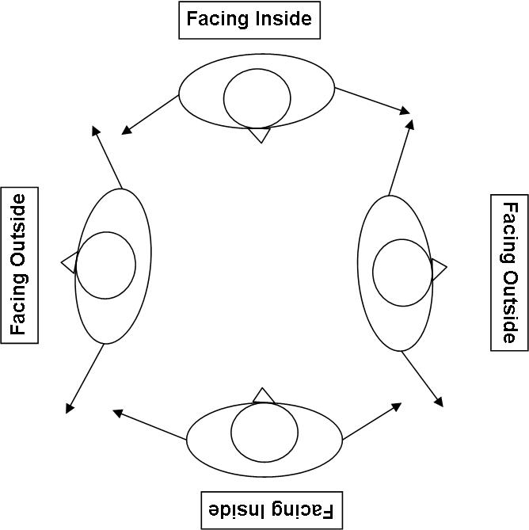

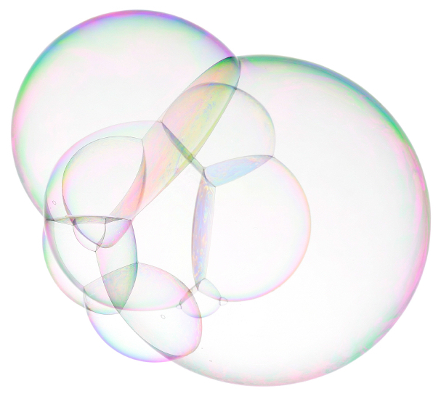  Soap bubbles | Self-assembly is a process by which molecules and cells form themselves into functional structures. Self-assembly occurs in nature: snowflakes, soap bubbles, and DNA are just three examples of things that build themselves.  Researchers in the field of nanotechnology are studying self-assembly in order to create new materials and technologies smaller than 100 nanometers in size. (A nanometer is a billionth of a meter.) Nanotechnology allows scientists and engineers to make things like smaller, faster computer chips and new medicines to treat diseases like cancer.

Exploring Fabrication—Self-Assembly

GAME 2—CAPSULE
Ready, set…  - Define a space for the activity to take place.  - Divide into two groups:  - Group 1: about a third of your participants  - Group 2: about two-thirds of your participants  Self-assemble!  Group 1:  - You must stand within the defined area.  - You can walk—not run—within this space.  - You cannot touch anyone from Group 2.  Group 2:  - Line up at the edge of Group 1’s space. Join hands to form a chain.  - Walk—don’t run—toward Group 1 and try to engulf them.  - Don’t break your chain, and don’t touch anyone from Group 1.  - When you have everyone from Group 1 inside your chain, the two ends of the chain hold hands to form a circle. | 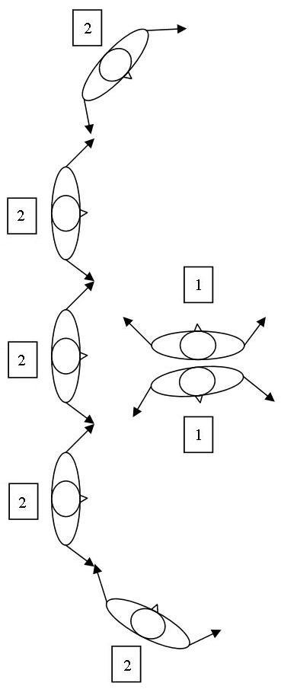

What’s going on?  You made a capsule! You’re a model for nanocapsules, tiny particles with an outside shell and hollow interior.  Tiny nanocapsules can be filled with medicine and designed to deliver it to diseased parts of the body, bypassing healthy parts. These “smart drugs” require much less medicine, so they have less harmful side-effects. Self-assembly is an important process for creating nanocapsules.  How is this nano? |  | 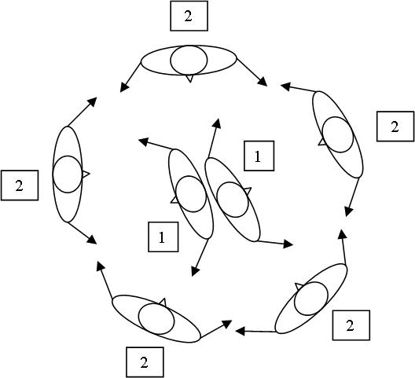
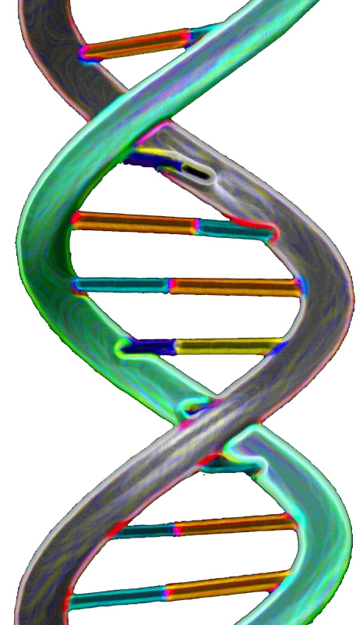  Illustration  of DNA | Self-assembly is a process by which molecules and cells form themselves into functional structures. Self-assembly occurs in nature: snowflakes, soap bubbles, and DNA are just three examples of things that build themselves.  Researchers in the field of nanotechnology are studying self-assembly in order to create new materials and technologies smaller than 100 nanometers in size. (A nanometer is a billionth of a meter.) Nanotechnology allows scientists and engineers to make things like smaller, faster computer chips and new medicines to treat diseases like cancer.

Exploring Fabrication—Self-Assembly

GAME 3—SNOWFLAKE
Ready, set…
- This game requires 9 or 15 participants. With 9 participants, divide into two groups. With 15 participants, divide into three groups.
- Divide into groups:
- Group 1 = 3 people, wearing RED gloves on BOTH hands
- Group 2 = 6 people, each wearing ONE RED glove and ONE BLUE glove
- Group 3 = 6 people, wearing ONE BLUE glove on one hand
Self-assemble!  Group 1:  - Stand so that each of your shoulders touches the shoulder of someone else in Group 1.  - You cannot face anyone else in Group 1.  Group 2:  - Extend your arms out from your sides.  - Find a hand to hold.  - You cannot hold hands with anyone else in Group 2.  - You must hold hands with someone wearing the same color glove.  Group 3:  - Extend your arms out from your sides.  - You must hold hands with someone who has the same color glove.  - You cannot hold hands with anyone else in Group 3. | 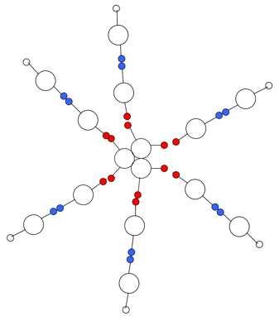
What’s going on?
You made a giant model of a snowflake! Snowflakes are one of nature’s best examples of self-assembly.

How is this nano?
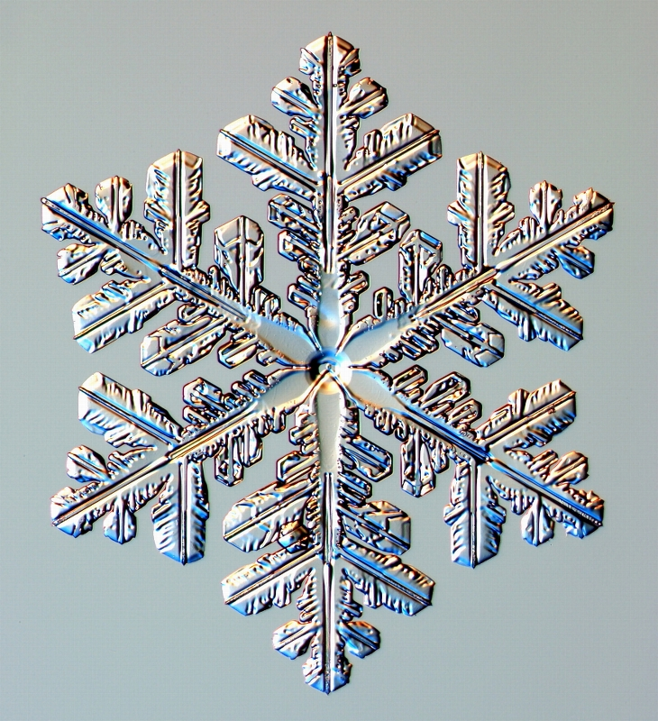  Snowflake | Self-assembly is a process by which molecules and cells form themselves into functional structures. Self-assembly occurs in nature: snowflakes, soap bubbles, and DNA are just three examples of things that build themselves.  Researchers in the field of nanotechnology are studying self-assembly in order to create new materials and technologies smaller than 100 nanometers in size. (A nanometer is a billionth of a meter.) Nanotechnology allows scientists and engineers to make things like smaller, faster computer chips and new medicines to treat diseases like cancer.

Learning objectives
- Self-assembly is a process by which molecules and cells form themselves into functional structures.
- Researchers in the field of nanotechnology are studying self-assembly in order to create new materials and technologies.

Materials
- 12 blue gloves
- 12 red gloves

The gloves can be any two colors. For one-time use, non-powdered vinyl or nitrile gloves (not latex) work well. For reuse, knit “magic” stretch gloves work well.

Notes to the presenter
Explain how the game will work before you begin. You can say something like:

Today we’re going to learn about a process called self-assembly. Self-assembly happens millions of times every day, all around us. Self-assembly is a process by which molecules and cells form themselves into functional structures. We’re going to be molecules and experiment with the process. Let’s start with our first game!

Before each game, you might want to read all rules out loud all the way through.

Related educational resources
The NISE Network online catalog (www.nisenet.org/catalog) contains additional resources to introduce visitors to self-assembly:
- Public programs include DNA Nanotechnology, Snowflakes: Nano at its Coolest, and Tiny Particles, Big Trouble!
- Exhibits include Creating Nanomaterials and NanoLab.

Credits and rights
This activity was adapted from Ready, Set, Self-Assemble, developed by the Children’s Museum of Houston. The original program is available on www.nisenet.org/catalog.

Illustration of DNA by James J. Caras, courtesy of National Science Foundation.

Photo of snowflake courtesy Kenneth Libbrecht, www.snowcrystals.com.

 | This project was supported by the National Science Foundation under Grant No. ESI-0532536.  Any opinions, findings, and conclusions or recommendations expressed in this program are those of the author and do not necessarily reflect the views of the Foundation.

Copyright 2009, Sciencenter, Ithaca, NY.

