Snowflakes: Nano at its coolest


Organization: Sciencenter, Ithaca, NY
Contact person: Rae Ostman
Contact information: rostman@sciencenter.org
607-272-0600

General Description

Stage presentation

“Snowflakes” is a public presentation that introduces nanoscale science through the study of a natural phenomenon: snow. The program considers what makes it snow, why snowflakes have six sides, and whether it’s true that no two snowflakes are alike. Visitors learn that the complex structure of snowflakes results from the nanoscale arrangement of water molecules in an ice crystal. They also learn that snowflakes are an example of self-assembled systems studied by nanoscientists. During the course of the program, visitors look at photos, watch movies of snowflakes growing, handle models, and observe real ice crystals growing in a chilled chamber.

Program Objectives

Big idea: Snowflakes have a complex structure, determined by the nanoscale arrangement of water molecules in an ice crystal and by the specific environmental conditions under which the snowflake forms.

Learning goals:
As a result of participating in this program, visitors will learn that:
- It snows when it’s cold and cloudy: the temperature is below freezing and the air is supersaturated with water vapor.
- Snowflakes almost always have six sides, because ice crystals most commonly have a hexagonal structure. The macroscale structure that we can see (the snowflake) reflects the nanoscale arrangement of water molecules.
- It’s true that no two snowflakes are exactly alike, but snowflakes can be classified into a number of types.
- Nano is very, very small.
- Nanoscientists learn about and make things that are too small to see.
- Snowflakes are an example of self-assembly in nature. Self-assembly is a process by which molecules and cells form themselves into specific, ordered structures under the right conditions.
- Researchers in the field of nanotechnology are studying self-assembly in order to create new materials and technologies.

Snowflakes: Nano at its coolest

Table of Contents
General Description 1
Program Objectives 1
Table of Contents 2
Time Required 3
Background Information 3
Materials 10
Set Up 18
Program Delivery 20
Safety: 20
Procedure and Discussion: 20
Tips and Troubleshooting: 29
Common Visitor Questions 30
Going Further… 32
Clean Up 32
Universal Design 32

Time Required

Set-up Program Clean Up
15 minutes 20 minutes 5 minutes

Background Information

Definition of terms
Nano is the scientific term meaning one-billionth (1/1,000,000,000) It comes from a Greek word meaning “dwarf.”
A nanometer is one one-billionth of a meter. One inch equals 25.4 million nanometers. A sheet of paper is about 100,000 nanometers thick. A human hair measures roughly 50,000 to 100,000 nanometers across. Your fingernails grow one nanometer every second.
(Other units can also be divided by one billion. A single blink of an eye is about one-billionth of a year. An eyeblink is to a year what a nanometer is to a yardstick.)
Nanoscale refers to measurements of 1 – 100 nanometers. A virus is about 70 nm long. A cell membrane is about 9 nm thick. Ten hydrogen atoms are about 1 nm.
At the nanoscale, many common materials exhibit unusual properties, such as remarkably lower resistance to electricity, or faster chemical reactions.
Nanotechnology is the manipulation of material at the nanoscale to take advantage of these properties. This often means working with individual molecules.
Nanoscience, nanoengineering and other such terms refer to those activities applied to the nanoscale. “Nano,” by itself, is often used as short-hand to refer to any or all of these activities.
Program-specific background
Snowflakes and ice crystals

Snowflakes are single crystals of ice that grow from water vapor (water in gas form). The growth of ice crystals is a surprisingly complex phenomenon, a function of temperature, supersaturation (humidity, or amount of water vapor in the air), and additional factors such as ventilation (air flow) and presence of other chemicals.

In nature, snowflakes form in a cloud, which is a large number of water droplets formed around dust particles. If the temperature of the cloud drops below the freezing point of water (32°F or 0°C), then the water droplets begin to freeze into tiny ice crystals. Unfrozen water vapor in the cloud then freezes onto the ice crystals, and the crystals grow.

Three things are required to grow snowflakes:
- Water (in the form of vapor, or gas)
- Cold (temperature below freezing)
- Nucleator (a tiny piece of dust or other material for the crystal to grow on)

Snowflakes usually start out as hexagonal prisms (six-sided plates or columns) that can grow both longer and broader faces. The growth of the faces of the prisms is called faceting.

Branches will often form on the prism, due to diffusion of the water droplets through the air. Water vapor freezes onto the corners of the prisms faster than the flat sides, because those parts stick out a little bit more. This process is called branching. Once branching starts, the branches grow quickly and often subdivide.

Another process that is important to the growth of snowflakes is surface melting. Water molecules bonded to the surface of the snowflake can melt from ice back into water, so crystal growth on the surface of a snowflake simultaneously includes water molecules freezing onto it and molecules melting and evaporating off of it.

In nature, a snowflake will travel through a cloud as it is growing, experiencing different temperatures and humidity levels along the way. This results in the great variety in shapes of snowflakes. All six sides of the snowflake experience nearly the same environment, so the six sides tend to grow in roughly the same pattern, making individual snowflakes symmetrical. Individual snowflakes vary because each snowflake experiences slightly different conditions as it moves through the cloud.

All matter is composed of tiny particles called atoms, which are the basic building blocks of nature. Atoms join together to form molecules, which are the smallest particles of a substance that retain its bulk properties. Molecules interact with each other to create biological compounds and organisms, and natural and technological materials and structures. The arrangement of molecules give a material its properties.

Snowflakes are six-sided because of the molecular structure of water molecules in an ice crystal. Water molecules are made of oxygen and hydrogen atoms. There are two hydrogen atoms for every oxygen atom. The chemical formula for water is H₂O.

Water molecules are not symmetrically shaped. The hydrogen atoms bond to the oxygen atom an angle of 105°. The shape of an individual water molecule is often described as a Mickey Mouse head: the oxygen atom forms Mickey’s face, and the two hydrogen atoms are his ears. In the illustration below, the red sphere represents the oxygen atom and the white balls represent the hydrogen atoms.

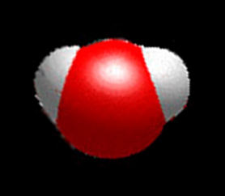
Illustration of a water molecule
Courtesy of NASA Marshall Space Flight Center

Because of this geometry, water molecules have a positive and a negative side. The oxygen atom has a negative charge, while the two hydrogen atoms have a positive charge.

When water molecules bond, the negatively-charged oxygen of one molecule is attracted to a positively-charged hydrogen of another molecule and they form a hexagonal shape. In the illustration below, the red spheres represent oxygen atoms and the white bars represent hydrogen atoms.

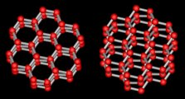
Two views of the crystal structure of ice
From Libbrecht (www.snowcrystals.com)

While it is true that no two snowflakes are exactly alike, snowflakes can be classified into a number of common types.
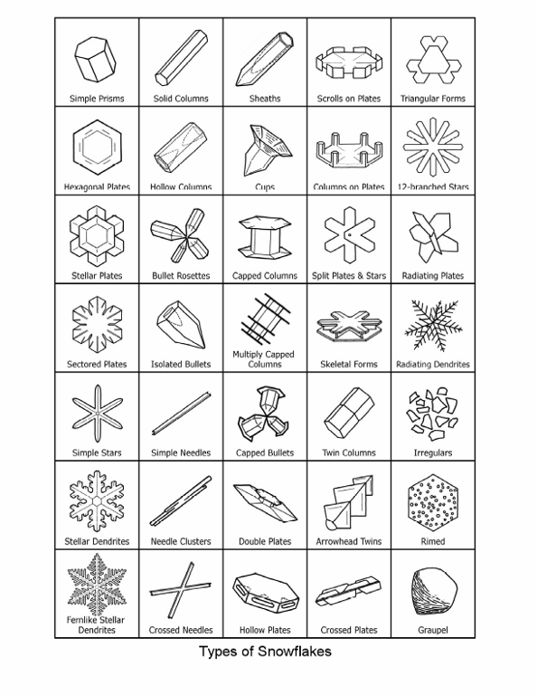
Types of Snowflakes
From Libbrecht (2003)

The type of snowflake that forms is determined by the weather conditions of temperature and humidity. The diagram below shows the different types of crystals that grow in air at atmospheric pressure, as a function of temperature and supersaturation of water vapor relative to ice.

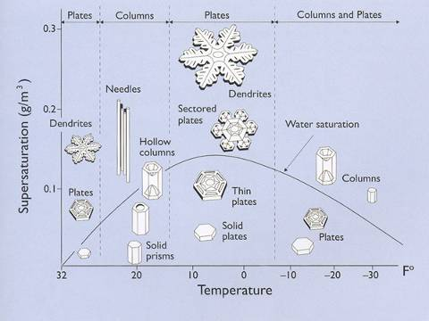
Snow crystal morphology diagram
From Libbrecht (2003)

Reading the morphology diagram:
- Temperature decreases from left to right. The diagram shows that as it gets colder, snowflakes first form plates, then columns, back to plates, and then a combination of both plates and columns. If you know what temperature it is outside, you could predict whether plate-shaped or column-shaped snowflakes would be more likely to form. (If it were very cold, you’d also need to know the humidity level.)
- Humidity (supersaturation) increases from bottom to top. The diagram shows that as it gets more humid, snowflakes grow into more complex patterns. At just below freezing, if the humidity is low snowflakes are likely to be simple plate patterns, but if the humidity is higher, more elaborate dendrites (plates with branches) are likely to form.

Snowflakes have long been a topic of interest for scientists and the public. In 1931, a scientist named Wilson Bentley published a series of photographs he had taken of snowflakes, with the result that snowflakes became an object of public fascination. Also in the 1930s, a scientist named Ukichiro Nakaya did the first in-depth laboratory study of snowflakes, documenting the types of shapes that grow in different metrological (weather) conditions. Kenneth Libbrecht at the California Institute of Technology is a current expert on snowflakes.

Nanoscale science and self-assembly

Self-assembly is a process by which molecules and cells organize themselves into functional structures. All biological organisms, including human beings, contain structures that are self-assembled. (DNA is one example.) Genetic codes and sequences guide the process of self-assembly, which occurs under specific conditions.

Nanoscientists think self-assembly could make the manufacturing of nanomaterials fast and cheap. They also think it will allow the creation of smaller structures than is possible with traditional technology.

Self-assembly in nanotechnology relies on chemical and physical forces to guide molecules into arranging themselves into predictable, ordered structures. The final structure is determined by properties of the molecules that are used, as well as the controlled environment in which they grow.

Self-assembly is a “bottom up” manufacturing technique, meaning that it begins with small pieces and builds them up to a larger structure. This is in contrast to “top down” techniques, where larger blocks of materials are pared down to create a smaller structure.

Nanotechnology research into self-assembly of crystals has already resulted in practical applications. IBM has produced a nanocrystal memory device made of arrays of 20 nm silicon nanocrystals, patterned using self-assembly.

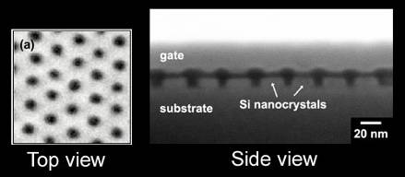
Silicon nanocrystals in a memory device,
embedded in areas created through self-assembly of a polymer
Image courtesy of IBM

To create the device, polymer molecules were self-assembled into a hexagonal, “honeycomb” pattern. The polymer was used as a stencil, and a harder substance was deposited. The polymer stencil was then removed. Finally, silicon nanocrystals were embedded where the polymer used to be.

References

Bentley, W. A. 2000. Snowflakes in photographs. Dover Publications.

Hiramatsu, Kazuhiko and Matthew Sturm. 2005. “A simple, inexpensive chamber for growing snow crystals in the classroom.” The Physics Teacher 43 (September 2005): 346-348.

IBM Research. IBM nanotechnology announcement at IEDM: Nanocrystal memory devices created using self assembly technique. domino.watson.ibm.com/comm/pr.nsf/pages/rsc.sa-iedm.html

Libbrecht, Kenneth G. 2008. “The enigmatic snowflake.” Physicsworld.com (January 3, 2008): physicsworld.com/cws/article/print/32277

Libbrecht, Kenneth G. 2005. “The physics of snow crystals.” Reports on Progress in Physics 68: 855-895.

Libbrecht, Kenneth G. 2003. The snowflake. Voyageur Press.

Libbrecht, Kenneth G. Snowcrystals.com: www.its.caltech.edu/~atomic/snowcrystals

Wikipedia
“Ice”: en.wikipedia.org/wiki/Ice
“Self-assembly”: en.wikipedia.org/wiki/Self-assembly
“Snow”: en.wikipedia.org/wiki/Snow

Materials

Materials to present the program
- Assembled ice crystal chamber (see below for materials and instructions to make it, and for instructions on preparing it for the presentation)
- Projector, screen and computer for PowerPoint presentation
- Dry ice for the chamber (see below)
- Warm water for the chamber (see below)
- Molecular models of ice (available at www.indigo.com)
- Optional: tactile models of the basic shapes of snowflakes (see below for materials and instructions to make them)
- Optional: tactile models of different types of snowflakes (see below for materials and instructions to make two types)
- Optional: printout of the PowerPoint presentation to offer as a handout.

Materials and instructions to make the ice crystal chamber

- Bottle with monofilament
- One plastic bottle with cap, 16 oz or 1 quart (500 ml to 1 l). Choose a clear bottle with a smooth neck.
- Punch two holes in the bottom of the bottle using a dissecting pick or other sharp instrument that makes a small hole. Place the holes near the edge, opposite each other.
- Thread the monofilament through the bottle so that two loose ends come out the top of the bottle.
- Pull the ends tight and tape them to the side of the bottle. Place the tape near the bottom of the bottle.
- Make a sleeve of black construction paper to cover the body (cylindrical part) of the bottle. The sleeve should not cover the shoulder and neck of the bottle.

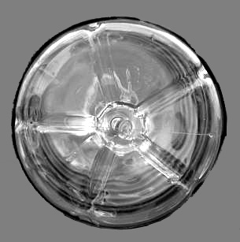 | 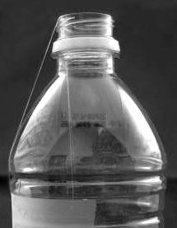 | 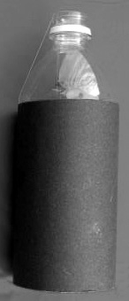
Holes punched  in bottom of bottle | Filament taped  to side of bottle | Paper sleeve  around bottle

- Insulating container, such as a Dewar or Styrofoam cooler, to hold the bottle and a surrounding layer of dry ice
- The container should be big enough so that the bottle fits into the container at least up to the neck, with a couple inches of space below it and all around it.

- Dry ice to pack into the container around the bottle.
- Choose pellet form if you can get it; otherwise, you’ll need to break up the dry ice into small pieces with a hammer or other tool.

- Protective material, such as cloth or paper, to cover the exposed dry ice and prevent visitors from touching it.

See “Set Up” below for instructions to prepare the chamber for each program.

Materials and instructions for making the optional tactile models of basic shapes of snowflakes

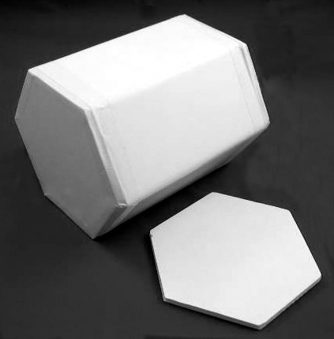
Tactile models of basic shapes of snowflakes
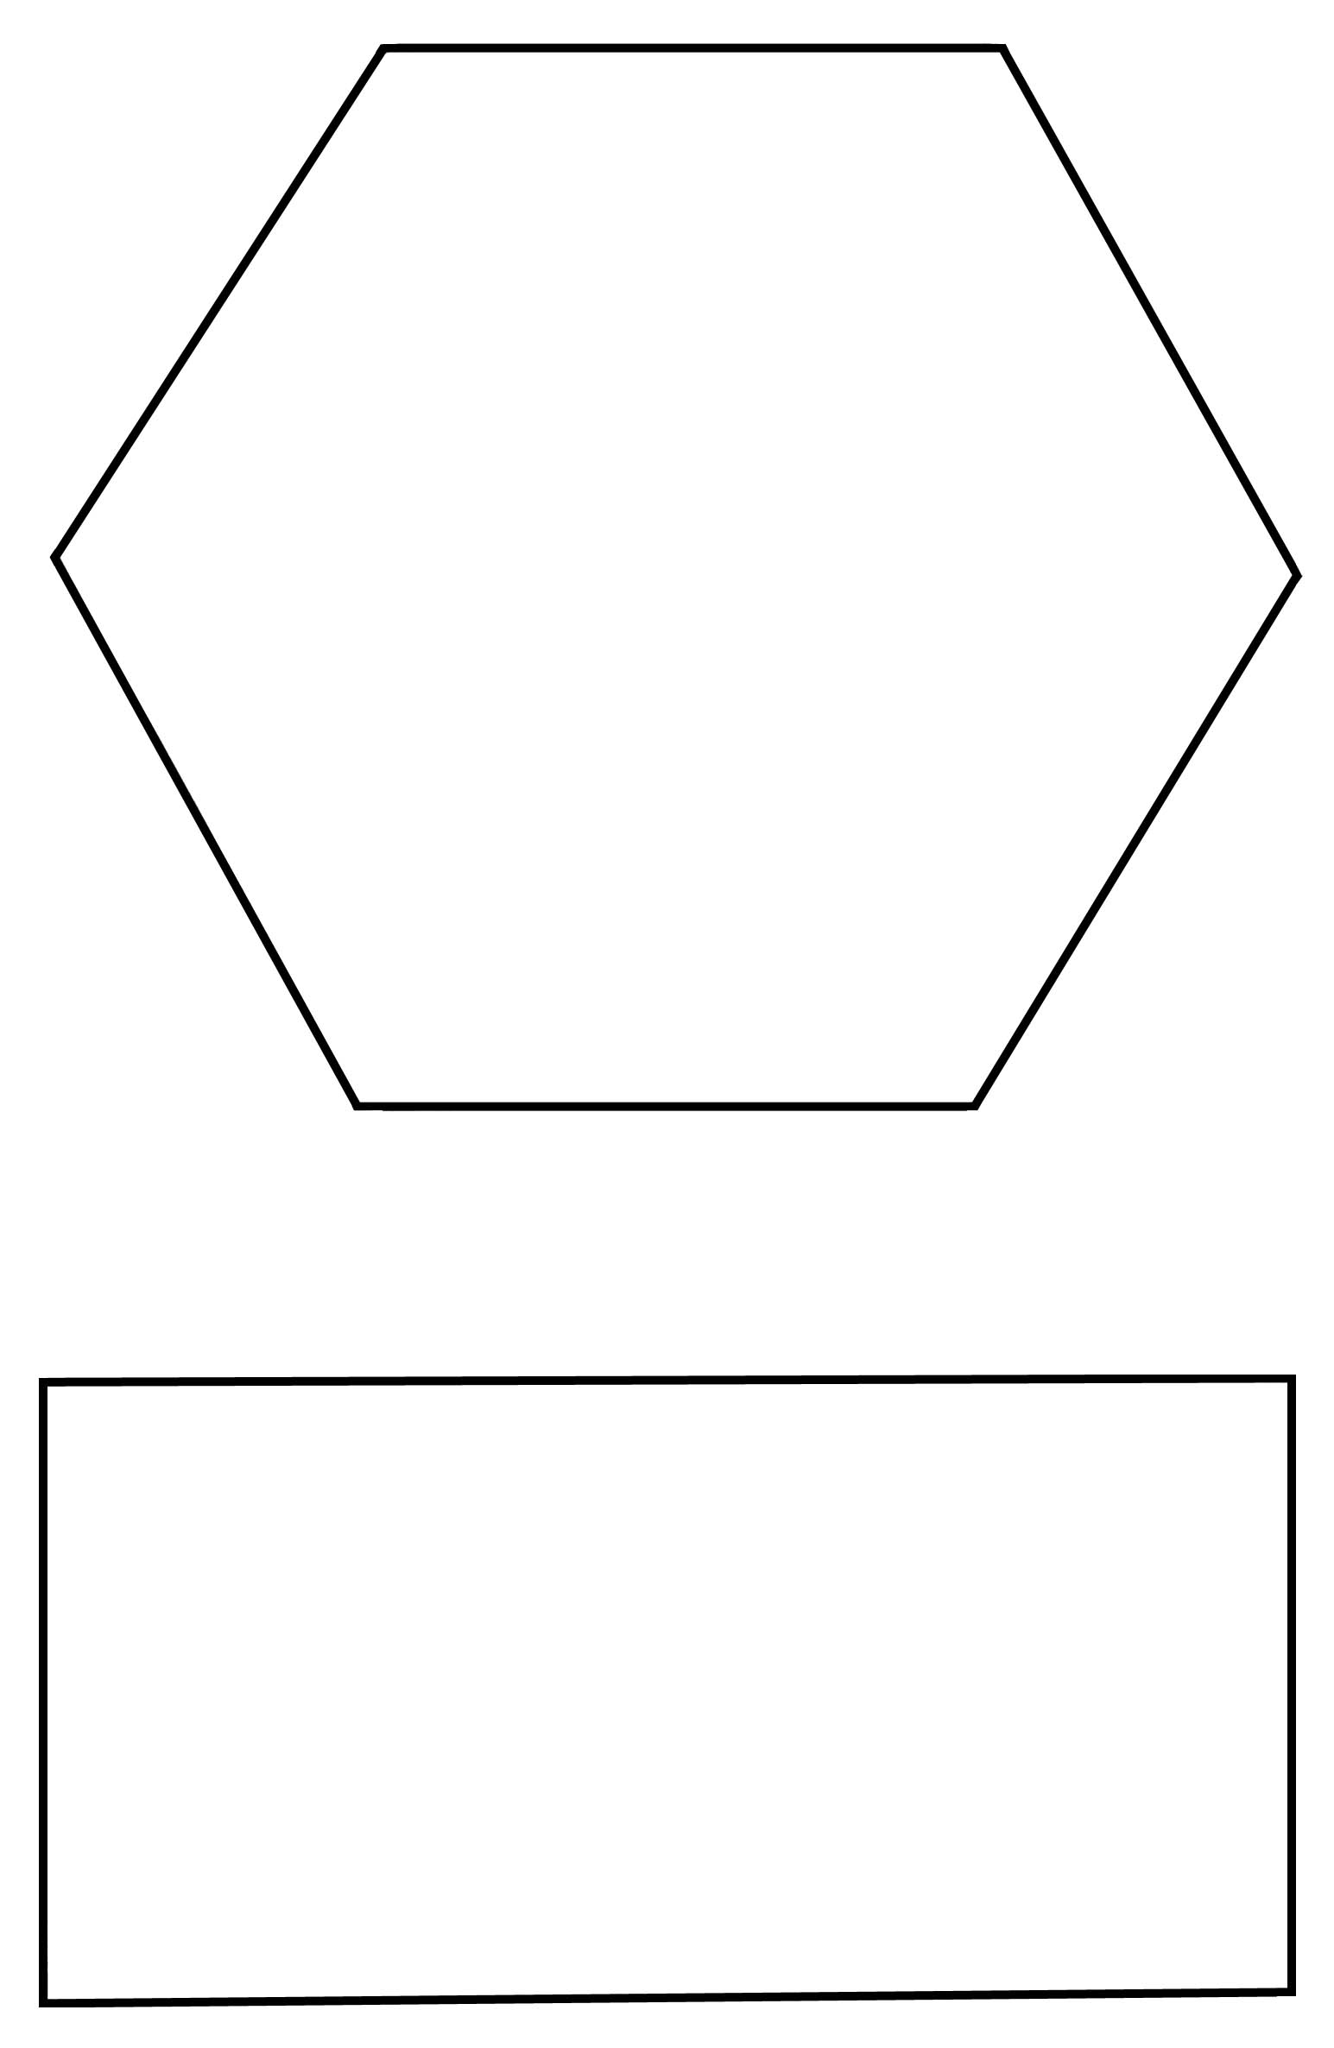
Template for tactile models of basic shapes
To make the basic plate model:
- Print the template
- Using scissors, cut out the hexagon shape.
- Trace the hexagon onto white foam core.
- Cut out the hexagon, using an X-Acto knife, a mat and a straight edge. Be careful!

To make the basic column model:
- Print the template
- Using scissors, cut out the hexagon and rectangle shapes.
- Trace the shapes onto white foam core. You’ll need two hexagons and six rectangles.
- Cut out the shapes, using an X-Acto type knife, a mat and a straight edge. Be careful!
- Use the foam core shapes to make your model. Place one hexagon on the table. Attach a rectangle to each side, using masking tape. The short end of the rectangle should sit on the surface of the hexagon.
- Tape the adjacent edges of the rectangles together.
- Tape the other hexagon to the top of the column.

Materials and instructions for making the optional tactile models of two types of snowflakes

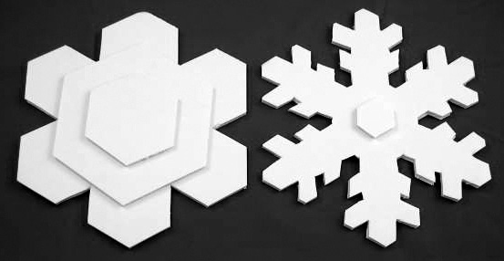
Tactile models of basic shapes of snowflakes

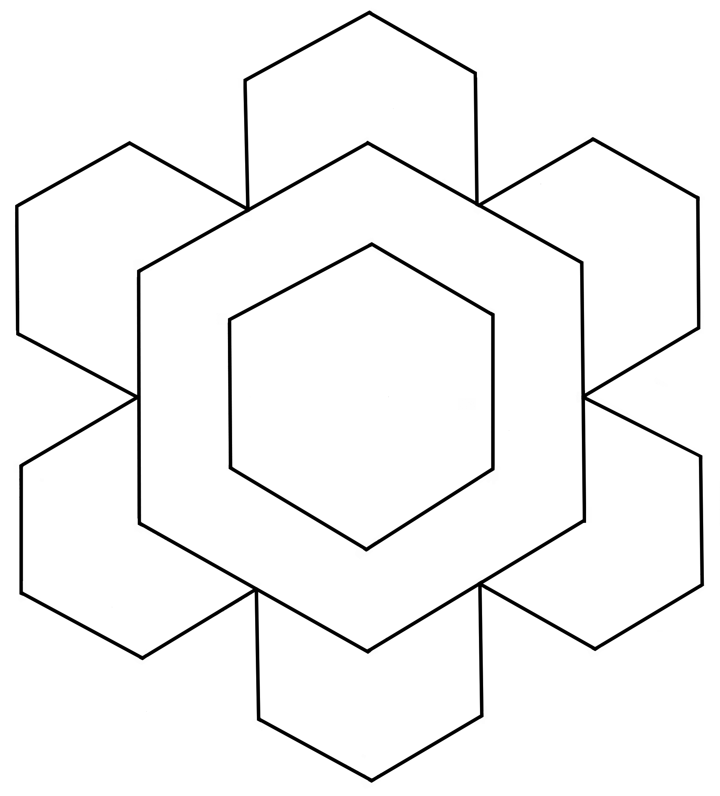
Template for stellar plate

To make the stellar plate model:
- Print three copies of the template.
- Using scissors, cut out the outer star from one copy of the template, and the larger hexagon from the second copy, and the smaller hexagon from the third copy.
- Trace the shapes onto white foam core.
- Cut out the shapes, using an X-Acto knife, a mat, and a straight edge. Be careful!
- Use the foam core shapes to make your model. Glue the larger hexagon onto the center of the star. Position the smaller hexagon so that the flat sides are parallel.

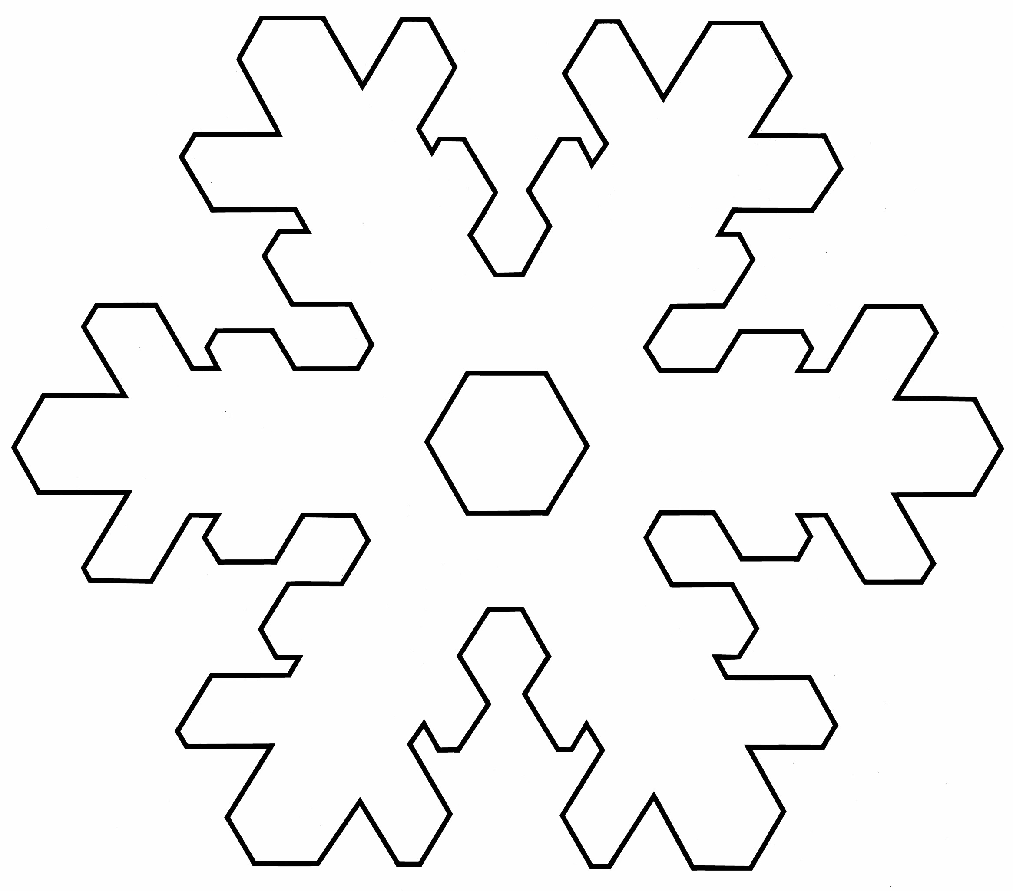
Template for stellar dendrite
To make the stellar dendrite model:
- Print two copies of the template.
- Using scissors, cut out the exterior shape from one template, and the interior hexagon from the other.
- Trace the shapes onto white foam core.
- Cut out the shapes, using an X-Acto knife, a mat and a straight edge. Be careful!
- Glue the smaller hexagon onto the center of the snowflake. Position the hexagon as in the template.

Set Up

Time: 15 minutes (allow 30 minutes if you need to crush your dry ice)

Step 1:

Prepare the dry ice. Begin this step about 30 minutes prior to the program.

If your dry ice came in pellet form, you can skip this step. If your dry ice is in block form, you’ll need to break it up into pieces the size of golf balls or smaller. Use a hammer or other tools.

PRECAUTION: Wear gloves and eye protection!

Step 2:

Prepare the ice crystal chamber. Begin this step about 15 minutes prior to the beginning of the program.

(Note: you will need to gather materials and put the chamber together ahead of time. See “Materials” above for instructions.)

To set up the chamber:
- Pour a small amount of warm water into the bottle, cap it, and shake it.
- Pour out the water.
- Breathe into the bottle about 7 times, to fill it with warm water vapor. Cap the bottle tightly.
- Place the bottle in the outer container. Pour in the dry ice. Be sure that the bottle is exposed to view from the neck up.
- Cover the exposed dry ice with a piece of cloth, crumpled paper, or other material so visitors can’t touch it.

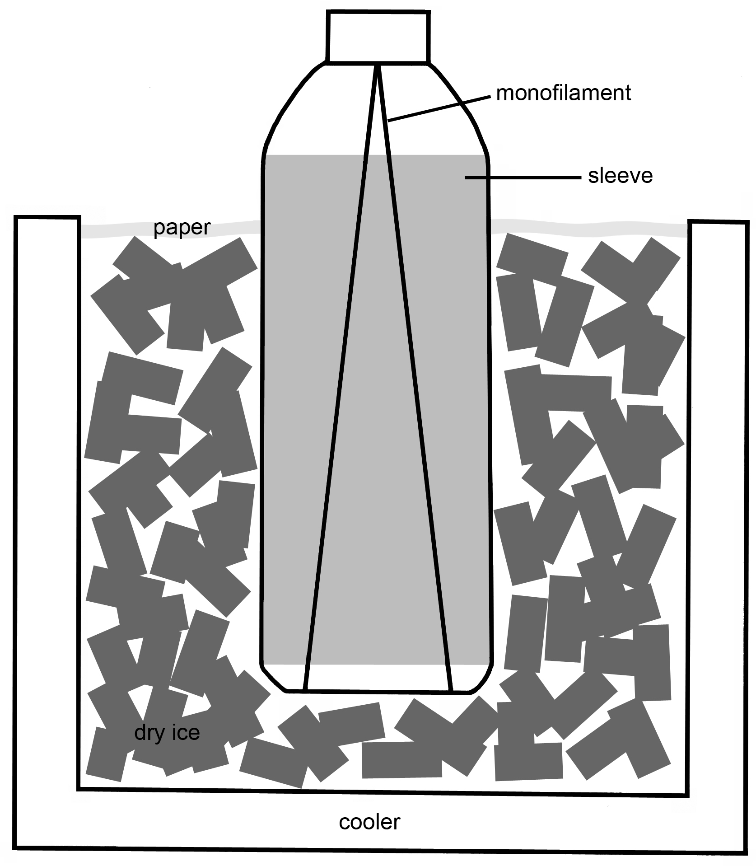
Assembled ice crystal chamber

Tiny crystals will start growing on the monofilament almost immediately. After about 15 or 20 minutes, there will be branches an inch or two long.

The branches are fragile, and can fall off the monofilament. Transport the chamber carefully, and make sure it doesn’t get jostled. If the branches do break off, you can add more water and water vapor to the bottle and return it to the container with dry ice to grow more.

Step 3:

Set up all the materials in your presentation space. Be sure that you have good sight lines for visitors to view the PowerPoint presentation, and easy access for them to approach and view the ice crystal chamber at the end of the program.

Once the program is set up, you can present it several times in succession. The ice crystals will last for a couple hours. If the crystals break off the monofilament, you can add more water and water vapor to the bottle and return it to the container with dry ice to grow more.

Program Delivery

Time: 20 minutes

Safety:

Wear gloves when you touch the dry ice. Wear gloves and eye protection if you crush the dry ice yourself. You can touch dry ice briefly without hurting yourself, but you can be injured from prolonged exposure.

When you present the chamber to visitors, be sure the dry ice is covered with a piece of cloth or crumpled paper. Don’t let visitors touch the dry ice.

Procedure and Discussion:

<SLIDE 1: Snowflakes: Nano at its coolest >

Welcome! Our program today is “Snowflakes: Nano at its coolest”

During this program we’re going to find out how a new field of research called nanoscale science is helping us to understand some of the basic processes of nature, like how snowflakes grow.

<SLIDE 2: What do you know about snow?>

But first, let’s talk a little bit about snow. What do you know about snow?

[Audience response.]

[If necessary, prompt: When does it snow? When does snow melt? What does snow look and feel like?]

<SLIDE 3: What do you wonder about snow?>

It sounds like you know quite a bit about snow! Is there anything you wonder about snow? Anything you’d like to know?

[Audience response. If necessary, prompt: Does snow always look and feel the same? What have you noticed about snowflakes? What shape are they? Are they all the same?]

<SLIDE 4: Outline>

Let’s find out how nanoscale science is helping to answer some basic questions about snowflakes:
- What makes it snow?
- Why do snowflakes have six sides?
- Is every snowflake different?

<SLIDE 5: When does it snow?>

First, let’s consider when it snows.

What kind of conditions do we need in order to have snow?

[Audience response. If necessary, prompt: Is it usually warm out when it snows? What is snow made out of?]

<SLIDE 6: It snows when…>

There are three things we need in order for it to snow.

Snowflakes are tiny little ice crystals, and we need water to make ice. So the first thing that’s necessary is water vapor in the air. Water vapor is water in gas form.

The second thing we need is something to turn the water into ice, and that is…what?

[Audience response.]

Cold! In order for the water to freeze into ice crystals, the temperature has to be below freezing. What’s the freezing point of water?

[Audience response.]

Water freezes at 32° Fahrenheit (or 0° Celsius), so it has to be colder than that to snow.

And finally, in order for snowflakes to form, usually there need to be tiny little particles in the air, such as dust, for the ice crystal to grow around. These tiny particles are called “nucleators.”

When all these things are present—water vapor, cold and tiny particles—then it can snow.

Snowflakes form in a cloud. Here’s how it happens:
- A cloud is made of tiny droplets of water that have attached themselves to pieces of dust.
- If it’s below freezing, some of those tiny droplets will freeze into tiny ice crystals. These tiny ice crystals are baby snowflakes.
- The snowflake grows when additional water vapor freezes onto the tiny crystal.
- As the snowflake grows, it moves through the cloud.
- Eventually, it gets heavy enough that it falls to the ground.

Let’s take a look at how snowflakes grow.

<SLIDE 7: Video 1>

This is a video loop of a real snowflake growing in a lab, made by a scientist named Kenneth Libbrecht at the California Institute of Technology. It took about an hour for this snowflake to grow inside a special chamber, but this is a time-lapse video so we can see it happening quickly.

What do you notice about the shape of snowflake? How does it change as it grows?

[Audience response. Prompt if necessary to elicit the following observations: It has six sides. It has six-fold symmetry. It gets bigger. It gets more elaborate, with more tiny branches appearing on each arm.]

Here’s another snowflake, again growing in Kenneth Libbrecht’s lab.

<SLIDE 8: Video 2>

Does this one look the same as the other snowflake? What’s the same about it and what’s different?

[Audience response: It has six sides and it’s symmetrical, but the exact shape is different.]

<SLIDE 9: Why do snowflakes have six sides?>

We noticed that both of these snowflakes have six sides. At the beginning of the program, some of you were wondering why most snowflakes have six sides.

It turns out that this is a really complicated and interesting question, and it’s one that scientists are only beginning to be able to answer.

Researchers who work in a field called nanoscale science are studying how crystals grow, including snowflakes.

<SLIDE 10: Nano is very, very small>

Has anyone heard of nanoscale science or nanotechnology? Or a nanometer? What do you think “nano” means?

Nano means “one-billionth”. If you put “nano” in front of anything, you mean one-billionth part of that thing.

So a nanometer is one-billionth of a meter.

A meter is about as long as the distance from my chin to my hand [hold arm straight out]. Or, if you’re a kid, a meter is about the distance from hand to hand if you hold your arms straight out. Everyone try holding out your arms: grownups like this [one arm out] and kids like this [two arms out].

A nanometer is one-billionth of that distance! That’s really small. It’s way too small to see.

Nanoscientists learn about and make things that are too small to see, like atoms and molecules. Some nanoscale science studies and makes things from these basic building blocks of nature.

<SLIDE 11: Snowflakes are nano!>

Let’s take the example of snowflakes.

To understand how snowflakes grow, nanoscientists study how individual water molecules grow into ice crystals.

What is a molecule? Can anyone tell us?

[Audience response.]

All matter is composed of tiny particles called atoms, which are the basic building blocks of nature. Atoms join with each other to form molecules. The arrangement of molecules gives a material its properties.

So, it’s the nanoscale arrangement of water molecules that gives snowflakes their properties.

It’s only very recently that scientists have been able to study and manipulate individual molecules, so important questions like how snowflakes grow are still being studied.

<SLIDE 12: Shape is determined by molecular structure>

Snowflakes are all based on a six-sided core, because that’s the shape the water molecules take when they form ice crystals.

[Optional: Hold up and pass around tactile models of ice crystals]

Most snowflakes start out as tiny hexagonal prisms – three-dimensional shapes with six-sides. They can grow vertically into long columns, or horizontally into flat plates.

[Optional: Hold up and pass around tactile models of basic snowflake shapes]

They can also grow branches at each of their six corners. This happens because the corners of the hexagon stick out more than the flat sides.

When the tiny ice crystal is in the cloud, water molecules in the air around it bump into the corners first, and attach themselves there. That makes the corners stick out even more, so the next molecules are even more likely to attach themselves there. Arms usually appear all at once on a snowflake. And once they appear, they usually grow pretty fast.

<SLIDE 13: Is every snowflake different?>

So if all snowflakes have six sides, how come they look so different from each other? Some of you may have heard that no two snowflakes are alike and wondered if that’s true.

<SLIDE 14: Snowflakes have many shapes>

It is true. Individual snowflakes are different because each snowflake experiences a slightly different environment as it falls through the cloud. But all six arms of a snowflake experience the same environment, which is why all the arms are very similar.

However, while it is true that no two snowflakes are exactly alike, snowflakes can be classified into a number of common types.

<SLIDE 15: Type depends on temperature and humidity>

The type of snowflake that forms depends on the temperature and humidity. This diagram shows temperature from left to right. As we move this way on the diagram [indicate left to right], the temperature gets colder.

The diagram shows humidity from bottom to top. As we move up in the diagram, there is more humidity in the air.

The diagram shows the different types of snowflakes that form at different temperatures and humidity levels. To see how this works, let’s look at one temperature zone at a time.

<SLIDE 16: Diagram with first column highlighted>

Let’s look at this first column [indicated left-hand column, lighter than rest of diagram.] This is a temperature range just below freezing (32° F or 0° C).

Take a look at the snowflakes in this column. Are they the basic plate shape, or the basic column shape?

[Audience response: Plates]

<SLIDE 17: Diagram with second column highlighted>

What happens when it gets a little colder, around 20° F (-7° C)? What shape snowflake forms then: plates or columns?

[Audience response: Columns]

So the basic shape switched from plates to columns as it got a little colder. Let’s see what happens when it gets colder yet.

<SLIDE 18: Diagram with third column highlighted>

What about when it gets colder yet, between about 15° F and -5° F (-9° C to -21° C)?

[Indicate highlighted column]

Now what shape are the snowflakes?

[Audience response: Plates]

Isn’t that interesting? As the temperature decreases—as it gets colder—the basic shape of snowflakes changes from plates, to columns, and back to plates.

Let’s take a look at humidity now, staying in this same temperature range.

[Indicate highlighted column]

What do you observe about the snowflake shapes as it gets more humid, as we move from bottom to top on the diagram?

[Audience response: The snowflakes get branches on them; they get more elaborate; they get bigger.]

We noticed lots of changes in the snowflakes as the amount of water vapor in the air increases. The basic plate shape stays the same, but the snowflakes get bigger; they grow branches; and they get fancier.

<SLIDE 19: Diagram with final column highlighted>

Now let’s look at the final column of the diagram.

[Indicate highlighted column.]

This is when it’s super cold, around -5° F to -35° F (-21° C to -37° C). What do you notice about the snowflake shape? Do we have plates or columns?

[Audience response: Both]

Right! When it gets really cold, snowflakes can be either plates or columns, depending on how much water vapor is in the air.

<SLIDE 20: Snowflakes self-assemble>

We can see that scientists have spent a lot of time studying snowflakes. They can even predict what kind of snowflakes will form in a certain kind of weather!

Why do scientists care so much about how snowflakes form? Any ideas?

[Audience response.]

One reason is that scientists want to understand our natural world better. They’re are trying to figure out how complex structures—like snowflakes, or trees, or people, or warthogs, or slime mold—grow in nature.

All of these things are examples of what scientists call self-assembly in nature.

Self-assembly means that molecules and cells organize themselves into functional structures. Human beings and all other living things contain structures (such as DNA) that are self-assembled.

Self-assembly requires having the right raw materials and the right environment. In the case of a snowflake, water molecules and dust particles are the raw materials, and the cold is the environment.

<SLIDE 21: Snowflakes and nano, in the future>

Self-assembly is one of the phenomena researchers are studying to make new materials and technologies at the nanoscale.

[Indicate image on left side of slide.]

Look at how tiny this computer chip is! It’s made up of tiny parts that are so small they’re measured in nanometers.

Regular tools and techniques are too big to use to create tiny things like this chip. We need new ways to build things this small.

Self-assembly might be one way to do that. If researchers could get molecules to form themselves into tiny parts for computer chips, it might be possible to make chips better, smaller and cheaper than we can today.

[Indicate image on right side of slide]

Some nanotechnology research into crystal self-assembly has already produced practical applications. IBM has developed a nanocrystal memory device, made using self-assembly.

<SLIDE 22: Snowflakes and nano, right now!>

The last thing I have to show you today is an example of self-assembly right here in the museum. While I was talking, I grew giant ice crystals, by putting together the raw materials and conditions needed to make snowflakes.

On your way out, you can stop by and see the ice crystals.

<SLIDE 23: Review>

But before we go, let’s make sure we answered our three questions.

What makes it snow?
[Audience response]

Why do snowflakes have six sides?
[Audience response]

Is every snowflake different?
[Audience response]

<SLIDE 24: Image sources>

<SLIDE 25: Image sources (continued)>

<SLIDE 26: NSF acknowledgement>

Thanks for coming to the program. Don’t forget to see the ice crystals before you go! I’m also happy to answer any questions you might have.

Talking points for the ice crystal chamber

Invite visitors to look into the bottle and tell you what they see. Ask them to be careful not to bump the container. Visitors should be able to see dendritic (branching) ice crystals growing on the fishing line.
- These ice crystals formed like the branches of a snowflake.
- They will grow until they’re an inch or so long. When they get much longer, they often fall off the string.

Explain how the apparatus works, or ask if visitors can figure it out:
- The dry ice surrounding the bottle makes it cold (below freezing).
- Before the program started, you swished a little bit of warm water in it, then blew into it to add water vapor.
- The fishing line is the nucleator that the ice crystal grows on. Because the crystal is held in place by the line, it stays in the right environment and can grow into a big ice crystal.

Ask visitors why they think the crystals grow in only one spot in the bottle, just above the level of the dry ice:
- Because this is the perfect environment: chilled by the cold air below, and fed water vapor by the warmer air above.

Tips and Troubleshooting:

Shortening the program

If your audience is getting restless, or you have young children in the audience, show Slide 15 (the morphology diagram) and briefly mention that snowflake type depends on temperature and humidity. Skip going through the diagram column by column (Slides 16-19).

Doing the program as a cart demonstration

This program can be done as a cart or tabletop demo, rather than as a large group presentation. Basically, the program is just condensed and made more casual and personal. To do the program as a demo, you can engage visitors by asking them if they’d like to see giant ice crystals growing. You can quickly elicit/explain the three things necessary for snowflakes to grow: cold, water vapor, and a nucleator. Then, you can tell visitors that scientists are interested in how snowflakes grow because they’re an example of self-assembly in nature. Finally, you can explain that self-assembly is an important area of research in nanotechnology, giving the example of the IBM memory device.

Visitors will then likely ask you the three questions covered in this program:
- What makes it snow?
- Why do snowflakes have six sides?
- Is every snowflake different?

You can print out the slideshow to help answer these questions. Visitors can handle the models of the basic shapes of snowflakes, and the models of the molecular structure of ice crystals.

You can also incorporate hands-on activities if you do this program as a cart demo. To explore the concept of self-assembly, visitors can drop a handful of O-shaped cereal into a bowl of water, and tap the bowl gently. The cereal will arrange itself into a neat, single layer in the center of the bowl. Another simple activity is cutting out paper snowflakes (six-sided, please!).

Common Visitor Questions

Why does some snow make a better snowball (snowman, snow fort)?

Snow varies a lot. For example, snowflakes can be larger or smaller, chunkier or fluffier, and wetter or drier. Snow that packs well is made of relatively wet snowflakes. Water sticks to itself and to ice.

Is snow just frozen rain?

No. Sleet is frozen rain. (See below, “What is sleet?”)

What is sleet?

Sleet is frozen rain. Rain forms in a cloud when water droplets attach to a nucleator. More liquid water droplets join a small raindrop, until it gets heavy enough to fall out of the cloud. If it freezes on the way down, it turns into sleet.

Snow is different, because it is an ice crystal that freezes and grows in the cloud first, and then falls to the ground.

What is hail?

Hail is large clumps of ice that form during a storm, when there is warm air near the ground and cold air higher up. It usually hails in the summer, not the winter, because there needs to be warm air near the Earth in order for hail to form.

Hail starts out in a cold, high cloud, as a tiny ice crystal frozen onto a nucleator. It starts to fall out of the cloud, but then it hits an updraft created by the warm air below. The updraft pushes the hail back up into the cloud where more water freezes onto it. Then it starts to fall again, and is pushed back up again. This can happen over and over. Sometimes hail can get really big—several inches across—before it finally falls to the ground.

If you cut a hailstone in half, you can see all the different layers of ice that were deposited onto it as it went up and down through the cloud.

What is frost?

Frost is made of ice crystals. Frost grows from water vapor in the air, like snowflakes do. The difference is that frost grows on solid surfaces on or near the ground (like windows, grass, and sidewalks). Snowflakes form on dust particles suspended in the air.

When air temperature is above freezing, water vapor in the air may still condense on objects near the ground, but it remains liquid. This is called dew. Frost is basically frozen dew.

What is dry ice?

“Dry ice” isn’t really ice at all. Ice is frozen water; dry ice is frozen carbon dioxide. It’s made by squeezing carbon dioxide gas under very high pressure, which heats it up. Then the pressure is suddenly removed, which allows the gas to expand and all the heat to escape, freezing the molecules solid. Dry ice is very cold—around -109.3°F (-78.5°C).

When dry ice warms up, it goes directly from a solid to a gas. This phase change is called sublimation. (Sublimation is different from melting, which is the phase change from solid to liquid.)

The white “smoke” that you see when dry ice sublimates is not the carbon dioxide gas, which is colorless and invisible. Instead, those are tiny droplets of water. Water vapor (gas) is in the air all the time, but we can’t see it. As the dry ice sublimates, very cold molecules of carbon dioxide float into the air. They touch water vapor, cooling it and making it condense into tiny droplets.

Can it ever get too cold to snow?

No. As air gets colder, it holds less and less water, making snow less and less likely, but never impossible. The coldest place on Earth is the South Pole, and it gets only 1 to 2 inches of snow per year–roughly the same amount of water as falls in the Sahara Desert.

Going Further…
Here are some resources you can share with your visitors:
Bentley, W. A. 2000. Snowflakes in photographs. Dover Publications.

Jefferis, David. 2006. Micro machines: Ultra-small world of nanotechnology. Crabtree Publishing.

Johnson, Rebecca L. 2006. Nanotechnology. Lerner Publications.

Libbrecht, Kenneth G. 2008. “The enigmatic snowflake.” Physicsworld.com (January 3, 2008): physicsworld.com/cws/article/print/32277

Libbrecht, Kenneth G. 2003. The snowflake. Voyageur Press.

Libbrecht, Kenneth G. Snowcrystals.com: www.its.caltech.edu/~atomic/snowcrystals

Maddox, Diane. 2005. Nanotechnology: Science on the edge. Blackbirch Press.

Wikipedia
“Ice”: en.wikipedia.org/wiki/Ice
“Self-assembly”: en.wikipedia.org/wiki/Self-assembly
“Snow”: en.wikipedia.org/wiki/Snow

Straight Dope
“No two snowflakes alike”: www.straightdope.com/classics/a3_392.html
“Too cold to snow”: www.straightdope.com/mailbag/msnow2cold.html

Clean Up

Time: 5 minutes

The ice crystal chamber should taken apart and dried before storing.

Leftover dry ice can be left in a sink or open cooler in a well-ventilated room to sublimate. Leave a note explaining what it is. Don’t leave dry ice unattended in a public area!

Universal Design

This program has been designed to be inclusive of visitors, including visitors of different ages, backgrounds, and different physical and cognitive abilities.

The following features of the program’s design make it accessible:

[ x ] 1. Repeat and reinforce main ideas and concepts
- The presentation is organized into discrete chunks.
- A content overview is provided at the beginning of the program (program outline). Visitors are periodically reminded of progress, and the content is summarized at the end of the program.
- Learning objectives are repeated throughout the presentation.

[ x ] 2. Provide multiple entry points and multiple ways of engagement
- The content is connected to visitors’ prior experiences and knowledge, and to their questions.
- Concise key phrases are used to support main ideas.
- Main ideas are presented through multiple senses (sight, hearing, and touch).

[ x ] 3. Provide physical and sensory access to all aspects of the
program
- Main ideas are presented through multiple senses (sight, hearing, and touch).
- Slides are made accessible by using large, high-contrast text and images; using clear fonts and graphics; and using color to make distinctions.
To give an inclusive presentation of this program:

- Make sure your face is visible at all times.
- Make sure you don’t stand in the way of the slides.
- Keep props and models visible when they are relevant.
- Pace the program so that visitors can follow the content easily.
- Pace the program so that the images, text, speaking and tactile models don’t compete with each other.
- Ask the audience questions, and check in with them along the way to make sure they’re engaged and following you.
- Use descriptive language to describe objects and images.
- Find a way to make the ice crystal demo accessible to as many visitors as possible. You might need to set up multiple chambers, or use a camcorder to project an image.
- Make a handout of the slide presentation available to visitors, either to use during the presentation or to take home.
- Make sure your audience knows about any special accommodations you offer.


This project was supported by the National Science Foundation under Grant No. ESI-0532536.

Any opinions, findings, and conclusions or recommendations expressed in this program are those of the author and do not necessarily reflect the views of the Foundation.

