

Exploring Structures—Buckyballs

Try this!  - Take a precut paper shape.  - Fold it along the scored lines to make a model of a nanoscale structure.  - Put the tabs in the slots to hold it together. What does your model look like?  What’s going on? | 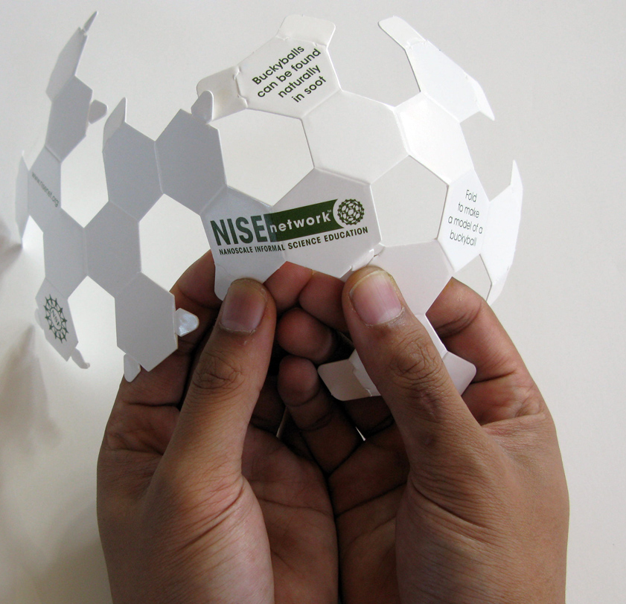
You’ve made a model of a buckyball, a tiny molecule made of 60 carbon atoms.

Buckyballs look like soccer balls or geodesic domes. They're named after the architect Buckminster Fuller, who made dome structures popular.

Buckyballs are just one form of carbon. Carbon can also form diamond, the hardest natural material known on Earth, and graphite, one of the softest materials.  Diamond, graphite, and buckyballs are all made entirely from carbon! They have different properties because the carbon atoms are arranged differently at the nanoscale. |   Diamond ring |   Pencil lead (graphite)
How is this nano?
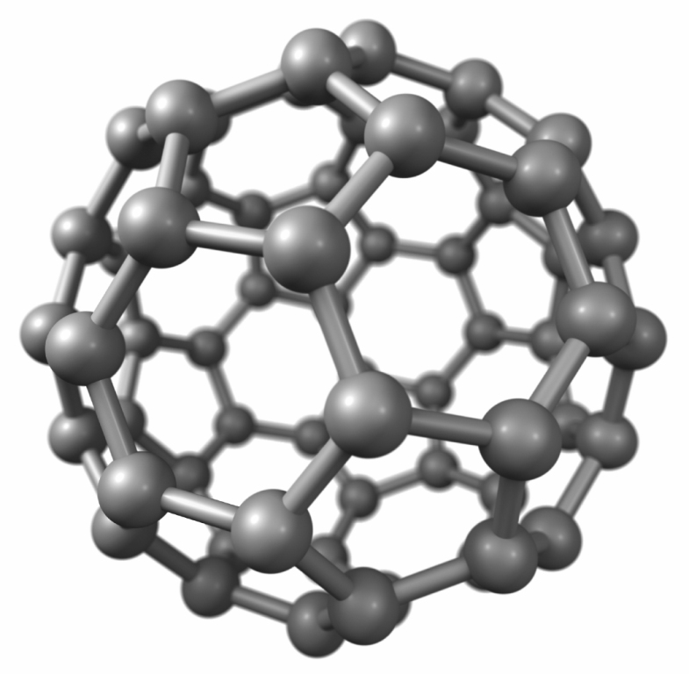  Model of a buckyball | Buckyballs are tiny, soccerball-shaped molecules made of carbon. Buckyballs are only one nanometer across! (A nanometer is a billionth of a meter.)  In the field of nanotechnology, scientists and engineers study the world of the nanometer and make new materials and tiny devices. They use special tools and equipment to detect and manipulate nanometer-sized particles like buckyballs.  Buckyballs are good lubricants because of their spherical shape. Their hollow structure could make them useful for delivering medicine in the future.

Learning objective
Buckyballs are tiny, soccerball-shaped molecules made of carbon.

Materials
- Die-cut paper buckyballs
- “Carbon Structures” poster

Die-cut buckyballs can be ordered from Mike Luongo, 617.686.5530. NISE Network partners may use the network’s buckyball die and artwork free of charge as long as the materials are used for educational, non-commercial purposes.

Related educational resources
The NISE Network online catalog (www.nisenet.org/catalog) contains additional resources to introduce visitors to atoms, molecules, and nanoscale structures:
- Public programs include Balloon Nanotubes, DNA Nanotechnology, Electric Squeeze, Forms of Carbon, Snowflakes: Nano at its Coolest, and World of Carbon Nanotubes.
- NanoDays activities include Exploring Size—Memory Game, Exploring Size—Powers of Ten Game, and Exploring Size—StretchAbility.
- Media include the poster and book How Small is Nano?, Image Scaler Software, Multimedia Zoom into a Human Hand, Multimedia Zoom into a Nasturtium Leaf, Scale Ladder, Zoom Into a Butterfly Wing, Zoom Into a Computer Chip, and Zoom Into the Human Bloodstream.
- Exhibits include Mixing Molecules, Three Drops, and Unexpected Properties.

Buckyball Background Information

What are buckyballs?  Buckyballs are tiny molecules made of 60 carbon atoms. They’re named after Buckminster Fuller, an architect who designed geodesic dome structures similar to the one at Epcot Center.  Buckyball molecules are just one form of carbon. Carbon atoms can bond together into many different structures, and different forms of carbon have very different properties.  What other forms can carbon take? | Model of a buckyball
Carbon can form diamond, the hardest natural material known on Earth. But it can also form one of the softest materials, graphite (pencil lead). Both diamonds and graphite are made entirely from carbon. They have different properties because the carbon atoms are arranged differently at the nanoscale.

Carbon can also form two tiny, nanometer-sized structures that are too small to see: buckyballs and carbon nanotubes. Buckyballs have a soccer-ball shape. Carbon nanotubes are long, hollow tubes. Buckyballs and carbon nanotubes have special properties due to the way their carbon atoms are arranged.
How are buckyballs and carbon nanotubes used?  Buckyballs are good lubricants because of their spherical shape. Their hollow structure could make them useful for delivering medicine in the future.  Carbon nanotubes are very strong and light, and can act as semiconductors or conductors. They’re used to strengthen composite materials. Researchers are studying ways to use  carbon nanotubes in electronics, fuel cells, and other applications.  Buckyballs and carbon nanotubes occur naturally. They’re found in soot and in outer space, and are produced when lightning strikes. Scientists who work on the nanoscale are studying how to make these tiny particles and how to use them to build other things. | 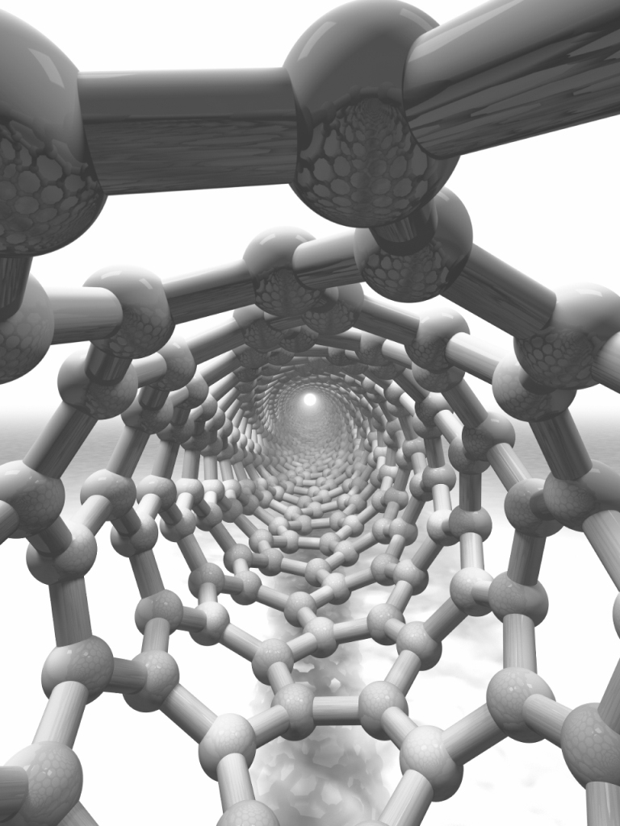  Model of the inside  of a carbon nanotube

Credits and rights
The information presented in this guide was adapted from:
- “Applications Activity: Nanoarchitecture,” developed by the National Science Foundation-supported Internships in Public Science Education (IPSE) Program at the Materials Research Science and Engineering Center (MRSEC) on Nanostructured Materials and Interfaces at the University of Wisconsin-Madison. The original activity is available at mrsec.wisc.edu/Edetc/IPSE/educators/carbon.html
- “Carbon Nanotubes & Buckyballs,” developed by the National Science Foundation-supported Materials Research Science and Engineering Center (MRSEC) on Nanostructured Interfaces at the University of Wisconsin-Madison. The original activity is available at mrsec.wisc.edu/Edetc/nanoquest/carbon/
- “Nanoarchitecture: Forms of Carbon,” developed by the National Science Foundation-supported Internships in Public Science Education (IPSE) Program at the Materials Research Science and Engineering Center (MRSEC) on Nanostructured Materials and Interfaces at the University of Wisconsin-Madison. The original activity is available at mrsec.wisc.edu/Edetc/IPSE/educators/activities/carbon.html
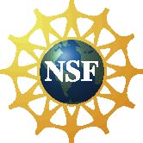 | This project was supported by the National Science Foundation under Award No. ESI-0532536. Any opinions, findings, and conclusions or recommendations expressed in this program are those of the author and do not necessarily reflect the views of the Foundation.

Copyright 2010, Sciencenter, Ithaca, NY. Published under a Creative Commons Attribution-Noncommercial-ShareAlike license: http://creativecommons.org/licenses/by-nc-sa/3.0/us/

