

Exploring Nanotechnology—Activity Name

Try this!
- Step 1 of instructions. Each action is a separate step.  - Step 2 of instructions. Each action is a separate step.  - Step 3 of instructions. Each action is a separate step.  - Step 4 of instructions. What do you notice?  - Step 5 of instructions. Now what do you notice? | [Photo showing how to do the activity. 1 ½ inches tall.] | [Optional second photo.  1 ½ inches tall.]

What’s going on?
This first sentence describes the expected result of the “Try this!” section and explains it. The remaining 1-2 sentences in this paragraph explain it further.

A second paragraph can provide additional information or further explanation. Each paragraph should be short, with a clear topic sentence.  The third paragraph (optional) can link the phenomenon of the activity to everyday life. Try to provide an example that’s relevant to a wide range of visitors.  A photo is optional in this section. Either the “What’s going on?” or the “How is this nano?” section should have a photo. Both sections can have a photo. Photos in “What’s going on?” are 2 inches high. Photos in “How is this nano?” are 1 ½ inches high. | 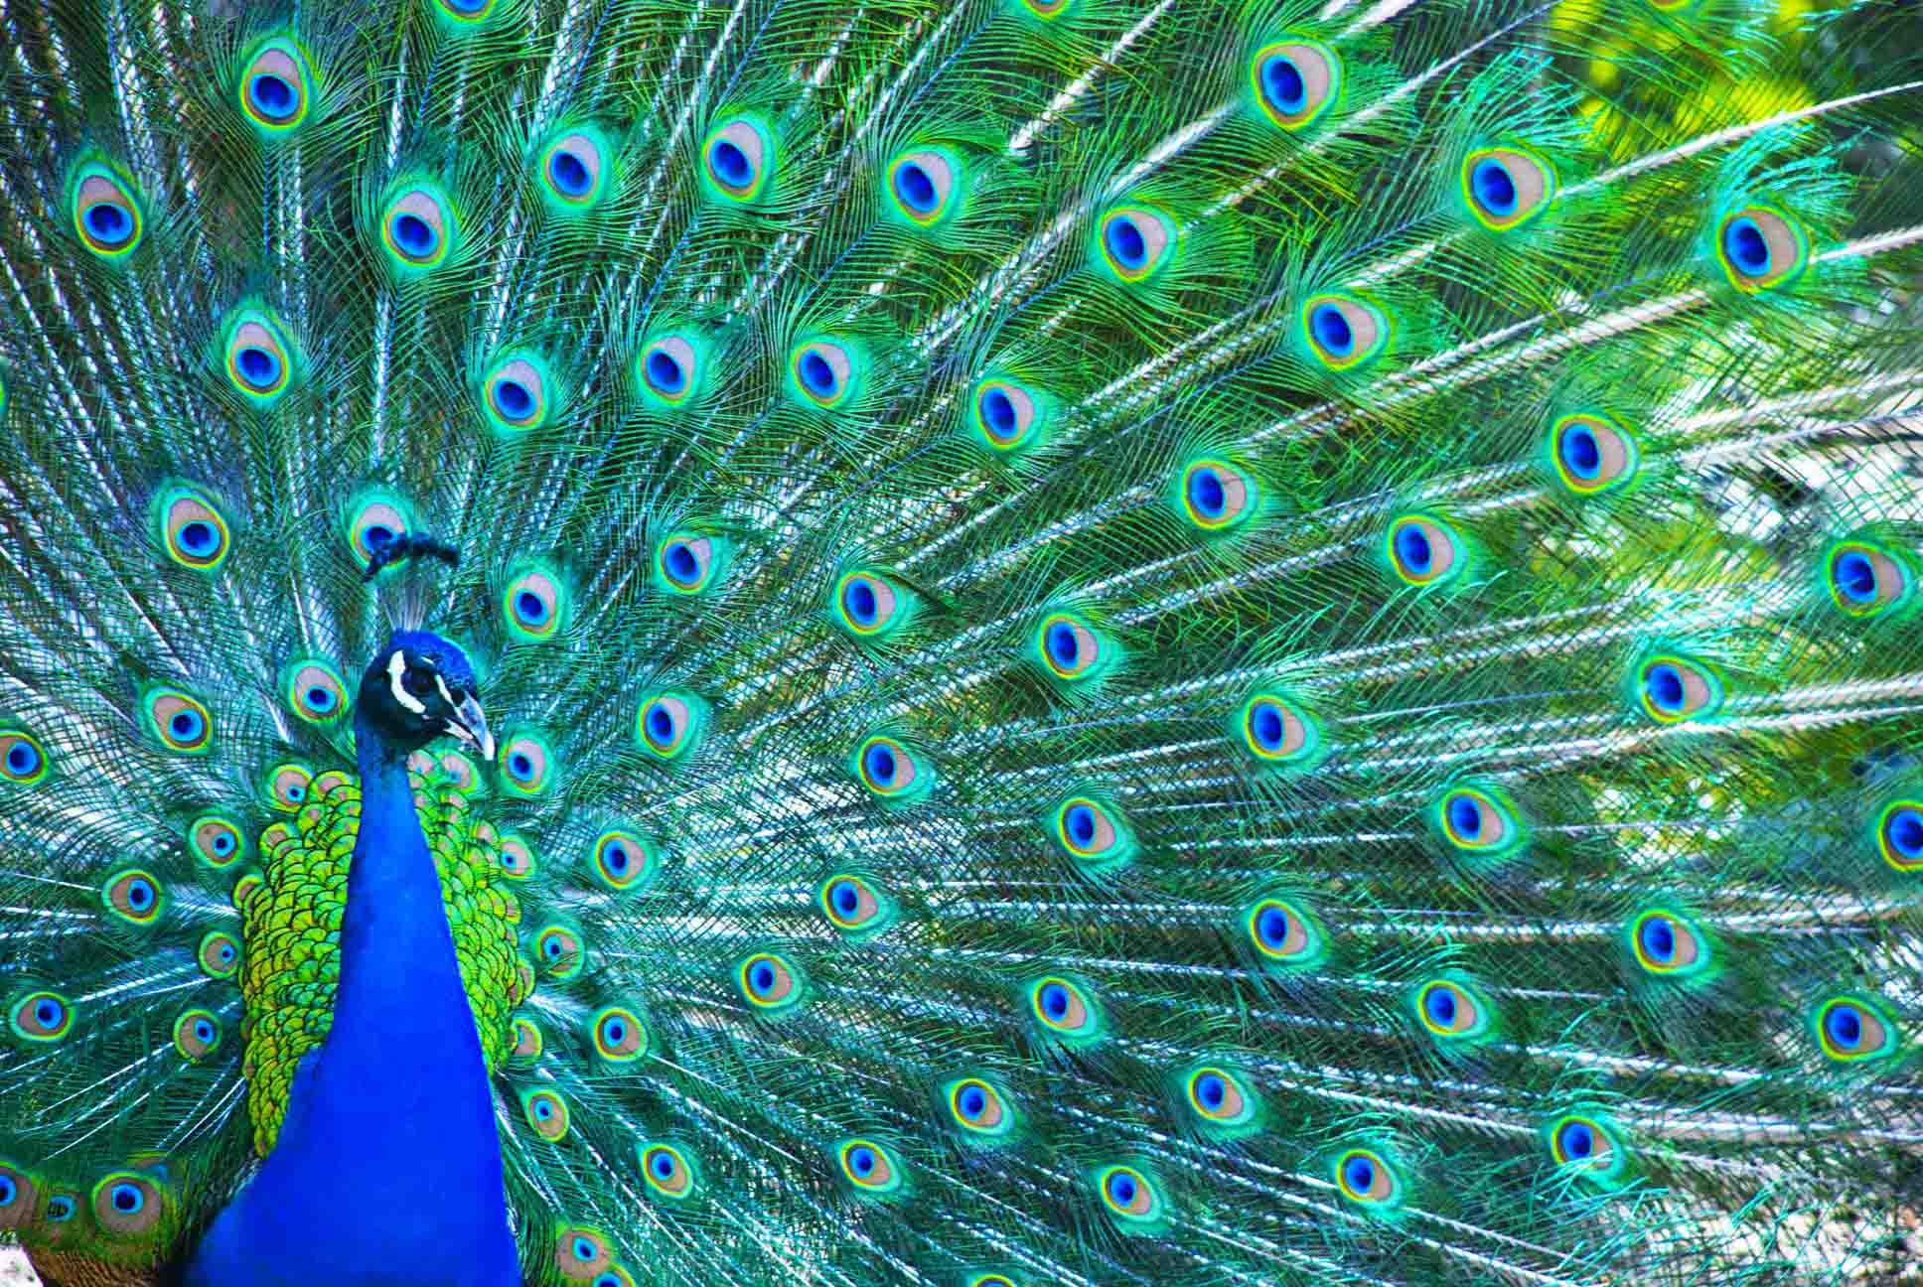  Photo caption

How is this nano?
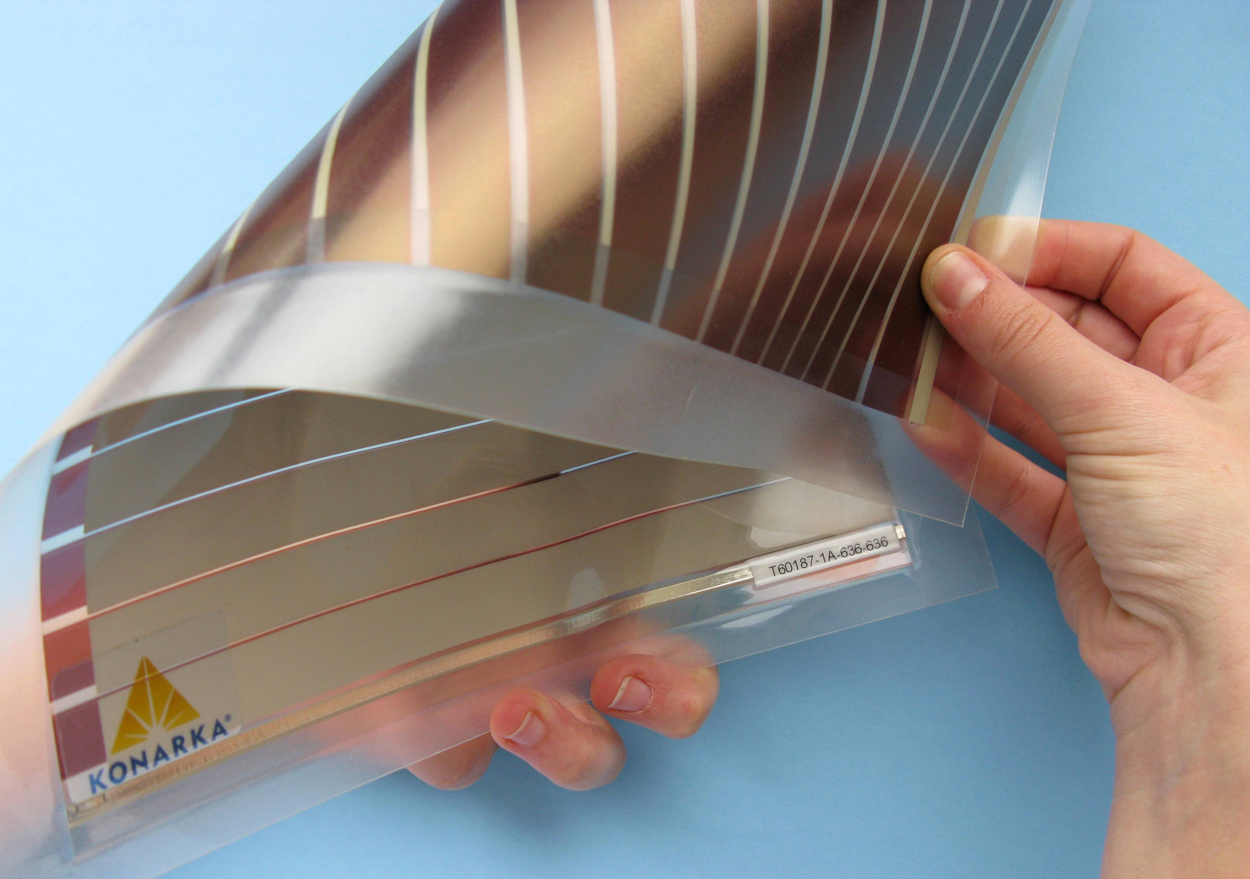  Photo caption | The first sentence of this section is the primary learning objective of the activity (bold). The second sentence elaborates or links the objective to nano.  Remaining paragraphs can be general information on nanotechnology and/or link the phenomenon to applications; e.g.:  Nanotechnology takes advantage of special properties at the nanoscale to create new materials and devices. Researchers are creating thin film batteries, solar cells, electronic displays, and coatings for different surfaces.

Note: “Try this!”, “What’s going on?” and “How is this nano?” must fit on one page, the front side of the activity guide!

Learning objectives
- Primary learning objective.
- Optional secondary learning objective.

Materials
- Material 1
- Material 2
- Material 3
- Material 4

Provide information on any hard-to-find or unusual materials. Include a source (type or store, and ideally a website) and part number (if applicable).

Provide a brief explanation of possible substitutes. Mention any substitutions that are not recommended.

Notes to the presenter
SAFETY: List any safety concerns or procedures (bold).
Before you begin:
- Advance prep, step 1.
- Advance prep, step 2.

Note any tips for successfully facilitating the activity. Note solutions to any common problems.
Provide tips or alternative ways to present the activity for different audiences.

Related educational resources
The NISE Network online catalog (www.nisenet.org/catalog) contains additional resources to introduce visitors to this topic:
- Public programs include [list here, titles in italics]
- NanoDays activities include [list here, titles in italics]
- Exhibits include [list here, titles in italics]
- Media include [list here, titles in italics]

Credits and rights
This activity was adapted from [original source]. The original activity is available at: [provide website or publication information.]
Specific material included in the NanoDays kits courtesy of ABC Company.
Photo of Xyz courtesy Name, Organization.

 | This project was supported by the National Science Foundation under Award No. 0940143. Any opinions, findings, and conclusions or recommendations expressed in this program are those of the author and do not necessarily reflect the views of the Foundation.

Published under a Creative Commons Attribution-Noncommercial-ShareAlike license: http://creativecommons.org/licenses/by-nc-sa/3.0/us/

Note: “Learning objectives”, “Materials”, “Notes to the presenter”, “Related educational resources”, and “Credits and rights” must fit on one page, the back side of the activity guide!

