Cleaning Our Water with Nanotechnology


Organization: Museum of Science, Boston
Contact person: Karine Thate
Contact information: kthate@mos.org; 617-589-4483

General Description

Stage Presentation with Demos

“Cleaning Our Water with Nanotechnology” is a public presentation about our drinking water and how we can make contaminated water safe to drink using a variety of technologies – including 3 new nanotechnologies for water purification. During the presentation, audiences consider the following questions: Which contaminants do we have in our water that makes it unsafe to drink? How do we typically purify our water – and what are the shortcomings/limitations of those technologies? How can new nanotechnologies purify our drinking water in new ways to help us in situations where large-scale water treatment isn’t appropriate? The presentation includes a variety of demonstrations to illustrate how these technologies work and some models to help visitors visualize what’s happening with these technologies at the nanoscale.

Program Objectives

Big idea:
To purify our drinking water, we need to remove contaminants including those that are much too small to see (tiny microbes and chemicals). While large-scale water treatment plants work well, there are times/places/situations where we don’t have access to these facilities and need to purify our water at the point of use. Nanotechnology is providing some new ways to purify our water at the point of use (better filters to remove tiny microorganisms and prevent filter-fouling).

Learning goals:
As a result of participating in this program, visitors will be able to:
- Recognize that water sources can be contaminated by microbes and chemicals – contaminants that are too small to see.
- Understand that these contaminants need to be removed to make the water safe to drink.
- Learn that nanotechnology has made possible some new water purification technologies that clean water very simply, effectively, and with very little power.

NISE Network content map main ideas:
[X] 1. Nanometer-sized things are very small, and often behave differently than larger things do.

[X] 2. Scientists and engineers have formed the interdisciplinary field of nanotechnology by investigating properties and manipulating matter at the nanoscale.

[X] 3. Nanoscience, nanotechnology, and nanoengineering lead to new knowledge and innovations that weren’t possible before.

[X] 4. Nanotechnologies have costs, risks, and benefits that affect our lives in ways we cannot always predict.

National Science Education Standards:
[ ] 1. Science as Inquiry
[ ] K-4: Abilities necessary to do scientific inquiry
[ ] K-4: Understanding about scientific inquiry
[ ] 5-8: Abilities necessary to do scientific inquiry
[ ] 5-8: Understanding about scientific inquiry
[ ] 9-12: Abilities necessary to do scientific inquiry
[ ] 9-12: Understanding about scientific inquiry

[X] 2. Physical Science
[ ] K-4: Properties of objects and materials
[ ] K-4: Position and motion of objects
[ ] K-4: Light, heat, electricity, and magnetism
[ ] 5-8: Properties and changes of properties in matter
[ ] 5-8: Motions and forces
[ ] 5-8: Transfer of energy
[ ] 9-12: Structure of atoms
[X] 9-12: Structure and properties of matter
[X] 9-12: Chemical reactions
[ ] 9-12: Motions and force
[ ] 9-12: Conservation of energy and increase in disorder
[ ] 9-12: Interactions of energy and matter

[X] 3. Life Science
[X] K-4: Characteristics of organisms
[ ] K-4: Life cycles of organisms
[X] K-4: Organisms and environments
[X] 5-8: Structure and function in living systems
[ ] 5-8: Reproduction and heredity
[ ] 5-8: Regulation and behavior
[X] 5-8: Populations and ecosystems
[ ] 5-8: Diversity and adaptations of organisms
[ ] 9-12: The cell
[ ] 9-12: Molecular basis of heredity
[ ] 9-12: Biological evolution
[ ] 9-12: Interdependence of organisms
[ ] 9-12: Matter, energy, and organization in living systems
[ ] 9-12: Behavior of organisms

[ ] 4. Earth and Space Science
[ ] K-4: Properties of earth materials
[ ] K-4: Objects in the sky
[ ] K-4: Changes in earth and sky
[ ] 5-8: Structure of the earth system
[ ] 5-8: Earth's history
[ ] 5-8: Earth in the solar system
[ ] 9-12: Energy in the earth system
[ ] 9-12: Geochemical cycles
[ ] 9-12: Origin and evolution of the earth system
[ ] 9-12: Origin and evolution of the universe

[X] 5. Science and Technology
[X] K-4: Abilities to distinguish between natural objects and objects made by humans
[X] K-4: Abilities of technological design
[X] K-4: Understanding about science and technology
[X] 5-8: Abilities of technological design
[X] 5-8: Understanding about science and technology
[X] 9-12: Abilities of technological design
[X] 9-12: Understanding about science and technology

[X] 6. Personal and Social Perspectives
[X] K-4: Personal health
[ ] K-4: Characteristics and changes in populations
[X] K-4: Types of resources
[X] K-4: Changes in environments
[X] K-4: Science and technology in local challenges
[X] 5-8: Personal health
[X] 5-8: Populations, resources, and environments
[ ] 5-8: Natural hazards
[X] 5-8: Risks and benefits
[X] 5-8: Science and technology in society
[X] 9-12: Personal and community health
[ ] 9-12: Population growth
[X] 9-12: Natural resources
[X] 9-12: Environmental quality
[X] 9-12: Natural and human-induced hazards
[X] 9-12: Science and technology in local, national, and global challenges

[X] 7. History and Nature of Science
[X] K-4: Science as a human endeavor
[X] 5-8: Science as a human endeavor
[X] 5-8: Nature of science
[ ] 5-8: History of science
[X] 9-12: Science as a human endeavor
[X] 9-12: Nature of scientific knowledge
[ ] 9-12: Historical perspective

Table of Contents
General Description 1
Program Objectives 1
Table of Contents 5
Time Required 6
Background Information 6
Definition of terms 6
Program-specific background 6
Materials 9
Set Up 11
Program Delivery 11
Safety 11
Suggested Script: 11
Tips and troubleshooting 18
Common visitor questions 19
Going Further… 20
Clean Up 21
Universal Design 22
Credits 23

Time Required

Set-up Program Clean Up

15 minutes 20 minutes 10 minutes

Background Information

Definition of terms

Nano is the scientific term meaning one-billionth (1/1,000,000,000). It comes from a Greek word meaning “dwarf.”
A nanometer is one one-billionth of a meter. One inch equals 25.4 million nanometers. A sheet of paper is about 100,000 nanometers thick. A human hair measures roughly 50,000 to 100,000 nanometers across. Your fingernails grow one nanometer every second.
(Other units can also be divided by one billion. A single blink of an eye is about one-billionth of a year. An eye blink is to a year what a nanometer is to a yardstick.)

Nanoscale refers to measurements of 1-100 nanometers. A virus is about 70 nm long. A cell membrane is about 9 nm thick. Ten hydrogen atoms are about 1 nm. At the nanoscale, many common materials exhibit unusual properties, such as remarkably lower resistance to electricity, or faster chemical reactions.
Nanotechnology is the manipulation of material at the nanoscale to take advantage of these properties. This often means working with individual molecules.
Nanoscience, nanoengineering and other such terms refer to those activities applied to the nanoscale. “Nano,” by itself, is often used as shorthand to refer to any or all of these activities.

Program-specific background

Clean water – for humans and animals, for agriculture, for industry – is a fundamental necessity. Nearly a billion people worldwide, however, do not have access to clean drinking water, and millions die each year (mostly children) from waterborne diseases contracted from unsafe water sources. It’s not possible to tell whether water is safe to drink just by visual inspection, as the contaminants can be on the micro- and nano-scale. To purify water for human consumption (drinking water), we need to remove (or reduce the concentration of): particulate matter, parasites, bacteria, algae, viruses, fungi and a range of dissolved chemicals.

Large-scale water treatment plants clean water effectively using a variety of possible techniques:
- Chemical treatments – For example, chlorine, chloramines, iodine, ozonation (ozone bubbles), etc. These typically act as disinfectants and kill/inactivate the microbes in the water.
- UV treatment – UV light damages the genetic material of microbes, inactivating them.
- Various filtration technologies (including membrane filters and reverse osmosis) – Cleans the water by excluding contaminants based on size. Either the holes in the membrane are small enough to prevent certain particles from passing through, or the contaminants in the water adhere to the surface of the material in the filter.
- Flocculation – Clarifies the water by causing a precipitate to form. Adding a chemical coagulant that creates clumps of impurities that can be removed by physical methods.

For more background, the Wikipedia article on Water Purification is a good place to start (http://en.wikipedia.org/wiki/Water_purification) . Also, contact your local water department to find out how the water is treated in your area.

However, the large-scale water treatment plants and the centralized water distribution and purification infrastructures we rely on in industrialized countries are enormously expensive, and are energetically and chemically intensive and require skilled engineers and laborers. There are certain situations and places where centralized water treatment isn’t an option and “point-of-use” water treatment is required – in areas too poor or remote to have centralized water treatment; in places were population is growing very quickly and demand outstrips supply; after natural disasters when centralized utilities shut down; or after a water main break (our own crumbling infrastructure will make this a bigger issue in the USA in the coming decades) when the water supply is contaminated during distribution. In these cases, we want to purify the water at the point of use – where it will be consumed. Point of use water treatment should be portable, simple, effective, easy-to-use, inexpensive and require very little or no power.

Some of the popular “point-of-use” water treatments currently available or commonly used include:
- Brita filters – activated carbon filters. Some contaminants adsorb to the activated carbon – but on it’s own it’s not sufficient for purifying water to make it potable. It’s appropriate for use in homes to improve the look, taste and smell of water that is already treated.
- Micro-filters – commonly used by hikers/campers. These remove some microbes (down to the micron size – but NOT nano-sized viruses). These don’t treat any kind of chemical contamination.
- Chemical treatments – chlorine tablets or drops, or iodine. These treat biological contamination, but many people don’t like the taste and don’t want to “clean” their water by adding chemicals to it – they’d rather just remove the contaminants without adding anything to the water.

Nanotechnology provides many promising solutions for improving “decentralized” or “point-of-use” water treatment – basically, becoming more efficient and effective about removing all the contaminants in water to make it safe to drink. The technologies discussed in this particular presentation deal with membranes or nano-filters – that either have nano-sized pores, or that utilize nanomaterials (carbon nanotubes) to filter out contaminants. There are other nanotechnologies related to water purification – everything from nanosensors to detect contaminants in the water, nanomaterials to help with water pollution remediation, to new desalination technologies and everything in between. The nanofilters for water purification are the most developed of these technologies which is why I’ve focused on them for this presentation.

A few great overview articles on this topic include:
- Nanotechnology and the Challenge of Clean Water (http://www.nature.com/nnano/journal/v2/n11/full/nnano.2007.350.html)
- Nanotechnology and Water Treatment (http://www.nanowerk.com/spotlight/spotid=4662.php)
- Water, Nanotechnology’s Promises, and Economic Reality (http://www.nanowerk.com/spotlight/spotid=2372.php)

Two much more detailed reports by the Meridian Institute include:
- Nanotechnology, Water, and Development (http://sites.merid.org/nano/waterpaper/?item=%2fnano%2fwaterpaper%2f&user=extranet%5cAnonymous&site=website)
- Overview and Comparison of Conventional and Nano-Based Water Treatment Technologies (http://sites.merid.org/nano/watertechpaper/?item=%2fnano%2fwatertechpaper%2f&user=extranet%5cAnonymous&site=website)

As I mentioned, there are many possible nanotech-enhanced water treatments – far too many to cover in a short presentation, so three specific (and relatively simple) nanotech-enabled water filtration technologies are mentioned in this program:

1) The Lifesaver bottle – an ultrafiltration membrane. The holes in this membrane are only 15 nanometers in size, small enough to keep out the smallest viruses. The website has more information about how it works, and the FAQs are worthwhile too. http://www.lifesaversystems.com/index.html. Finally, there is a great TED talk video of the CEO talking about how the technology works – very easy to understand and great background. http://www.ted.com/talks/lang/eng/michael_pritchard_invents_a_water_filter.html. This technology is already commercially available.

2) Seldon Technologies Water Stick and Water Box – a “Nanomesh” filter which incorporates carbon nanotubes. The Nanomesh allows water to flow through quickly at a higher rate than an ultrafiltration membrane, but the carbon nanotubes attract contaminants. Microbes and chemicals adsorb (stick to the surface of) to the CNTs leaving the water chemical free. Lots of info on their website: http://www.seldontech.com/index2.html. MOS featured this technology in science news spot for New England Cable News. You can see the video here: http://www.mos.org/events_activities/videocasts/videocasts_archive&d=3131. This technology is available for export, but technically still being “tested” in the US.

3) Electrochemical Carbon Nanotube Filter – invented by Chad Vecitis, a professor at Harvard University. It’s still in the research phase, but is promising in early tests. A carbon nanotube filter that takes advantage of the electrical conductivity of carbon nanotubes. By hooking up small power source to the filter, it is electrified and does electrochemistry as the water passes through. The electrical current kills or degrades the microbes or chemical contaminants, slowing the process of filter-fouling, keeping the filter clean for longer and reducing the need for frequent cleaning or replacement of the filter. More information on Chad’s research here: http://environmental-technology.seas.harvard.edu/. Two journal articles on this topic include:

C.D. Vecitis, M.H. Schnoor, Md.S. Rahaman, J. Schifmann, M. Elimelech, "Electrochemical Multiwalled Carbon Nanotube Filter for Viral and Bacterial Removal and Inactivation", Environmental Science & Technology, 2011, 45, 3672-3679.

C.D. Vecitis, G. Gao, H. Liu, "Electrochemical Carbon Nanotube Filter for Adsorption, Desorption, and Oxidation of Aqueous Dyes and Anions", Journal of Physical Chemistry C, 2011, 115, 3621.

That said, there are of course concerns and unanswered questions on how to distribute these technologies economically, equitably, etc. These concerns are not explicitly dealt with in this presentation (as it would expand an already long presentation), but questions on this topic often come up after the presentation, so it’s a good idea to have read some background.

Materials

- “Cleaning Our Water with Nanotechnology” PowerPoint presentation including the following videos:
- Man_drinks_water_from_Charles.mov (for slide 3)
- Filter_Fouling.mov (for slide 22)
- Electrochemical_Filter.mov (for slide 24)
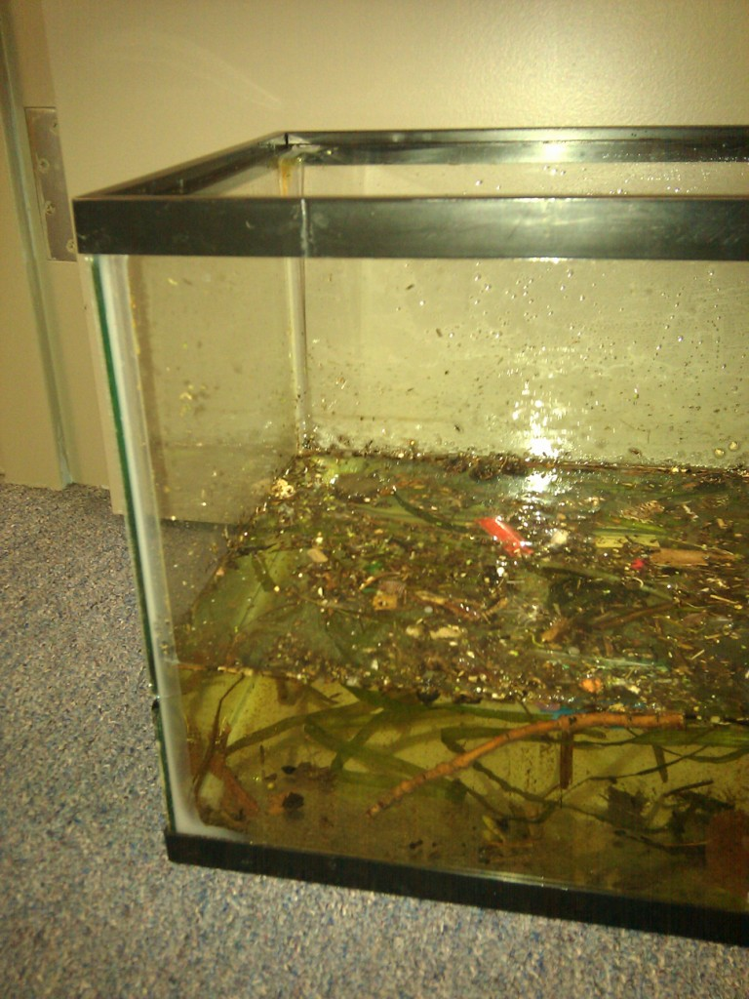
- A clear aquarium tank or clear jug filled with “dirty” water from any local outdoor source (river or lake). Be sure to include floating debris, garbage, plant matter, etc.
Note: This will need to be covered and replaced every week or two as it gets too smelly and dirty if left untended.
- A small kitchen sieve with handle (to scoop physical debris from water)
- Clear plastic cup

A few water filtration technologies, for example:
- Brita Filter (available from Amazon or any department store)
- Iodine tablets and Chloride dioxide drops or tablets (available from Amazon, REI or similar outdoor store)
- A microfilter for campers/hikers

- Empty 5 gallon bottle from office water cooler.
- Regular size ½ liter or 20 oz bottle of water.

- A nanotech-enhanced water filter for demonstration – either the Lifesaver Bottle or Seldon’s Water Stick. Lifesaver bottle can be purchased from Amazon for approx. $150.
The Seldon Water stick is not yet available commercially, but you may contact Seldon Technologies to see if they will give you a sample product for “testing”.
- A clear jug filled with “dirty” water to use on either nanotech enhanced technology, and a clean empty glass to collect the clean water. Water can either from a natural water source, you can “dirty” the water yourself with food coloring.
Note: Practice using the filters first to become comfortable with them. For example, with the LifeSaver bottle, the clean water comes out with great force if you pump too much. Also, the Seldon WaterStick needs to be “primed” before the show, so you can get clean water with just a few pumps.

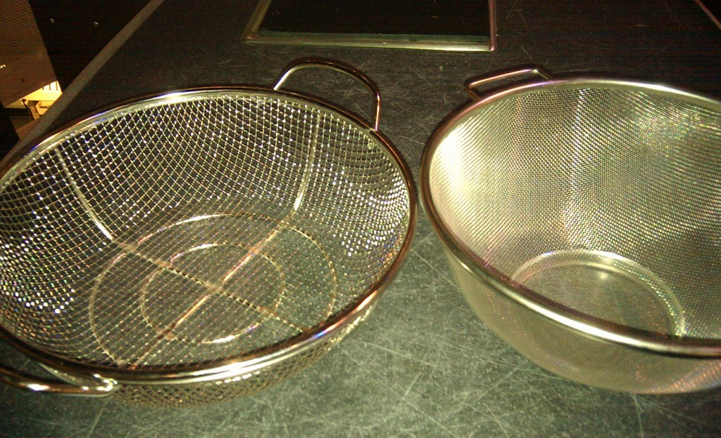
- 2 kitchen colanders/sieves with different size holes – one with fine mesh (typical sieve); another with larger holes (more like a grilling basket).
- 2 different sized and colored beads – large beads to represent bacteria; smaller beads to represent viruses. Note: The smaller beads should be small enough to fall through the sieve with the large holes – so only the larger beads are caught. The fine mesh sieve should catch both the small and large beads.
- 2 clear plastic cups (each holding a mixed combination of small and large beads – representing contaminated water)
- A plastic container to catch the beads that fall through the sieve. Include paper towels or foam at the bottom of the container to prevent beads from bouncing.

- A model of a bacteria and virus – 10-15 cm in size approx. These can either be made from small rubber or Styrofoam balls, or you could use stuffed models like these: http://www.thinkgeek.com/geektoys/plush/6708/. Plastic novelty toys from toy/craft stores could also work (search online for “puffer worm” toys).
- Small ball representing a virus – should be smaller than 2 cm.
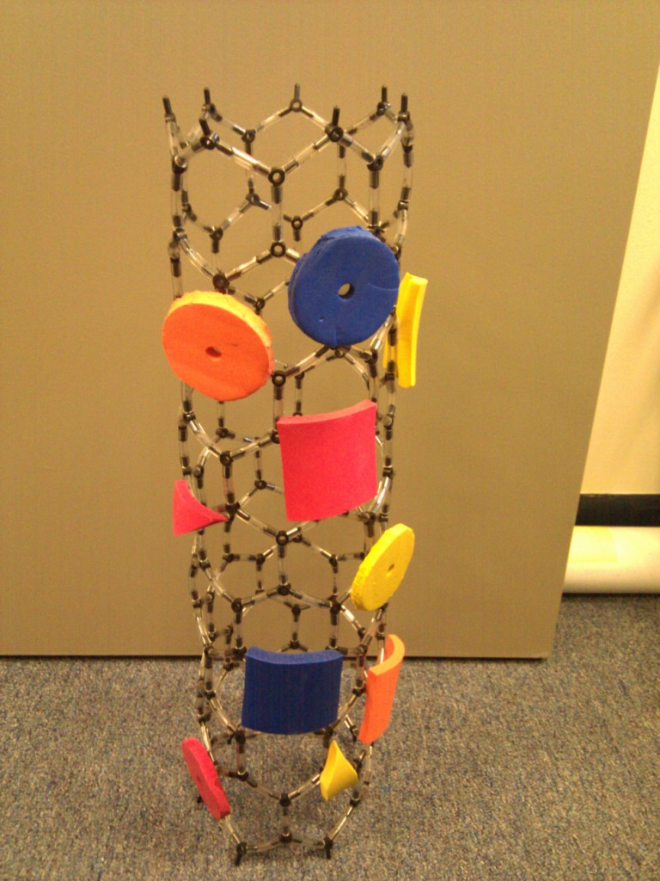
- Carbon Nanotube model. For example: http://www.indigo.com/models/gphmodel/carbon-nanotube-model-W.html
- Small foam pieces of different colors and size to represent different contaminants
- Velcro strips/pieces with sticky-backs to attach/detach foam pieces to carbon nanotube model.

Set Up

Time: 15 minutes
- Collect water from a local, nearby water source (hopefully, this is done ahead of time). A tank of water can be used for several shows, but shouldn’t be kept for more than a week or so.
- Set up props on table/cart as grouped in the materials list above, so they are readily accessible when called for in the script.
- Test out or prime the LifeSaver water bottle or Seldon Waterstick to make sure it’s ready to go for the presentation.

Program Delivery

Time: 20 minutes

Safety
Do not let visitors drink contaminated or cleaned water from the tanks or water purification devices. If using either nanotech enhanced water purification technology, be sure that the “clean” hose or end does not get contaminated by dirty water. Museum educators wanting to show the devices in action may drink the cleaned water if they are comfortable (and if they’re sure they’ve used the devices properly), but a better option is to use “simulated” dirty water in the nanotech devices (with food coloring and solid debris), instead of water from a natural “dirty” water source.

Suggested Script:
(Feel free to adapt/revise to tailor content to your visitors).
[Slide 1 – Title Slide]
Good afternoon everyone, and welcome to __________________. My name is _________________ and today, I’m going to talk about how we clean our water.

[Slide 2 – Dirty River Water]
I have a tank I’ve filled up from the river/lake right near outside the museum – from _______________________ (name local water source) (fill a glass from the tank). How many of you would be willing to DRINK this water right out of an urban, polluted water source? (Raises hand, looking encouraging?) Anyone? (Ham it up and dramatize as necessary... if kids volunteer, ask them “REALLY?!? You think your parents would let you drink this?!?!”)

Not many of you…

Why not? (Solicits answers from the audiences…)

What if I told you that…

[Slide 3 – Man drinking water from Charles River video]
THIS man that – drank water right out of a polluted river. His name is Alan Cummings and he’s the CEO of a Vermont start up company called Seldon Technologies that uses nanotechnology to purify drinking water. So, to put his technology to the test he used it to drink water right out of the Charles River – a polluted river that runs right through the center of Boston – and did it on TV in front of New England viewers.

[Slide 4 – Dirty River Water]
So, what do you think YOU’d have to do first to clean the water to a point where you would be comfortable drinking it?

(holds up props/examples of these filtration technologies)
What if you skimmed up all the junk floating on the top (using a sieve)?
Would you trust your BRITA filter?
Would you think boiling it would be enough?
What about iodine or chlorine treatments?

Well, most people think those wouldn’t be sufficient – after all, it’s an urban, polluted river through a very highly populated area. All sorts of bad stuff - dangerous chemicals, pollutants, waste, overflow from the sewers - ends up in the river…. But what about a river like...

[Slide 5 – Mountain stream]
– THIS? Have you ever been out in the country hiking or camping and come across these beautiful crisp, clean mountain streams… Ever been tempted to just scoop up a handfuls and take a few sips…

Now, is THAT a good idea?
Most of you know that it’s NOT a good idea. While chemical pollutants may not be a big problem out here, there are other things to be concerned about. No matter how clean it LOOKS – there are contaminants that are too small to see. You don’t know what’s happening just upstream.

[Slide 6 – Moose/Beaver – or replace with images of your local wildlife]
You see, animals like these guys aren’t very careful about where they put their waste...

[Slide 7 – hiker]
and sometimes neither are these animals.

There are some nasty little critters in animal waste that can make you pretty sick.

So, what are these little critters that I’m talking about?

[Slide 8 – Wanted Poster]
The bacteria, viruses and protozoa that cause waterborne disease!

[Slide 9 – Images of microbes]
Giardia for one. This critter is a protozoan parasite - it’s TINY, but can make you VERY sick - causing diarrhea, nausea, cramps.
Other dangers are bacteria like this one - E. coli. Or other types of bacteria that cause disease like cholera and typhoid…
But that’s not all – we also have to be worried about – viruses – like hepatitis, or rotavirus... all of which make you very ill.

Bacteria, protozoa and viruses make A LOT of people very sick. World-wide, water-borne diseases are responsible for killing about 2 million people each year - most of them children.

The tricky thing is that they are much too small to see in our water - so you can’t tell by looking at it whether your water is safe to drink... Millions of bacterial cells can fit in a single drop of water.

Which brings us to our next question...
Between the chemical pollutants we have in our urban water, to these microbes that can be found in any water source, how do we actually get these tiny things OUT of water and make sure it’s clean enough to drink?

Well the answer to that depends on who we are, and where we live.

[Slide 10 – kitchen faucet]
Most of us don’t have to worry about that – it’s already done for us by the time it gets to our homes - chemical pollutants and dangerous microbes are removed from our water. The water that comes out of our kitchen sinks is safe – we can drink it without worrying because our large-scale water treatment plants work pretty well. For example, the water here at the museum is treated at a large-scale water treatment plant, and this is how the water is treated…

[Slide 11 – water treatment facility]
(Feel free to customize this slide with images and details of your local water treatment – check out their website to see how it’s treated… if not, just use this example as a “typical” large-scale water treatment plant)
(For example, the museum’s water originally comes from _____ reservoir or ground water in _______ location…. Travels through pipes until it arrives at ______ water treatment plant)
The plant treats the water in a few steps – first they add a chemical that creates floating clumps of impurities that are skimmed off. During the next step, they add ozone bubbles which disinfect the water and kills all the bacteria, viruses, and protozoa. Then they put it through another filter to remove organic compounds, and finally they add 2 more chemicals - Chlorine and Chloramine - which kill any left over microbes – but more importantly, they stay in the water and keep it free from microbes as it travels through the miles of underground pipes on it’s way to the museum or to your homes.

That’s just one example of how water is treated – and it’s pretty typical – but some other treatment plants might use other treatments (UV, reverse osmosis). They usually work pretty well and provide millions of us with safe clean water.

But there’s still a problem… They all require lots of:

[Slide 12 – energy, money, infrastructure, engineers]
energy, money, infrastructure, chemicals, and skilled engineers and laborers.

And there are places or situations when we don’t have access to all this for centralized water treatment… Any ideas what some of those might be? (Solicit answers from audience.... Perhaps prompt them with “have you ever traveled anywhere where it wasn’t safe to drink tap water?”)

[Slide 13 – remote, poor and overpopulated areas]
In developing countries – many areas too poor or too remote to have centralized water treatment. Some countries like India and China are having trouble keeping up with demand – they can’t build water treatment plants, or lay down pipe fast enough to meet the growing population.

[Slide 14 – disaster damage]
After disasters like Hurricane Katrina or the tsunamis in Asia, or the quakes in Haiti and Japan. Utilities shut down after major crises, and residents find there is no clean water or power available.

[Slide 15 – crumbling pipes]
Even here at home… when we have a water main break or other problem with our pipes. Our own infrastructure is OLD – many of our pipes were put in place a century ago or more and they’re having an increasing number of problems. Have you ever had a boil water order after a water main break in your community? Those situations could end up happening more and more often.

So, what do we do?

[Slide 16 – bottled water]
We can cart in bottled water… It’s safe , portable, and you can have safe drinking water ANYWHERE.... but it’s really heavy so not so easy to move around… just think how much water you use everyday - from drinking to cooking to bathing to laundry to watering your lawn - it really adds up. The national average for water use is about 98 gallons of water PER PERSON per day! (Show 5 gallon water cooler bottle as prop) That’s almost 20 of these 5 gallon bottles. That would weigh more than 800 pounds - 800 pounds of water for each person! Imagine hauling that around. Not to mention that the production, transportation and disposal of plastic water bottles is an environmental nightmare in itself. (per capita use varies widely by location – from a low of 50 gallons per person per day in the northeastern states to a high of nearly 200 gallons per person per day in some southwestern states. Find out the use in your area to customize this to your location. A 5 gallon water bottle weighs about 40 pounds).

[Slide 17 – 3 researchers]
That’s why researchers are looking for new solutions… technologies that can help us simply, cheaply and easily clean water on the spot with out a lot of equipment or power or having to add chemicals – Purify water where you want to use it… taking everything out of the water that we want to remove, without having to add chemicals in to the water.

So, I’m going to share with a few stories about 3 people who saw this problem and wanted to do something about it – find new ways and new technologies to purify our water. The common thread? All 3 of these people use nanotechnology to do that. The first 2 technologies are already developed and commercially available, the last technology is still in the research phase and undergoing development.

[Slide 18 – LifeSaver bottle images]
The first and simplest technology is from Michael Pritchard in the UK. After watching the aftermath of the tsunamis in Southeast Asia and the flooding in New Orleans after Hurricane Katrina – that he realized what a problem it was to get fresh life saving clean water to people in disasters – and he was inspired to do something about it. He created the “Lifesaver” bottle. Just pop open one end, fill it with any water you can find (even from a puddle) pump the handle a few times and out comes clean water. (Show prop if you have it)

Really simple, no power is needed, and you can get thousands of liters of water with a single filter.

The way it works is similar to any filter - you push the water through a membrane that has tiny holes.
Basically, it’s a sieve - like what you might use in the kitchen (show prop)- but with much smaller holes because it needs to get out tiny bacteria and viruses. Now a lot of people think that bacteria and viruses are about the same size (show bacteria and virus model - similar in size). But that’s not the case. Bacteria are much, much bigger than viruses. If I was the size of a bacteria - a virus would be smaller than this small model (show smaller model - approx size of ping pong ball). Lets say this cup represents some dirty water - the orange balls represent bacteria, and the green balls represent much smaller viruses... Now a lot of filters have holes that are small enough to keep out bacteria (demo - pour 2 size balls through a seive - larger ones (bacteria) are trapped, but smaller ones pass through), but the holes are too big to keep out the tiny viruses (the green particles). So you need a filter with MUCH smaller holes.

The LifeSaver bottle (show bottle) filter has much smaller holes – about 15 nm in size – small enough to keep out even the smallest viruses. So it works more like this model (show sieve with smaller holes and poor bacteria/viruses balls through it - everything is caught). You can see both bacteria and viruses are trapped by this filter - because it has such small holes. It’s simple and effective - and doesn’t just come in this bottle format - they’ve also made a jerry can version that can supply villages and schools with clean water - it was recently put to the test in Haiti.

But we can do better - this solves the problem of taking the smallest biological contaminants out, but with holes too small, it limits how much water can flow through quickly. Also, small pore size on a filter doesn’t remove dissolved chemical contaminants on it’s own - we need something more...

[Slide 19 – Alan Cummings and the WaterBox]
So that brings us back to Alan Cummings – the guy I showed at the start of the presentation who drank water out of Boston’s Charles using this device (show WaterStick if you have physical prop, otherwise show image of WaterBox). His company Seldon Technologies – based out of Vermont, developed a better water filter. Now their inspiration for this technology came from a little farther a field – SPACE!

[Slide 20 – Space station and astronaut]
They first developed this filter for NASA – because one of the biggest limits in having manned space flight is providing enough clean water for the astronauts – and since water is so heavy, they don’t want to carry much of it – so NASA was looking for technologies that would allow them to purify small amounts of water right on space craft – to let them recycle and reuse water, so spacecraft have to bring less of it with them. They also wanted the water filter to be small and use very little power. Stephanie Wilson is one of the astronauts that used a prototype of the device.

[Slide 21 – Nanomesh filter and WaterBox]
Seldon’s technology is called a Nanomesh filter – it actually has larger pore size (holes) than the life saver bottle to let the water flow through at a faster rate, but also uses a material called carbon nanotubes to get rid of contaminants in the water. Now carbon nanotubes (show model) are tiny tubes made of carbon - this model shows you their shape and structure - but the real ones are about 100 million times smaller - only a few nanometers across - thousands of times thinner than the width of a single human hair.

Why would we want to add this to our filter? Well, a lot of pollutants (show foam pieces representing pollutants) will adsorb - basically stick to or attach to - carbon. It’s the same idea with activated carbon filters – like Brita filters for example. But they do this on the surface of carbon. (stick stuff pollutants to outside of CNT model (velcro)). Because these tubes are so tiny have LOTS of surface area and they’re arranged in such a way to let water flow through much more easily than activated carbon filters, so they are much more effective and trapping and removing microbes and chemicals.

They have a few different versions - a water stick that someone could use to drink water right from a polluted source, a filter you could hook up to indoor plumbing, or a water box that is portable to pump larger volumes of water. (Demonstrate water stick on stage). Here you can see the filter in action - it’s taking polluted water from the jug on the left and putting clean drinking water in the glass on the right. (Take a sip!)

[Slide 22 – filter fouling animation]
Those technologies work well - but after a while the filter will clog and water won’t flow through as easily or be cleaned as well. And since we’re trapping microorganisms like bacteria - these microbes can start growing on the filter. That’s called filter-fouling and it means that we need to clean or replace the filter regularly. Actually, this is true of any filtering technology.

Wouldn’t it be great to have a self-cleaning filter? One nano researcher has an idea of how to do that.

[Slide 23 – Chad Vecitis and CNT filter]
Meet Chad Vecitis, a young researcher at Harvard, who has a great idea for improving water filters even more - the technology he is developing takes these carbon nanotube filters a step farther.

He starts with a carbon nanotube filter – this photo here - it looks pretty similar to the other one we saw from Seldon. But Dr. Vecitis is taking advantage of another property of Carbon Nanotubes - that they are extremely good at conducting electricity.

[Slide 24 – Electrochemical CNT filter animation]
That means we can hook up a power source to our filter (it doesn’t even need to be a powerful one - even a few AA batteries would produce enough) - and electrify it. We’re doing electrochemistry now as the water runs through the filter - that sounds fancy - but all that means is that were using electricity to kill/inactivate/degrade the bacteria and viruses and other contaminants that build up the filter to help keep it clean and slow filter fouling, so you don’t need to clean or replace the filter as often.

So, this technology is still in the research phase and isn’t available yet, but it’s promising – it takes everything out that we want to remove from the water – AND it’s essentially a self-cleaning filter – simple and uses only a small amount of power. And this type of technology could also make a big difference for our large-scale water treatment as well.

[Slide 25 – Dripping faucet]
So, these are just a few stories of real people who are using science and engineering skills to find real solutions to very big problems. These 3 nanotech-based water filters are providing some innovative ways we could provide clean drinking water - simply, cheaply, with little power - to more people, in more situations and places. They are simple solutions, but the science behind these technologies has only just become available in the last 10 years with nanotechnology. Now, nanotech is not a silver bullet solution to this problem - but it is going to be part of a whole suite of solutions that address our water challenges in the coming decades.

The even bigger issue is that the world is running out of clean water sources for our growing population. We’re so lucky to have clean water delivered right to where we live and work - that we don’t need to collect it miles away and carry it back to our homes... But that doesn’t mean we can be wasteful with it. What we can do RIGHT NOW is conserve water - think about how much you’re using everyday - 3 gallons of water per minute in the shower, 40 gallons per load of laundry, 15 gallons per cycle of your dishwasher, running your garden hose is 9 gallons per minute. Think about your water use and how you might reduce it - a shorter shower, waiting until you have a full load to do the laundry, watering your lawn at night or in the early morning. There are lots of simple steps we can all take each day to conserve water - our most valuable resource.

[Slide 26 – Questions?]
Thank you very much for joining me today. I’m happy to answer any questions you have. Otherwise, I hope you enjoy the rest of your day here at the museum.

[Slide 27 -30 – Credits]

Tips and troubleshooting
This presentation can be enhanced and made more relevant to your visitors, by researching a little bit about your local water treatment and local water use. A few slides/images can be customized to reflect what happens in your area.

Be sure to test the nanotech-enhanced filters ahead of time as it takes a few tries to get comfortable with how they work and the best way to demonstrate this on stage.

Common visitor questions
Aside from the questions below, this presentation seems to draw a wide variety of questions on water purification or waster water treatment in general (or specific questions about your local water treatment plant), as well as questions on well-water quality concerns, and a few other topics outside the scope of the presentation. Reading some general background articles on how water is treated could be helpful, or refer them to your local water department who should be able to answer.

Are these technologies already being used (already available on the market)?
The answer is “yes” for the first 2 technologies and “not yet” for the 3rd technology. The LifeSaver bottle has been in use and commercially available for the last few years. The British military in particular use this technology in the field. For the last couple of years, the Seldon WaterStick has been available for export, but still is “under testing” in the United States. It’s not commercially available yet, but is being distributed in limited quantities as part of “testing”. The US military is already a big customer for Seldon and has purchased and currently use large numbers of WaterSticks and WaterBoxes. Both companies have donated materials/supplies for relief efforts in the developing world and their technologies are already being used for select projects in Haiti, Japan, Rwanda, and elsewhere.

Chad Vecitis’s technology is not yet available – it’s only in the research phase and his published papers are proof of concept. Chad would need an investor/company to commercialize his technology.

How expensive are these technologies? Cheap enough to use in developing countries? Are we able to distribute these where they are needed?
As is typical of any new technology, they are still relatively expensive ($150 for the LifeSaver Bottle and $100 for the WaterStick). While they’ve been distributed in small quantities free of charge for relief efforts, large scale distribution of these technologies isn’t yet possible. This presentation mainly tackles the science of the problem, as the economic, political, and logistical barriers to equitably distributing these technologies is another matter entirely – and quite a complex one at that. An interesting online article - Water, Nanotechnology’s Promises, and Economic Reality (http://www.nanowerk.com/spotlight/spotid=2372.php) - addresses this topic and is a worth a read.

What’s the difference between an activated carbon filter and a carbon nanotube filter?
Activated carbon filters – like Brita filters – are quite common. They are simply made of a carbon rich material that has been processed in such a way to give it lots of surface area. Brita filters for example are made of charred coconut husks. Contaminants adsorb to (stick to or react with) the surface of the carbon helping clean the water. While the activated carbon has lots of surface area, it can be difficult to structure the filter in such a way to allow the water to flow freely and quickly and for the contaminants to have lots of access to the surface of the area of the carbon for adsorption.

Carbon nanotube (CNT) filters work in the same general way as activated carbon – except the nanostructure of a carbon nanotube allows you to better take advantage of the incredibly large surface area of CNTs. The CNT filter can be structured so that water can flow quickly and easily through the large pores, while the contaminants are brought in close proximity to the surface of the carbon nanotube so they are attractd and trapped by the filter. CNTs can also be specially marked/tagged to attract certain contaminants.

Do any of the nanotubes end up in the filtered water? Aren’t they dangerous?
Seldon’s tests have shown there is no measurable trace of CNTs in the effluent (clean water). While aerosolized CNTs have been a concern during manufacturing, there does not seem to be any health/safety concern for use of the CNT filters since they are not passing into the water that is filtered.

What happens to these filters after they are finished their useful life? Are there disposal concerns?
Like almost any water filter that has finished its useful life, it will be disposed of in a landfill. There aren’t yet facilities to treat/recycle/reuse these filters. Disposal concerns do not seem to be any greater than for other water filters. However, this brings up a good point that as there is much research into new materials, there is also a lot research into the impact of the “lifecycle” of nanomaterials from “cradle to grave” – from harvesting raw materials and manufacture, to use, to disposal – to make sure that we aren’t creating new environmental or societal problems while trying to solve one.

Going Further…
The best sources for additional information would be the websites of the technologies highlighted in this presentation, or the website of your local water department.

A few great overview articles on this topic include:
- Nanotechnology and the Challenge of Clean Water (http://www.nature.com/nnano/journal/v2/n11/full/nnano.2007.350.html)
- Nanotechnology and Water Treatment (http://www.nanowerk.com/spotlight/spotid=4662.php)
- Water, Nanotechnology’s Promises, and Economic Reality (http://www.nanowerk.com/spotlight/spotid=2372.php)

Two much more detailed reports by the Meridian Institute include:
- Nanotechnology, Water, and Development (http://sites.merid.org/nano/waterpaper/?item=%2fnano%2fwaterpaper%2f&user=extranet%5cAnonymous&site=website)
- Overview and Comparison of Conventional and Nano-Based Water Treatment Technologies (http://sites.merid.org/nano/watertechpaper/?item=%2fnano%2fwatertechpaper%2f&user=extranet%5cAnonymous&site=website)

Websites for the 3 technologies highlighted in this presentation:

The Lifesaver bottle – http://www.lifesaversystems.com/ TED talk video - http://www.ted.com/talks/lang/eng/michael_pritchard_invents_a_water_filter.html

Seldon Technologies Water Stick and Water Box – http://www.seldontech.com/ .
New England Cable News video: http://www.mos.org/events_activities/videocasts/videocasts_archive&d=3131.

Electrochemical Carbon Nanotube Filter – Chad Vecitis’s Lab at Harvard: http://environmental-technology.seas.harvard.edu/.

Two journal articles on this topic include:
C.D. Vecitis, M.H. Schnoor, Md.S. Rahaman, J. Schifmann, M. Elimelech, "Electrochemical Multiwalled Carbon Nanotube Filter for Viral and Bacterial Removal and Inactivation", Environmental Science & Technology, 2011, 45, 3672-3679.

C.D. Vecitis, G. Gao, H. Liu, "Electrochemical Carbon Nanotube Filter for Adsorption, Desorption, and Oxidation of Aqueous Dyes and Anions", Journal of Physical Chemistry C, 2011, 115, 3621.

Clean Up

Time: 10 minutes

Be sure to empty the water filters of left over water before storing them. Note that the LifeSaver should be stored with a small amount of water in it to prevent the ultrafiltration membrane from drying out.

As you store the filters, make sure that the “clean” hoses or ends of the filter remain separate/protected from any source of contamination. Do not touch them with hands that are wet with “contaminated” water.

Be sure to empty/replace the tank with local river/lake water every week or two, or else the standing water will begin to smell and grow thick with algae.

Otherwise put props away/store in a bin/box for the next presentation.

Universal Design

This program has been designed to be inclusive of visitors, including visitors of different ages, backgrounds, and different physical and cognitive abilities.

The following features of the program’s design make it accessible:

[X] 1. Repeat and reinforce main ideas and concepts
Several key ideas are repeated throughout the program, including: that natural water sources are contaminated with microbes and chemicals that are to small to see; these contaminants need to be removed from water before it is safe to drink; new nanotechnologies can help clean the water where we want to use it – simply, easily and with very little power.

[X] 2. Provide multiple entry points and multiple ways of engagement
In addition to demonstrating the technologies in action, several physical analogies describing how these nanotechnologies work are provided to help visitors visualize what’s happening on the nanoscale - comparing nanofilters to kitchen sieves and microbes to beads; showing using the CNT and foam models to show how contaminants adsorb to the surface of the nanotube.

[ X] 3. Provide physical and sensory access to all aspects of the program
In addition to the visual images on the slides, and the verbal descriptions from the presenters, there are numerous physical props (that visitors may touch and explore after the presentation) and several videos to show what’s happening.

To give an inclusive presentation of this program:

Be sure to speak slowly and clearly, facing the audience and do not obscure your mouth when speaking. Invite audience members to physically touch and explore the props after the show. Hold up props or display them in a manner that they can be seen by everyone in the audience.

There is a lot of information packed into this program; as a result, it is important to avoid sounding overly professorial in delivering it. Using your own personal style of humor and drama can go a long way in breaking up some of the information here.

Credits
   | Development of this product was supported by the Nanoscale Science and Engineering Center headquartered at Harvard University, the Center for High-rate Nanomanufacturing at Northeastern University, University of Massachusetts-Lowell, and University of New Hampshire, with support from the National Science Foundation.
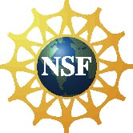 | Dissemination of this project was supported by the National Science Foundation through the NISE Network under Award No. 0940143. Any opinions, findings, and conclusions or recommendations expressed in this program are those of the author and do not necessarily reflect the views of the Foundation.
 | Published under a Creative Commons Attribution-Noncommercial-ShareAlike license: http://creativecommons.org/licenses/by-nc-sa/3.0/us/

