

Exploring Fabrication—Gummy Capsules

Try this!  - Place the sieve into the bowl of salt water (calcium chloride solution).  - Gently squeeze the bottle of sodium alginate “worm goo,” so that individual droplets of liquid fall into the sieve.  - Lift the sieve out of the bowl.  - Feel the droplets. Are they still liquid?  - Try squeezing a droplet. What happens?  What’s going on? | 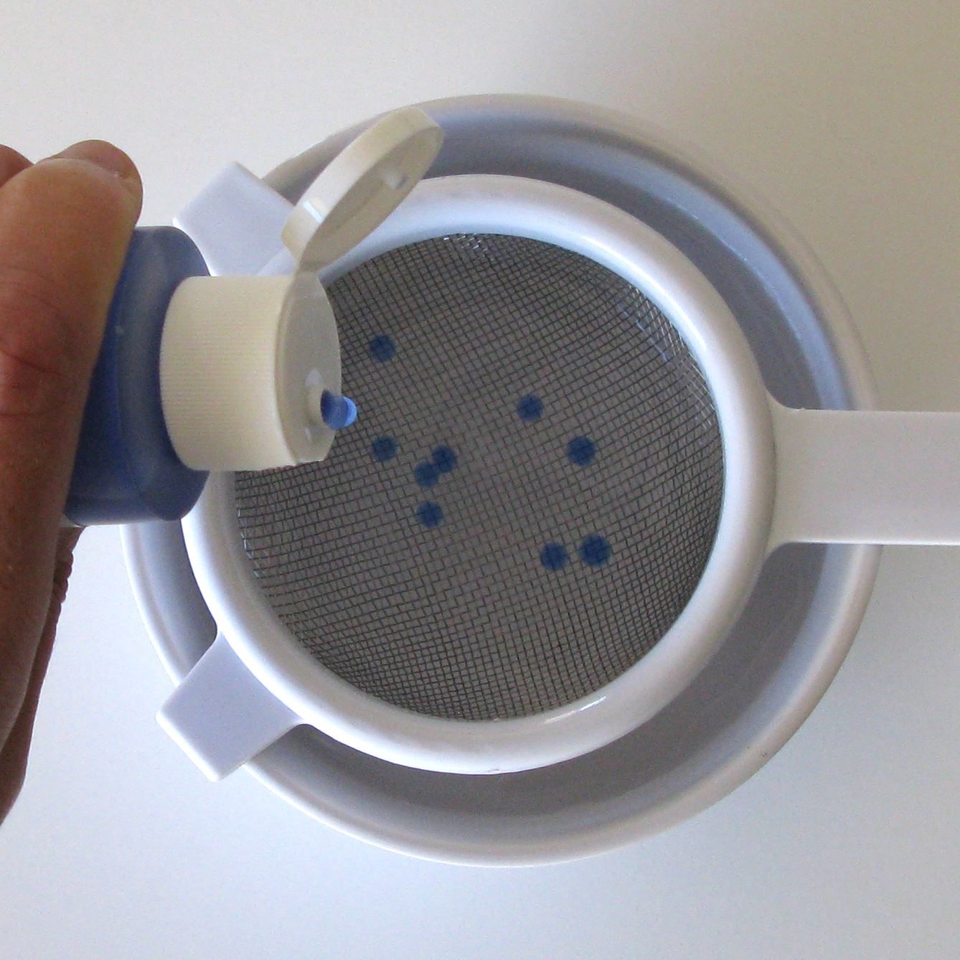
When the liquid droplets come into contact with the salt water, a chemical reaction takes place and creates a polymer. A polymer is a long chain-like molecule made up of many repeating units linked together.

The polymer forms on the outside surface of the droplets, where they touch the salt water, creating a shell around the liquid interior. The salt water is a solution of calcium chloride. The liquid in the squirt bottle is sodium alginate, a polysaccharide with many short polymer molecules. The calcium ions in the salt water cross-link (bond) these short polymer molecules into longer strands, turning the sodium alginate liquid into a thick gel.

The polymer droplets you made are similar to nanocapsules, tiny particles with an outside shell and hollow interior that can be filled. To create functional structures that are 100 nanometers or smaller in size, scientists use a process called self-assembly, in which nanostructures actually assemble themselves! (A nanometer is a billionth of a meter.)

Nanocapsules can be designed to deliver medicine to diseased parts of the body, bypassing healthy parts. For example, research at Duke University led to the development of liposome nanocapsules that bring cancer medication to tumors. These targeted delivery systems use much less medicine, so they can have fewer and less harmful side effects.

How is this nano?
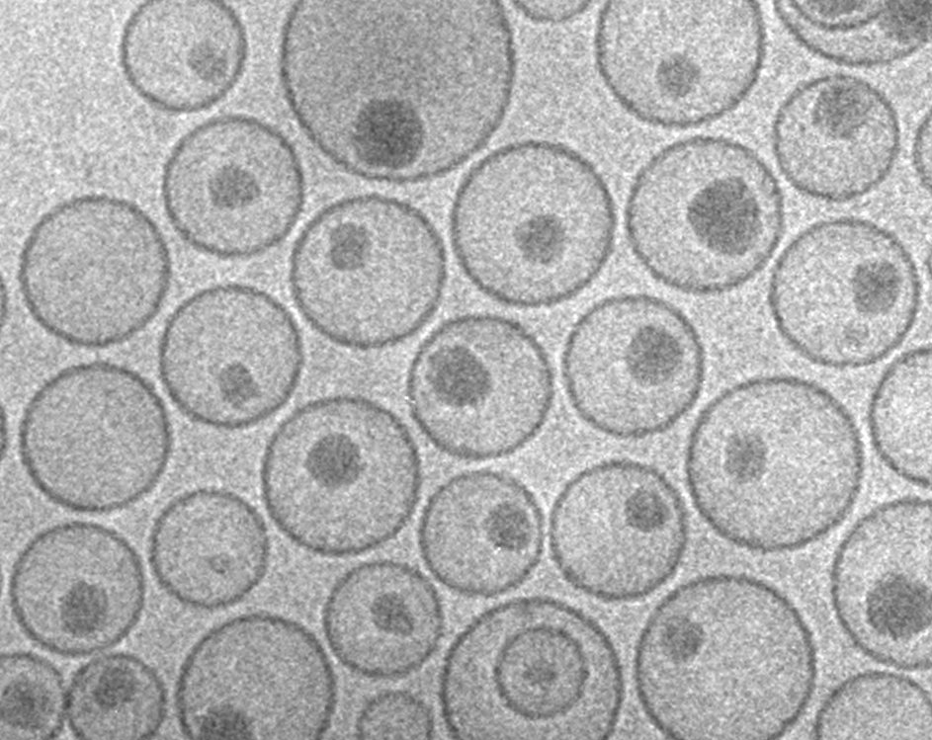  Nanocapsules carrying  cancer medication  100 nm diameter | Self-assembly is a process by which molecules and cells form themselves into functional structures. Self-assembly occurs in nature—snowflakes, soap bubbles, and DNA are just three examples of things that build themselves.  Researchers in the field of nanotechnology are studying self-assembly in order to create new materials and technologies smaller than 100 nanometers in size. (A nanometer is a billionth of a meter.)  Nanotechnology allows scientists and engineers to make things like smaller, faster computer chips and new medicines to treat diseases like cancer.

Learning objectives
- Self-assembly is a process by which molecules and cells form themselves into functional structures.
- Self-assembly is used to make nanocapsules, which can deliver medication.

Materials
- “Worm goo” sodium alginate liquid in squirt bottle
- “Worm goo activator” calcium chloride crystals
- Small bowl
- Small sieve (mesh strainer) that nests inside the bowl
- Plastic spoon

The chemicals for this activity are available at www.stevespangler.com (#WORM-700).

Notes to the presenter
SAFETY: Visitors should not ingest the chemicals. Visitors should be supervised when doing this activity. You may choose to perform this as a demonstration, rather than allowing visitors to do it as a hands-on activity.

Before beginning this activity, fill the bowl with warm water. Add half a spoon of calcium chloride, and stir.

During the activity, you’ll need a trash can nearby to dispose of the polymer.

Related educational resources
The NISE Network online catalog (www.nisenet.org/catalog) contains additional resources to introduce visitors to nanofabrication and self-assembly:
- Public programs include DNA Nanotechnology, Snowflakes: Nano at its Coolest, Shrinking Robots!, Sweet Self-Assembly, and Tiny Particles, Big Trouble!
- NanoDays activities include Exploring Fabrication—Self-Assembly, Exploring Structures—DNA, Exploring Tools—Mitten Challenge, and Exploring Tools—Special Microscopes.
- Media include Intro to Nanomedicine and What Happens in a Nano Lab?
- Exhibits include Creating Nanomaterials, NanoLab, Nanomedicine Explorer, and Treating Disease.

Credits and rights
This activity was adapted from Sweet Self-Assembly, developed by the Children’s Museum of Houston for the NISE Network. The original program is available at www.nisenet.org/catalog.

Image of nanocapsules courtesy Katarina Edwards, Uppsala University.

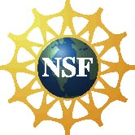 | This project was supported by the National Science Foundation under Award No. 0940143. Any opinions, findings, and conclusions or recommendations expressed in this program are those of the author and do not necessarily reflect the views of the Foundation.

Copyright 2011, Sciencenter, Ithaca, NY. Published under a Creative Commons Attribution-Noncommercial-ShareAlike license: http://creativecommons.org/licenses/by-nc-sa/3.0/us/.

