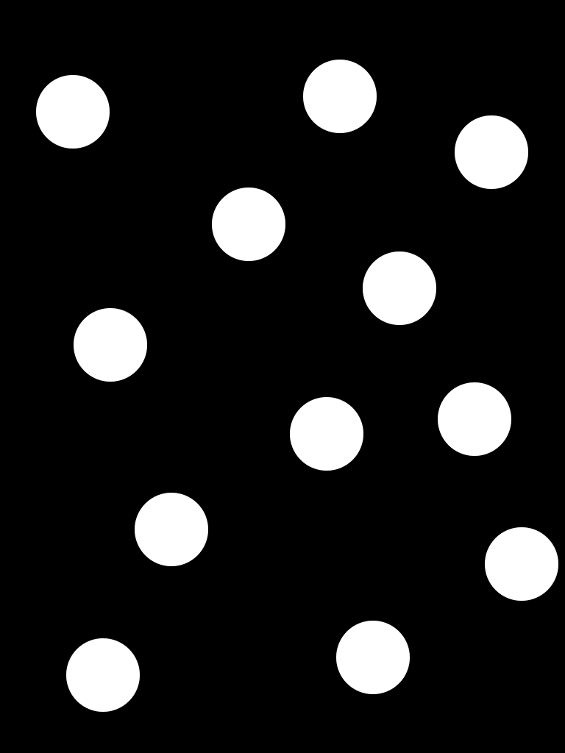
Sunscreen without Nanoparticles

