Nano in Nature—Gecko’s Feet

Check this out!

Look closely at the Gecko’s feet.

Please do not touch or tap on the container.

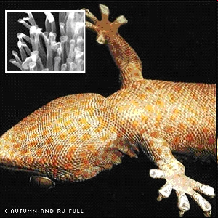

How is this Nano?
An example of nano in nature can be found on the feet of geckos. Geckos have the ability to run across walls and ceilings, sticking effortlessly to the slickest surface! On the bottom of each gecko foot are half a million microscopic hairs, each about one-tenth the diameter of a human hair. The end of each hair splits into hundreds of tinier hairs, measuring just 200 nanometers across. When a gecko presses its foot down, these tiny hairs spread out, pressing closely against the surface.

