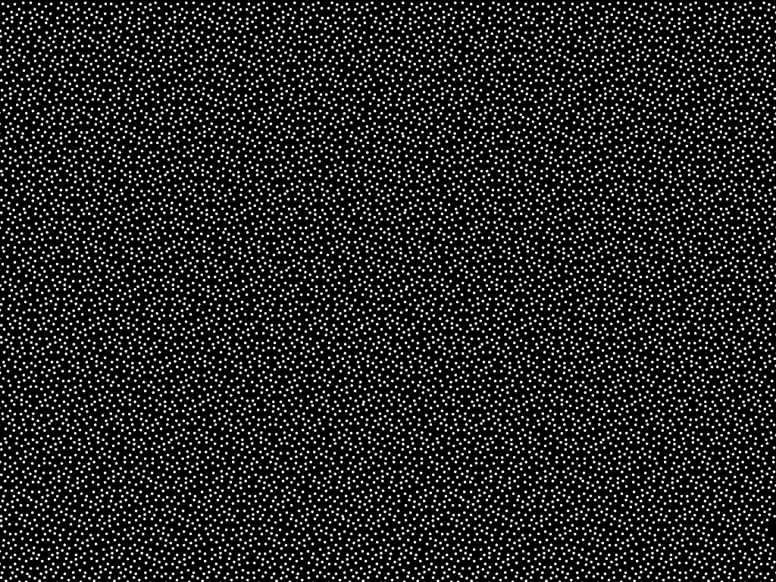
Sunscreen with Nanoparticles

