Elephant Ears
- Color the ears.
- Cut out the ears along the dotted lines.
- Wrap a headband around the child’s head and tape it in place.
- Tape the ears to the headband.

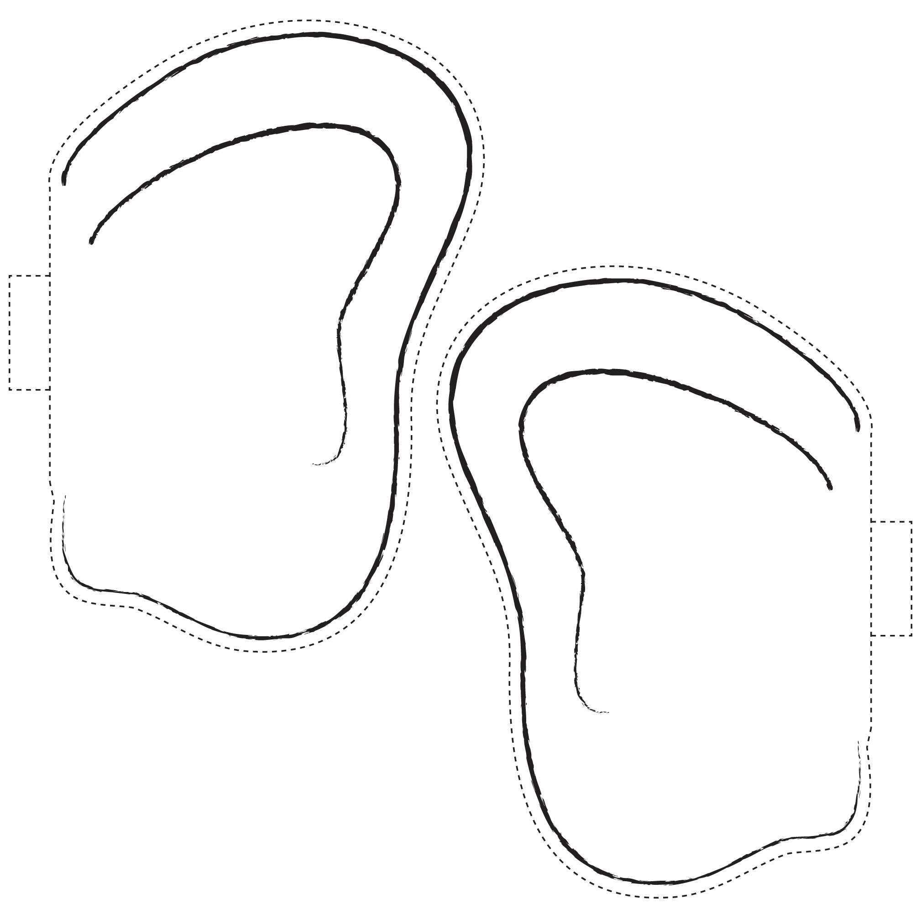

Materials
- Elephant Ears template (one per child)
- Precut headbands
- Safety scissors
- Tape
- Crayons

The NanoDays 2013 physical kit comes with precut headbands. You can easily make your own headbands by cutting 1-inch strips from extra-large sheets of paper (around 24” long).

Notes to the presenter
Before doing this activity, review the complete lesson plan and prepare materials for the craft activity:
- Photocopy the Elephant Ears template, so that you have a copy for each child.
- Precut headbands so that you have one per child.

Credits and rights
The Elephant Ears craft activity was adapted from “Everyone’s an Elephant!” copyright Dr. Seuss Enterprises, L.P.
The original activity is available at http://www.seussville.com/activities/HORTON_ElephantEars_1.pdf

The accompanying story time program was adapted from Horton Senses Something Small, developed by the Sciencenter for the NISE Network. The original program is available at www.nisenet.org/catalog

This project was supported by the National Science Foundation under Award No. 0940143. Any opinions, findings, and conclusions or recommendations expressed in this program are those of the author and do not necessarily reflect the views of the Foundation.

Copyright 2012, Sciencenter, Ithaca, NY. Published under a Creative Commons Attribution-Noncommercial-ShareAlike license: http://creativecommons.org/licenses/by-nc-sa/3.0

