
Exploring Materials—Polarizers
Try this!  - Use strips of transparent tape to make designs on a clear plastic sheet. Put down lots of overlapping pieces of tape!  - Place your design between two polarizing filters and hold everything up to a diffuse light source—a window during daylight or an overhead light.  - Try rotating one of the filters. What happens to your design? | 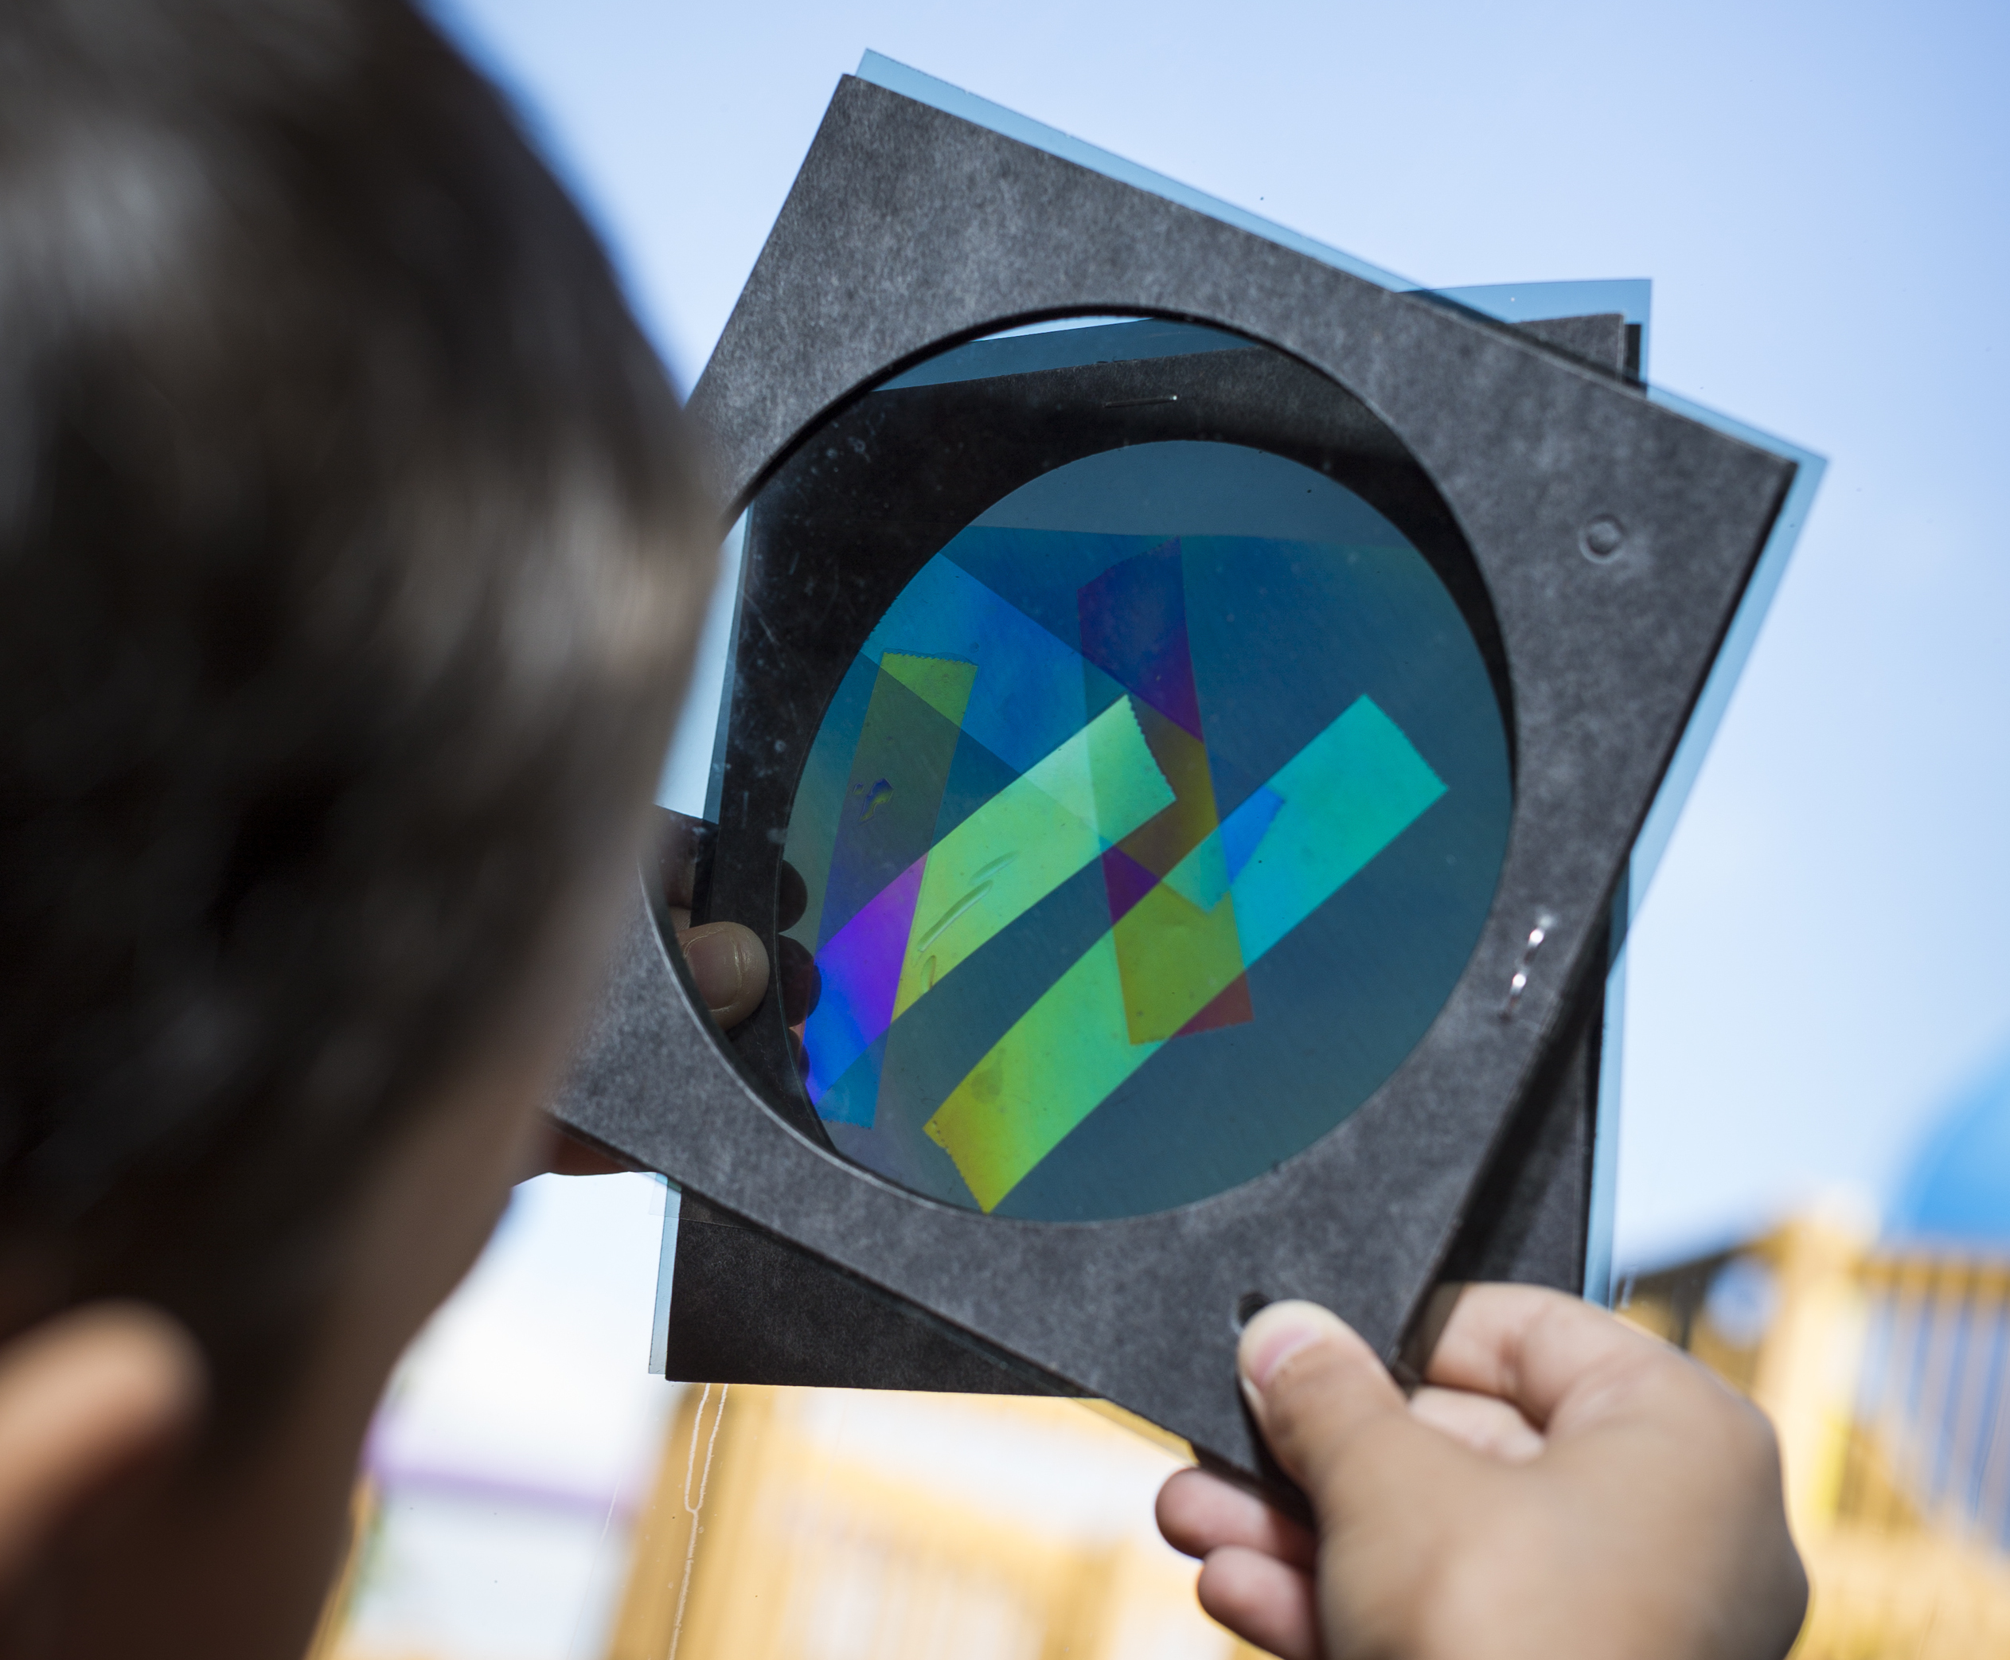

What’s going on?  Polarizing filters block light. The light they block depends on the polarizer’s orientation. When two polarizers are rotated the same way, most of the light gets through. When they’re rotated 90 degrees to each other, the filters block all the light waves, and are known as “crossed polarizers.”  Certain materials like mica, Plexiglas®, corn syrup, and transparent tape exhibit beautiful colors when placed between two crossed polarizers. These materials produce colors because they are birefringent. In birefringent materials, light passes through the material at different speeds. | 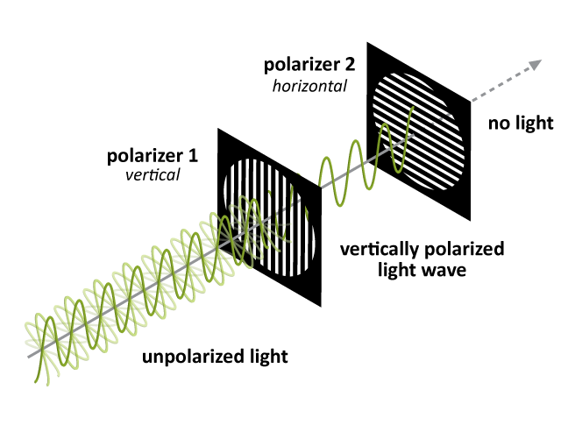  Polarizers only allow certain orientations of light waves to get through
The transparent tape interacts with polarized light in a special way because of the structure of the tape. The tape consists of long polymer molecules that are stretched along the length of the tape. As a result, light moves through the tape at different speeds, depending on whether it’s oriented parallel or perpendicular to these long polymer molecules. Once the light makes it through the tape, the light components that were moving quickly recombine with the ones that were moving more slowly, producing waves with new properties. The second polarizing filter blocks most of these waves, which filters the white light and produces the different colors we see. The color of the tape is determined by the direction the light moves and the thickness of the tape. So we can produce different colors by placing the tape at different angles or by stacking pieces of tape on top of each other.

How is this nano?

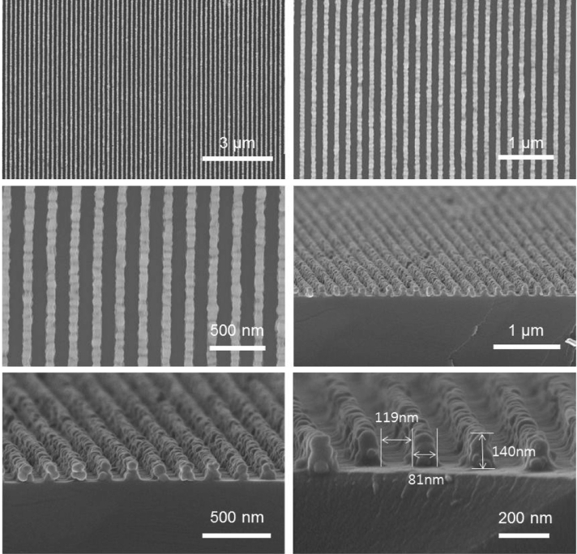  Nanowire Grid Polarizers (NWGPs) | The way a material behaves on the macroscale is affected by its structure on the nanoscale. Researchers are studying ways to make polarizers out of aligned metal nanowires. The nanowires they use are less than 100 nm wide, much too small for us to see with our eyes! In these nanowire grid polarizers (NWGPs), light that is oriented parallel to the NWGP interacts with the metal wires and is reflected from the surface. However, light perpendicular to the wires transmits through.  NWGPs show a lot of promise and have many advantages over more conventional polarizers. For example, NWGPs are more compact and have wide viewing angles, making excellent polarizers. However, like many new technologies, there are still manufacturing and performance challenges that engineers must solve before these polarizers can become widely used.

Learning objectives
- The way a material behaves on the macroscale is affected by its structure on the nanoscale.
- Nanotechnology takes advantage of special properties at the nanoscale to improve existing materials.

Materials
- Polarizing filters (2) in cardboard holders
- Overhead transparency sheets
- Transparent tape
- Diffuse light source (a window during daylight hours or an overhead light)
- “How polarizers block light” image sheet
Polarizing filters are available at www.teachersource.com (Item # PF-4).
Transparent tape can be found at office supply stores such as www.staples.com (Item # 609009).
Be sure to use “transparent” tape, not “invisible” or “magic” tape. It should have a clear, non-matte finish. Test the tape before you try this with visitors to ensure that it works for this activity.

Notes to the presenter
SAFETY NOTE: Visitors should not be looking at direct sunlight. If you are doing this activity outside or near a window, be careful not to ask visitors to look directly into the sun.
Ask visitors to hold the polarizers by the holders to avoid fingerprints on the polarizers.
Visitors can take home the clear plastic sheets with tape on them, but not the polarizing filters. Since visitors will not be allowed to take the polarizing filters with them, you can suggest one way that they can continue their experimenting at home using a computer screen and some polarized sunglasses. Filters inside the screen polarize the light coming out of the computer and the sunglasses act as the second filter. They can also look at materials such as plastic silverware, plastic wrap, or other molded clear plastics by placing them in front of the computer screen and looking through the sunglasses.

Related educational resources
The NISE Network website (www.nisenet.org) contains additional resources to introduce visitors to the fundamentals of nanoscale science and technology:
- Public programs include Nanotechnology: Small Science, Big Deal!
- NanoDays activities include Exploring Forces—Gravity, Exploring Forces—Static Electricity, Exploring Materials—Nano Gold, Exploring Properties—Surface Area, Exploring Properties—Electric Squeeze, and Exploring Properties—Capillary Action.
- Media include the Intro to Nanotechnology video, the Mr. O video series, the Nano and Me video series, and the What’s Nano About…? video series.
- Exhibits include the Nano mini-exhibition, At the Nanoscale, and Unexpected Properties.

Credits and rights
Image of Nanowire Grid Polarizer courtesy Kyung S. Park, Hanyang University, Seoul, Korea.

 | This project was supported by the National Science Foundation under Award No. 0940143 and 0937591. Any opinions, findings, and conclusions or recommendations expressed in this program are those of the author and do not necessarily reflect the views of the Foundation.

Copyright 2014, Sciencenter, Ithaca, NY. Published under a Creative Commons Attribution-Noncommercial-ShareAlike license: http://creativecommons.org/licenses/by-nc-sa/3.0.

Polarization Background Information

How do polarizers work?
To understand how polarizers work, we need to think about light behaving like a wave. Every light wave has a particular orientation. Most light sources, like light bulbs or the sun, produce light waves oriented in all directions. We call this type of light randomly polarized light, meaning it doesn’t have a preferred orientation.
A polarizer affects light by blocking certain orientations of light. Once light goes through, it is plane polarized, meaning that all of the light waves are now parallel to each other.
When you look through two (or more) polarizer films, the brightness depends on how the polarizer films are aligned. So when you rotate the polarizer films, the brightness changes. When you have two polarizers that are aligned parallel to each other, the light that makes it through the first polarizer will make it through the second polarizer. Parallel polarizers like this let the most light through and look the brightest. Conversely, when you have two polarizers that are perpendicular to each other, the light that makes it through the first polarizer is oriented perpendicular to the second polarizer, so it will be blocked. Polarizers that are perpendicular to each other, called crossed polarizers, let the least light through and look the darkest. The quality of a polarizer is often measured by the difference in brightness between the brightest (parallel) and darkest (perpendicular) orientations.

How are polarizers made?
Polarizers are made in many ways. One of the most common polarizers is known as a Polaroid and consists of iodine crystals embedded in a polymer. To create the polarizer, the polymer film is stretched, which causes the polymers to align. Then the film is dipped in a solution of iodine and the iodine molecules attach themselves to the polymer. The Polaroid’s ordered structure allows it to absorb light that is parallel to the polymer chains and transmit light that is perpendicular to the chains. Researchers are trying to create even better polarizers using aligned nanowires instead of iodine-coated polymer chains.
Where do we use polarizers?
Polarizers are all around us! We use polarizers in liquid crystal displays, in telescopes, and in sunglasses. Polarized sunglasses are especially helpful when we’re looking at water or snow, because the glare from these surfaces is extremely polarized. Polarizers can very efficiently reduce the glare. Polarizers are even used in some of the glasses worn to make 3D movies come to life. |   Without polarized lens |   With polarized lens

