

Using a multimeter with
Exploring Properties—Electric Squeeze

What is a multimeter?

A multimeter is a device that can measure current, voltage, and resistance in electrical circuits. Your multimeter comes with a red and black wire. These wires are called test probes or leads. Plug the black probe into the COM port and the red probe into the port labeled VΩMA.  In the Exploring Properties—Electric Squeeze activity a multimeter can be used in place of the analog ammeter. Use the alligator clips to connect the piezo disk to the multimeter test probes. When the piezo disk is hit or squeezed, the multimeter will measure the electric current produced. | 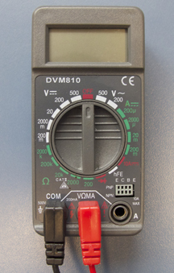 | 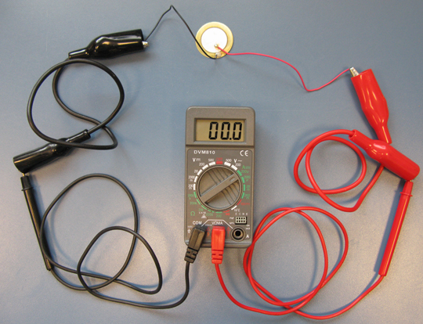
What setting should the multimeter be on?
For the Exploring Properties—Electric Squeeze activity, you’ll need to measure current in microamps (µA). The dial should be on the 200µA setting. This range is sensitive enough for the multimeter to measure the small amount of current generated by hitting the piezo disk. | 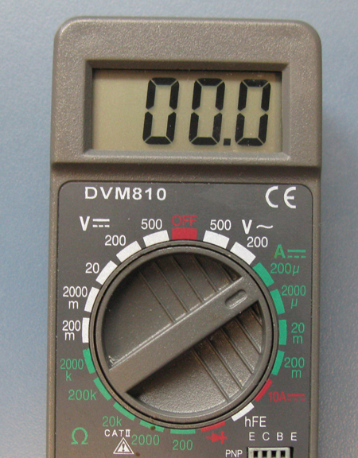

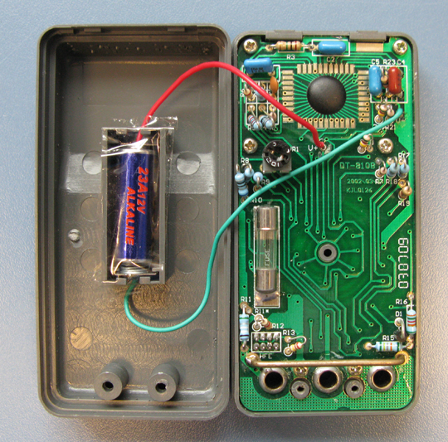 | How to care for your multimeter  Always turn off the multimeter when not in use to conserve battery life.  If the battery in your multimeter dies, you’ll need a small screwdriver and an A23 battery. Remove the screws from the back of the case and replace the old battery.

