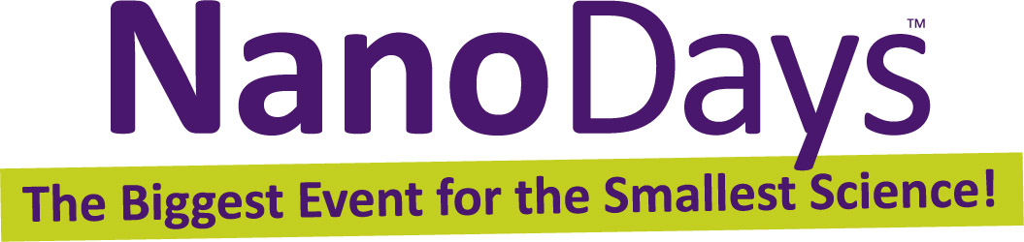
Your logo here

Date:
Contact:
Phone: Email:

Celebrate NanoDays™ 2015 at [Name of your organization]
[Insert your local NanoDays location, dates, and specific activity information here].
NanoDays at [name of your organization] is part of a nationwide festival of educational programs about nanoscale science and engineering.
NanoDays is organized by the Nanoscale Informal Science Education Network (NISE Net), and takes place nationally from March 28 – April 5, 2015. This community-based event is the largest public outreach effort in nanoscale informal science education and involves science museums, research centers, and universities from Puerto Rico to Alaska.
NanoDays celebrations bring university researchers together with science educators to create learning experiences for both children and adults to explore the miniscule world of atoms, molecules, and nanoscale forces. Most NanoDays events combine fun hands-on activities with presentations on current research. A range of exciting NanoDays programs demonstrate the special and unexpected properties found at the nanoscale, examine tools used by nanoscientists, showcase nano materials with spectacular promise, and invite discussion of technology and society.
The local community can enjoy many of these activities. Visitors can experience the power of science fiction storytelling—creating their own imagined future full of new nanotechnologies. Hands-on activities invite visitors to explore polarized light, investigate how scientists use special tools to study tiny things, and imagine how nanotechnology could change how we eat! Other activities include experimenting with heat transfer and completing an electrical circuit using the world’s thinnest material. [Edit for your institution]

More about Nano and NISE Network

At the nanoscale—the scale of atoms and molecules—many common materials exhibit unusual properties. Our ability to manipulate matter at this size enables innovations that weren’t possible before. Nanotechnology is revolutionizing research and development in medicine, computing, new materials, food, energy, and other areas.
Nano will affect our economy, the environment, and our personal lives. Some scientists think that future nanotechnologies and materials could transform our lives as much as cars, the personal computer, or the Internet! But the costs, risks, and benefits of this new technology can be difficult to understand, both for experts and for the general public. The NISE Network helps museums, research institutions, and the public learn from each other about this emerging field so that together we can make informed decisions.
The Nanoscale Informal Science Education Network (NISE Net) is a national community of researchers and informal science educators dedicated to fostering public awareness, engagement, and understanding of nanoscale science, engineering, and technology. The NISE Network community in the United States is led by 12 organizations, and includes hundreds of museums and universities nationwide. NISE Net was launched in 2005 with funding from the National Science Foundation, and received a five-year renewal in 2010.
Through products like NanoDays, the NISE Network is actively building partnerships between science museums and research centers to increase their capacity to engage the public in learning about nanoscale science and engineering.

For more information about NISE Net or to download a digital NanoDays kit please visit:
www.nisenet.org/nanodays.

For more information about Nano please visit:
www.whatisnano.org

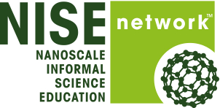
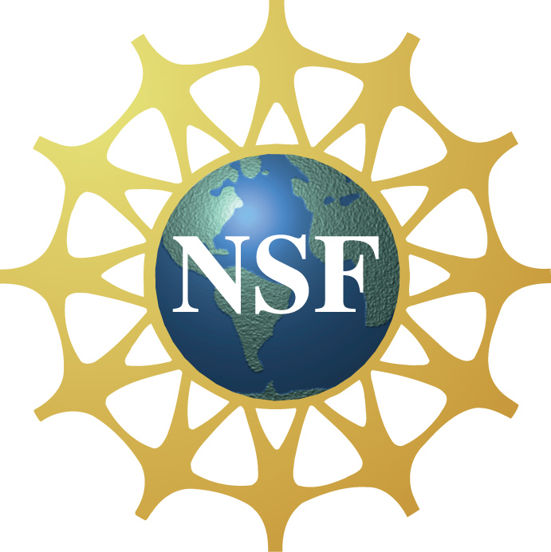
This project is based on work supported by the NSF under Award Nos. 05322536 and 0940143.
NanoDays™ is trademarked by North Carolina State University and used by the NISE Network with permission.

