Exploring Products—Computer Hard Drives

Try this!  - Place a ring magnet on one of the ring stands.  - Take the magnet off, flip it over, and put it back on the stand. What happens?  - Use a row of 8 magnets to make a code! Choose a letter of the alphabet and look it up on the Binary Code sheet.  - In this code, a magnet that sticks to the stand represents a 0 and a magnet that floats represents a 1. | 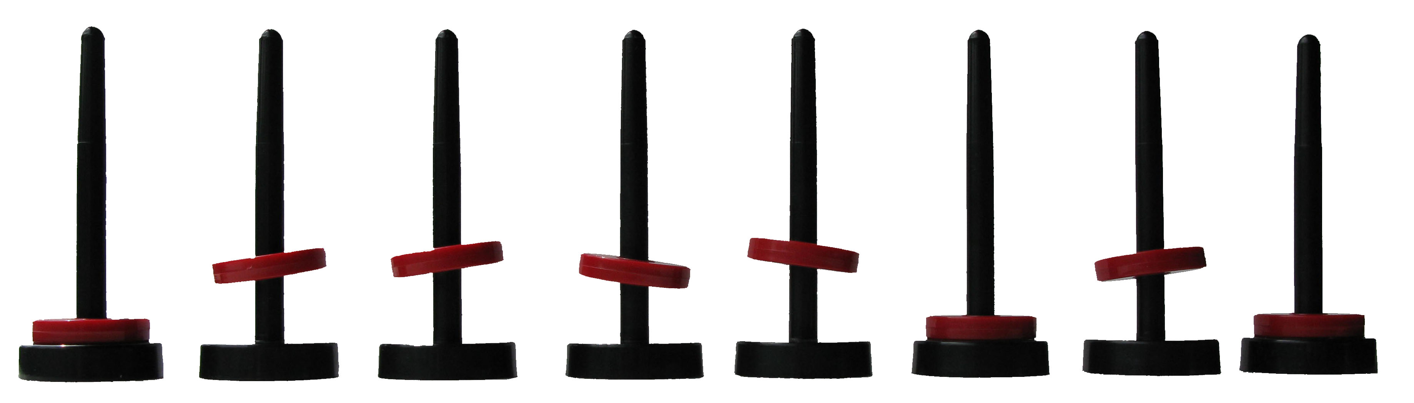
What’s going on?
You’re using the ring magnets as a model for how computer hard drives store information! The ring magnets either float or stick to the magnet in the base of the stand, depending on which magnetic pole is facing down.

Computers use binary code to store information. Binary code is a series of 1s and 0s. In computer documents like text files, each letter is represented by a particular combination of 1s and 0s. The letter z, for example, is usually stored in computers as 01111010. Each of these 1s and 0s is called a “bit,” so the code for the letter z has eight bits.  Hard drives use magnetic regions on the hard disk surface to represent these 1s and 0s. If the region is magnetized with the north pole facing up, it represents a 1. If the south pole is facing up, it represents a 0. | 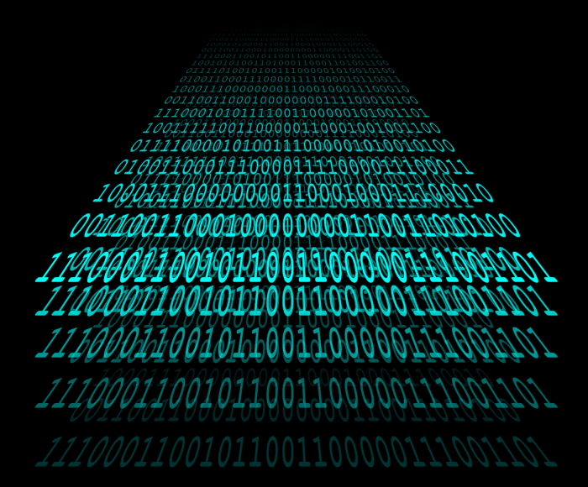

Hard drives made today store bits in tiny magnetic regions that are about 50 nanometers wide and only a few nanometers thick. (A nanometer is a billionth of a meter.) The smaller the magnetic regions, the more information a hard drive can hold. That’s why some new hard drives are the same size as older models but can hold much more.

When we talk about the capacity of hard drives in gigabytes or terabytes we’re actually counting the number of magnetic regions they contain. Byte is a word that means “8 bits.” Giga- means a billion. Tera- means a trillion. So a hard drive with a terabyte of storage space uses around 8 trillion magnetic regions!
Now try…
- Look at the “Data Storage” sheet to compare how much information magnets of different sizes can store in the same amount of space.
- Make your own binary code! Use a pencil to fill in the circles on the “My Name in Binary Code” sheet.

How is this nano?
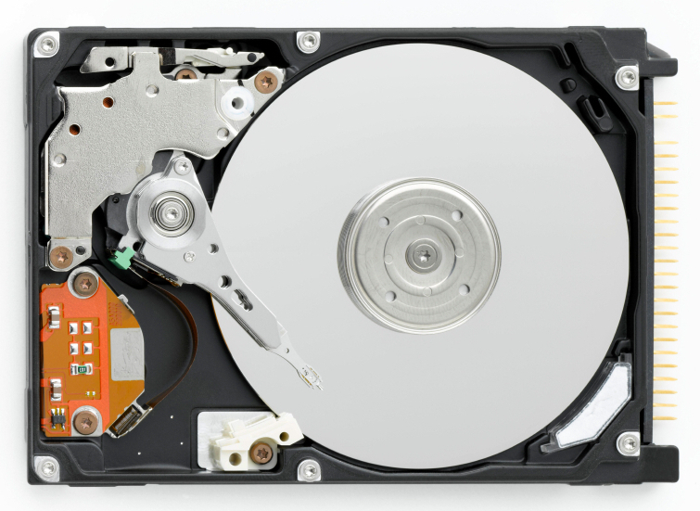 | Computer hard drives are one the most common applications of nanotechnology. Hard drives use tiny, nano-sized magnetic regions on their disks to make the binary code that holds information. The smaller the regions, the more information a hard drive can hold in the same amount of space.  Nanotechnology takes advantage of different material properties at the nanoscale to make new materials and tiny devices smaller than 100 nanometers in size. (A nanometer is a billionth of a meter.)

Learning objectives
- Computer hard drives are one of the most common applications of nanotechnology.
- Nano-sized magnetic regions allow hard drives to hold a lot of information in a small space.

Materials
- 8 floating ring magnets with stands
- “Binary Code” reference sheet
- “Data Storage” reference sheet
- “My Name in Binary Code” take-home sheets
- Pencils

Floating ring magnets and stands are available from www.teachersource.com (#M-780).

Notes to the presenter
For this activity, you just need one ring magnet per stand. Before you do the activity, remove the extra magnets and set them aside. It’s best to use the same color magnet for all eight stands.

The “Binary Code” reference sheet and take-home sheets only have the codes for lower case letters in the 8-bit ASCII character-encoding scheme. The first three “bits” (or magnets) are the same for all the lower case letters (011). Uppercase letters, numbers, and symbols can be represented by changing the first three magnets. Uppercase letters start with 010 (instead of 011).

Related educational resources
The NISE Network online catalog (www.nisenet.org/catalog) contains additional resources to introduce visitors to nanomaterials and nanotechnology in consumer products:
- Public programs include Aerogel, Future of Computing, Ink Jet Printer, Nanoparticle Stained Glass, and Nanosilver: Breakthrough or Biohazard?.
- NanoDays activities include Exploring Materials—Ferrofluid, Exploring Materials—Liquid Crystal Displays, Exploring Materials—Thin Films, Exploring Products—Nano Fabrics, Exploring Products—Nano Sand, and Exploring Products—Sunblock.
- Media include Everything is Made of Atoms and Zoom into a Computer Chip.
- Exhibits include Bump and Roll, Changing Colors, NanoLab, and Nanotechnology—Fact or Fiction?

Credits and rights
This activity was adapted from the “Magnetic Mad Libs” activity developed by Ted Gudmundsen of the Ralph Group at Cornell University and Educational Programs Office of the Cornell Center for Materials Research Center. The original activity is available at http://www.ccmr.cornell.edu/education/educational-resources/lending-library-of-experiments/physics-kits/magnetic-mad-libs/

Image of computer display with “binary data” by W Rebel, Wikimedia Commons.

This project was supported by the National Science Foundation under Award No. 0940143. Any opinions, findings, and conclusions or recommendations expressed in this program are those of the author and do not necessarily reflect the views of the Foundation.

Copyright 2012, Sciencenter, Ithaca, NY. Published under a Creative Commons Attribution-Noncommercial-ShareAlike license: http://creativecommons.org/licenses/by-nc-sa/3.0/us/

