Thermal Conductivity of Graphene

When you use electronic devices, like laptops, cell phones, and video game consoles, they generate a lot of heat. Managing that heat is a critical issue. When engineers design electronics they carefully consider which materials will work best to quickly transfer and dissipate heat. Copper is one of several common materials currently used to keep electronic devices cool. Like most materials, as it gets thinner, copper’s thermal conductivity decreases. As engineers design smaller, thinner electronic devices, these thinner materials can’t transfer heat quickly enough.

One promising material to deal with heat generation is graphene. Graphene, a single layer of carbon atoms arranged in a honeycomb pattern, is the thinnest existing material and has the highest known thermal conductivity. Unlike most other materials, the thermal conductivity of a stack of carbon sheets actually gets better as it gets thinner and thinner until you get down to one single sheet—graphene! So as electronics get smaller and smaller, and generate more and more heat, new materials like graphene may prove to be better at preventing our devices from overheating.

Graphene is already being used in some devices. These devices currently use multi-layered graphene because it’s easier to make and more reliable, but still has a very high thermal conductivity. As researchers develop easier ways to manipulate this superthin material, graphene may become more commonplace in our devices.
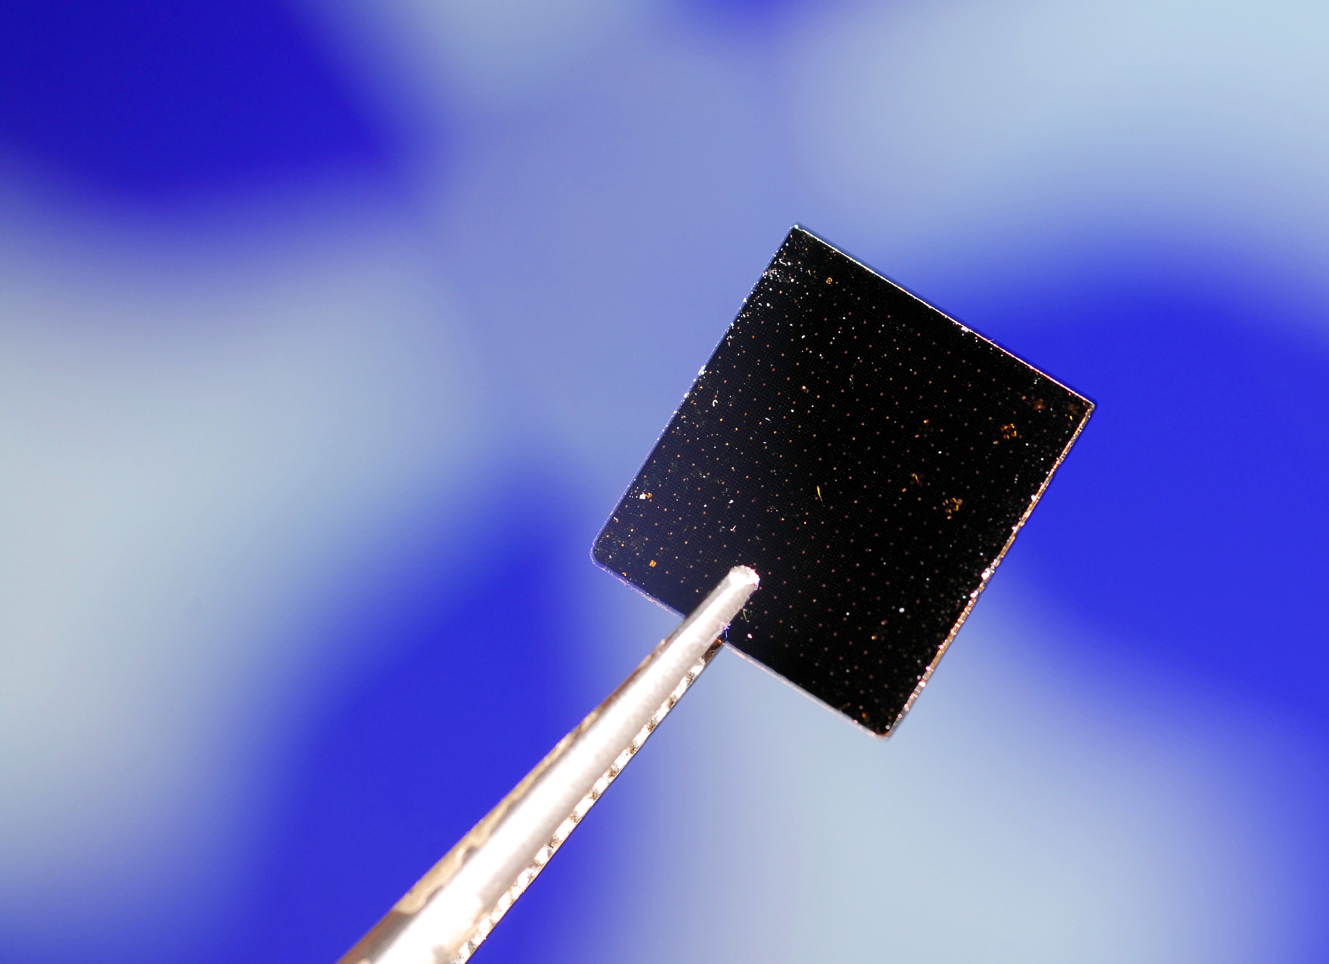

In the future, cell phones may use individual sheets of graphene to keep the electronics from overheating

