

Exploring Properties—Heat Transfer
Try this!  - Feel both blocks. Which one feels warmer to your touch?  - Make a prediction: Which block will cause an ice cube to melt faster?  - Place a cube of ice on each block. Do they melt at the same rate? Which one melted faster? | 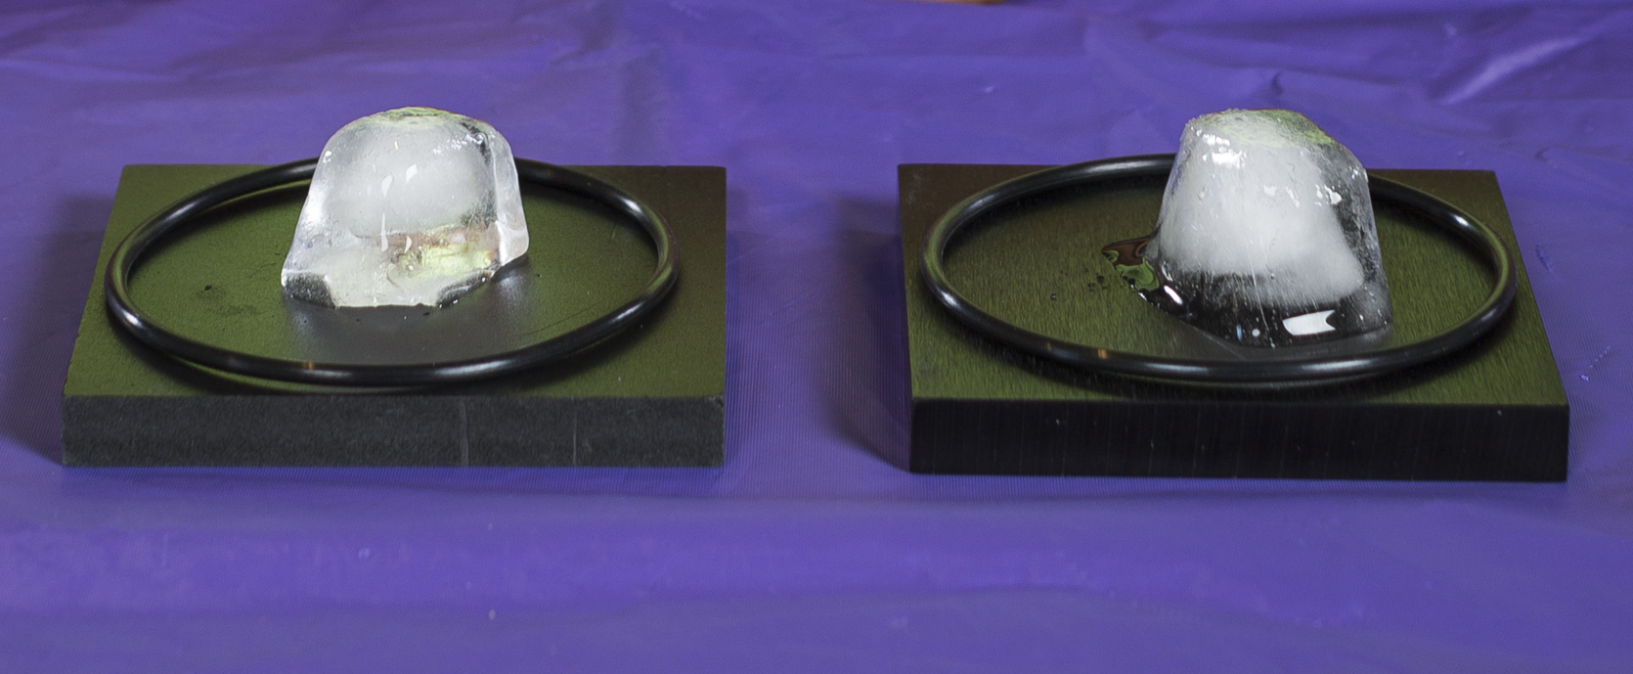

What’s going on?
One of the blocks is made of aluminum and the other is made of high-density foam. They are both at room temperature, but even though the aluminum block feels colder, it actually makes the ice melt faster!
When you touch the aluminum block, the heat of your hand quickly transfers away into the block. This leaves your hand feeling cold. But when you touch the foam block, only a little heat slowly flows into the block. So your hand still feels warm. Remember both blocks are at room temperature, much warmer than an ice cube! Heat transfers quickly from the aluminum block to an ice cube, melting it very quickly. But heat only slowly transfers to the ice cube on the foam block, making it melt more slowly.
The difference happens because of thermal conductivity. Thermal conductivity measures how quickly heat flows through a material. The aluminum has a higher thermal conductivity and the foam has a lower thermal conductivity.
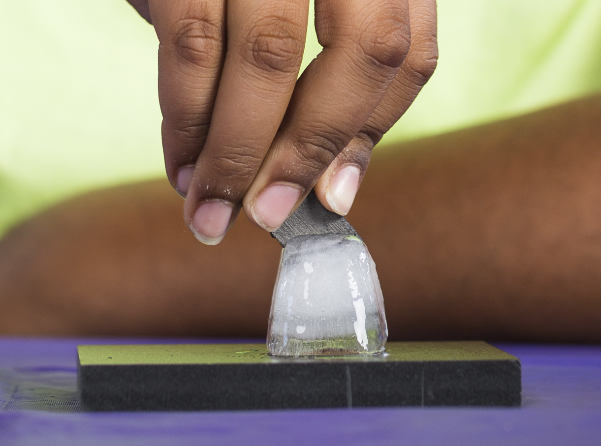
Now, try this!
- Press the edge of the graphite piece into an ice cube.
- What happens to the ice? Do you feel anything surprising in the fingers holding the graphite?

What’s going on?
You are slicing the ice with the heat from your hand! The little piece of graphite is a very good conductor of thermal energy. The heat flows from your hand quickly and easily through the graphite and to the ice. The graphite piece in the demo is a very pure and highly ordered form of graphite—unlike the graphite in a regular pencil, which has various clays in it.

How is this nano?
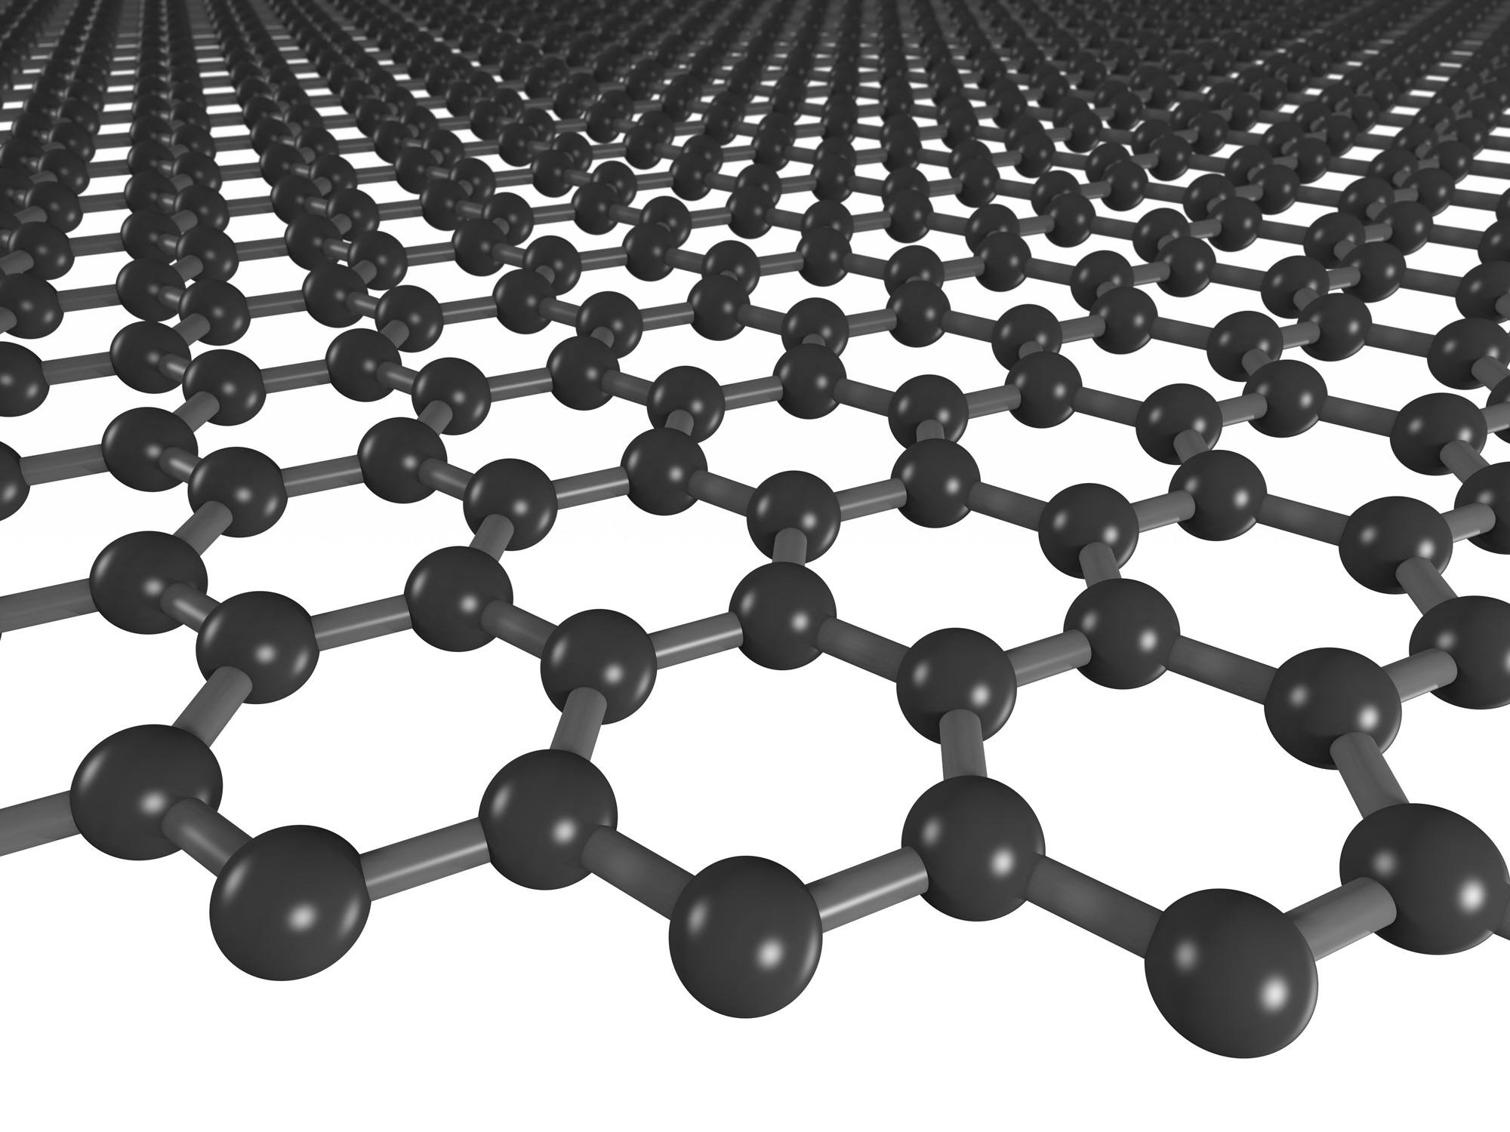  Graphene | The way a material behaves on the macroscale is affected by its structure on the nanoscale. Graphene is a single layer of carbon atoms arranged in a honeycomb pattern. It is the thinnest material that exists.  While most nanoscale films have poor thermal conductivity, graphene has excellent thermal conductivity. In 2008, researchers at the University of California, Riverside showed that graphene’s thermal conductivity is about 20 times greater than aluminum, 10 times greater than copper, and 3 to 5 times greater than diamond (the previous record holder). Graphene has the potential to play a major role in keeping future electronic devices from overheating!

Learning objectives
- The way a material behaves on the macroscale is affected by its structure on the nanoscale.
- Heat flows through different materials at different rates.

Materials

- Black aluminum block
- Black high-density foam block
- O-rings (2)
- Pyrolytic graphite piece
- Sponge
- Insulated bag
- Ice cube tray and ice
- “Thermal Conductivity of Graphene” sheet

Ice-melting block sets are available from scientific suppliers, such as www.arborsci.com (#P6-7060).
Pyrolytic graphite pieces are available from magnet suppliers, such as www.kjmagnetics.com (#PG1).

Notes to the presenter
Important note: Take care when using the pyrolytic graphite piece. It is fragile and can break easily. For younger visitors, offer to help them slice the ice and then allow them to touch the graphite piece to feel the cold.
Advanced preparation:
Be sure to have enough ice on hand for the number of visitors you are expecting. The ice should be stored in the freezer until it is needed for the activity. If you make the ice in advance and mix it all together in the freezer bag, be sure it doesn’t stick together as this can make it harder to do the activity.
During the activity:
- The provided insulated bag will help to keep the ice cool during the activity for at least a few hours, but may need to be emptied and refilled if the ice begins to melt.
- The O-rings are meant to contain the water on the block after the ice is melted. They may be omitted from the activity if you wish.
- After performing the demo, be sure to dry off the blocks with the sponge provided in preparation for the next visitor.
Discussion ideas:
In your discussion of thermal conductivity, use familiar examples to illustrate how thermal energy flows between materials. Some visitors may have noticed that in the morning, bathroom tiles feel cold and uncomfortable, while a bathroom rug feels warmer. The rug and the tiles in the room are the same temperature, but the tiles have a higher thermal conductivity and the heat from your feet flows more quickly into them—making them feel cold to the touch.
You may also want to discuss how the materials we use for certain products are influenced by their thermal conductivity. In cooking, we use copper, aluminum, and stainless steel pots because those materials quickly transfer heat from the burner to the food. (They have a high thermal conductivity.) On the other hand, materials like Styrofoam and feathers transfer heat slowly—they have a low thermal conductivity. These materials make good insulators, so we use them in products like coolers or jackets to prevent heat from being transferred. You can connect these examples to graphene by saying that engineers are still trying to find or create materials that have even better heat transfer properties, and one of the promising materials is graphene.

Related educational resources
The NISE Network website (www.nisenet.org) contains additional resources to introduce visitors to the fundamentals of nanoscale science and technology:
- Public programs include Nanotechnology: Small Science, Big Deal!, Forms of Carbon, World of Carbon Nanotubes, and The Future of Computing.
- NanoDays activities include Exploring Materials—Graphene, Exploring Materials—Nano Gold, and Exploring Properties—Invisibility.
- Media include the Intro to Nanotechnology video, the Mr. O video series, and the Nano and Me video series.

Credits and rights
 | This project was supported by the National Science Foundation under Award No. 0940143 and 0937591. Any opinions, findings, and conclusions or recommendations expressed in this program are those of the author and do not necessarily reflect the views of the Foundation.

Copyright 2014, Sciencenter, Ithaca, NY. Published under a Creative Commons Attribution-Noncommercial-ShareAlike license: http://creativecommons.org/licenses/by-nc-sa/3.0.

