Nanotechnology “Mirage”

Researchers are experimenting with ways of bending light to cloak objects. For example, scientists at the University of Texas at Dallas have created a transparent curtain made out of millions of carbon nanotubes, which can hide objects underwater. When an alternating electric current is run through the curtain, it quickly becomes very hot. The temperature difference between the curtain and the surrounding water causes light rays to bend away rather than be reflected to your eye. This creates a mirage that hides whatever is behind the curtain.

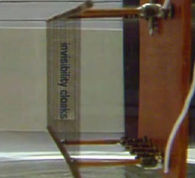
Carbon nanotube screen in front of text that says “invisibility cloaks.”  Here, the screen is turned off. | Now the screen is turned on.  Electricity creates a mirage effect, hiding the words.

Think about it…  - What would you do if you had an invisibility cloak? What do you think other people might do?  - Would you make rules for how people could use invisibility cloaks? |  | Video of the nanotechnology “mirage” in action:  http://www.youtube.com/watch?v=Nfnbj9r1-2I

