Exploring Size—Moving Molecules

Try this!  - Look inside the toy. Is it filled with anything?  - Try to get the pinwheels to spin! Stand a few feet away.  - Aim the toy, pull back the handle, and release it.  (Try again if you miss the first time.)  - What made the pinwheels move? | 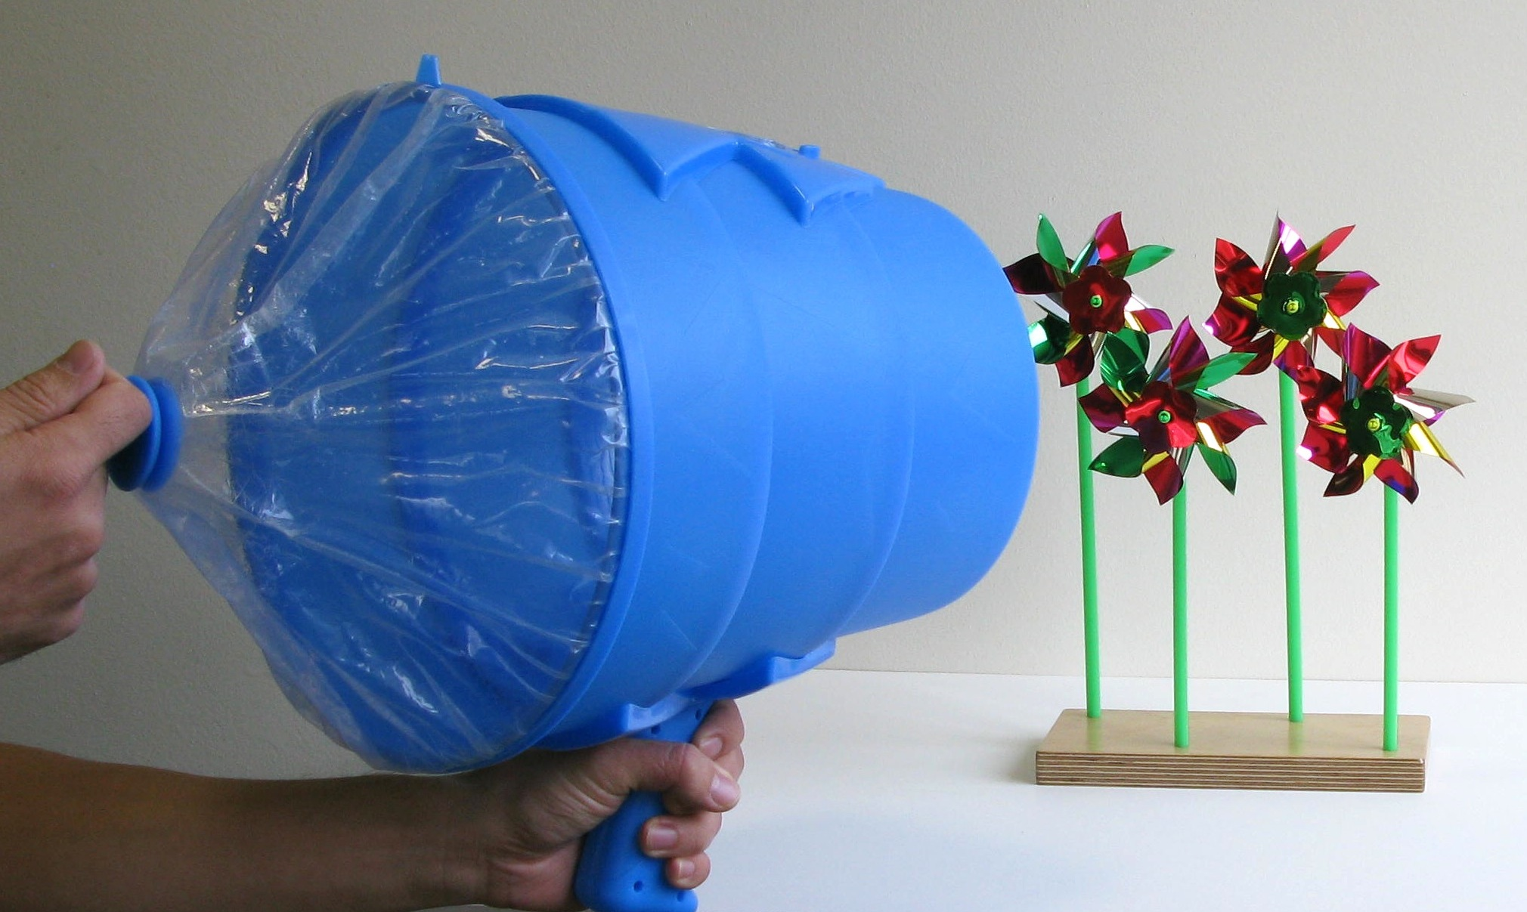
What’s going on?
Molecules moved the pinwheels! The toy isn’t empty—it’s filled with air. When you pull and release the plastic sheet on the back of the toy, you push air toward the pinwheels. When the air hits the pinwheels’ blades, they spin.  Like everything on Earth, air is made of tiny “building blocks” called molecules. Examples of molecules in air are oxygen (O₂), nitrogen (N₂), carbon dioxide (CO₂), and water (H₂O).  These molecules are made of atoms, which are tiny particles smaller than a nanometer. (A nanometer is a billionth of a meter.) Examples of atoms include carbon, oxygen, and hydrogen. Around 90 different kinds of atoms occur naturally on Earth.  Individual molecules are too small to see with our eyes. The molecules that make up gases are relatively far apart, so we can’t see air. The molecules that make up solid things are relatively close together, so we can see a pinwheel (but not its individual molecules). | Wind farm

Although we can’t see air, we can feel it and observe how it interacts with other things, like pinwheels or giant wind turbines. Wind turbines gather energy from moving air, which can be turned into electricity.

How is this nano?
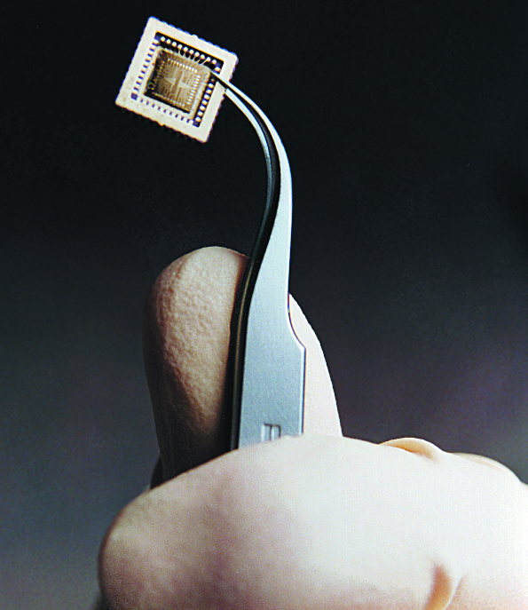  Computer chip | A nanometer is a billionth of a meter. That’s very, very small—too small to see with just your eyes. Atoms and molecules, the building blocks of our world, are examples of things measured in nanometers.  Researchers use special tools and equipment to detect and manipulate nanometer-sized things. In the field of nanotechnology, scientists and engineers make new materials and tiny devices smaller than 100 nanometers in size. Sometimes, they build things out of individual atoms!  Nanotechnology allows scientists and engineers to make things like smaller, faster computer chips and new medicines to treat diseases like cancer.
Learning objectives
- A nanometer is a billionth of a meter.
- Air is made of molecules, which are tiny nanometer-sized particles.

Materials
- Air cannon toy
- Pinwheels (4)
- Pinwheel stand

Airzooka air cannon toys are readily available from toy stores, including www.walmart.com and www.toysrus.com.

Notes to the presenter
Before doing this activity, insert the pinwheels into the stand. Test to see that they spin freely. If they don’t, loosen them up by spinning them by hand.

Visitors should stand a small distance away from the pinwheels. In order to be able to talk to visitors and assist them, you should stand near them (rather than next to the pinwheels).

You may need to help young children and individuals with limited strength to hold the toy and pull the handle. To make the toy easier to use for some visitors, you can remove the elastic cord that attaches the plastic sheet to the barrel. Visitors can then push in the plastic sheet to make a puff of air, without having to pull against the elastic band. With this accommodation, visitors will need to stand very close to the pinwheels. Alternatively, they can direct the air onto the hand of another person to feel, rather than using the pinwheels. (Note that it will take some time to re-attach the elastic if you make this modification.)

Related educational resources
The NISE Network online catalog (www.nisenet.org/catalog) contains additional resources to introduce visitors to the nanoscale and nanometers:
- Public programs include Cutting it Down to Nano and Shrinking Robots!
- NanoDays activities include Exploring Size—Measure Yourself, Exploring Size—Memory Game, Exploring Size—Powers of Ten Game, Exploring Size—Scented Balloons, Exploring Size—StretchAbility Game, and Exploring Size—Tiny Ruler.
- Media include the poster and book How Small is Nano?, the Intro to Nano video, Multimedia Zoom into a Human Hand, Multimedia Zoom into a Nasturtium Leaf, and the posters Zoom into a Butterfly Wing, Zoom into a Computer Chip, and Zoom into the Human Bloodstream.
- Exhibits include At the Nanoscale.

Credits and rights

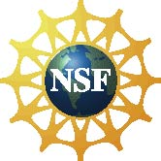 | This project was supported by the National Science Foundation under Award No. 0940143. Any opinions, findings, and conclusions or recommendations expressed in this program are those of the author and do not necessarily reflect the views of the Foundation.

Copyright 2012, Sciencenter, Ithaca, NY. Published under a Creative Commons Attribution-Noncommercial-ShareAlike license: http://creativecommons.org/licenses/by-nc-sa/3.0

