Exploring Nano & Society—You Decide!

Try this!  - Look at the green cards with different technologies. If you got to decide, which ones would you make sure people had?  - Place the technologies in order of importance, in your opinion. Which ones are the most useful? Which are less useful?  - Choose one of the yellow cards with different people on them.  - Pretend you’re the person on the card. Do you think they would decide that the same technologies are important? Or would they change the order of the technology cards? | 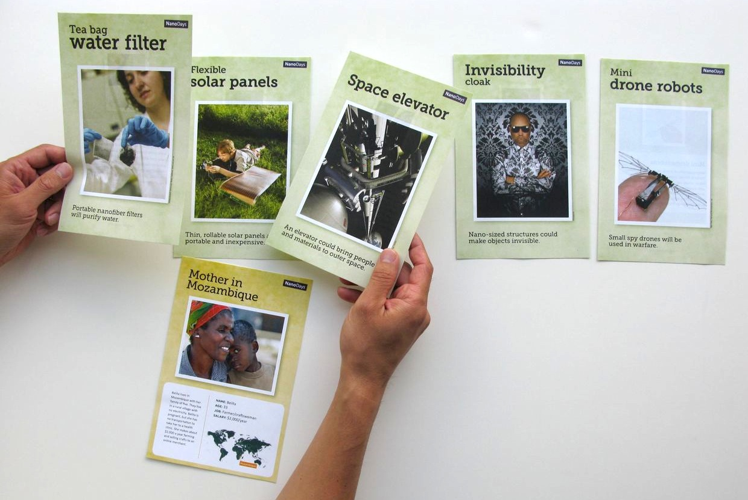
What’s going on?
Different people think different technologies are important. You might put the technologies in a different order from someone else in your family, or someone else in a different part of the world. Sometimes, it’s hard for us to know which technologies another person might value.  People’s values determine which technologies are made and used. We all make decisions related to technologies—as individuals and as a society.  For example, security is a priority for the US government, so a lot of our national budget goes toward military funding. Safety is also a priority for many parents, who might pay for alarm systems for their home or cell phones for their children. | 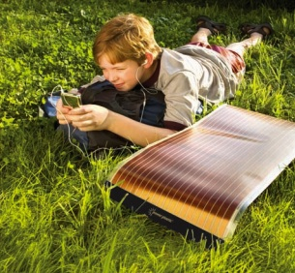

How is this nano?
Lab-on-a-chip  screens for diseases | Technologies and society influence each other. People’s values shape how nanotechnologies are developed and adopted. In our country, a lot of our work developing new nanotechnologies goes toward computing, energy, medicine, and military applications. These efforts reflect what we collectively think is important. In other countries, people choose to invest in different kinds of technologies.  Nanotechnology takes advantage of the different physical forces at the nanoscale to make new materials and tiny devices smaller than 100 nanometers in size. (A nanometer is a billionth of a meter.) Nanotechnology allows scientists and engineers to make things like smaller, faster computer chips and new medicines to treat diseases like cancer.

Learning objectives
- Technologies and society influence each other.
- People’s values shape how nanotechnologies are developed and adopted.

Materials
- Playing cards

Notes to the presenter
This activity is designed as an open-ended, conversational experience. There is no right or wrong way for visitors to sort the cards. To help visitors think about how to prioritize the technologies, you can ask them to think about which ones might be most useful or important and explain why they think so. After they chose a character card, you can ask them which technologies they think that person would find important, suggesting some factors the character might consider.

You can adjust this game to work for different audiences. For families with young children, try starting with 3-5 technologies. (Good choices include the space elevator, the teabag water filter, the invisibility cloak, the solar cells, and the mini drone robots.) Young children may have a hard time understanding the different perspectives represented by the character cards, but they often can recognize that they would sort the cards differently from other people in their family.

This activity is easy to facilitate with a little practice—but before doing it with visitors, become familiar with the cards and try it out a few times with a friendly audience.

Related educational resources
The NISE Network online catalog (www.nisenet.org/catalog) contains additional resources to introduce visitors to the relationship between nanotechnology and society:
- Public programs include Exploring Nano & Society—Flying Cars, Nanotech and Consumer Products, Shrinking Robots!, and Would You Buy That?
- NanoDays activities include Exploring Nano & Society—Space Elevator and Exploring Properties—Invisibility.
- Forums include Energy Challenges, Nanotech Solutions?, Nanomedicine in Healthcare, Privacy—Civil Liberties—Nanotechnology, and Risks, Benefits, and Who Decides?
- Media include Does Every Silver Lining Have a Cloud?, Is that Robot Real?, Let’s Talk About It, Same Sides, Societal and Ethical Implications Posters, and Wonders and Worries of Nanotechnology.
- Exhibits include Balance our Nano Future and Nanotechnology: Fact or Fiction?

Credits and rights
This activity was created as a collaboration of the NISE Network and the Center for Nanotechnology in Society at Arizona State University.

Image of thin film solar cell courtesy of Konarka Technologies.

Image of lab on a chip courtesy of Agilent.

This project was supported by the National Science Foundation under Award Nos. 0940143 and 0937591. Any opinions, findings, and conclusions or recommendations expressed in this program are those of the author and do not necessarily reflect the views of the Foundation.

Copyright 2012, Sciencenter, Ithaca, NY. Published under a Creative Commons Attribution-Noncommercial-ShareAlike license: http://creativecommons.org/licenses/by-nc-sa/3.0

