Exploring Tools—Mystery Shapes

Try this!  - Put your hand inside the box. What do you feel?  - Draw a picture of one of the objects you feel inside the box.  - Now take the object out of the box and compare it to your picture. What information does your picture include? What’s missing?  - Try another object and compare it to the first. | 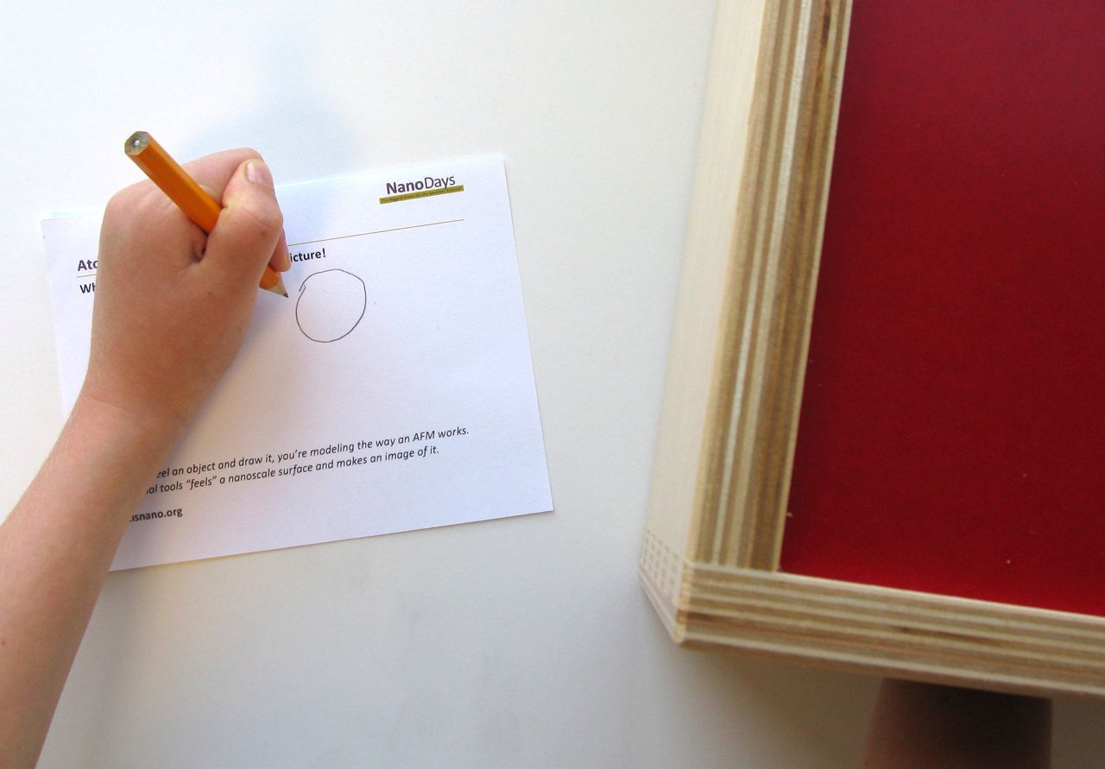
What’s going on?
When you feel a mystery shape in the box and draw an image of what it looks like, you’re modeling the way that a special tool called a scanning probe microscope (SPM) works. Your hand is acting like the sensing part of the SPM, while your brain acts like the computer program that creates a picture of what the tool “feels.”  SPMs let us make images of tiny, nano-sized things like atoms that are much too small to see, even with powerful light microscopes. Things this small are measured in nanometers. A nanometer is a billionth of a meter.  SPMs use a super-sharp tip to move across a nanoscale surface. To make an image, researchers move the tip back and forth across the sample many times. A computer program combines the data to create an image. | 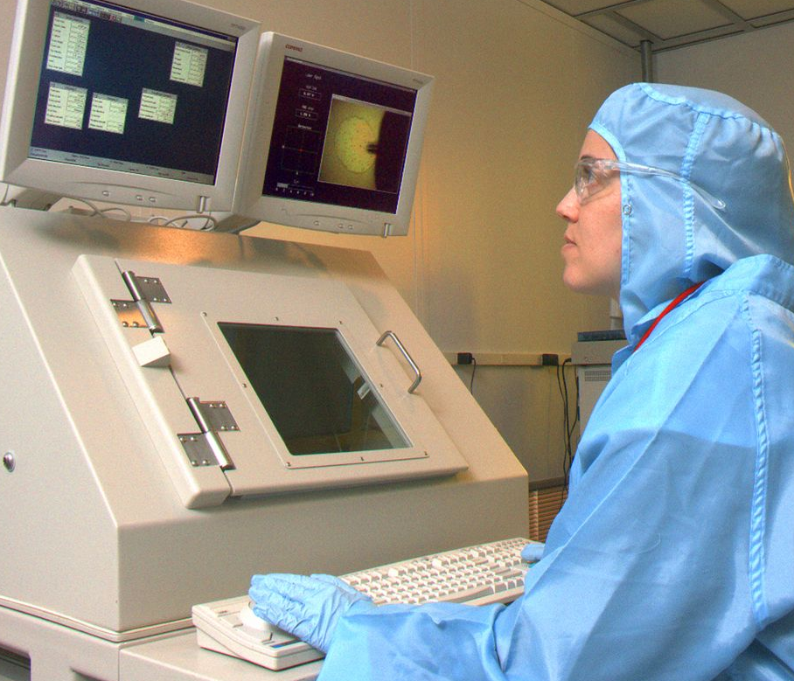  Researcher using an SPM
SPMs are very powerful. Some of them can even detect and make images of individual atoms! However, they still can’t capture every detail about nano-sized objects. Researchers use other tools to learn things that SPMs can’t detect.

Similarly, your fingers can’t detect all the information about the mystery shapes in the box. When you pulled out the objects and looked at them, you probably were able to gather even more information about them (such as what color they were). The pictures you drew captured some of the information you could gather by touching the objects, but some other things you could feel (such as the material) might be missing from your picture.
How is this nano?
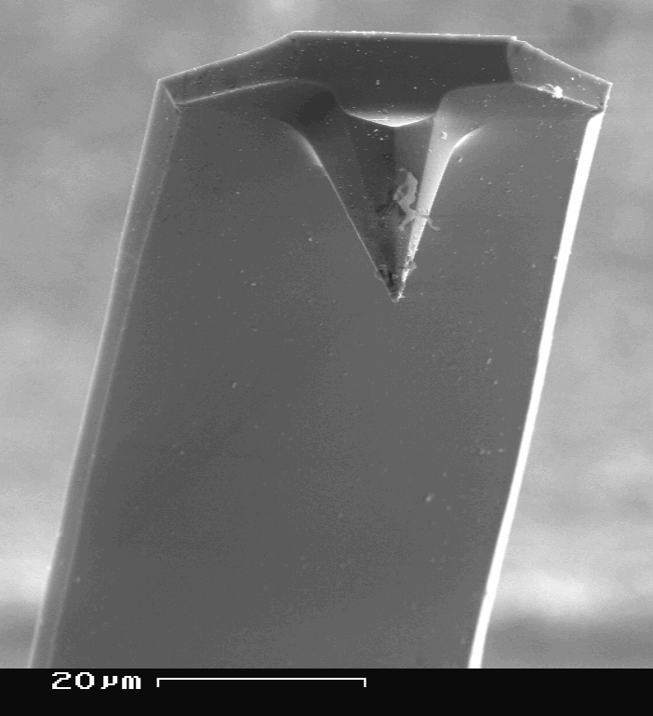  Tip of an SPM | Scientists use special tools and equipment to work on the nanoscale. Scanning probe microscopes (SPMs) allow researchers to detect and make images of objects measured in nanometers—or even smaller. (A nanometer is a billionth of a meter.)  The invention of SPMs was a great breakthrough in the field of nanotechnology. Once scientists could make pictures of things as small as individual atoms, they could begin to manipulate and study things at this super-tiny scale. Without SPMs, nanotechnology wouldn’t be where it is today!

Learning objective
Scientists use special tools and equipment to work on the nanoscale.

Materials
- Tactile box
- Assorted small objects to hide in the box
- “Scanning Probe Microscope” cards
- Pencils

The tactile box included in the NanoDays kit is available from www.lakeshorelearning.com (#RJ27). You can substitute a cloth bag or a cardboard box with holes cut in the sides.

Notes to the presenter
SAFETY: Some of the objects used in this activity could present a choke hazard to young children. Supervise visitors at all times while doing this activity. You may choose to remove or replace the smaller objects.

There are two holes in the tactile box, one on each end. One is for visitors to feel the objects and one is for you to use to hide new objects.

It works well to have visitors start with a selection of balls that are different colors and materials, then try other objects such as small toy animals. You can find other mystery shapes for visitors to feel, in addition to those included in the activity.

Young children, individuals with limited dexterity, and low-vision visitors may prefer to describe what they feel rather than draw it.

While most visitors are enthusiastic about discovering the “mystery shapes” in the box, some may hesitate to put their hands inside. You can reassure them that there’s nothing scary or icky in the box!
Related educational resources
The NISE Network online catalog (www.nisenet.org/catalog) contains additional resources to introduce visitors to nanotechnology and the tools researchers use to study and make things that are too small to see:
- Public programs include Attack of the Nanoscientist, Cutting it Down to Nano, Intro to Nano, Ready, Set, Self-Assemble, and Tiny Particles, Big Trouble!
- NanoDays activities include Exploring Size—Powers of Ten Game, Exploring Tools—Mitten Challenge, and Exploring Tools—Special Microscopes.
- Media include the video What Happens in a Nano Lab?
- Exhibits include Creating Nanomaterials and NanoLab.

SPM Background Information

What are SPMs?
Scanning probe microscopes (SPMs) are a family of tools used to make images of nanoscale surfaces and structures. They use a physical probe to scan the surface of a sample, gathering data to create a three-dimensional image of it. In addition to visualizing nanoscale structures, some kinds of SPMs can be used to move individual atoms.

SPMs are different from other kinds of microscopes because the user doesn’t see the surface directly. Instead, the tool “feels” the surface and creates an image to represent it.

How do they work?
SPMs are very powerful microscopes. An atomic force microscope, or AFM, is a specific kind of SPM.

An AFM has a probe tip mounted on the end of a cantilever. The tip can be as sharp as a single atom. It can be moved precisely and accurately back and forth across the surface of the sample.  When the tip is near the sample surface, the cantilever is deflected by a force. AFMs can measure deflections caused by many kinds of forces, including mechanical contact, electrostatic forces, and magnetic forces. The distance of the deflection is measured by a laser that is reflected off the top of the cantilever and into an array of photodiodes. | 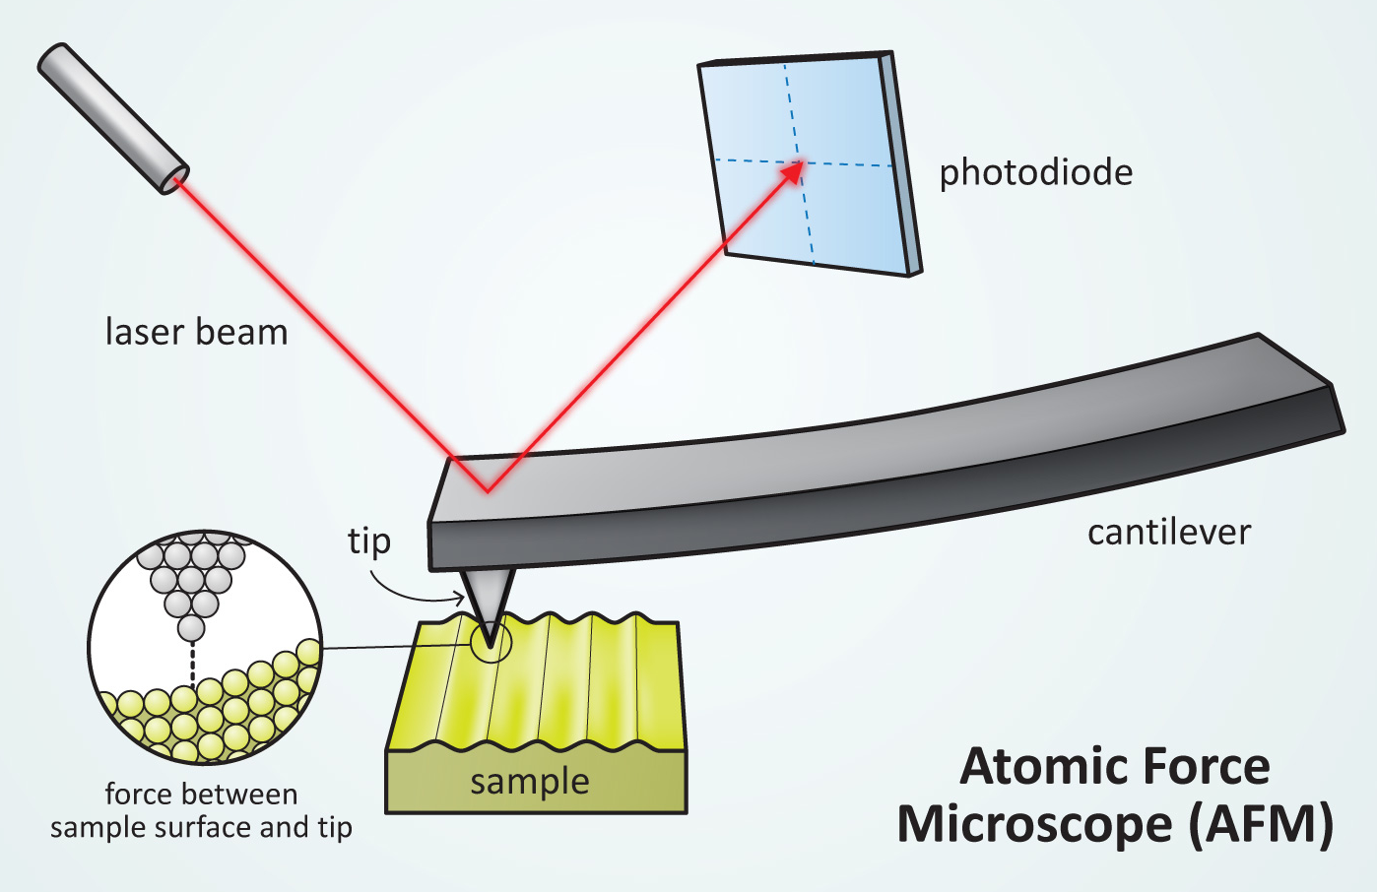

Some AFMs can detect differences in height that are a fraction of a nanometer! (A nanometer is a billionth of a meter.)

Researchers use AFMs in a number of different ways, depending on the information they’re trying to gather. The tip of the tool can be in constant contact with the sample, it can be slightly above the sample, or it can tap gently on the sample as it moves.

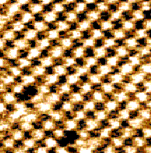  AFM image of salt (NaCl) | The AFM tip is moved back and forth across the sample many times. A computer program combines the data to create an image.  AFM images are inherently black and white. To make them easier to interpret, they are often colorized. Different colors are used to indicate differences in height along the surface.  AFMs can be used with almost any type of material, including biological samples. They have been used to image DNA, individual proteins, and even living cells.

Credits and rights
Photograph of researcher using AFM by Charles Harrington Photography, courtesy of Cornell Nanoscale Facility.

Image of AFM tip by SecretDisc, from Wikimedia Commons.

Illustration of AFM by Emily Maletz for the NISE Network.

Image of sodium chloride courtesy of Ernst Meyer, University of Basel, from Wikimedia Commons.

This project was supported by the National Science Foundation under Award No. 0940143. Any opinions, findings, and conclusions or recommendations expressed in this program are those of the author and do not necessarily reflect the views of the Foundation.

Copyright 2012, Sciencenter, Ithaca, NY. Published under a Creative Commons Attribution-Noncommercial-ShareAlike license: http://creativecommons.org/licenses/by-nc-sa/3.0

