

Comparing Microscopes Background
Microscope types
Light Microscope: Light microscopes are the cheapest and most common type of microscope. If you’ve used a microscope at school or at home, you’ve probably used this type of microscope. In a light microscope, light illuminates the sample and produces a 2D image in the eyepiece. This kind of microscope is great for looking at bugs, flowers, and onion skin. But these microscopes can’t identify features smaller than about 200 nanometers. To see features smaller than 200 nanometers, scientists must use an electron microscope. Light microscopes have been around since the 16th century! Light microscopes can be as cheap as $50, or they can run into the tens of thousands of dollars for research-grade models! | 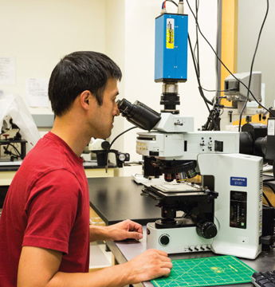

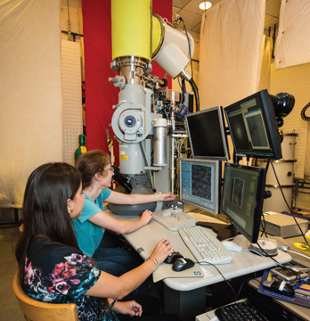 | Transmission Electron Microscope (TEM): TEMs shoot electrons through thin samples and look at the electrons that have reached the other side. Even though TEMs are large and expensive, they are actually similar to overhead projectors, since both produce 2D “shadows” of a sample. TEMs have incredible resolution, so it’s possible to image individual atoms with a TEM! TEMs were invented in 1931 by Ernst Ruska and Max Knoll. TEMs cost between $400K and $4M!

Scanning Electron Microscope (SEM): Like TEMs, SEMs shoot electrons at samples. But in SEMs, the samples are thicker so the electrons don’t pass through the samples. Scientists get information about the sample by detecting electrons that are reflected or emitted from the sample. SEMs have a very high resolution, but they cannot image individual atoms. The SEM was invented in the 1950s by Charles Oatlev and now cost between $200K and $400K! | 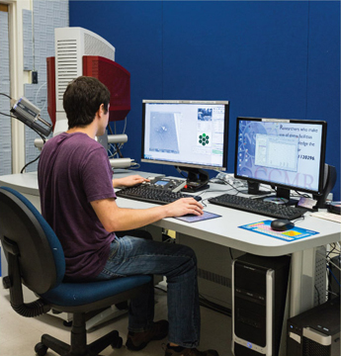

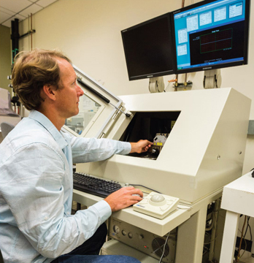 | Atomic Force Microscope (AFM): AFMs are sensitive instruments that produce height maps of a sample’s surface. During an AFM scan, a cantilever with a small tip on the end moves across the sample. This process is similar to how a blind person reads Braille or how a record player converts grooves on a vinyl record into music you can hear. AFMs are so sensitive that they can image individual atoms. And AFMs can do more than just image – they can even move atoms! AFMs were developed in the 1980s by Gerd Binning and Heinrich Rohrer. AFMs cost between $50K and $200K.

Challenges
Here are a few challenges scientists and engineers face when using AFMs, SEMs, and TEMs:

Preparing samples for a vacuum: TEMs and SEMs are operated under a vacuum, which means that the air inside the microscope chambers has been removed. Outer space is also a vacuum! These microscopes have to be under a vacuum so that the electron beam will travel in a straight line and hit the sample. Since the samples are also under a vacuum, they can’t be wet or they will release water molecules and destroy the vacuum. This is a problem for biological samples, since they are naturally wet. Scientists have ways of removing the water, but these methods can change or damage the sample!

Preventing sample vibrations: Imaging samples with the AFM, TEM and SEM can be tricky, since even tiny vibrations can cause big problems! When scientists are imaging tiny nanoscale features, even small vibrations such as footsteps in the room next door can jiggle the sample too much and ruin the images. To help minimize these effects, these microscopes are placed on special tables called vibration isolation tables that minimize vibrations.

