

Comparing Microscopes

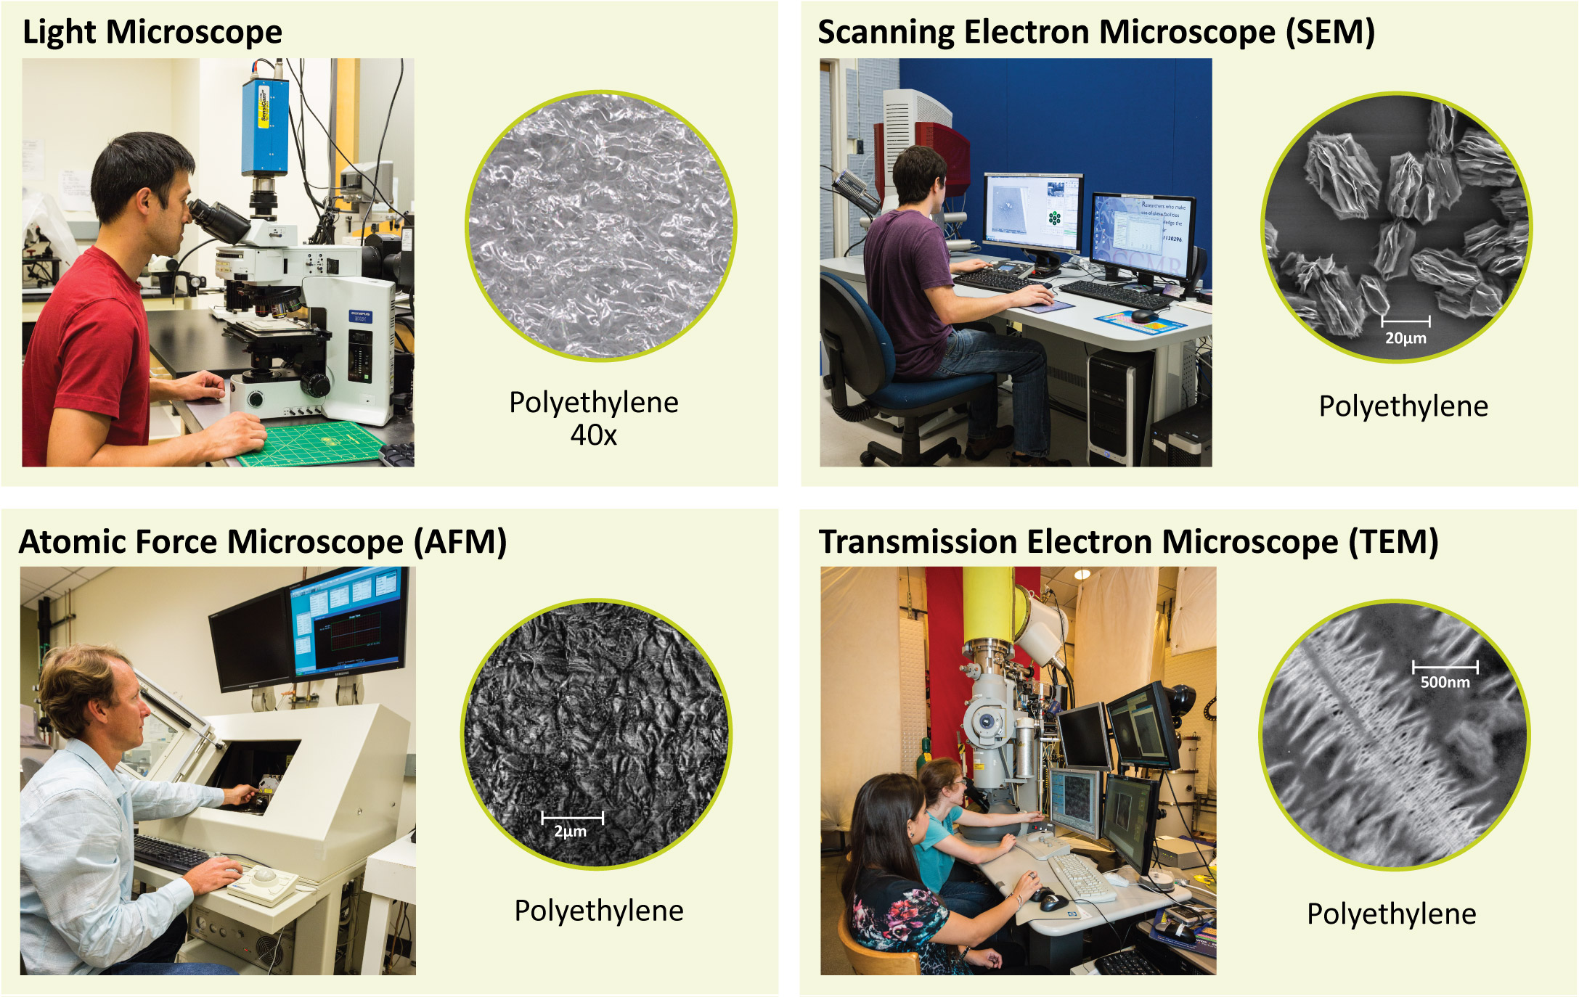
Nanoscientists use many different types of microscopes to study and make tiny things.
The different tools create very different images of the same material—in this case polyethylene, a common plastic.

