Drought

Facilitation Guide

Four Sections, 85 minutes total

Highlighted text is suggested language.

General Intro to “Ottawatta” – 15 minutes
Lead Facilitator
- The lead facilitator will give an introduction to “Ottawatta,” the city your table will be creating a resilience plan for. If the participants have any questions about the intro exploration of the city, all the information is on StoryMap “Welcome to Ottawatta” under the tabs on the top.  - The introduction will include:  - What is the city like?  - How is it affected by drought?  - Who and what is affected by drought? | 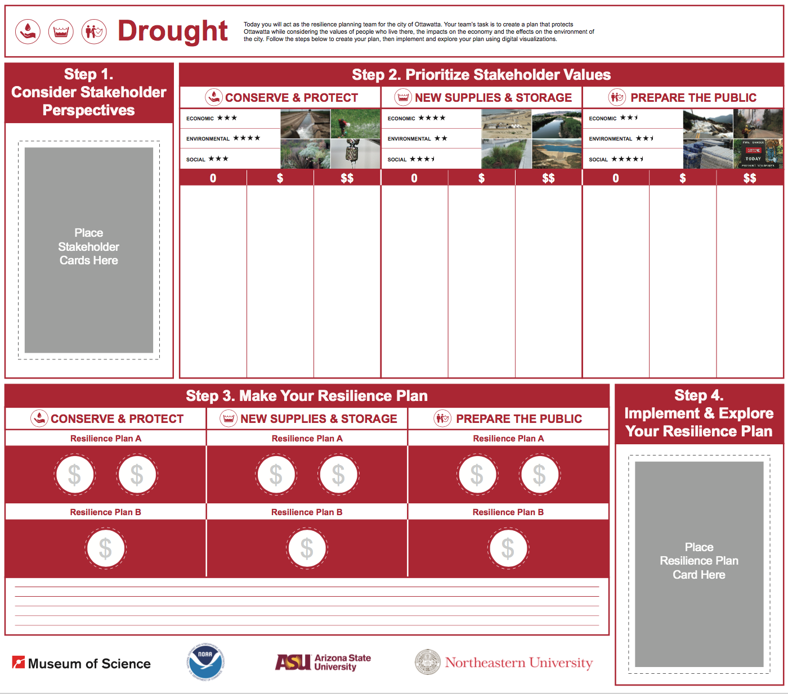
Drought, Welcome & Introductions –1 minute
Materials Needed: Participant Workbooks
- Group introductions: Have the participants go around the table and say their names.  - Be sure to point out and read through the Ground Rules for discussion, located on the table in the plastic stand.  - “The lead facilitator just introduced the city of “Ottawatta” and some problems it is facing due to drought. In this session, you will be discussing how drought impacts Ottawatta and the people who live there, make a plan based on three strategies, then visualize what happens when they are implemented.” To make this clear, you can introduce the participants to these same steps #1-4 located on the board.  - Facilitators hand out the participant workbooks.  - “Here is a workbook you can use to jot down any thoughts or ideas you have during the discussion that you don’t want to forget. We will not collect your notes pages unless you want us to. The last two pages are for later on in the session and will be collected. You will have 2 hours to complete this session.” | 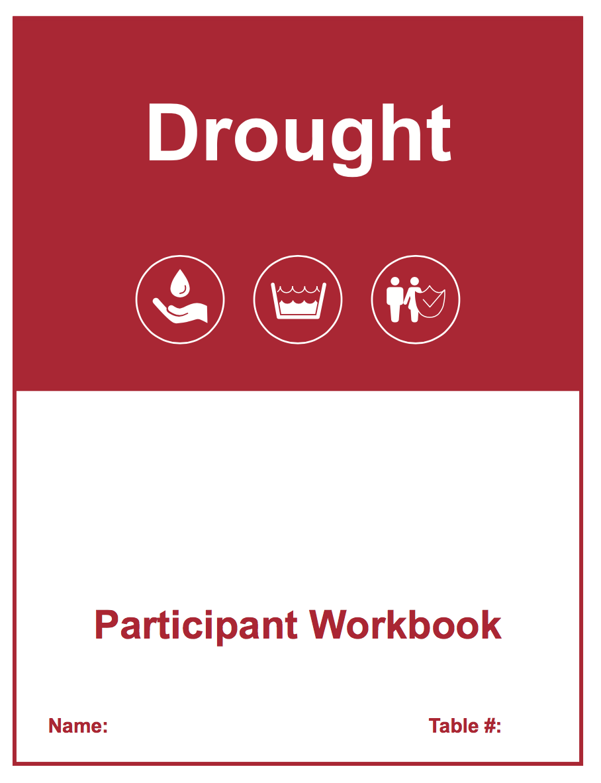

Step 1: Consider Stakeholder Perspectives – 14 minutes
Materials Needed: Stakeholder Cards, Participant Workbooks
- Facilitators hand out stakeholder cards to table participants. Not everyone will have a card to read this time, so make sure next time others have a chance to read.  - “You are going to start the discussion by thinking about some of the people who live in the city and what they prioritize. I’m going to hand out stakeholder cards, and you will go around the table reading the cards out loud. You can follow along in your workbook.”  - Participants read through stakeholder cards. Encourage the participants to place the card on the table after they read it. They should think about the values of each of the stakeholders instead of acting as that stakeholder.  - Discuss stakeholder priorities around prompting questions.  - “Now that we know a little more about the people who live in Ottawatta, let’s think about what their priorities would be for a resilience plan.”  - “Do you have any initial thoughts on what these stakeholders would prioritize? Would they be most concerned about: the economy, environment, or social aspects of a resilience plan?” | 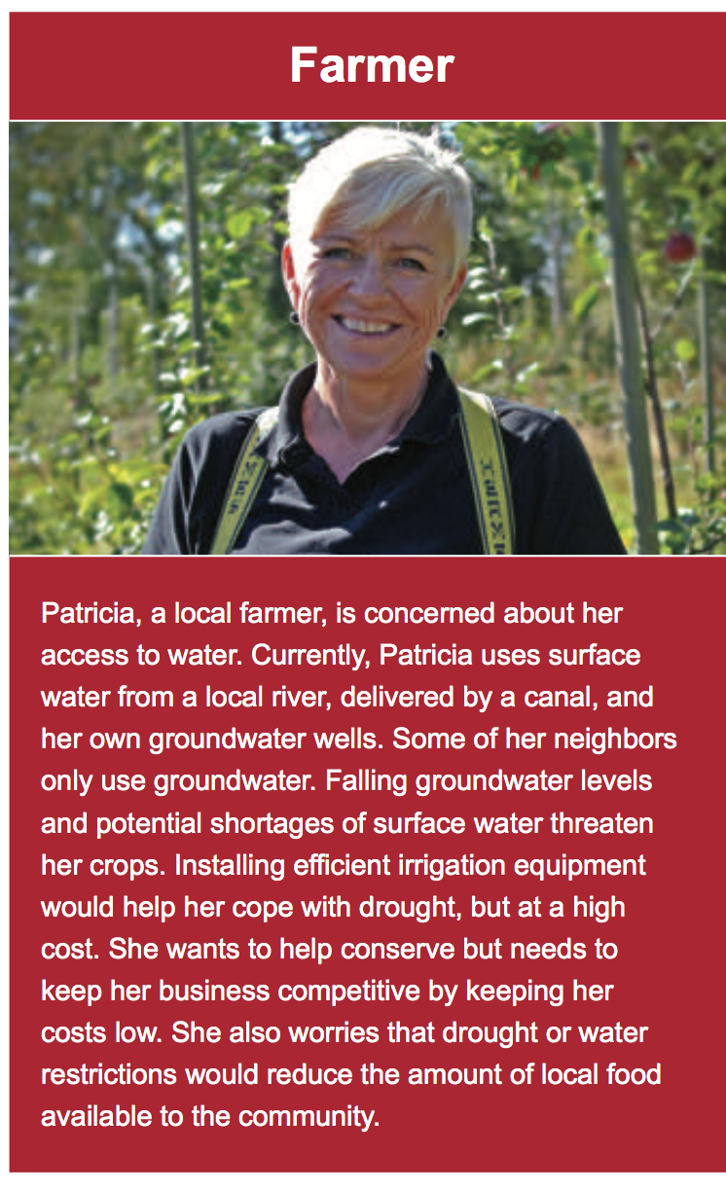
Step 2: Prioritize Stakeholder Values – 25 minutes
Materials Needed: Participant Workbooks, Stakeholder Cards, Stakeholder Icons, Board
- Facilitator should have the participants turn to the Resilience Strategy section of their workbook. Have one participant read the row labeled “Conserve & Protect” (including the sections with stars). Try to have someone read who didn’t have a chance to read in the last section.  - “Next you are going to start thinking about how each of these stakeholders feel about three possible resilience strategies outlined in your workbook. We will go through this step in three sections, and will begin with someone read the strategy “Conserve and Protect” out loud from their workbook, including the sections with the stars. The stars rank how well the strategy performs in each category.”  - Once the strategy is read out loud, facilitators place one set of stakeholder icons from the envelope on the table.  - “This board has three boxes next to each of the three strategies – Conserve and Protect, New Supplies and Storage, and Prepare the Public. You are going to think about how much each of the stakeholders value the strategy and put stakeholder icons in the box that represents how much money the stakeholders would want the city to spend on each strategy. This is not how much money will be coming out of the pockets of the stakeholders, but how much money they would support the city spending on each strategy. We will do this one strategy at a time, beginning with the “Conserve and Protect” strategy you just read out loud.”  - Participants can think about how each stakeholder would value each strategy based on the economic, environmental, and social aspects of each strategy outlined in their workbooks.  - You will repeat the above process two more times with “New Supplies and Storage” and “Prepare the Public”.  - Once the participants have made their choices, tape the stakeholder icons in their place. The stakeholders can remain on the table for reference. | 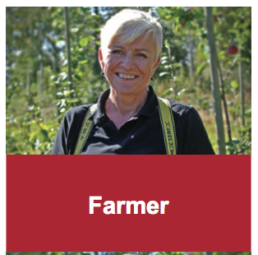  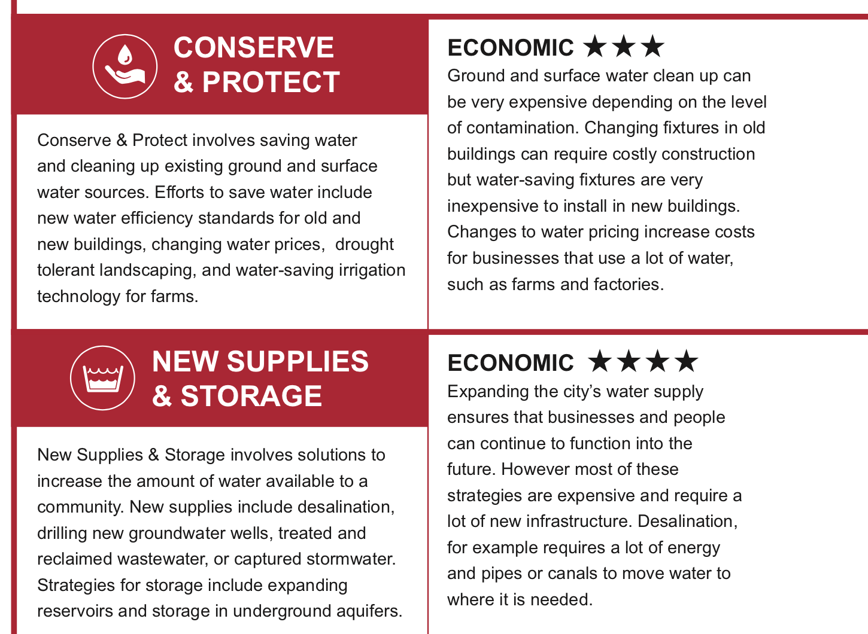

Step 3: Make your resilience plan – 20 minutes
Materials Needed: Strategy Option (A & B) Cards, Participant Workbooks, Coin Tokens, Board
- Facilitators hand out strategy option (A & B) cards to table participants.  - “Now you are going to learn more about how the strategies can be put into practice as proposed by city planners, engineers, scientists and local government officials. These strategy options outlined on the cards and in your workbook, will be combined to make a resilience plan later in this session. Please follow along in your workbooks while they are read out loud.”  - Participants will go around the table to read the cards out loud. Remember to make sure everyone has a chance to read. Try to have someone new read out loud this time.  - Facilitators put three coin tokens on the table.  - “As a table, you are going to make a resilience plan using the strategy options that were just read out loud. You have three coins that you can distribute among the strategy options. Each Option A costs two coins, and each Option B costs one coin. You cannot use all three coins on one strategy, you can only choose to do Option A or Option B for each strategy. Or, you can choose not to use all of the coins, and ‘leave it be’ and choose to not use one of the strategy options.  - Participants take 1 minute to write down their own plan in their workbook on the “My Resilience Plan 1” page.  - “Before you start the table discussion, you have two minutes to write down your ideas and thoughts on paper. You can write your ideas in your workbook on the ‘My Resilience Plan 1’ page.” Write down what plan you would choose, and which you would not and why. What do you like about your plan? What would you change?  - Participants have a table discussion on plan options.  - “As a table, you will now discuss what combination of strategy options you would like to put together to make an overall resilience plan for Ottawatta. You have 15 minutes for this section.”  - Facilitators make sure that there is time for the participants to make a final plan before moving on to the next section. The table does not need to be in complete agreement, but a plan must be made for the next section. Individual views on the plan were captured in their worksheet responses.  - Facilitators should tape down the coins once the participants choose a plan. The boards will be collected and photographed by staff members after the forum. | Card:  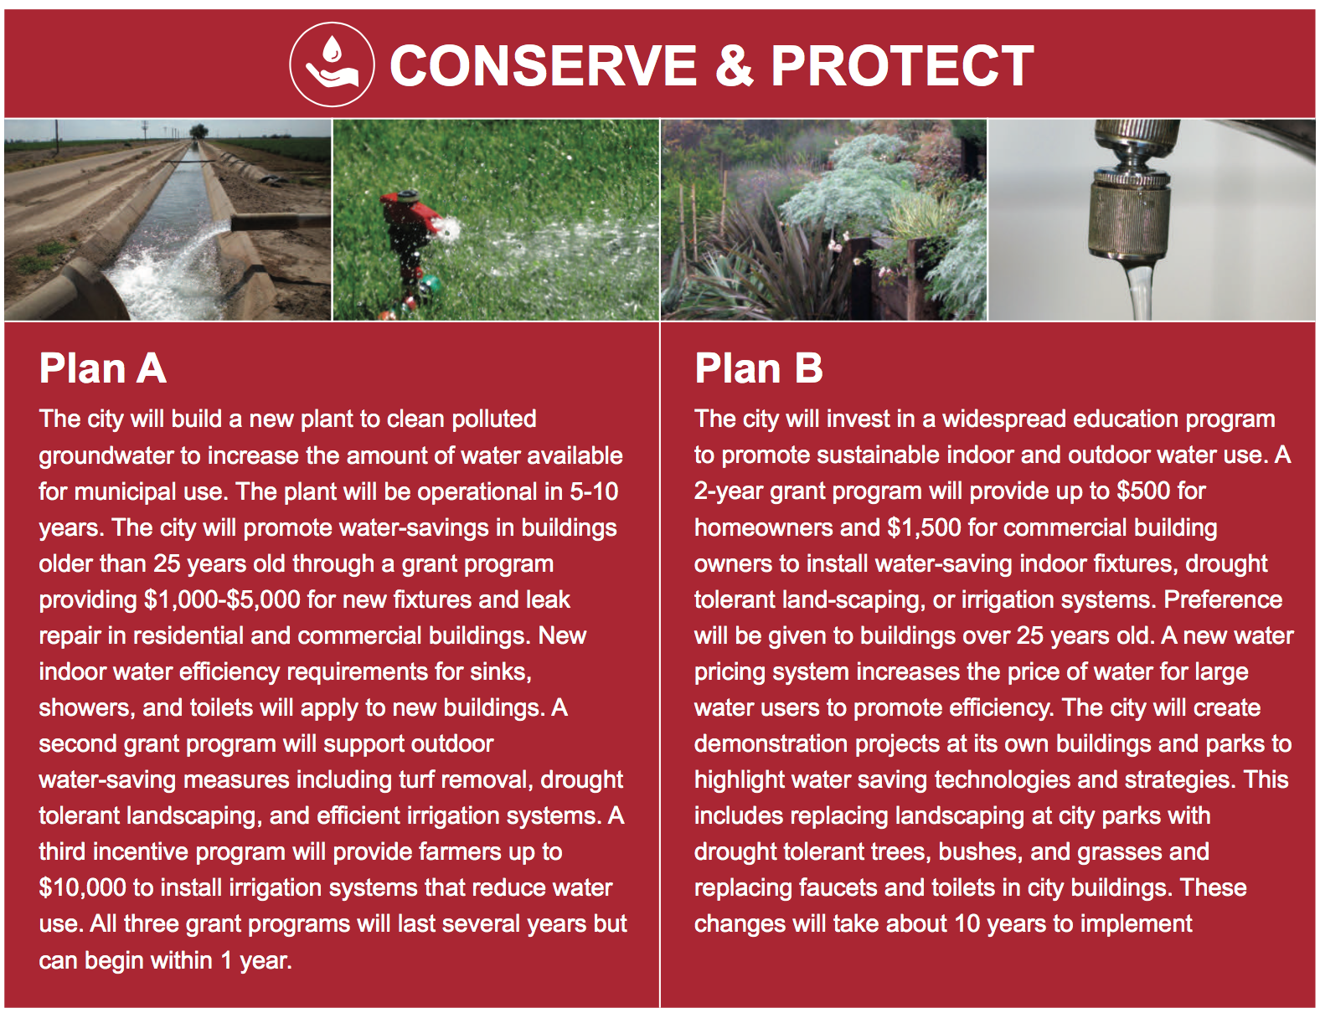  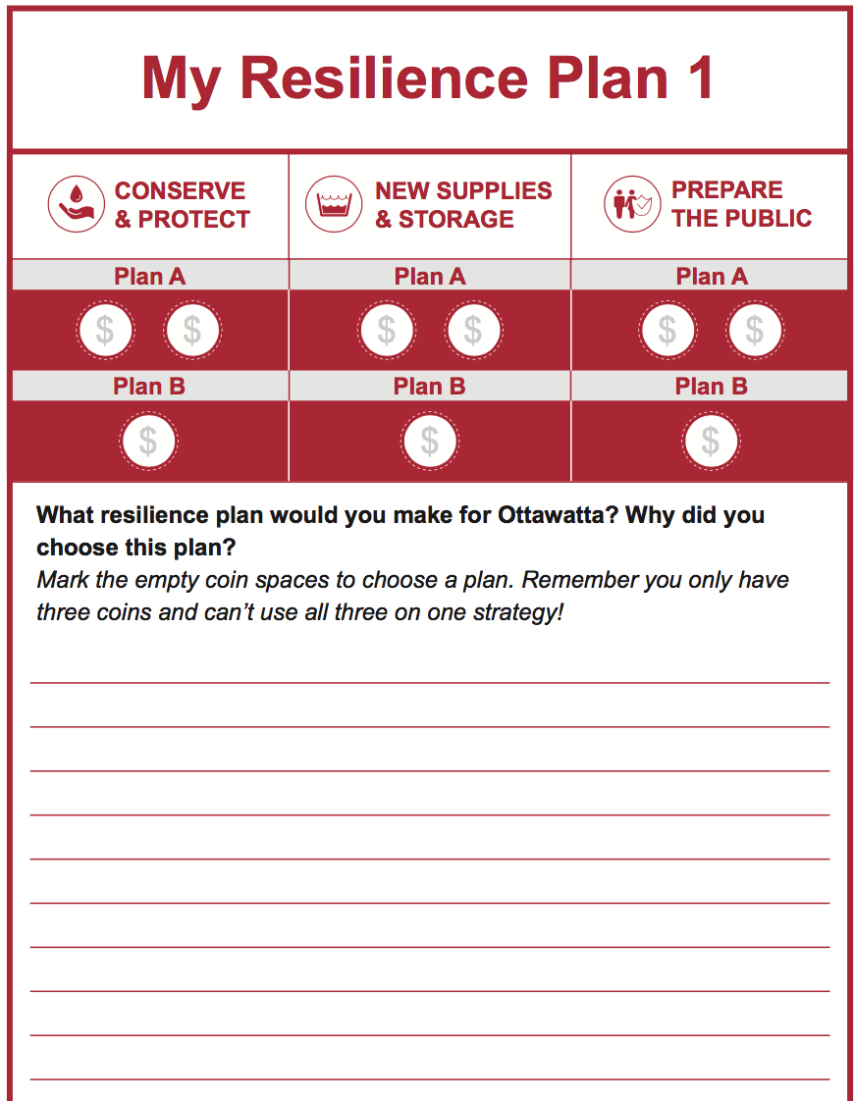  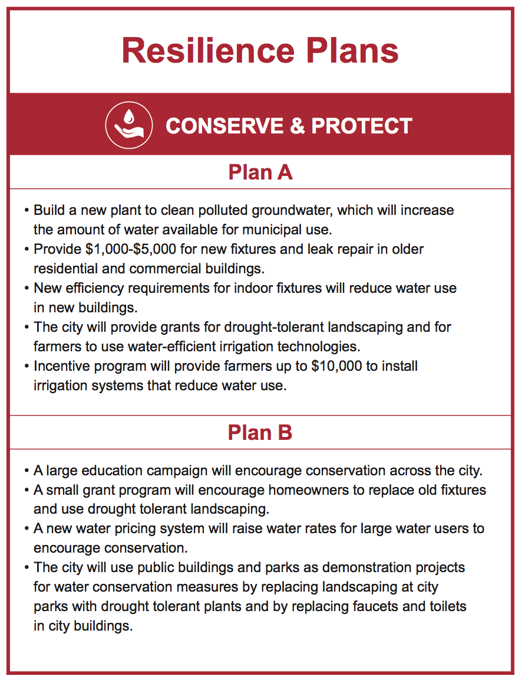  Workbook:

Step 4: Implement and explore your resilience plan – 10 minutes
Materials Needed: List of Visualization links & Final Resilience Plan Cards
- Facilitators at each table will guide the participants to see what happened to the community at large and to certain stakeholders using ArcGIS Story Map.  - “Now that you have created a plan, let’s see what it will look like when it’s implemented in Ottawatta. We will 10 minutes to click through the visualizations on story map and discuss how the plan has affected the city and the people who live there. While I’m opening the story map, please read the appropriate final resilience plan out loud. This will give you an overview of your plan before clicking through story map.”  - While you access the storymap, have one of the participants read the resilience plan card that corresponds to the plan you chose (DR_000) out loud as an overview of their plan, then place it on the board.  - “Here is a visualization of the resilience plan you created. Do you notice any changes?”  - Click on the appropriate link for your table’s chosen plan and click through it by clicking on the top tabs and scrolling down through them.  - You, or a participant can read the text out loud.  - Once the participants understand how their plan affects Ottawatta, the Facilitator should ask prompting questions about the economic, social and environmental impacts of the table’s plan. Some options for questions are below.  - “How do you think your resilience plan impacted the economy?”; “How do you think your resilience plan impacted the society?; “How do you think your resilience plan impacted the environment?”  - “Did the plan impact the city in a positive or negative way? How so? Were some areas/people impacted positively, and some negatively? What do you think about that?” | 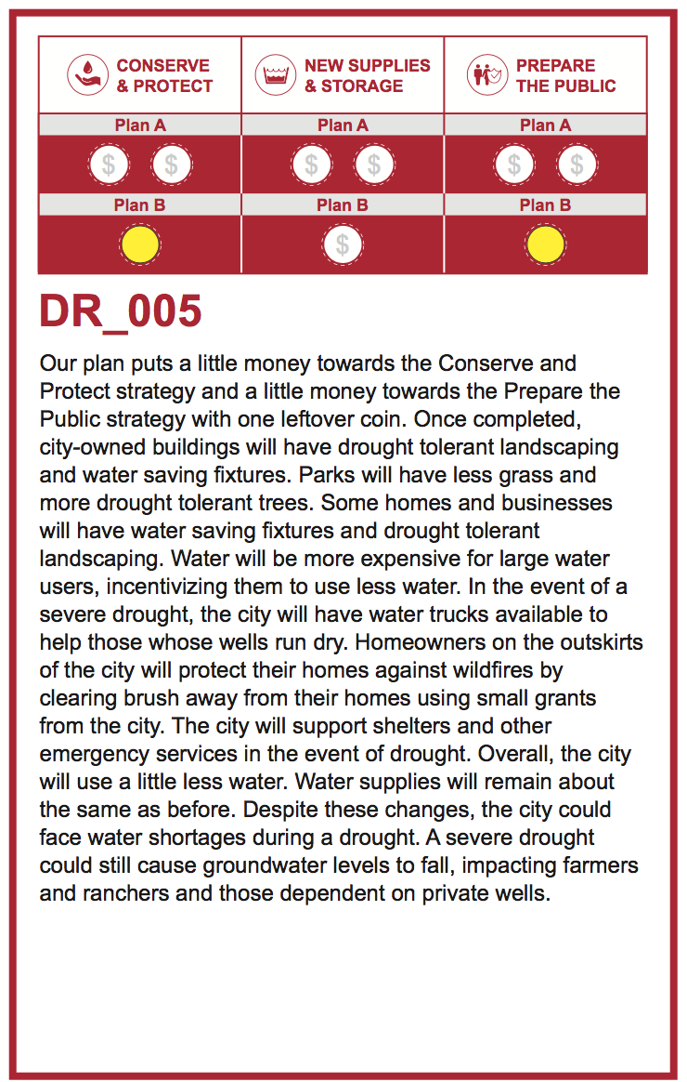

RESILIENCE PLAN VISUALIZATIONS LEGEND

Legend
Water supply and use sliders  - Represents change in water use and supply from current state.  - If the sliders are both in the center, then water use and water supply in the future are about the same as current use and supply.  - Does not account for potential shortages due to drought or increase in demand due to population growth.  - In general, decreasing use and increasing supply will make the community more resilient to drought | 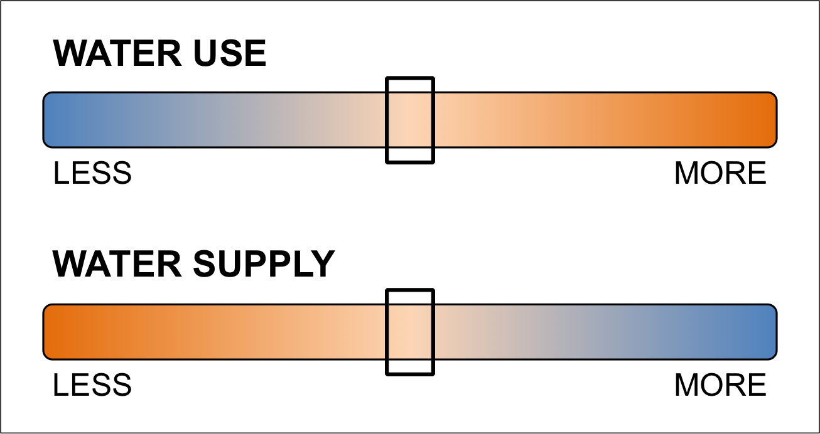
New water mains
Wildfire preparation zones | 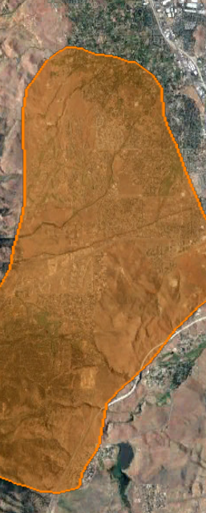
Wildfire/watershed restoration area | 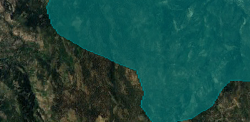
Polluted groundwater plume | 