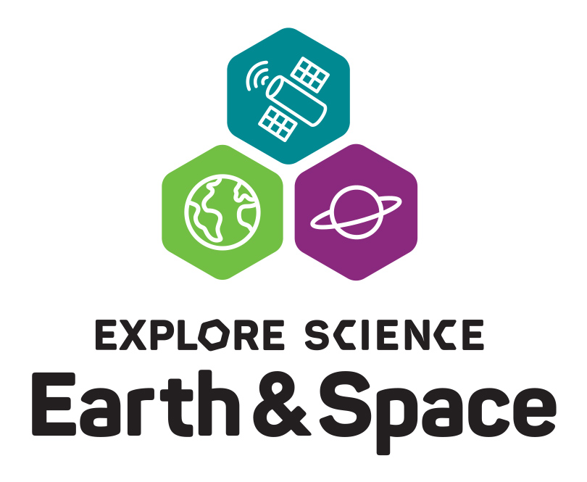
Your logo here

Date:
Contact:
Phone:
Email:

Explore Earth and space science at [name of your organization]!

[Insert your local Explore Science: Earth & Space location, dates, and specific activity information here].

The Explore Science: Earth & Space event at [name of your organization] is part of a nationwide celebration of educational programs designed to engage audiences in the awe-inspiring fields of Earth and space science. This exciting event is an opportunity to connect with current NASA science research and explore Earth and space phenomena.

The Explore Science: Earth & Space event will include exciting science, take-home materials, and engaging discussion about science and society. Participants will have a chance to make their own spin art nebula, play the Mission to Space game, explore star formation, discuss what it might be like to mine an asteroid, and much more! These fun activities introduce guests to the ongoing research happening at NASA in the fields of heliophysics, Earth science, planetary science, and astrophysics, and allow them hands-on interaction with Earth and space science concepts.
[Insert information or edit the above about other special activities that your location may host, information about local partnerships and collaborations, and any other event-specific information.]
The Explore Science: Earth & Space project is led by Arizona State University, in collaboration with the National Aeronautics and Space Administration (NASA). Explore Science: Earth & Space toolkits are developed and distributed nationwide by the National Informal STEM Education Network (NISE Net). Throughout spring and summer of 2020, events are taking place at 350 museums and institutions throughout the country.

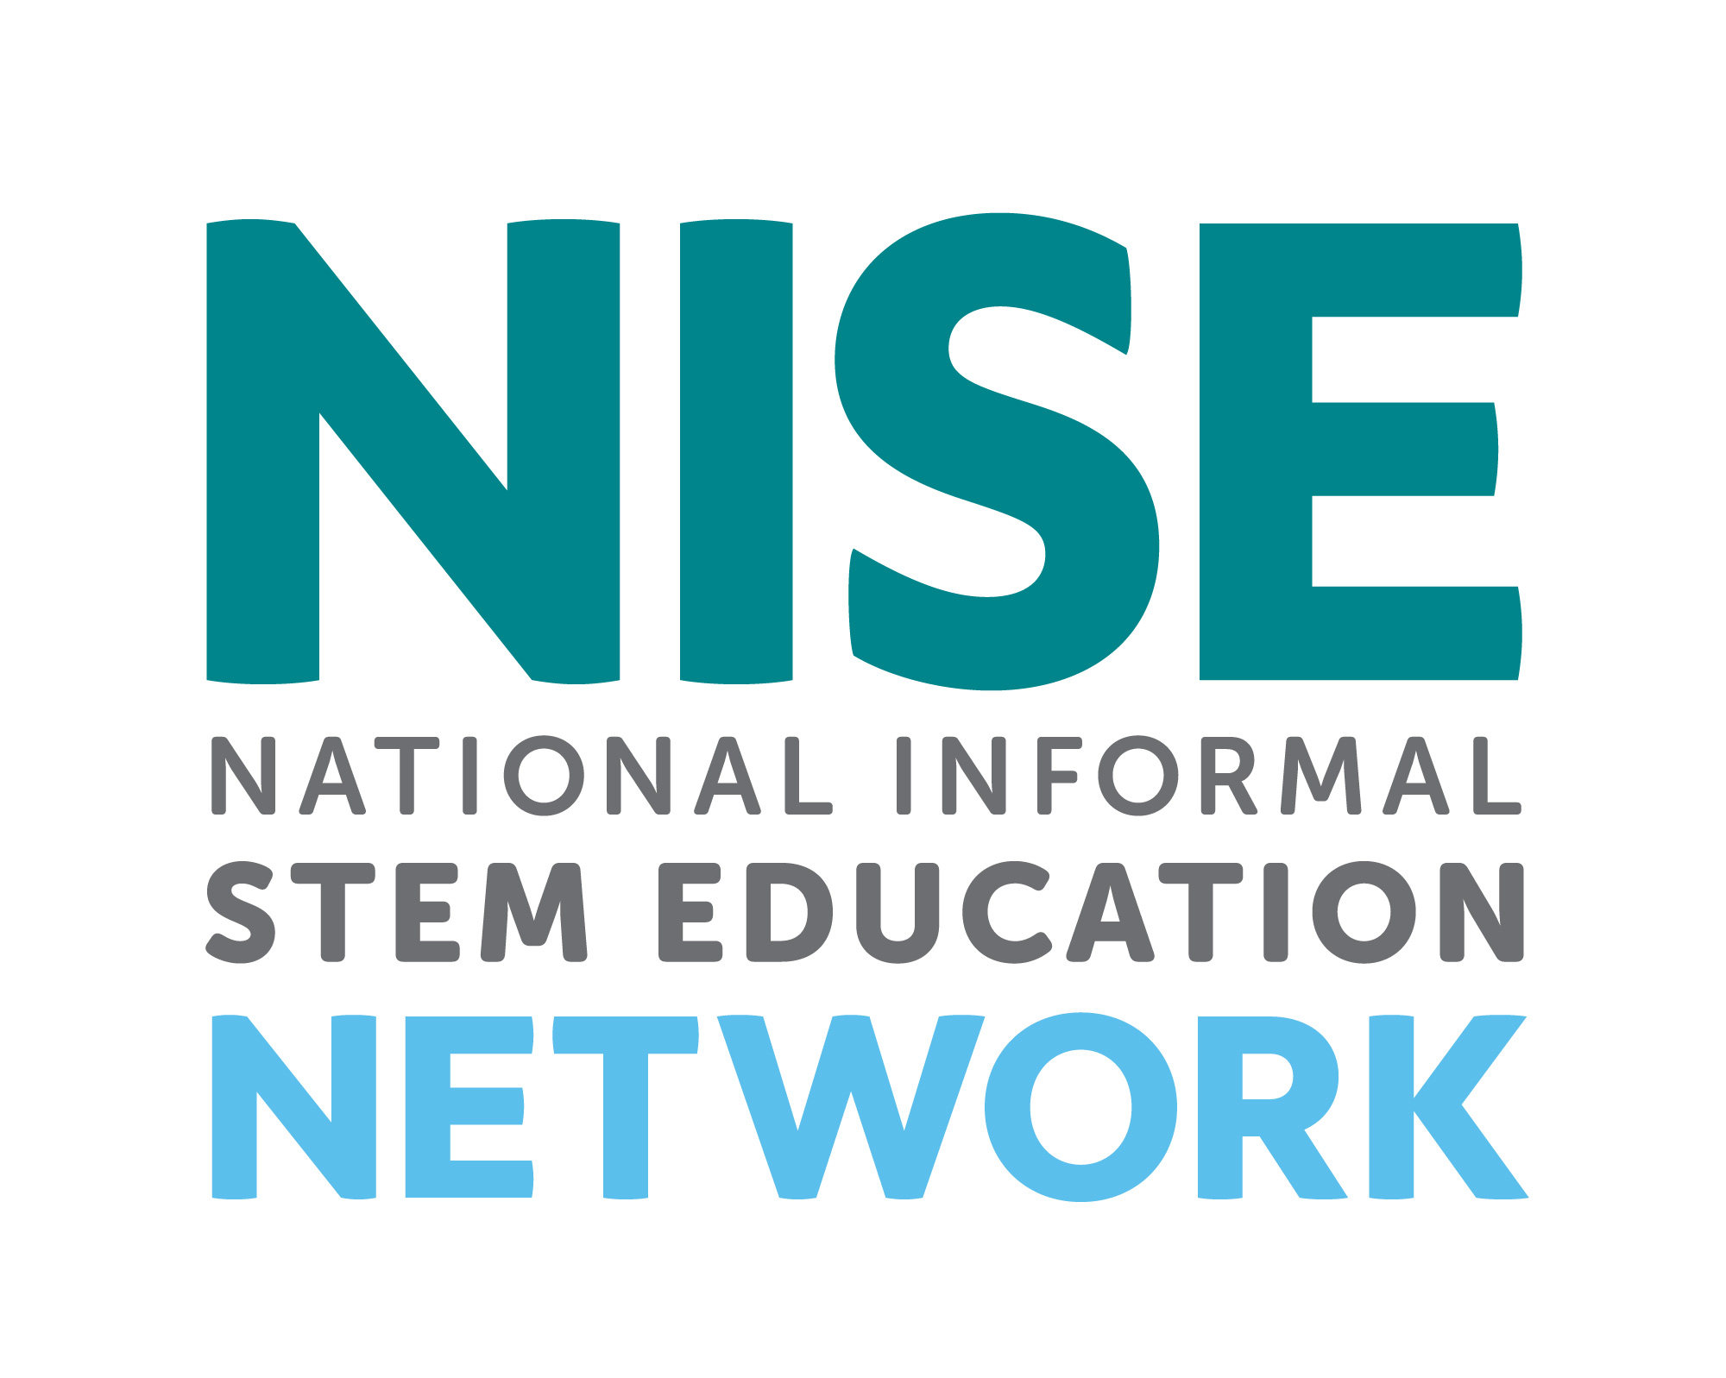
______________________________________________________________________________
The National Informal STEM Education Network (NISE Network) is a national community of informal educators and scientists dedicated to fostering public awareness, engagement, and understanding of current science, technology, engineering, and math (STEM). For more information about NISE Net and to download a digital Explore Science: Earth & Space toolkit please visit: www.nisenet.org.

This material is based upon work supported by NASA under cooperative agreement award number NNX16AC67A and 80NSSC18M0061. Any opinions, findings, and conclusions or recommendations expressed in this material are those of the author(s) and do not necessarily reflect the view of the National Aeronautics and Space Administration (NASA).

