Drought ONLINE

Facilitation Guide
StoryMap Link: https://nu.maps.arcgis.com/apps/MapSeries/index.html?appid=64c264c15299442985b058643228c46d

Four Sections, 75 minutes total

Highlighted text indicates suggested dialogue for facilitators

MAIN ZOOM ROOM: General Intro to “Ottawatta” – 5 minutes
Lead Facilitator
- The lead facilitator will give an introduction to “Ottawatta,” the city your group will be creating a resilience plan for. If the participants have any questions about the intro exploration of the city, all the information is on StoryMap “Welcome to Ottawatta” under the tabs on the top.  - The introduction will include:  - What is the city like?  - How is it affected by drought?  - Who and what is affected by drought? | 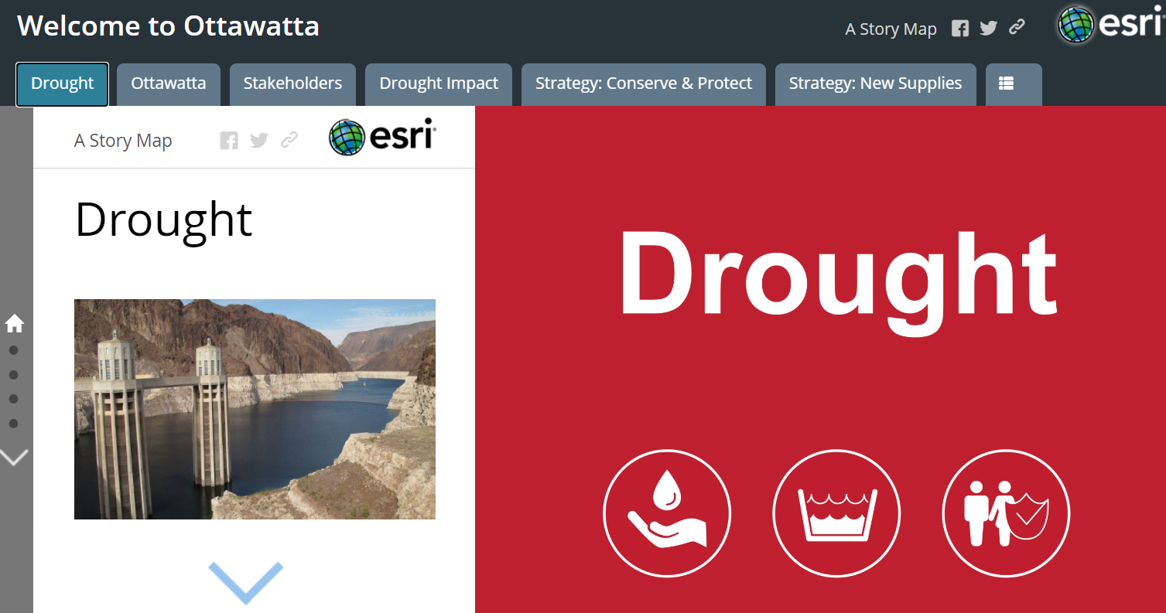
BREAKOUT ROOMS: Drought, Welcome & Introductions –2 minutes
Materials Needed: Online Gameboard and/or StoryMap
- Group introductions: “Before we get started let’s take some time to learn about each other. We’ll go around the screen introducing ourselves, where we live, and what brought each of us to the forum tonight. I’ll start.” Have the participants go around the virtual breakout and say their names.  - “The lead facilitator just introduced the city of “Ottawatta” and some problems it is facing due to drought. In this session, you will be discussing how drought impacts Ottawatta and the people who live there, make a plan based on three strategies, then visualize what happens when they are implemented.”  - Facilitators put StoryMap link in the chat: https://nu.maps.arcgis.com/apps/MapSeries/index.html?appid=64c264c15299442985b058643228c46d  - “This is the online portal we will be using today. We will be able to look at the stakeholders in Ottawatta, learn about the resilience plans and submit our plan. You can also go back to the tabs shown in the main room if you have any question about Ottawatta. I will also be sharing my screen with the information.” | 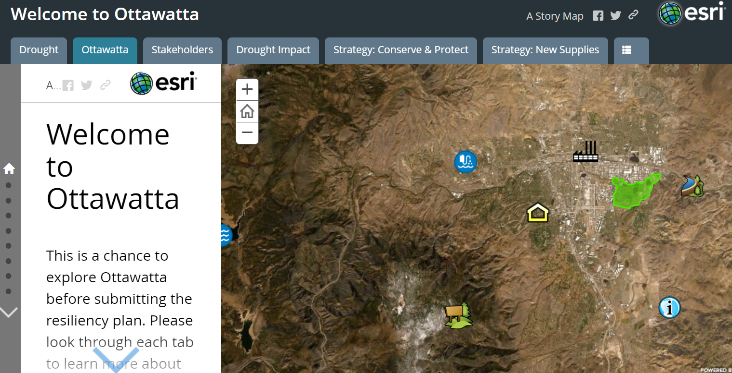

Step 1: Consider Stakeholder Perspectives – 14 minutes
Materials Needed: Gameboard Powerpoint and/or StoryMap
- Facilitators can either share their screen with the stakeholders up or have individuals have it up on their own laptops.  - “You are going to start the discussion by thinking about some of the people who live in the city and what they prioritize. I’m going to share my screen of the stakeholders, and you will go around the breakout room reading the cards out loud. You can follow along on my screen or your own screen.” Remind them they are not acting like those stakeholders, they are just more perspectives to consider along with their own.  - Participants read through stakeholders. They should think about the values of each of the stakeholders instead of acting as that stakeholder.  - Discuss stakeholder priorities around prompting questions.  - “Now that we know a little more about the people who live in Ottawatta, let’s think about what their priorities would be for a resilience plan.”  - “Do you have any initial thoughts on what these stakeholders would prioritize? Would they be most concerned about: the economy, environment, or social aspects of a resilience plan?” | 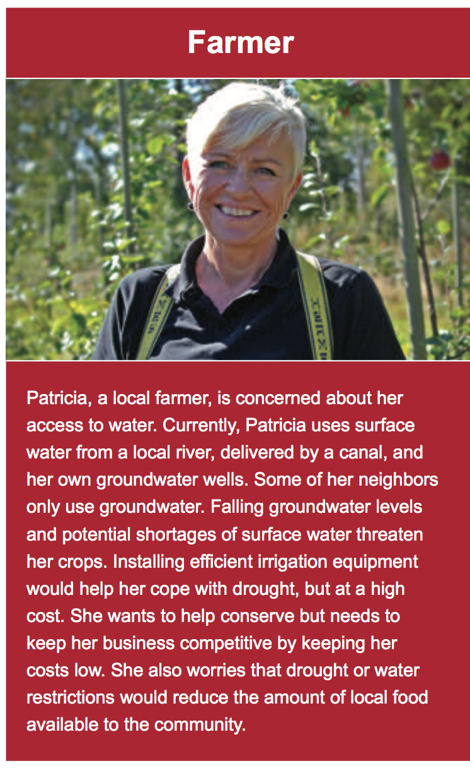
Step 2: Prioritize Stakeholder Values – 25 minutes
Materials Needed: StoryMap and PowerPoint
- Facilitator should share their screen with the PowerPoint slide “prioritize stakeholder values.” If participants have StoryMap open, have the participants click Resilience Strategy tabs on StoryMap. Have one participant read the row labeled “Conserve & Protect” (including the sections with stars). Try to have someone read who didn’t have a chance to read in the last section.  - “Next you are going to start thinking about how each of these stakeholders feel about three possible resilience strategies outlined on the slide. We will go through this step in three sections, and will begin with someone read the strategy “Conserve and Protect” out loud from their screen, including the sections with the stars. The stars rank how well the strategy performs in each category.”  - Facilitator move to the next slide.  - “This PowerPoint has three boxes next to each of the three strategies – Conserve and Protect, New Supplies and Storage, and Prepare the Public. You are going to think about how much each of the stakeholders value the strategy and put stakeholder icons in the box that represents how much money the stakeholders would want the city to spend on each strategy. This is not how much money will be coming out of the pockets of the stakeholders, but how much money they would support the city spending on each strategy. We will do this one strategy at a time, beginning with the “Conserve and Protect” strategy you just read out loud.”  - Participants can think about how each stakeholder would value each strategy based on the economic, environmental, and social aspects of each strategy. Move the Stakeholder icons to the box that represents how much money the stakeholders would want the city to spend on each strategy.  - You will repeat the above process two more times with “New Supplies and Storage” and “Prepare the Public”.  - Once the participants have made their choices, save the stakeholder icons in their place. | 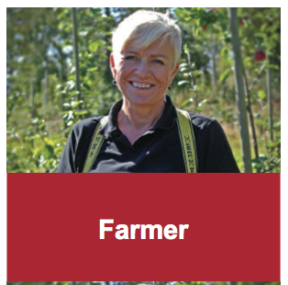  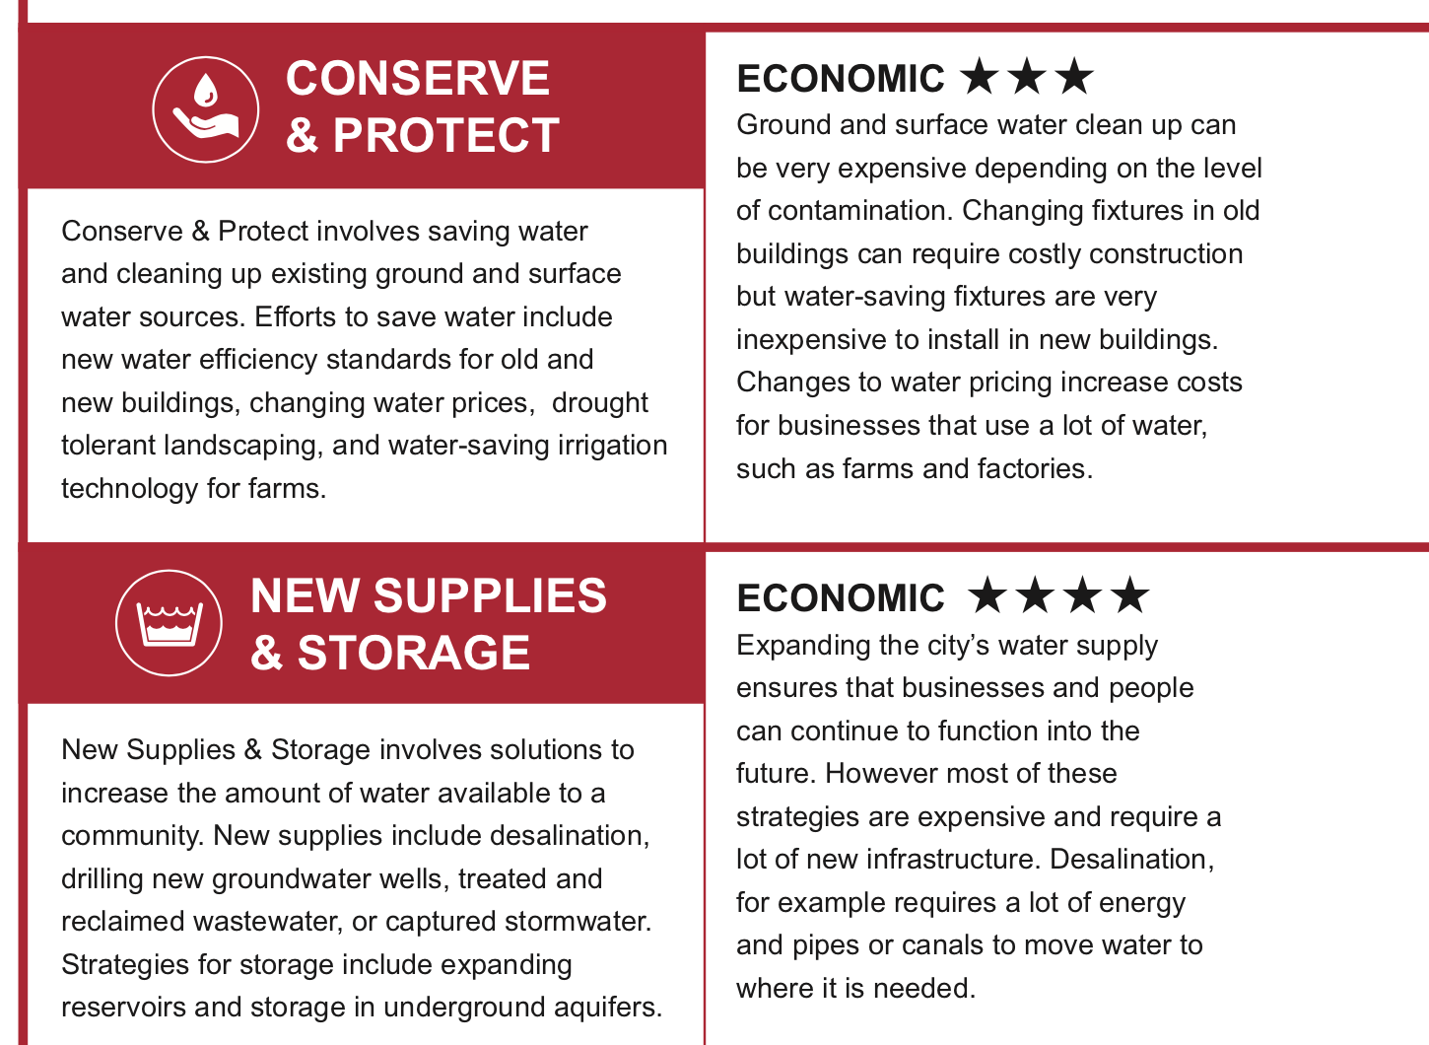

Step 3: Make your resilience plan – 20 minutes
Materials Needed: StoryMap and PowerPoint
- Facilitators move slide to “make your resilience plan”  - “Now you are going to learn more about how the strategies can be put into practice as proposed by city planners, engineers, scientists and local government officials. These strategy options outlined on the screen and on StoryMap, will be combined to make a resilience plan later in this session. Please follow along in your screen while they are read out loud.”  - Participants will go around the breakout room to read the cards out loud. Remember to make sure everyone has a chance to read. Try to have someone new read out loud this time.  - Facilitators pull up the PowerPoint slide that says “my resilience plan” with 3 yellow circles.  - “As a group, you are going to make a resilience plan using the strategy options that were just read out loud. You have three coins that you can distribute among the strategy options. Each Option A costs two coins, and each Option B costs one coin. You cannot use all three coins on one strategy, you can only choose to do Option A or Option B for each strategy. Or, you can choose not to use all of the coins, and ‘leave it be’ and choose to not use one of the strategy options.  - Participants take 1 minute to think or write down their own plan on their own.  - “Before you start the group discussion, you have two minutes to write down your ideas and thoughts on paper. Write down what plan you would choose, and which you would not and why. What do you like about your plan? What would you change?  - Participants have a group discussion on plan options.  - “As a group, you will now discuss what combination of strategy options you would like to put together to make an overall resilience plan for Ottawatta. You have 15 minutes for this section.”  - Facilitators make sure that there is time for the participants to make a final plan before moving on to the next section. The group does not need to be in complete agreement, but a plan must be made for the next section. | Card:  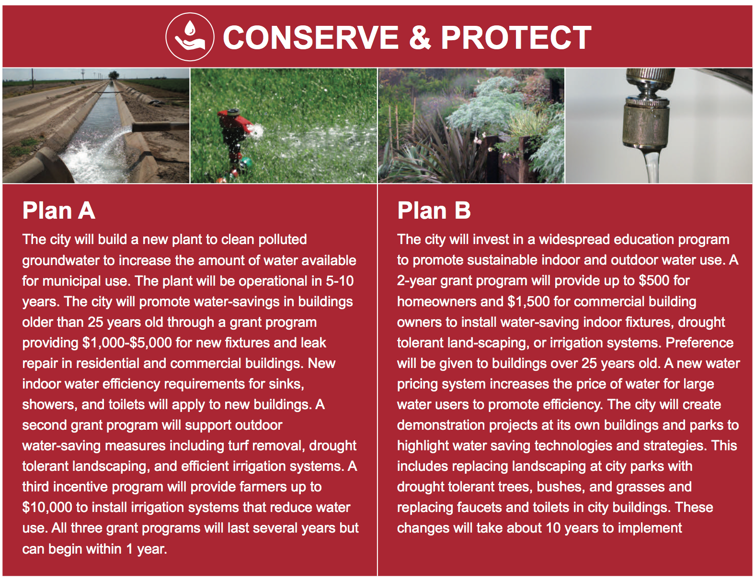

Step 4: Implement and explore your resilience plan – 10 minutes
Materials Needed: StoryMap
- Facilitators in each group will guide the participants to see what happened to the community at large and to certain stakeholders using StoryMap visualizations.  - Once the group chooses a plan, have ONLY THE FACILITATOR choose “submit your resiliency plan to us by clicking here” This will lead you to a google form where you can click and submit the plan your group chose. Once you have done that, instruct the group to go to “visualize your plan by the options below.” Scroll to your plan and click it, this will open a new tab to be able to fully explore your plan as a group.  - “Now that you have created a plan, let’s see what it will look like when it’s implemented in Ottawatta. We will have 10 minutes to walk through the plan on StoryMap and discuss how the plan has affected the city and the people who live there. Please read the introduction to the appropriate final resilience plan out loud. This will give you an overview of your plan before going through the rest of the tabs”  - “Here is a visualization of the resilience plan you created. Do you notice any changes?”  - Click on the appropriate link for your groups’ chosen plan and click through it by clicking on the top tabs and scrolling down through them. Either you or the participants can read through the tabs.  - Once the participants understand how their plan affects Ottawatta, the Facilitator should ask prompting questions about the economic, social and environmental impacts of the group’s plan. Some options for questions are below.  - “How do you think your resilience plan impacted the economy?”; “How do you think your resilience plan impacted the society?; “How do you think your resilience plan impacted the environment?”  - “Did the plan impact the city in a positive or negative way? How so? Were some areas/people impacted positively, and some negatively? What do you think about that?”  - Once you are finished discussing your plan, head back into the main Zoom room. | 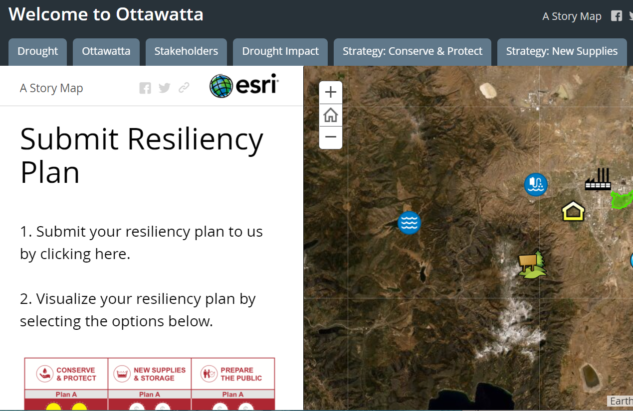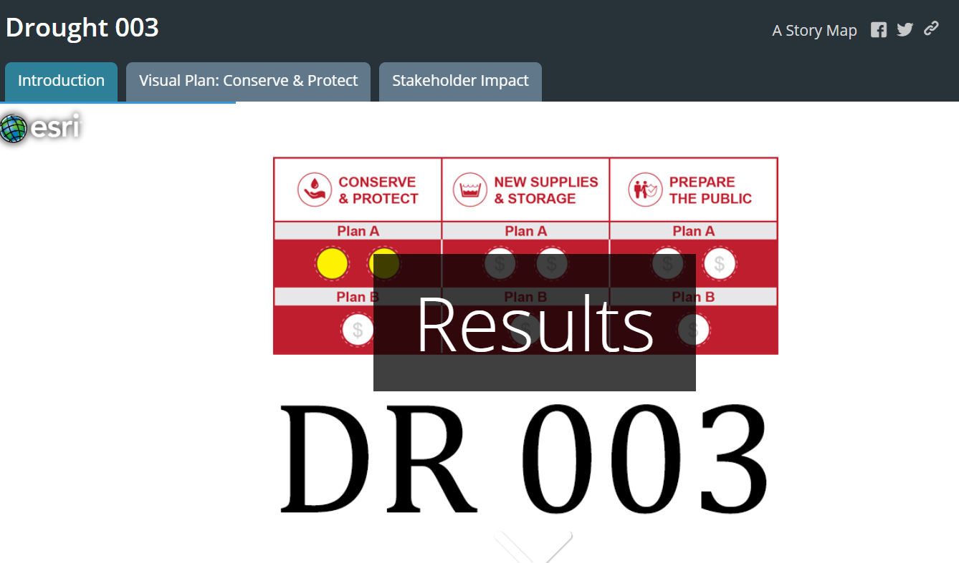
StoryMap Link: https://nu.maps.arcgis.com/apps/MapSeries/index.html?appid=64c264c15299442985b058643228c46d
Using ESRI Storymap: https://www.youtube.com/watch?v=55e2tiLpvcs&feature=youtu.be

RESILIENCE PLAN VISUALIZATIONS LEGEND

Legend
Water supply and use sliders  - Represents change in water use and supply from current state.  - If the sliders are both in the center, then water use and water supply in the future are about the same as current use and supply.  - Does not account for potential shortages due to drought or increase in demand due to population growth.  - In general, decreasing use and increasing supply will make the community more resilient to drought | 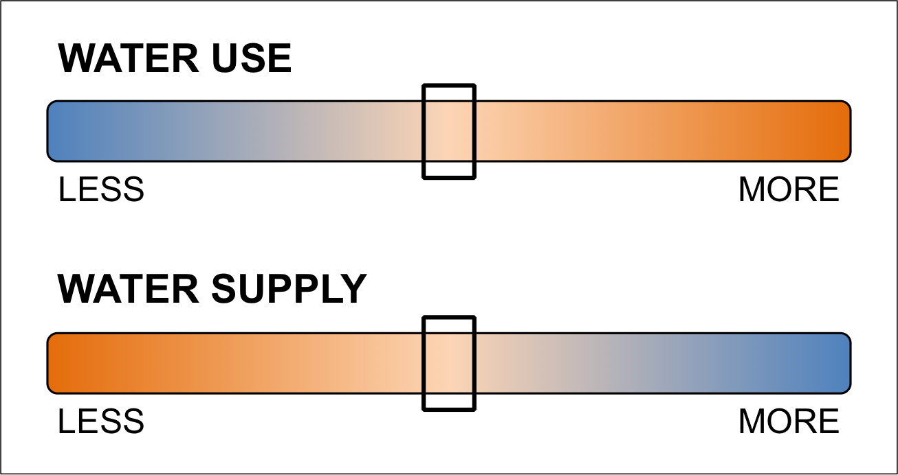
New water mains
Wildfire preparation zones | 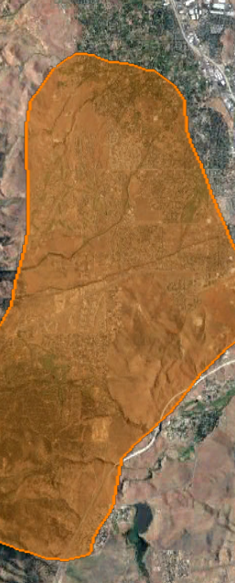
Wildfire/watershed restoration area | 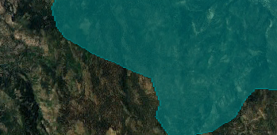
Polluted groundwater plume | 