  - Project Planning Table
  - Planning Activity

OVERVIEW
The project planning table helps professionals at cultural organizations such as museums think through potential sustainability-related projects for their institutions. It can be used as a tool to facilitate a sustainability planning process and document a sustainability plan.

MATERIALS
- Sustainability project planning table
The materials are available for free download from nisenet.org. You can print the table on a large sheet of paper to capture ideas during a meeting and/or or create a digital version of table that you can update as your plans develop. The version attached to this guide is formatted for 11”x17” paper. You may choose to have your team work on one document all together, or split up into small groups and combine your tables later.

USING THE TABLE
Use the table to document, assess, and plan sustainability efforts at your organization. The columns of the table represent different aspects of an organization’s work, including its facilities and operations; public engagement and learning; policy and governance; and community partnerships. The rows of the table capture the degree to which efforts are existing and well established; under development; or future possibilities. You can modify the column and row headers to better fit your organization.
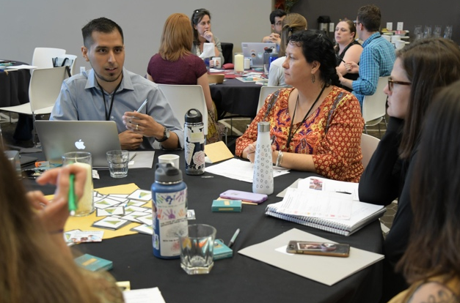
You can do the table on your own or work with others. If you collaborate, allow time for discussion about current projects, ways to improve them, and ideas for the future as you fill in the table.
The completed chart shows an organization’s full sustainability plan. It can be modified through time as a plan evolves, and it can also be used to communicate a finalized plan at a glance.

REFLECTION
Once you have filled in the table, take time to consider some or all of the following reflection questions:
- Has your organization tried anything in the past that did not go well? What can you learn from those efforts?
- Are there areas where sustainability is well established at your organization and areas where your work needs strengthening?
- Did this activity give you new ideas for how you could integrate sustainability into your own work or ways you can partner with others?
- Are there financial or feasibility concerns for current or future efforts?
- Which current and potential future efforts are best aligned with your organization’s priorities and capacity?
- Where do you want to invest your resources now and in the future?
- What immediate next steps do you identify?
- What concrete resources would help you move your plans and ideas forward?
- Did you come up with any ideas that aren’t be a good fit for your organization on its won but could be taken up through partnerships with others in the community?

CREDITS AND RIGHTS
Created by Arizona State University for the NISE Network. Copyright 2019, Arizona State University. Published under a Creative Commons Attribution-Noncommercial-ShareAlike license: http://creativecommons.org/licenses/by-nc-sa/3.0/us/
This activity and planning table are based on a tool created by Nicole Haahr at the Children’s Museum of New Hampshire.
Image of educators copyright Arizona State University.
The Rob and Melani Walton Sustainability in Science and Technology Museums program is supported through funding from the Rob and Melani Walton Foundation.

  - Sustainability Project Planning Table

 | Facility and operations | Public engagement and learning | Governance and policy | Community partnerships
Well established program or practice
Efforts that are under development or could be improved
Ideas for future efforts

