SDG Brainstorm
  - Worksheet

DISCUSSION

Review the 17 Sustainable Development Goals (SDGs) below. For each goal, consider:

Does this goal align with your organization’s mission? If so, do you have initiatives that address this goal, or could you create new initiatives to address it?

Are there other organizations in your community that address this goal?

You might choose to answer these questions for all 17 or just a few that align with your organization’s priorities. Each goal includes an example to help you brainstorm. As you work, you can delete the example text and fill in your own ideas. When you’re finished, work through the reflection questions at the bottom of page 4 with others from your organization.

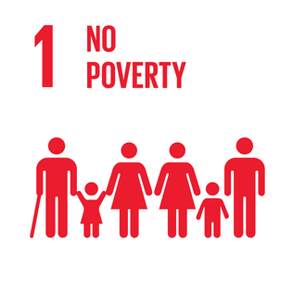 | EXAMPLE: We provide free admissions passes to social service organizations to give out to their patrons, but not many families use the passes. On a trial basis, we could try letting families in without passes or proof of income if they ask for free admission and see what effect it has.
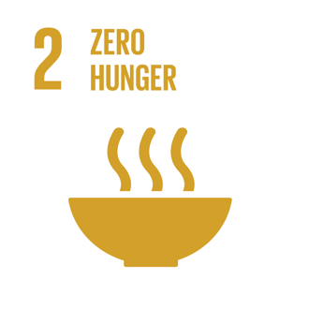 | EXAMPLE: Can we make visits to the food bank fun for kids by providing hands-on activities they can do while their parents are shopping? Can we set up a collection box for the food bank that our museum visitors could contribute to?
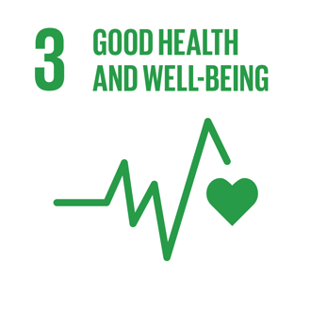 | EXAMPLE: Our play grocery store has information about nutrition but our vending machine and cafeteria do not offer many healthy food choices. We should see if we can provide better options.
 | EXAMPLE: Our entire mission is focused on learning opportunities for families and kids! In addition, we partner with schools by providing field trip and outreach programs. There are many other organizations with educational missions, and we could make stronger connections with them.
 | EXAMPLE: Every year for women’s history month we highlight the accomplishments of local women and the potential of all girls to succeed. We also offer special programs for both brownies/girl scouts and cub/boy scouts. We could reach out to women’s support groups and/or LGBTQ organizations in our community and learn more about what they do.
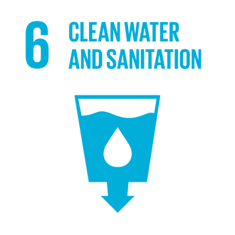 | EXAMPLE: Our summer campers test water in the stream outside our museum to see if our local water is clean. We should see if there are any citizen science projects that we could contribute data to.
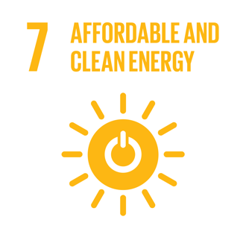 | EXAMPLE: We have an exhibit that shows how solar panels work, which is sponsored by our local energy utility. We could add information about how families can enroll in the program to use clean energy sources and let visitors know that our museum participates.
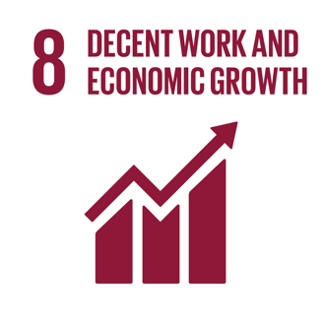 | EXAMPLE: We participate in our community’s job training program for teens. Some of our staff and volunteers feel that this is a very time intensive effort. Can we increase internal support for the program if we frame it as a sustainable development effort? Could we get funding for the program if we pitch it this way?
 | EXAMPLE: Our maker space is designed to inspire the innovators of the future. Our library has similar programming, so could sustainability be a way to distinguish what we do?
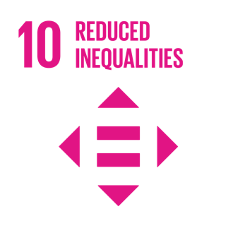 | EXAMPLE: We provide outreach programs to every elementary school in our county so that all children in our region have access to high quality learning opportunities outside of school. Maybe we can encourage other organizations to do the same and apply for funding together.
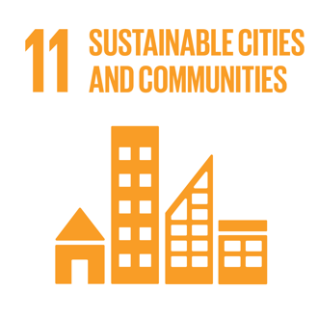 | EXAMPLE: When we opened, our museum renovated an existing building and helped to revitalize our downtown area. Now, can we do something that is focused on outdoor amenities for the neighborhood?
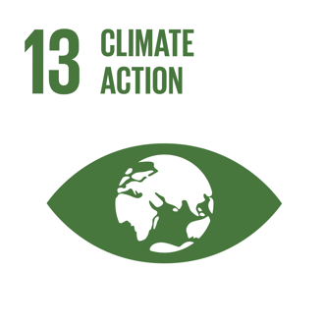 | EXAMPLE: Our museum has issued a statement about our position with regard to climate science, but we don’t have very much about this topic in our exhibits or programs. Could the youth climate movement be a way to engage kids who have “aged out” of our other offerings?
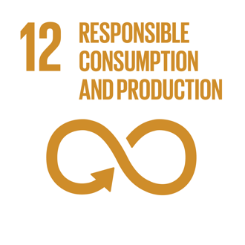 | EXAMPLE: We stopped using disposable service ware in our cafeteria or our events. However, our craft and make-and-take programs still use a lot of materials and create waste that isn’t recyclable—can we improve there?
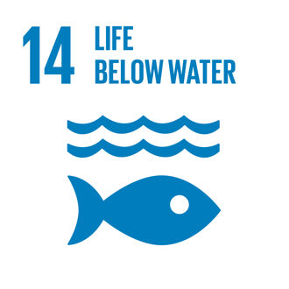 | EXAMPLE: Our coral reef tank shows the diversity of animals that live in the ocean. We could have our animal care specialists talk more about conversation and preserving biodiversity when they do public presentations.
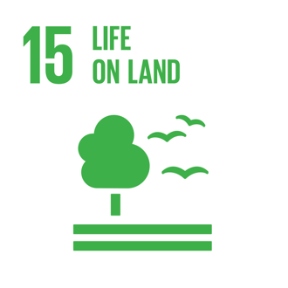 | EXAMPLE: The city maintains native plants and interpretive signage near our building. We have talked about doing programming related to these plantings. We could see if our local university extension would do something for summer camp.
 | EXAMPLE: We allow community groups to use our meeting space free of charge. We can reach out to these and other organizations and see if there is more we can do.
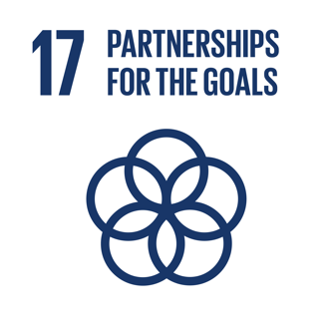 | EXAMPLE: Our partnerships are pretty strong with other organizations that have an educational mission, such as the university, the school district, and afterschool programs. We would like to build new partnerships with organizations that support other goals, especially social service organizations that help families with food insecurity and homelessness.

REFLECTION
Did this activity give you a new perspective on what sustainability is?

Did this activity give you new ideas for how you could integrate sustainability into your work? Or new groups you could partner with?

Was there anything surprising about the SDGs or their connections to your organization? Anything interesting or inspiring?

Does this activity suggest any ideas that you want to pursue?

CREDITS AND RIGHTS
Created by Arizona State University for the NISE Network. Copyright 2019, Arizona State University. Published under a Creative Commons Attribution-Noncommercial-ShareAlike license: http://creativecommons.org/licenses/by-nc-sa/3.0/us/

The Sustainable Development Goals (SDGs) icons are used according to the United Nations guidelines: https://www.un.org/sustainabledevelopment/wp-content/uploads/2019/01/SDG_Guidelines_AUG_2019_Final.pdf
The Rob and Melani Walton Sustainability in Science and Technology Museums program is supported through funding from the Rob and Melani Walton Foundation.

