Explorando herramientas: Formas misteriosas

¡Intento esto!  - Pon tu mano dentro de la caja. ¿Qué sientes?  - Haz un dibujo de uno de los objetos que sentiste dentro de la caja.  - Ahora saca el objeto de la caja y compáralo con lo que dibujaste. ¿Qué información tiene tu dibujo? ¿Qué le hace falta?  - Haz lo mismo con otro objeto y compáralo con el primero. | 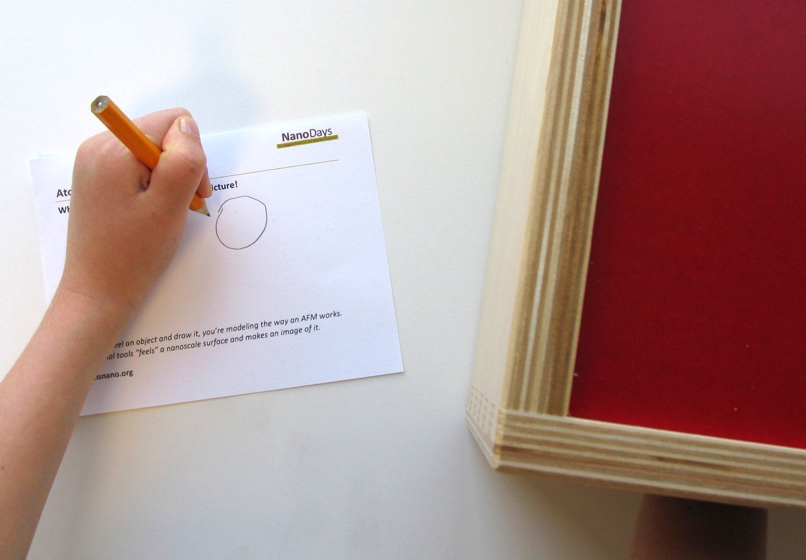
¿Qué sucede?
Al tocar la “forma misteriosa” que está en la caja y dibujar lo que piensas que es, estás imitando la manera en la que un instrumento especial llamado microscopio de sonda de barrido (SPM por sus siglas en inglés) funciona. Tu mano actúa como la parte sensible del SPM, mientras tu cerebro actúa como el programa de computadora que crea una imagen de lo que el instrumento “siente.”  Estos microscopios nos permiten producir imágenes de cosas pequeñas, cosas de tamaño nanométrico como átomos que son demasiado pequeños para ser vistos, incluso con poderosos microscopios de luz con mucha potencia. Las cosas así de pequeñas se miden en nanómetros. Un nanómetro es una milmillonésima parte de un metro.  El microscopio de sonda de barrido (SPM, por sus siglas en inglés) utiliza una punta muy afilada para moverse a través de una superficie nanométrica. Para hacer una imagen, los investigadores mueven la punta hacia adelante y hacia atrás muchas veces a través de la muestra. Un programa de computadora combina los datos para crear una imagen. | 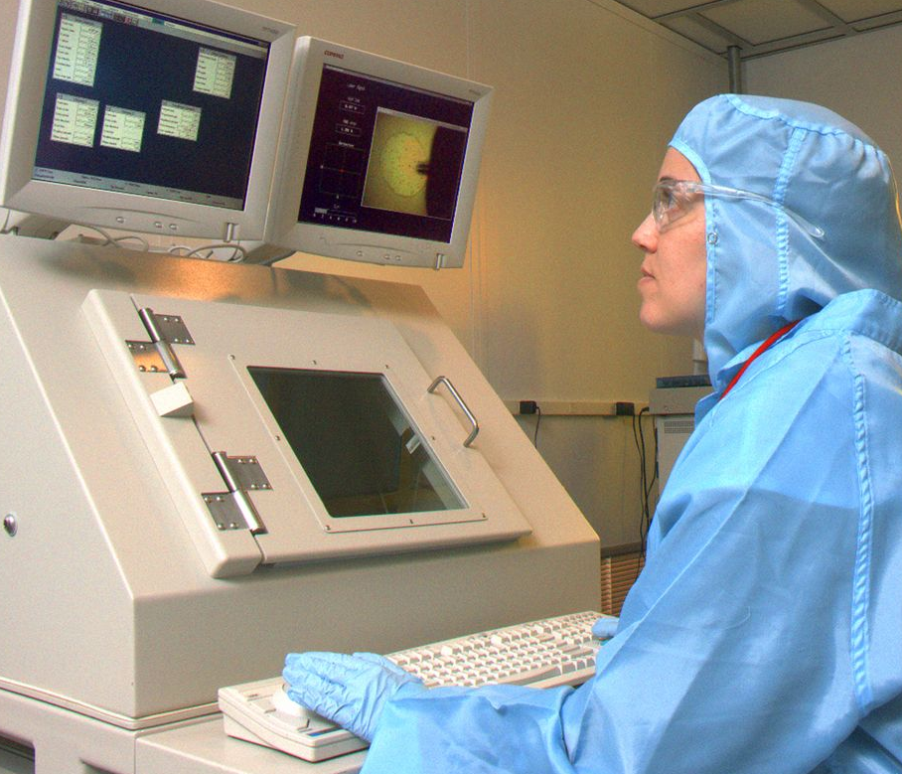  Investigador usando un microscopio  de sonda de barrido
Los microscopios de sonda de barrido son muy poderosos. ¡Incluso algunos pueden detectar y crear imágenes de átomos individuales! Sin embargo, todavía no pueden capturar todos los detalles de los objetos de tamaño nanométrico. Los investigadores utilizan otros instrumentos para aprender cosas que estos microscopios no puede detectar.

Asimismo, tus dedos no pueden detectar toda la información acerca de las formas misteriosas que están en la caja. Al sacar y ver los objetos de la caja, probablemente pudiste obtener más información acerca de ellos (como de qué color eran). Las imágenes que dibujaste contienen la información que pudiste obtener al tocar los objetos, pero otras cosas que a lo mejor sentiste (como el material) quizás faltaron en tu dibujo.

¿Por qué es nanotecnología?
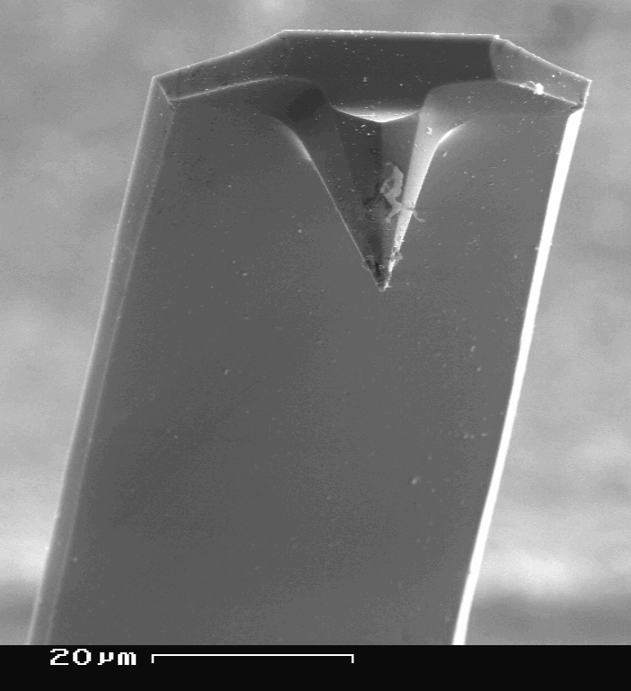  Punta de un SPM | Los científicos usan herramientas y equipos especiales para trabajar en la nanoescala. Los microscopios de sonda de barrido (SPM) les permiten a los investigadores detectar y hacer imágenes de objetos que se miden en nanómetros, e incluso cosas más pequeñas. (Un nanómetro es la milmillonésima parte de un metro).  La invención de SPM significó un gran avance en el campo de la nanotecnología. Una vez que los científicos pudieron hacer imágenes de cosas tan pequeñas como átomos individuales, también pudieron empezar a manipular y estudiar las cosas en esta escala tan diminuta. Sin SPM, ¡la nanotecnología no estaría donde se encuentra hoy!

Learning objective
Scientists use special tools and equipment to work on the nanoscale.

Materials
- Tactile box
- Assorted small objects to hide in the box
- “Scanning Probe Microscope” cards
- Pencils

The tactile box included in the NanoDays kit is available from www.lakeshorelearning.com (#RJ27). You can substitute a cloth bag or a cardboard box with holes cut in the sides.

Notes to the presenter
SAFETY: Some of the objects used in this activity could present a choke hazard to young children. Supervise visitors at all times while doing this activity. You may choose to remove or replace the smaller objects.

There are two holes in the tactile box, one on each end. One is for visitors to feel the objects and one is for you to use to hide new objects.

It works well to have visitors start with a selection of balls that are different colors and materials, then try other objects such as small toy animals. You can find other mystery shapes for visitors to feel, in addition to those included in the activity.

Young children, individuals with limited dexterity, and low-vision visitors may prefer to describe what they feel rather than draw it.

While most visitors are enthusiastic about discovering the “mystery shapes” in the box, some may hesitate to put their hands inside. You can reassure them that there’s nothing scary or icky in the box!
Related educational resources
The NISE Network online catalog (www.nisenet.org/catalog) contains additional resources to introduce visitors to nanotechnology and the tools researchers use to study and make things that are too small to see:
- Public programs include Attack of the Nanoscientist, Cutting it Down to Nano, Intro to Nano, Ready, Set, Self-Assemble, and Tiny Particles, Big Trouble!
- NanoDays activities include Exploring Size—Powers of Ten Game, Exploring Tools—Mitten Challenge, and Exploring Tools—Special Microscopes.
- Media include the video What Happens in a Nano Lab?
- Exhibits include Creating Nanomaterials and NanoLab.

SPM Background Information

What are SPMs?
Scanning probe microscopes (SPMs) are a family of tools used to make images of nanoscale surfaces and structures. They use a physical probe to scan the surface of a sample, gathering data to create a three-dimensional image of it. In addition to visualizing nanoscale structures, some kinds of SPMs can be used to move individual atoms.

SPMs are different from other kinds of microscopes because the user doesn’t see the surface directly. Instead, the tool “feels” the surface and creates an image to represent it.

How do they work?
SPMs are very powerful microscopes. An atomic force microscope, or AFM, is a specific kind of SPM.

An AFM has a probe tip mounted on the end of a cantilever. The tip can be as sharp as a single atom. It can be moved precisely and accurately back and forth across the surface of the sample.  When the tip is near the sample surface, the cantilever is deflected by a force. AFMs can measure deflections caused by many kinds of forces, including mechanical contact, electrostatic forces, and magnetic forces. The distance of the deflection is measured by a laser that is reflected off the top of the cantilever and into an array of photodiodes. | 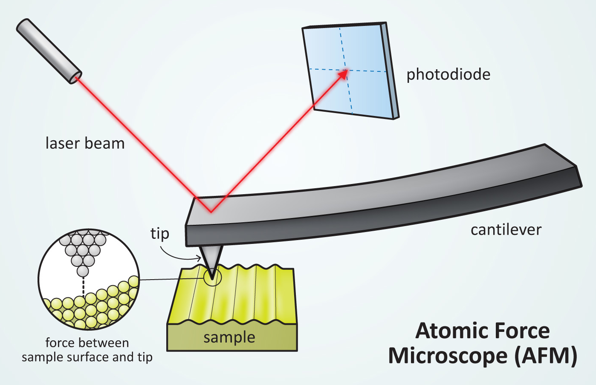

Some AFMs can detect differences in height that are a fraction of a nanometer! (A nanometer is a billionth of a meter.)

Researchers use AFMs in a number of different ways, depending on the information they’re trying to gather. The tip of the tool can be in constant contact with the sample, it can be slightly above the sample, or it can tap gently on the sample as it moves.

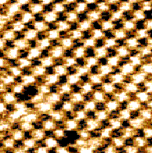  AFM image of salt (NaCl) | The AFM tip is moved back and forth across the sample many times. A computer program combines the data to create an image.  AFM images are inherently black and white. To make them easier to interpret, they are often colorized. Different colors are used to indicate differences in height along the surface.  AFMs can be used with almost any type of material, including biological samples. They have been used to image DNA, individual proteins, and even living cells.

Credits and rights
Photograph of researcher using AFM by Charles Harrington Photography, courtesy of Cornell Nanoscale Facility.

Image of AFM tip by SecretDisc, from Wikimedia Commons.

Illustration of AFM by Emily Maletz for the NISE Network.

Image of sodium chloride courtesy of Ernst Meyer, University of Basel, from Wikimedia Commons.

This project was supported by the National Science Foundation under Award No. 0940143. Any opinions, findings, and conclusions or recommendations expressed in this program are those of the author and do not necessarily reflect the views of the Foundation.

Copyright 2012, Sciencenter, Ithaca, NY. Published under a Creative Commons Attribution-Noncommercial-ShareAlike license: http://creativecommons.org/licenses/by-nc-sa/3.0

