**Macintosh HD:Users:raeostman:Desktop:Frankenstein200 Design Pack:Frankenstein200 Logo:EPS - Print:frankenstein200-K.epsFACILITATOR GUIDE TO**

**DOUGH CREATURE**

# DESCRIPTION

In this activity, learners make a creature out of conductive dough and use it to create an electrical circuit. The activity is designed to prompt conversation and reflection about responsible innovation, inspired by themes raised in Mary Shelley’s novel *Frankenstein.*

# AUDIENCES

This activity is best suited for ages 7 and up. Younger children can participate successfully with support from an educator or caregiver.

# LEARNING OBJECTIVES

# The primary objective of this activity is to encourage creativity and reflection about responsible innovation. In addition, learners will explore the following concepts:

# People are creative! We’re always learning more about the world and inventing new things.

* It’s important to think ahead as we study science and make new technologies.
* Researchers in the field of *cellular agriculture* combine knowledge from farming and medicine to produce agricultural products from cell cultures.

# MATERIALS

* Squishy Circuits kit, containing:
  + Colored play dough (conductive)
  + White modeling clay (insulating)
  + Battery pack with wire leads and AA batteries
  + LED bulbs, 10mm diffused (variety of colors)
  + DC hobby motor with wire leads
  + Hobby buzzer with wire leads
  + Plastic tools to cut and shape dough and clay
* Extra AA batteries
* Plastic board to use as work surface (1 per station)
* Activity booklet
* Sign holder and table sign

Sources and instructions for creating your own kit materials are provided at the end of this facilitator guide.

# PRESENTATION

**Preparation:**

Before beginning this activity, go through it yourself. This will ensure that you can easily help participants, and will help you work out how to best organize your materials. Make a few sample dough creatures to show participants. Be sure you know how to complete a circuit, avoid short circuits, and get the bulbs, motor, and buzzer to work.

To familiarize yourself with the activity, use the activity booklet. It provides step-by-step instructions for the activity. It also includes contextual information about Mary Shelley’s novel *Frankenstein* and the questions the story raises for current science and engineering.

**Set up:**

* Check that your equipment is all in working order. Be sure your battery pack has working batteries. Check the bulbs and dispose of any burnt out LEDs (short circuits can ruin the bulbs).
* Set out all materials.

**Activity flow:**

Open by asking participants if they’ve ever heard of Frankenstein’s “monster.” Share that the original story was written 200 years ago by Mary Shelley, and has been retold many times. Ask if they know what happens in the story, and establish the basic plotline. In the novel, a student named Victor Frankenstein builds a creature from dead body parts, and uses electricity to bring it to life. Unfortunately, Frankenstein didn’t think ahead to what his creature would do, or how he would take care of it, if he succeeded in bringing it to life.

Show participants the materials and ask if they would like to make their own creature that conducts electricity. Share the activity guide with participants, so they can follow use the instructions and read the information. Be sure they learn the basics of how to make a circuit and avoid short circuits with the materials before they begin a more complex project.

Then invite participants to make their own creature and bring it to “life” with a bulb, buzzer, or motor. As they plan and build their creatures, you can ask guiding questions, such as:

* *What kind of creature do you want to make?*

As they complete their projects, be sure to ask participants some or all of the reflection questions! These questions will give participants a chance to think about why people create, and to consider why it might be important to plan ahead and take responsibility for the things we create:

* *What is your creature like? Is it kind, silly, or naughty?*
* *Does it get along with others?*
* *What does your creature do?*
* *Where does it live?*
* *Who takes care of it?*

Finally, return to Mary Shelley’s story. Victor Frankenstein built a creature and brought it to life, but he didn’t take responsibility for it. The creature was miserable, and did some very bad things. For example, he set fire to the house of a family that was mean to him.

* *Did Frankenstein spend too much time working on his experiments, and not enough time thinking about what might happen if he succeeded?*

There’s no right or wrong answer to the reflection questions! Everyone can form their own opinions. You can help encourage visitors to develop and share their own ideas by referring to the Conversation Tips guide.

**Clean up:**

* Wipe down all the metal components with a damp cloth after use. The play dough contains salt that will rust the components.
* Keep the play dough and modeling clay in air-tight containers so they don’t dry out.

**Audiences:**

Young children and individuals with special needs may need assistance with some steps in this activity.

**Safety:**

* Supervise young children to ensure they do not mouth any materials, as some materials may present choking hazards.
* The battery pack has two wire leads. Participants should not allow the metal ends of the two leads to touch each other, as this will create a short circuit and could cause the materials to get very hot. Metal parts should always have a lump of dough or clay in between them.
* If a circuit feels hot, or you notice any conductive dough turning black or bubbling, turn off the battery pack and eliminate any short circuits before proceeding.

**PROGRAMMING OPTIONS**

This activity can be incorporated into a variety of educational programs, such as after-school programs, family workshops, and summer camps. In longer program formats, you can use videos and books to familiarize participants with the Frankenstein story:

* The 1931 Hollywood movie *Frankenstein,* directed by James Whale, introduced the world to Boris Karloff’s iconic version of the creature.
* *Frankenweenie* is a 2012 retelling of the Frankenstein story, directed by Tim Burton.
* There are also many books that share the story, which are appropriate for a variety of audiences.

You can also use videos to introduce new fields of research, such as synthetic biology and genetic engineering, that are modifying existing living things and creating new forms of life:

* [Synthetic Biology Explained](https://youtu.be/mlOFE9-3CN0) (Grist) introduces a new field of research that combines the principles of engineering with the building blocks of biology. YouTube: https://youtu.be/mlOFE9-3CN0

# MATERIALS INFORMATION

**Sources:**

* Squishy Circuits kits can be purchased at <http://squishycircuits.com/>. You can also restock or build your own kit:
  + Play dough (conductive) and modeling clay (insulating) can be purchased at craft and discount stores.
  + Battery packs, LED bulbs, motors, buzzers, and wire leads can be purchased at electronics stores.
  + Plastic cutlery can be used as cutting and shaping tools.
* Plastic cutting boards are available at discount stores.
* Print materials for this activity can be downloaded from [nisenet.org](http://nisenet.org/).

**CREDITS AND RIGHTS**



Copyright 2017, Arizona State University. Published under a Creative Commons Attribution-Noncommercial-ShareAlike license: <http://creativecommons.org/licenses/by-nc-sa/3.0/us/>

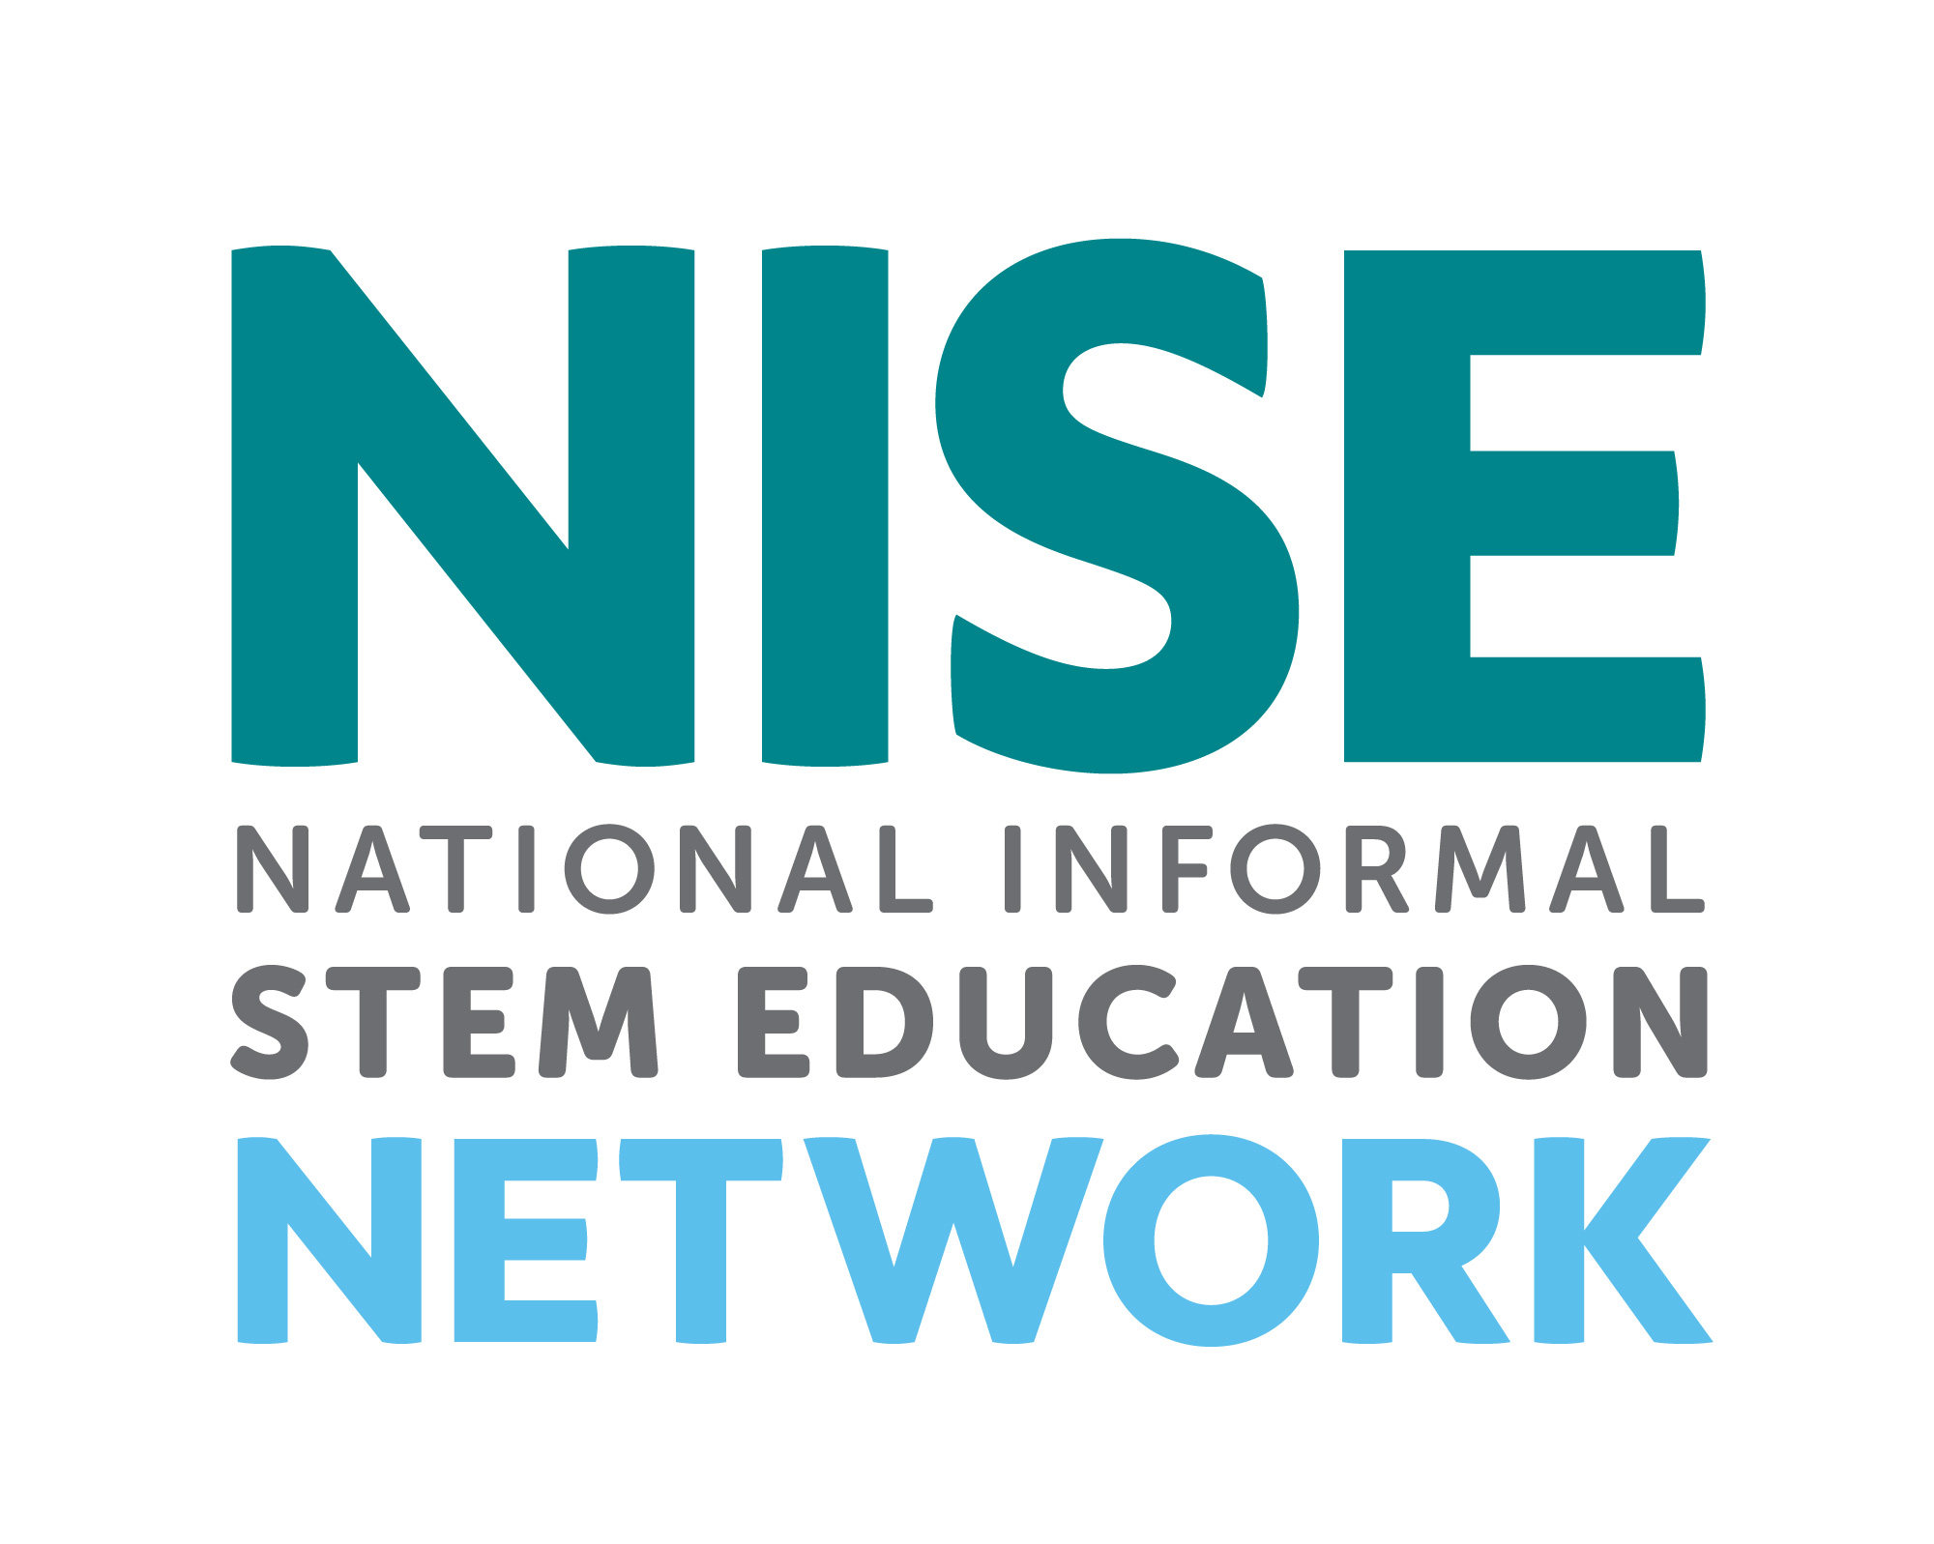

Distributed in collaboration with the National Informal STEM Education Network: nisenet.org



This project was supported by the National Science Foundation under Grant Number 1516684. Any opinions, findings, conclusions, or recommendations expressed in this program are those of the authors and do not necessarily reflect the views of the Foundation.

This activity was adapted fromSquishy Circuits, developed by AnnMarie Thomas at the University of St. Thomas. Retrieved from: <http://courseweb.stthomas.edu/apthomas/SquishyCircuits/index.htm>

Instruction and promotion photos by the Science Museum of Minnesota for Frankenstein200.

Illustration from an early edition of *Frankenstein* from Wikimedia Commons. Retrieved from: https://commons.wikimedia.org/wiki/File:Frankenstein,_pg_7.jpg

Photograph of a researcher holding a cultured beef burger courtesy Maastricht University. Used with permission.

Photograph of Boris Karloff as Frankenstein’s monster from Wikimedia Commons. Retrieved from: https://commons.wikimedia.org/wiki/File:Frankenstein%27s_monster_(Boris_Karloff).jpg

Photograph of baby feet from Wikimedia Commons. Retrieved from: https://commons.wikimedia.org/wiki/File:Baby_feet.jpg