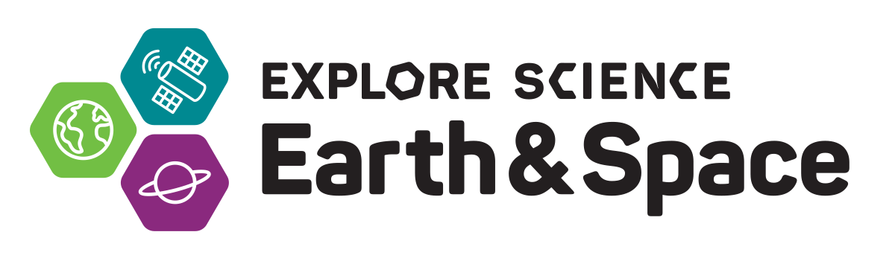
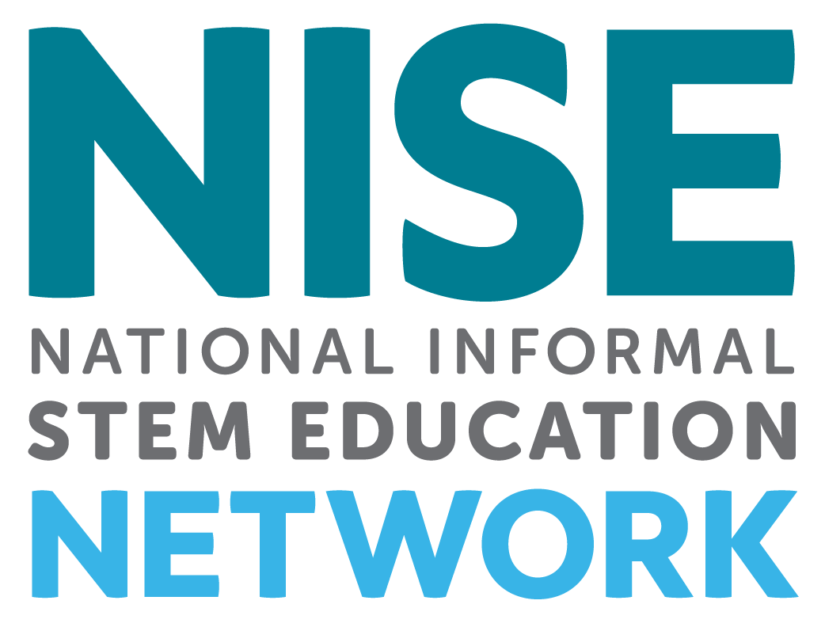

Toolkit Application Overview
________________________________________________________________________________

Revised 8-28-19

The National Informal STEM Education Network (NISE Net) is pleased to offer 350 free Explore Science: Earth & Space 2020 toolkits to new and existing eligible partners in the United States.
In collaboration with NASA, the NISE Network has assembled a new set of engaging, hands-on Earth and space science experiences with connections to science, technology, and society.

The 2020 Explore Science: Earth & Space toolkit will ship in two parts this year!
- Part A will ship in January 2020 and will include a set of hands-on activities.
- Part B will ship in August 2020 and will include a hands-on collaborative Moon game as well as science activities about the Moon
There is one application for the 2020 toolkit - all successful applicants will receive both Part A and Part B of the toolkit. Each part of the toolkit will require a report, please see the requirements section of the overview for further details.

________________________________________________________________________________

TOOLKIT CONTENTS & AUDIENCES
Three hundred and fifty (350) free Explore Science: Earth & Space physical 2020 toolkits will be awarded to successful applicants from eligible organizations.
- Activities are designed for use in children’s museums, science centers, science museums, public planetariums and observatories, and NASA visitor centers in the United States.
- Activities are designed for family audiences with a range of experiences appropriate for visitors ages 4 through adult
  - One activity is designed specifically for early childhood audiences (ages 0 - 4)
  - Some activities are more appropriate for slightly older audiences (ages 8 - adult)
- Explore Science: Earth & Space 2020 toolkits will include:
  - Hands-on activities to engage the public in Earth and space sciences including: heliophysics, Earth science, planetary science, astrophysics, and their connections to society
  - Professional development materials including facilitation & content training videos
  - Event planning guides
  - Marketing and promotional materials

In addition to the physical toolkits, all digital materials will be available online for free download. The NISE Network will also be hosting a series of one-hour online workshops featuring a variety of topics; all online workshops will be recorded and archived.

________________________________________________________________________________
________________________________________________________________________________

TIMELINE
- September 1, 2019: Online application opens to apply for a free physical toolkit
- November 1, 2019: Deadline to submit application
- December 2019: Notification of award decisions
- January 2020: Part A of physical toolkit shipped to successful applicants
- March - May 2020: Successful applicants host required public event(s) with Part A
- June 15, 2020: Part A required report due online
- August 2020: Part B of physical toolkit shipped to successful applicants
- September 2020 - January 2021: Successful applicants engage local audiences with Part B
- February 1, 2021 Part B required report due online

________________________________________________________________________________

ELIGIBILITY

The physical toolkit is designed for informal science education public events and outreach. To be eligible to receive a physical toolkit, organizations must be:
- Located in the United States (including US territories)
- Public informal science outreach and education institutions such as:
  - science museums and science centers,
  - children’s museums,
  - natural history museums,
  - public planetariums and observatories, and
  - NASA visitor centers.
Please note that K-12 schools, afterschool programs, libraries, parks, and astronomy clubs are not eligible to receive physical toolkits. Consider downloading a digital toolkit if your organization does not meet eligibility criteria. Digital toolkits will be available for download after the physical toolkits ship.

________________________________________________________________________________

DIGITAL TOOLKIT

In addition to the physical toolkits, digital versions of the toolkit will be available online as a free download. Part A will be available in February 2020, Part B will be available in August 2020. Digital versions of past toolkits for 2017, and 2018, and 2019 toolkits are available online at:
http://www.nisenet.org/earthspacekit
________________________________________________________________________________

________________________________________________________________________________

APPLICATION PROCESS

Applications for a physical 2020 toolkit must be submitted online using SurveyGizmo
by November 1, 2019:
https://www.surveygizmo.com/s3/5165260/Earth-Space-Toolkit-2020-Application
Preview the application: Please note that it is NOT possible to save your work in the SurveyGizmo online form and return for additional edits. Applications left idle for too long will go blank when you progress to the next screen. Please plan to complete the online application in one session. You may want to write your responses in a Word doc, save, and then cut and paste that information into this application. You may download the application in PDF and Word document formats here:

http://www.nisenet.org/earthspacekit-apply

________________________________________________________________________________

SELECTION PROCESS

A total of 350 copies of the 2020 toolkit will be awarded through a competitive award process. The NISE Network project team will review all toolkit applications and award toolkits only to organizations that meet the eligibility criteria. Successful applications will demonstrate strong alignment with the project purpose, comply with the project requirements, reach local underserved audiences, and help the project achieve geographic diversity. If multiple applications are received from the same geographic location, applicants will likely be asked to collaborate on an event and to share a toolkit. Applicants will be informed of award status in December 2019.

________________________________________________________________________________

REQUIREMENTS

Organizations receiving the 2020 Explore Science: Earth & Space toolkit are required to:

- TOOLKIT PART A: Spring 2020 event -
Hold a public engagement event using Part A of the toolkit. Public events can be stand-alone events OR toolkit activities can be incorporated into an existing STEM public engagement event during March - May 2020. A list of example STEM events is included in the section below, “STEM Educational Events - Using Your Toolkit All Year Long”.

- TOOLKIT PART B: Fall 2020 public engagement -
Engage the public using Part B of the toolkit including the immersive Moon game. Public engagement offerings can be stand-alone OR you can incorporate into existing regular STEM programming on-site or off-site during September 2020 - January 2021. Examples could include afterschool programming, birthday parties, homeschool programs, youth-serving organization outreach, regular museum floor programming, etc.
- Report on the use of the toolkit:
Physical toolkit recipients are required to complete two online reports describing their experiences with toolkit Part A and Part B. Toolkit recipients will be provided with a link to these online reports. Reports will include optional evaluation questions to capture the impacts of the project activities on the public.
Kit recipients are required to submit reports by:
- June 15, 2020 for Part A of the 2020 toolkit
- February 1, 2021 for Part B of the 2020 toolkit (this will be a shorter report)

Additional suggestions (not required but encouraged):

- Attending Professional Development online workshops for informal science educators: The NISE Network will offer a variety of free, one-hour online workshops featuring a variety of topics. All online workshops will be recorded and archived. More information will be available through the NISE Network newsletter: http://www.nisenet.org/newsletter
https://www.nisenet.org/event-type/online-workshop

- Collaborating with local experts: We encourage you to collaborate with both local scientists (Earth and space science professionals) and local enthusiasts (e.g. amateur astronomy clubs) - please see the section of this overview entitled “Collaborations and Finding Local Experts”

- Collaborating locally to reach underserved audiences: Partnerships with K-12 schools, afterschool programs, local chapters of national youth-serving organizations, libraries, and local community groups can help your event reach underserved audiences. Tips for collaboration can be found here: http://www.nisenet.org/collaboration-guide
- Annual Partner Survey: In additional to the required reports, we encourage you to participate in the NISE Network annual partner survey conducted by project evaluators. We use the information collected in this survey when we report to our funders. We also use the survey as a way to gather feedback to understand and enhance the NISE Network partner experience.

________________________________________________________________________________

________________________________________________________________________________

STEM EDUCATIONAL EVENTS - USING YOUR TOOLKIT ALL YEAR LONG

We also encourage you to use your toolkit all year round, during celestial events, STEM educational events, and other programming for public audiences:

Celestial events: Meteor showers, lunar eclipses, full moons, planetary events, and more:
- http://earthsky.org/tonight
- https://in-the-sky.org/newscal.php
- https://nightsky.jpl.nasa.gov/planner.cfm
- https://stardate.org/nightsky
- http://www.timeanddate.com/astronomy
- http://www.skyandtelescope.com/observing/sky-at-a-glance/

Earth and space science events:
- World Water Day, March 22, 2020: http://worldwaterday.org
- Earth Hour, March 28, 2020: https://www.earthhour.org
- Global Astronomy Month, April: http://www.gam-awb.org/
- Yuri's Night, April 12, 2020: https://yurisnight.net
- Earth Day, April 22, 2020: http://www.earthday.org
- National Environmental Education Week, week of Earth Day https://www.neefusa.org/greening-stem/environmental-education-week
- Astronomy Day (Spring), May 2, 2020: https://www.astroleague.org/al/astroday/astrodayform.html
- Astronomy Week (Spring), April 27-May 3, 2020: https://www.astroleague.org/astronomyday/facts
- World Oceans Day, June 8, 2020: http://www.worldoceansday.org/
- Asteroid Day, June 30, 2020: http://asteroidday.org
- International Observe the Moon Night, October 5, 2019, September 26, 2020 (The date is selected to enhance visibility of lunar topography): http://observethemoonnight.org https://moon.nasa.gov/observe-the-moon/annual-event/overview/
- Astronomy Day (Fall), September 26 2020: https://www.astroleague.org/al/astroday/astrodayform.html
- Astronomy Week (Fall), September 21 - 27, 2020: https://www.astroleague.org/astronomyday/facts
- World Space Week, October 4-10, 2020: http://www.worldspaceweek.org
- Earth Science Week, October 13-19, 2019; October 11-17, 2020: http://www.earthsciweek.org/

More STEM related-events:
- http://www.nisenet.org/seasons

________________________________________________________________________________

________________________________________________________________________________

COLLABORATIONS & FINDING LOCAL EXPERTS

We strongly encourage you to collaborate with local experts consisting of both Earth and space science professionals and science enthusiasts in your area. Volunteer experts are a key ingredient to many successful public engagement efforts.

It is up to your organization to choose your local collaborators. Regional hub leaders can assist you in finding local partners in your geographic area. Toolkits will include training and orientation materials to help prepare your event volunteers and staff for using the activities.

Volunteer networks focused on astronomy and space include: 1) The Solar System Ambassadors Program (SSA), 2) The Night Sky Network, and 3) AAS Astronomy Ambassadors; these volunteer networks can be searched by state and city to find a possible volunteer nearest you. Local colleges and universities can also provide expertise in Earth and space sciences.

1) The Solar System Ambassadors Program (SSA) is a public outreach program designed to work with motivated volunteers across the nation. These volunteers communicate the excitement of the Jet Propulsion Lab’s (JPL) space exploration missions and information about recent discoveries to people in their local communities. There are 700 Ambassadors in 50 states, Washington DC, Puerto Rico, US Virgin Islands, and Guam. Volunteer ambassadors bring the excitement of space to the public. Ambassadors are space enthusiasts from various walks of life who are interested in providing greater service and inspiration to the community at large.
https://solarsystem.nasa.gov/ssa/home.cfm

2) The Night Sky Network is a nationwide coalition of amateur astronomy clubs bringing the science, technology, and inspiration of NASA's missions to the general public. Night Sky Network members share their time and telescopes to provide you with unique astronomy experiences at science museums, observatories, classrooms, and under the real night sky.
https://nightsky.jpl.nasa.gov/index.cfm

3) AAS Astronomy Ambassadors: The American Astronomical Society (AAS), in partnership with the Astronomical Society of the Pacific (ASP), members of the Center for Astronomy Education (CAE), and other organizations active in science education and public outreach (EPO), has launched a series of professional development workshops and a community of practice designed to help improve early-career astronomers’ ability to effectively communicate with students and the public. Called Astronomy Ambassadors, the program provides mentoring and training experiences for young astronomers, from advanced undergraduates to new faculty. It also provides access to resources and a network of contacts within the astronomy EPO community.
https://aas.org/outreach/roster-aas-astronomy-ambassadors

4) Colleges and Universities: Many colleges and universities have astronomy and Earth science departments. Others may have clubs or local chapters of professional societies. Once you connect with a faculty or staff member they should be able to also suggest undergraduate and graduate students who could volunteer at your event.
________________________________________________________________________________

________________________________________________________________________________

FINDING ADDITIONAL VOLUNTEERS

In addition to finding subject matter experts, you will probably need to recruit other volunteers to help with your event. Potential sources of volunteers may include:
- College students, classes, or clubs with community service requirements
- High school science clubs, or students suggested by local high school science teachers
- Local chapters of professional science and engineering groups that are often associated with local colleges, such as:
o American Indian Science and Engineering Society: http://www.aises.org/
o National Action Council for Minorities in Engineering: http://www.nacme.org
o National Society of Black Engineers (NSBE): http://www.nsbe.org/home.aspx
o National Organization for the Professional Advancement of Black Chemists and Chemical Engineers (NOBCChE): http://www.nobcche.org/
o National Organization of Gay and Lesbian Scientists and Technical Professionals: http://www.noglstp.org
o Society for Advancement of Chicanos and Native Americans in Science (SACNAS): http://sacnas.org
o Society of Asian Scientists and Engineers: http://www.saseconnect.org
o MAES - Latinos in Science and Engineering: http://mymaes.org
o Society of Hispanic Professional Engineers: http://shpe.org
o Society of Women Engineers (SWE): https://swe.org/
- Drama and theater students
- Local industry staff and retirees

________________________________________________________________________________

MORE NASA RESOURCES

NASA Museum Alliance: The Museum Alliance is a community of practice comprising informal science educators at museums, science centers, planetariums, NASA Visitor Centers, Challenger Learning Centers, observatories, zoos, aquariums, parks, and nature centers who wish to share NASA information with their visitors. It is intended to bring current NASA Science and Technology to visitors through professional development of the museums’ staff, advance notice of NASA events, and provision of materials such as visualizations, access to NASA experts, educational materials, etc.
https://informal.jpl.nasa.gov/museum/

________________________________________________________________________________

________________________________________________________________________________

MORE INFORMATION

For project questions and inquiries, please contact your regional hub leader listed below.

________________________________________________________________________________

REGIONAL HUB LEADERS

NISE Network regional hub leaders will be able to help connect you with experts in your area and answer other questions about the project:

- NORTHEAST
CT, DC, DE, MA, MD, ME, NH, NY, NJ, OH, PA, RI, VT, WV
Ali Jackson, ajackson@sciencenter.org, Sciencenter, Ithaca, NY, 607-272-0600x144

- SOUTHEAST
AL, AR, FL, GA, KY, LA, MS, NC, OK, PR, SC, TN, TX, VA, & USVI
Brad Herring, brad.herring@lifeandscience.org, Museum of Life and Science, Durham, NC,
919-220-5429x360

- MIDWEST
IA, IL, IN, KS, MI, MN, MO, ND, NE, SD, WI
Christina Leavell, cleavell@smm.org, Science Museum of Minnesota, St. Paul, MN,
651-221-9434

- WEST
AK, AZ, CA, CO, HI, ID, MT, NM, NV, OR, UT, WA, WY, & AS & GU
Frank Kusiak, frank_kusiak@berkeley.edu, Lawrence Hall of Science, Berkeley, CA,
510-643-7827

________________________________________________________________________________

ACKNOWLEDGEMENTS
This material is based upon work supported by NASA under cooperative agreement award numbers NNX16AC67A and 80NSSC18M0061. Any opinions, findings, and conclusions or recommendations expressed in this material are those of the author(s) and do not necessarily reflect the view of the National Aeronautics and Space Administration (NASA).

________________________________________________________________________________

