**Try this!**

|  |  |
| --- | --- |
| HAL:Users:alijackson:Desktop:Moon poster.jpg  1  3  2 | Look at the poster of the Moon. It’s pretty far away! What do you see? Does the surface of the Moon remind you of anything?  Now, try using a pair of binoculars to look at the poster of the Moon. What do you see? Does using this tool let you see any better?  There are ten animals hidden on the poster of the Moon. Mark where you see the animals on your printout of the Moon. How many did you find? Can you find them all? Tip: You can try drawing what you see on the Moon, or just make an “X” where you see it. |

*Tools help scientists study objects that are very far away.*

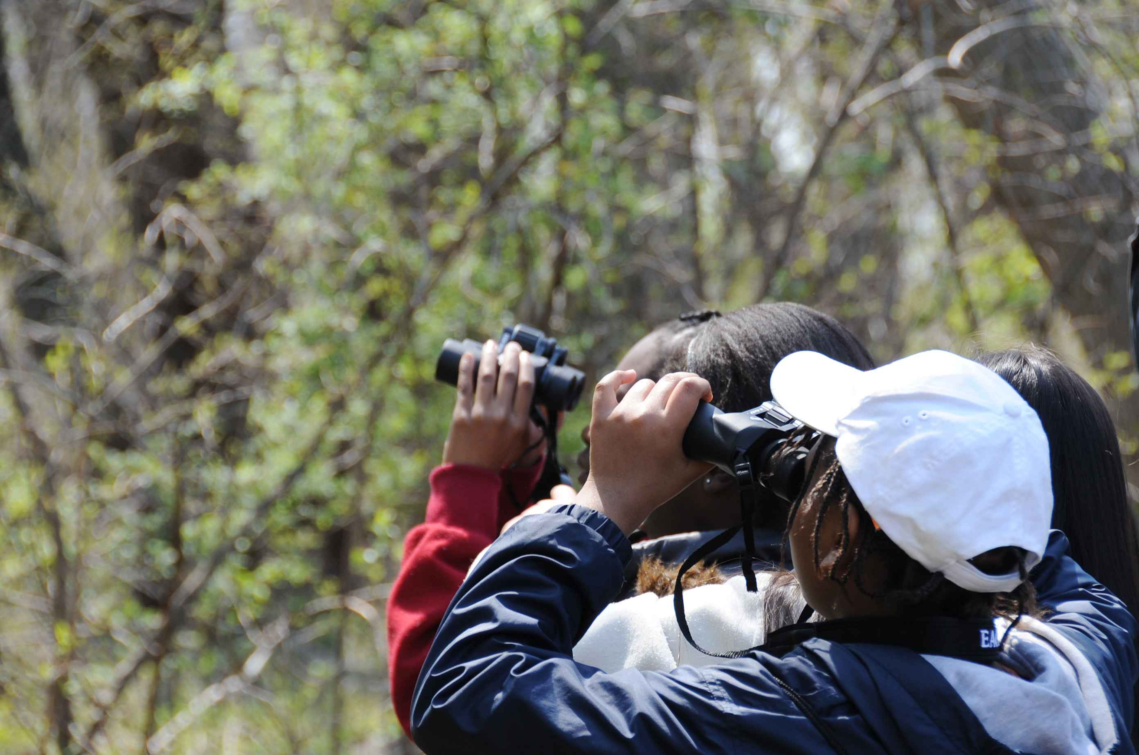**Binoculars make distant objects appear closer.** In this activity, the binoculars are tools that helped you find tiny objects hidden on the surface of the Moon poster. They are great tools for making observations of things that are too dim, small, or far away to see using just your eyes.

People use binoculars to watch birds in trees, see rocks on faraway mountaintops, find features on the Moon, or search for planets in the night sky. The binoculars allow us to see more detail in these distant objects so we can learn more about them.

**Sometimes people use binoculars to bird-watch.**

**NASA scientists use powerful telescopes to study objects in space.** Telescopes are a bit like really, really big binoculars. Telescopes can gather even more light and help us see things that are even farther away.

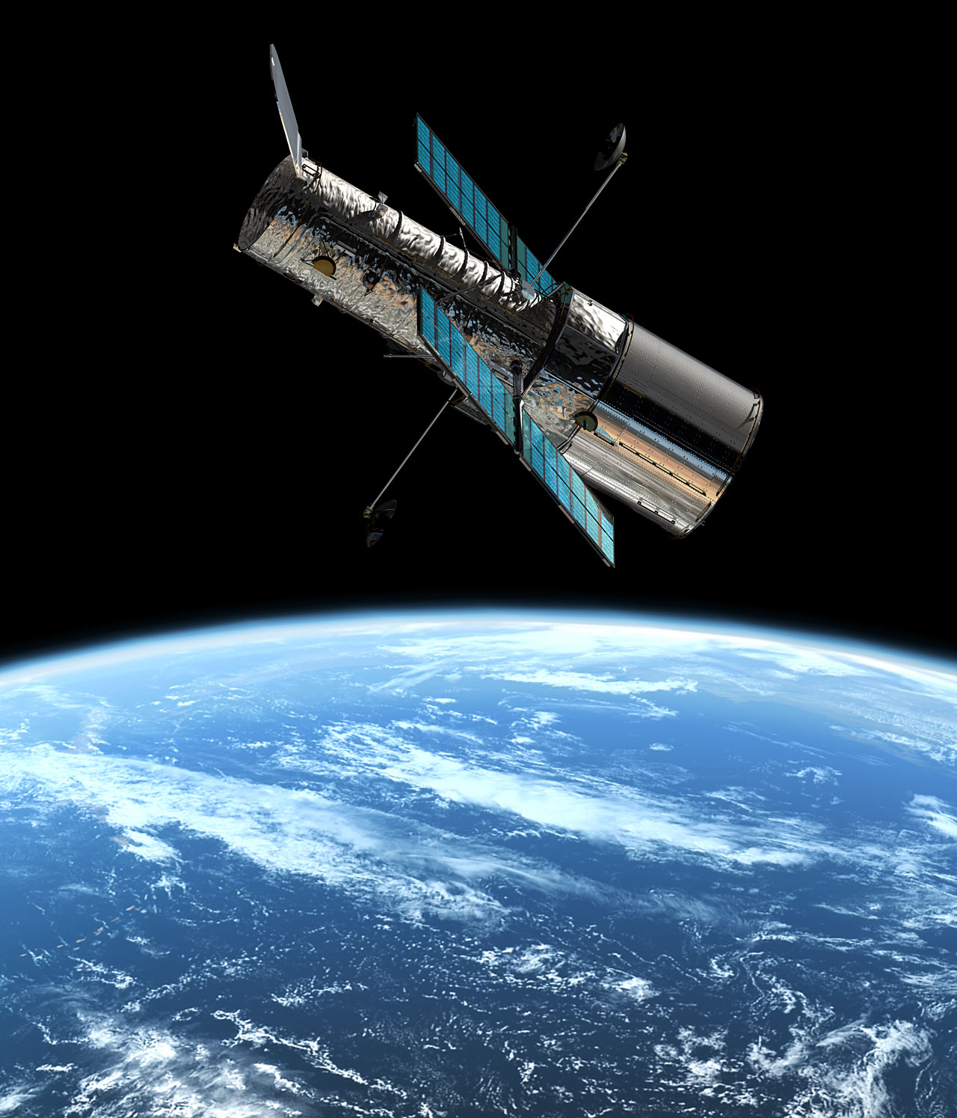Binoculars and telescopes both work because they gather more light than our eyes can gather alone, and then they help bring that light into focus. Binoculars use two different lenses.The lens closest to the object is the *objective*. It gathers light and brings it to a focus. The lens closest to your eye is the *eyepiece*. It magnifies the image to make it appear closer.

Binoculars work well for observing objects here on Earth, but scientists use larger and more powerful tools like telescopes to look back toward Earth from space, or out at the solar system and beyond.

**The Hubble Space Telescope orbits Earth, making observations of distant objects in the universe.**