**Try this!**

|  |  |
| --- | --- |
| 2  3  1 | Do this activity with a friend! One person is *Mission Control* and one is the *Rover*. You’re going to work together to move the *Rover* through the Mars landscape!  First, *Mission Control* walks through the pretend Mars landscape and uses the program board to create a set of commands for the *Rover* to follow.  Be sure to tell the *Rover* when to pick up a rock sample and help it avoid all the obstacles. Each blue arrow is one step. Each yellow star means the *Rover* should stop and sweep his or her hands over the ground to search for a rock sample.  Next, the *Rover* should close his or her eyes or wear a blindfold. *Mission Control* reads each command to the *Rover*. The *Rover* must follow the commands exactly.  After going through the landscape, talk about what was hard or easy. What would you do differently next time? |

*Teams of scientists and engineers use rovers and other robotic vehicles to explore distant worlds.*

**Rover missions, like those to Mars, are carefully planned here on Earth.** In this activity, you and your friend acted out a few steps of a rover mission to Mars. Communication between mission control and the rover sure is tricky!

Researchers know that it is better to go slowly and carefully than to go too fast and get stuck. While rovers may seem a little like a remote-controlled toy car, rover drivers cannot actually use a joystick to direct a rover in real time. It takes 4 to 24 minutes for a data signal to reach Mars. The team must create a series of commands and send them to the rover in one bundle.

**Opportunity landed on Mars in 2004 and was only supposed to work for 90 Mars days, but it’s been working far longer.**

Mission control carefully plans the rover’s route to each science target, helping it avoid dangerous obstacles. No matter how cautious mission control is, parts of the rover can still break, so a replica of the Mars rover (even of the broken tools) is kept at a laboratory here on Earth. The team can test each move using only the tools and systems still available on Mars.

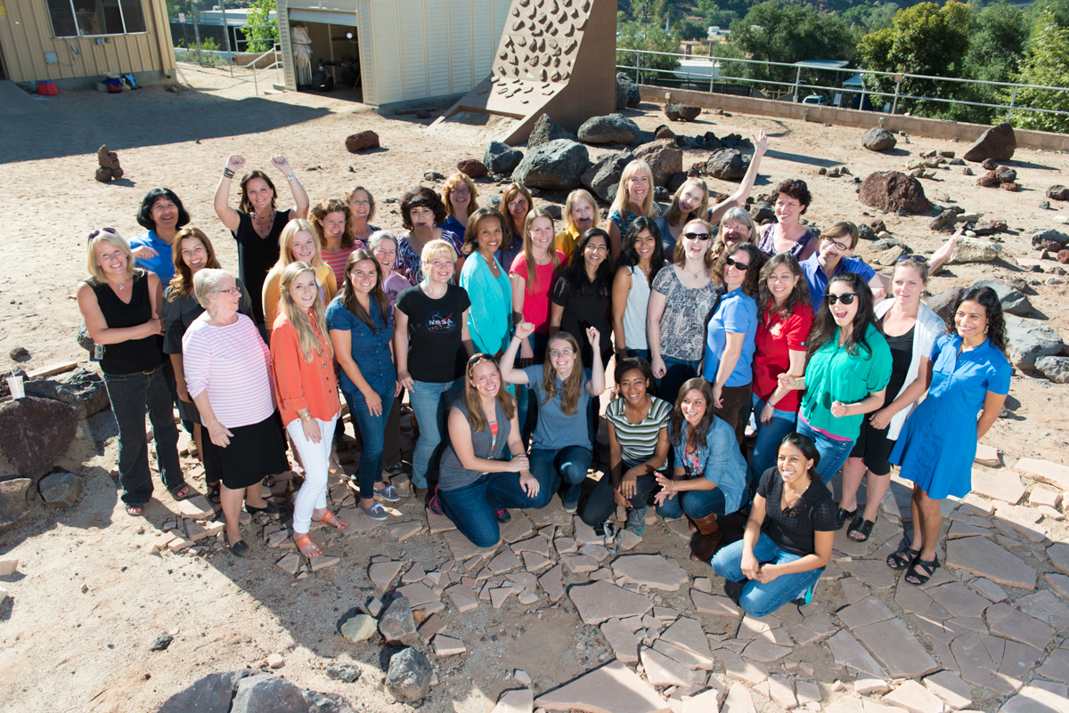HAL:Users:alijackson:Desktop:spacer.gif**NASA missions require large teams of people working together.** They have diverse interests and expertise, and may include project managers, computer engineers, mechanical engineers, aerospace engineers, astrobiologists, astrophysicists, atmospheric scientists, planetary scientists, and other professionals.

On Mars, NASA is looking for signs of previous life, studying the planet’s climate and geology, and preparing for human exploration.

**These are just some of the members of the Mars mission team in the rover yard at NASA’s Jet Propulsion Laboratory.**