Try this!
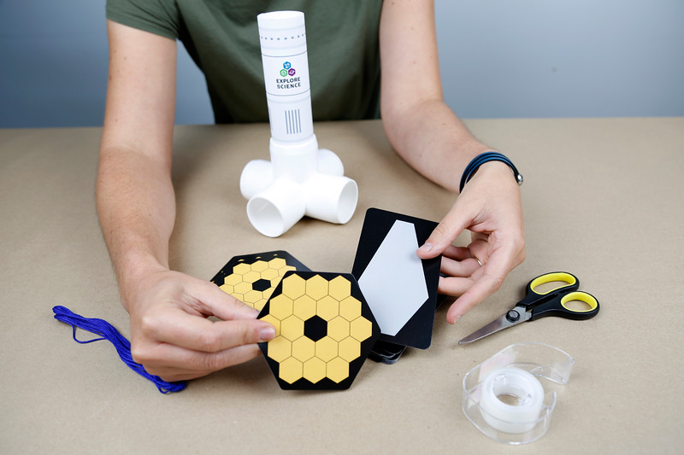  2  1  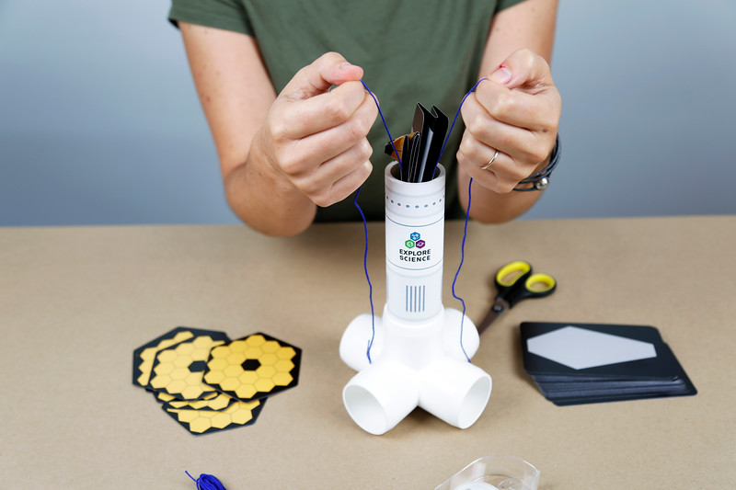  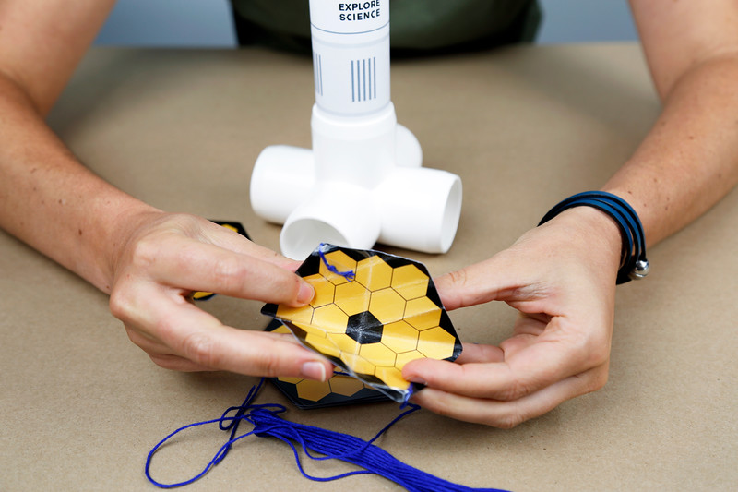  3 | Build a simple model space telescope! Your design should include at least one golden mirror array, one sunshield, two pieces of string, and some tape.  The telescope will need to fold to fit into the white tube representing a rocket compartment. You must be able to unfold it just by pulling on the two pieces of string.  Next, test your design! Fold your space telescope into the rocket model and use the string to deploy the telescope.  Did it work? If not, make some changes and try again! If it did, you can try modifying your design.
Engineers design, build, and test new technologies to study the universe.

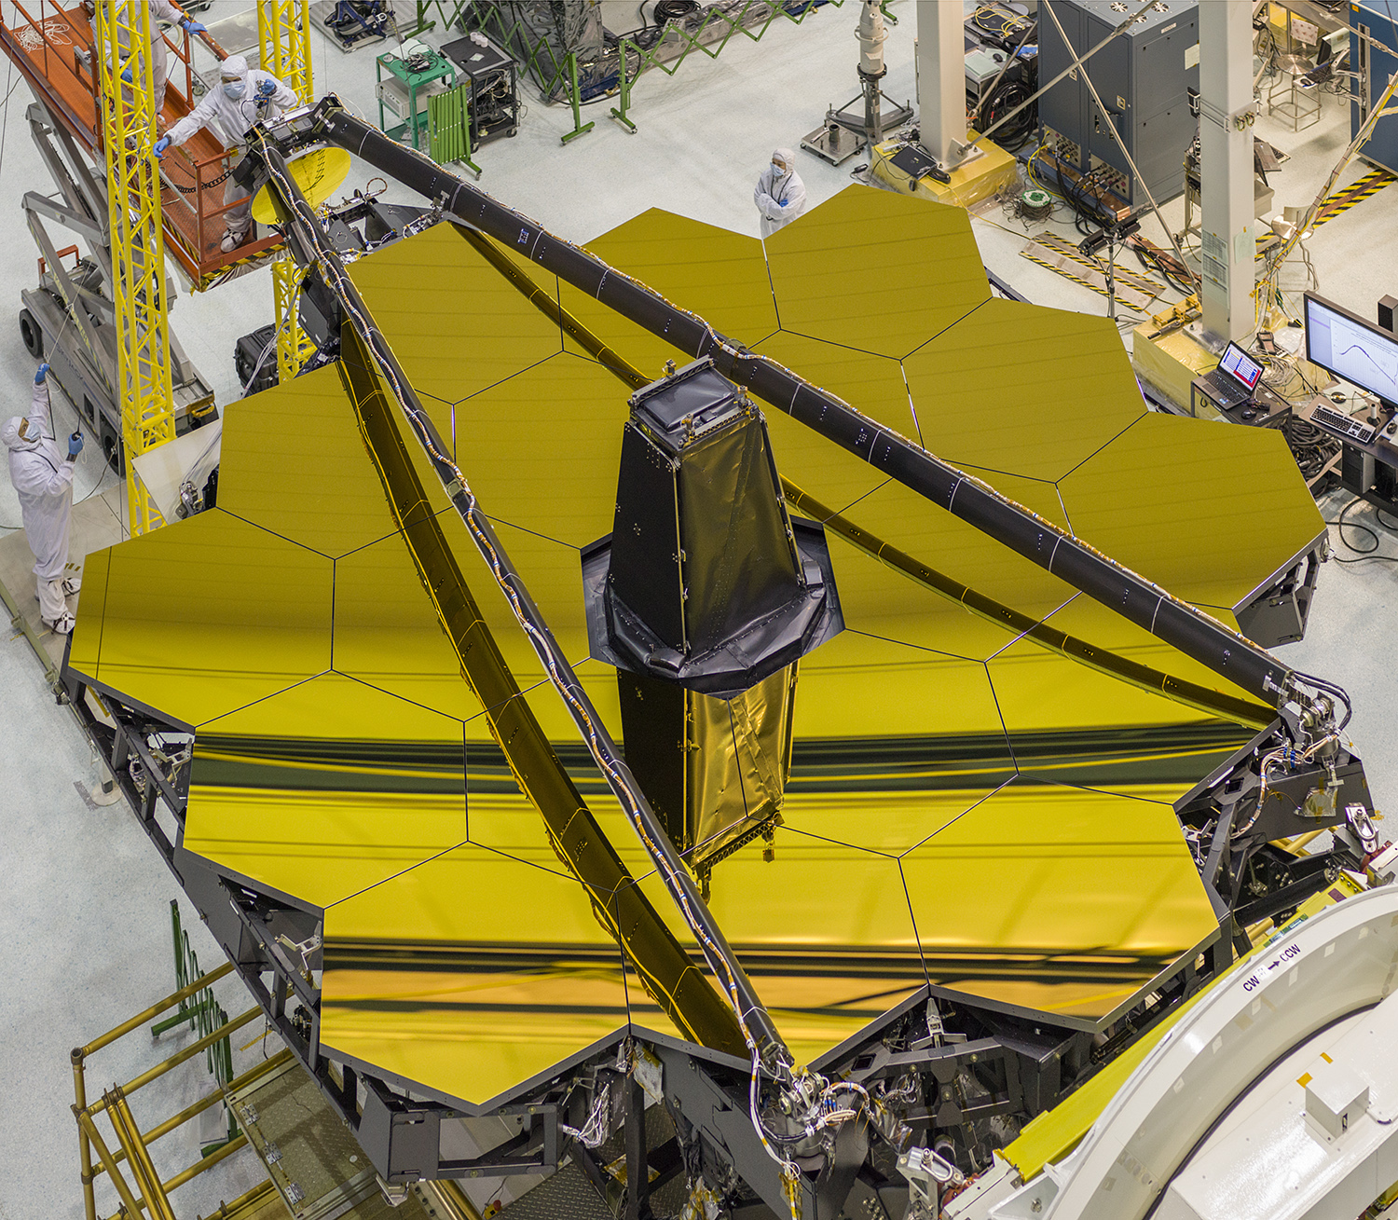
Careful planning and design help us make new discoveries and better understand Earth and space. In this activity you made a simplified model similar to the James Webb Space Telescope. All the components of the real telescope need to be carefully folded to fit into the payload compartment of an Ariane 5 rocket and launched into space!
Telescopes are scientific tools that collect light so that we can see distant and faint objects better. Ground-based telescopes can be effective tools for some research, but NASA also uses telescopes based in space. Earth’s atmosphere distorts light, making starlight twinkle and images less clear, and it absorbs some wavelengths of light. Space telescopes help scientists gather images of distant objects in the full electromagnetic spectrum without atmospheric distortion.
The Webb telescope’s iconic gold mirror array is actually made of 18 interlocking, foldable segments.

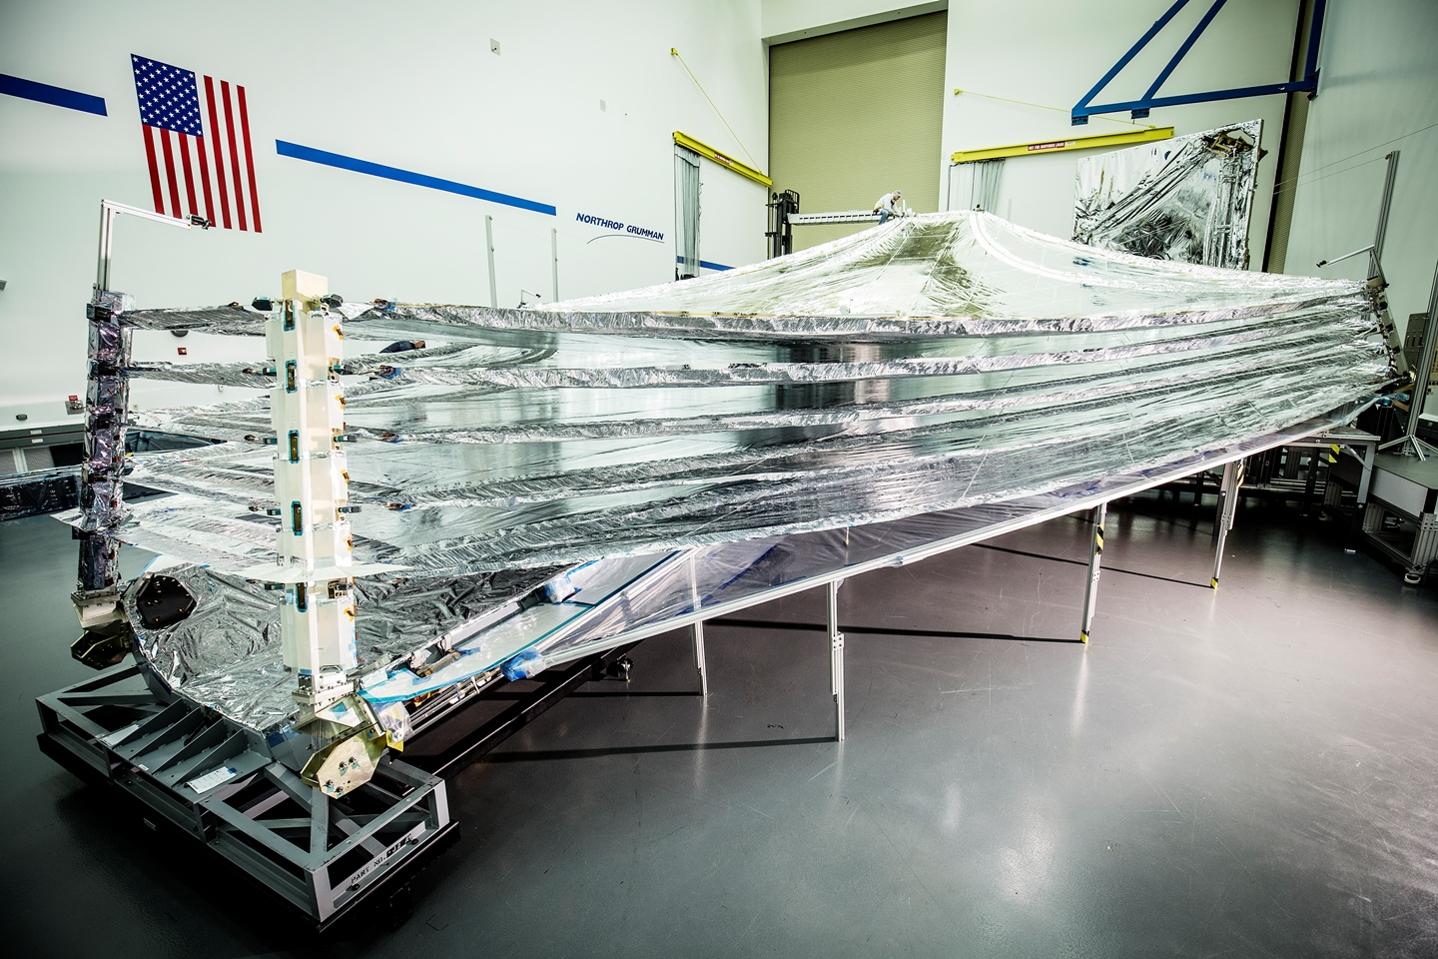
NASA teams work together to launch, guide into orbit, and operate a space telescope. Each new science mission at NASA requires diverse groups of scientists, engineers, managers, and other people with varied skills—perhaps even expert paper folders—to make the project a success.
For example, many different partners have worked together on the Webb telescope in preparation for its launch in late 2018. The telescope will study the early history of our universe, the development of our solar system, how other stars and planets form, and the potential habitability of planets orbiting nearby stars.
Inspiration for some foldable space telescope designs comes from origami.

