**Macintosh HD:Users:raeostman:Desktop:Frankenstein200 Design Pack:Frankenstein200 Logo:EPS - Print:frankenstein200-K.epsFACILITATOR GUIDE TO**

**FRANKENTOY**

# DESCRIPTION

In this activity, learners make a “creature” by mixing and matching different parts of toys. The activity is designed to prompt conversation and reflection about responsible innovation, inspired by themes raised in Mary Shelley’s novel *Frankenstein.*

# AUDIENCES

This activity is best suited for ages 5 and up. Younger children can participate successfully with support from an educator or caregiver.

# LEARNING OBJECTIVES

# The primary objective of this activity is to encourage creativity and reflection about responsible innovation. In addition, learners will explore the following concepts:

* People are creative! We’re always learning more about the world and inventing new things.
* It’s important to think ahead as we study science and make new technologies.
* Researchers in the fields of *genetic engineering* and *synthetic biology* can create modified and entirely new organisms.

# MATERIALS

* Variety of mix-and-match toy parts
* Background images (optional)
* Activity booklet
* Sign holder and table sign

Materials sources and instructions for creating your own kit materials are provided at the end of this facilitator guide.

# PRESENTATION

**Preparation:**

To familiarize yourself with the activity, use the activity booklet. It provides step-by-step instructions for the activity. It also includes contextual information about Mary Shelley’s novel *Frankenstein* and the questions the story raises for current science and engineering.

**Activity flow:**

Open by asking participants if they’ve ever heard of Frankenstein’s “monster.” Share that the original story was written 200 years ago by Mary Shelley, and has been retold many times. Ask if they know what happens in the story, and establish the basic plotline. In the novel a student named Victor Frankenstein builds a creature from dead body parts, and uses electricity to bring it to life. Unfortunately, Frankenstein didn’t think ahead to what his creature would do, or how he would take care of it, if he succeeded in bringing it to life.

Tell participants that now they can make their own pretend creature from individual parts, like Victor Frankenstein did. You (or a caregiver) can assist participants as needed. Share the activity guide with participants so they can follow use the instructions and read the information.

When they have completed a creature, invite the participants to describe it. You can ask a variety of reflection questions, such as:

* *What kind of creature is it?*
* *Is it a pet or a wild animal?*
* *What does your creature say and do?*
* *Where does it live?*
* *Can it make friends with another creature?*

These reflection questions will give participants a chance to think about why people create, and to consider why it might be important to plan ahead and take responsibility for the things we create.

Finally, return to Mary Shelley’s story. Victor Frankenstein built a creature and brought it to life, but he didn’t take responsibility for it. The creature was miserable, and did some very bad things. The creature promises that he will no longer do bad things if Victor makes a female companion for him. You can ask some additional reflection questions:

* *Does Frankenstein’s creature deserve a mate so he isn’t all alone?*
* *What might happen if there were two creatures?*

There’s no right or wrong answer to the reflection questions! Everyone can form their own opinions. You can help encourage visitors to develop and share their own ideas by referring to the Conversation Tips guide.

**Audiences:**

Young children and individuals with special needs may need assistance with some steps in this activity.

Depending on your audience, you may want to use toy animals only, and not include human-like doll parts. Some participants may find the idea of combining animals and humans to be a sensitive topic. If you do decide to incorporate dolls and other toys that resemble humans, you may want to begin with the stuffed animal parts first and then introduce the doll parts. This will give participants a chance to reflect on how their feelings about “hybrid” creatures may have changed when they include human-like elements.

**Safety:**

Supervise young children to ensure they do not mouth any materials, as some materials may present choking hazards.

**PROGRAMMING OPTIONS**

This activity can be incorporated into a variety of educational programs, such as after-school programs, family workshops, and summer camps. In longer program formats, you can use videos and books to familiarize participants with the Frankenstein story:

* The 1931 Hollywood movie *Frankenstein,* directed by James Whale, introduced the world to Boris Karloff’s iconic version of the creature.
* *Frankenweenie* is a 2012 retelling of the Frankenstein story, directed by Tim Burton.
* There are also many books that share the story, which are appropriate for a variety of audiences.

You can also use videos to introduce new fields of research, such as synthetic biology and genetic engineering, that are modifying existing living things and creating new forms of life:

* [Synthetic Biology Explained](https://youtu.be/mlOFE9-3CN0) (Grist) introduces a new field of research that combines the principles of engineering with the building blocks of biology. YouTube: https://youtu.be/mlOFE9-3CN0

# MATERIALS INFORMATION

**Sources:**

The toy parts used in this activity are not commercially available. They can be made from inexpensive stuffed animals and dolls with soft bodies.

**Preparation:**

To make your own stuffed toy parts, you’ll need around five stuffed toys, similar in size but with variety in their body parts (e.g., arms, legs, and wings). Toys can be purchased at a discount store. You’ll also need Velcro, sewing scissors, heavy-duty thread, a needle, and a thimble (optional). Velcro and sewing supplies can be purchased at sewing or crafts stores.

* Start by cutting the parts of the toy from the main body (legs, arms, head, wings, and so forth) and sewing the cut parts shut so the stuffing doesn’t come out.
* Attach the Velcro to each point of the toy body where a limb could attach, being sure that you always divide and attach the two halves of the Velcro in the same way. Each toy body should have the same side of the Velcro (fuzzy or scratchy) and each part should have the other side. This will ensure that every part will attach to every body.
* Depending on your selection of toys, you may need to add Velcro to all the bodies where (for example) wings could be, even if the original toy didn’t have a tail or wings. This will let participants mix and match all the parts with all the bodies.

**Alternative:**

Rather than using stuffed toy parts, it is also possible to do this activity by having participants cut up recycled pictures of animals and people. They can tape or glue them to a background image to make a fantastical creature. Magazines and calendars are good sources of animal pictures and backgrounds.

**CREDITS AND RIGHTS**



Copyright 2017, Arizona State University. Published under a Creative Commons Attribution-Noncommercial-ShareAlike license: <http://creativecommons.org/licenses/by-nc-sa/3.0/us/>

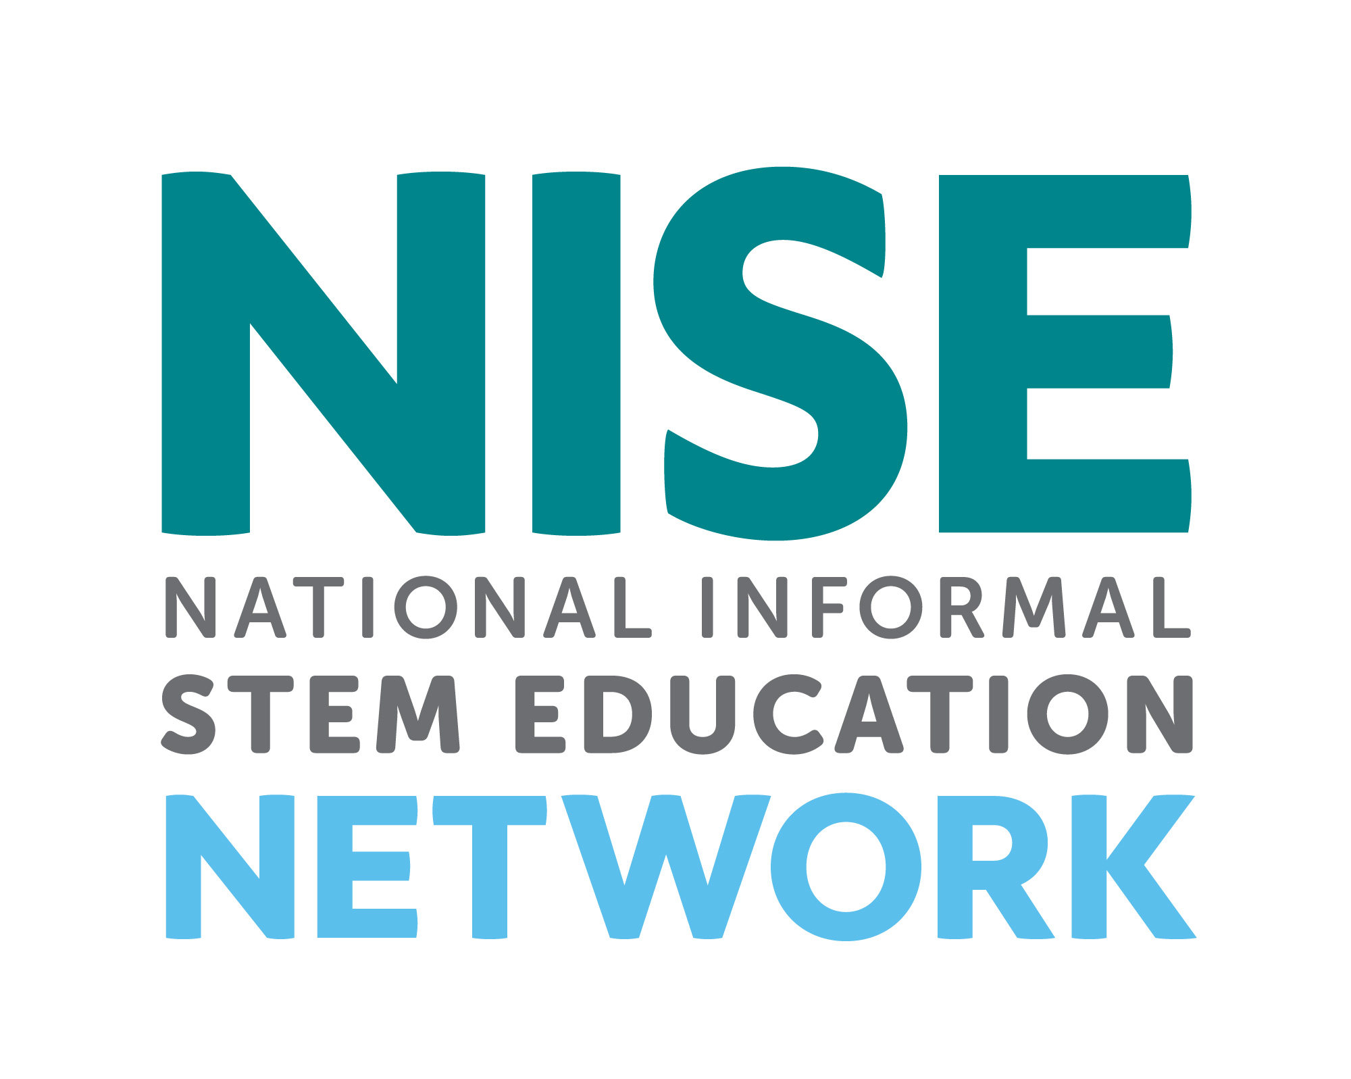

Distributed in collaboration with the National Informal STEM Education Network: nisenet.org

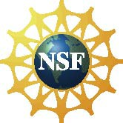

This project was supported by the National Science Foundation under Grant Number 1516684. Any opinions, findings, conclusions, or recommendations expressed in this program are those of the authors and do not necessarily reflect the views of the Foundation.

Instruction and promotion photos by the Science Museum of Minnesota for Frankenstein200.

Illustration from an early edition of *Frankenstein* from Wikimedia Commons. Retrieved from: https://commons.wikimedia.org/wiki/File:Frankenstein,_pg_7.jpg

Photograph of pig from Public Domain Pictures. Retrieved from: http://www.publicdomainpictures.net/view-image.php?image=167761&picture=little-pig-in-barn

Movie still of the monster’s bride from Wikimedia Commons. Retrieved from: https://commons.wikimedia.org/wiki/File:Bride_of_frankenstein_1935_still_03.jpg

Photograph of woolly mammoth museum diorama from Wikimedia Commons. Retrieved from: https://commons.wikimedia.org/wiki/File:Woolly_mammoth.jpg