**Macintosh HD:Users:raeostman:Desktop:Frankenstein200 Design Pack:Frankenstein200 Logo:EPS - Print:frankenstein200-K.epsFACILITATOR GUIDE TO**

**SCRIBBLE BOT**

# DESCRIPTION

In this activity, learners make a toy bot with a surprising ability: it scribbles on a sheet of paper. The activity is designed to prompt conversation and reflection about responsible innovation, inspired by themes raised in Mary Shelley’s novel *Frankenstein.*

# AUDIENCES

This activity is best suited for ages 7 and up. Younger children can participate successfully with support from an educator or caregiver.

# LEARNING OBJECTIVES

# The primary objective of this activity is to encourage creativity and reflection about responsible innovation. In addition, learners will explore the following concepts:

# People are creative! We’re always learning more about the world and inventing new things.

* It’s important to think ahead as we study science and make new technologies.
* Researchers who study *artificial intelligence* make machines that can reason and learn over time.

# MATERIALS

* Pool noodles, cut into 6” lengths (1 per participant)
* Thin markers (3–4 per participant)
* Rubber bands (2 per participant)
* Craft materials for decoration (such as googly eyes, foam stickers, chenille stems, and feathers)
* Battery-operated electric toothbrushes (several on hand for participants to use)
* Spare AA batteries
* Safety scissors
* Tape
* Paper
* Trays to hold the paper and contain the bots while they scribble
* Activity booklet
* Sign holder and table sign
* Optional: Large roll of paper to cover an entire table or tape onto the floor, so that several bots can scribble at once.

Sources and instructions for creating your own kit materials are provided at the end of this facilitator guide.

# PRESENTATION

**Preparation:**

Before beginning this activity, build a few scribble bots for practice. This will ensure you know how to make one so you can easily help participants, and will help you work out how to best organize your materials. It will also give you some examples to show participants.

To familiarize yourself with the activity, use the activity booklet. It provides step-by-step instructions for the activity. It also includes contextual information about Mary Shelley’s novel *Frankenstein* and the questions the story raises for current science and engineering.

**Activity flow:**

Open by asking participants if they’ve ever heard of Frankenstein’s “monster.” Share that the original story was written 200 years ago by Mary Shelley, and has been retold many times. Ask if they know what happens in the story, and establish the basic plotline. In the novel, a student named Victor Frankenstein builds a creature from dead body parts, and uses electricity to bring it to life. Unfortunately, Frankenstein didn’t think ahead to what his creature would do, or how he would take care of it, if he succeeded in bringing it to life.

Show participants the example projects and ask them if they’d like to make their own scribble bot and bring it to “life.” Emphasize that they will use their own creativity (but you or a caregiver can help as needed).

Share the activity booklet with participants, so they can follow use the instructions and read the information. You (or a caregiver) can assist participants as needed.

As participants work, you can help them with the mechanics of their automata and ask guiding questions, such as:

* *How can you give your creature its own personality and abilities?*

After the participants have built their bots, they’ll use it to make a drawing. Be sure they place their sheet of paper, and the scribble bot, in a tray. This will keep the bot from skittering off the paper and on to the table. You can ask questions and make suggestions to encourage longer play with their bot:

* *What can you change to make your scribble bot move differently?*
* *Is your bot alive, or does it just seem to be?*
* *Are its scribbles “art”? If so, who is the artist—you or your bot?*

If scribble bots get stuck in one position, make certain that you are using a flat surface and the fine-tip markers. Sometimes a larger or worn out tip on a marker will cause a scribble bot to catch on the grooves of the table or tray. You can also try adjusting the position or angle of the bot’s legs.

Finally, return to Mary Shelley’s story. Victor Frankenstein built a creature and brought it to life, but he didn’t take responsibility for it. The creature was miserable, and did some very bad things.

* *Do you think Victor Frankenstein is responsible for his creature’s actions?*
* *What do you think Victor should have done when he realized the creature committed murder?*

There’s no right or wrong answer to these questions! Everyone can form their own opinions. You can help encourage visitors to develop and share their own ideas by referring to the Conversation Tips guide.

**Audiences:**

* Young children and individuals with special needs may need assistance with some steps in this activity.
* Some adults may prefer to play with a pre-made bot rather than make their own—but with encouragement everyone can enjoy this activity.

**Safety:**

Supervise young children to ensure they do not mouth any materials, as some materials may present choking hazards.

**PROGRAMMING OPTIONS**

This activity can be incorporated into a variety of educational programs, such as after-school programs, family workshops, and summer camps. In longer program formats, you can use videos and books to familiarize participants with the Frankenstein story:

* The 1931 Hollywood movie *Frankenstein,* directed by James Whale, introduced the world to Boris Karloff’s iconic version of the creature.
* *Frankenweenie* is a 2012 retelling of the Frankenstein story, directed by Tim Burton.
* There are also many books that share the story, which are appropriate for a variety of audiences.

You can also use videos to show participants examples of automata, computers, and robots.

* [Atlas, the Next Generation](https://youtu.be/rVlhMGQgDkY) (Boston Dynamics) show a humanoid robot doing a variety of things—including recovering from human harassment. YouTube: https://youtu.be/rVlhMGQgDkY
* [Erica: Man Made](https://youtu.be/57Maw9Sn89w) (The Guardian) explores what it means to be human, and introduces an extremely lifelike humanoid robot. YouTube: https://youtu.be/57Maw9Sn89w
* In [Robot Meets Self Driving Car](https://youtu.be/vtX-qVUfCKI) (Mobilegeeks.de), two humans take a humanoid robot for a ride in a self-driving car. YouTube: https://youtu.be/vtX-qVUfCKI.
* A game show segment, entitled [IBM’s Watson Supercomputer Destroys Humans in Jeopardy](https://youtu.be/WFR3lOm_xhE) (Engadget) supports conversation about the difference between mechanical automata and computers. YouTube: https://youtu.be/WFR3lOm_xhE
* [What is the Turing Test?](https://youtu.be/sXx-PpEBR7k) (CNET) introduces the concept of artificial intelligence, and describes a famous test for distinguishing people from computers. YouTube: https://youtu.be/sXx-PpEBR7k

# MATERIALS INFORMATION

**Sources:**

* Pool noodles are available at discount stores. They can be cut into 6” pieces using large scissors, a serrated bread knife, or a saw. Be careful!
* Electric toothbrushes are available at discount stores. Get the kind with a vibrating head, not a rotating head. Inexpensive ones can be found at dollar stores, and seem to work better for this activity than some costlier options. If you have a choice, it is more convenient if the on/off switch is on the butt end of the toothbrush rather than along the handle (that way, the switch is exposed when the toothbrush is inside the pool noodle). Finally, check to see if your brush comes with batteries! You may need to purchase those separately.
* All other materials are available at craft, educational supply, or discount stores.
* Print materials for this activity can be downloaded from [nisenet.org](http://nisenet.org/).

To save costs, you can allow participants take home their pool noodle creature but ask them to leave the electric toothbrushes for others to use. When participants are done playing with their bot, you can perform a “toothbrush-ectomy” on the scribble bot!

**CREDITS AND RIGHTS**



Copyright 2017, Arizona State University. Published under a Creative Commons Attribution-Noncommercial-ShareAlike license: <http://creativecommons.org/licenses/by-nc-sa/3.0/us/>

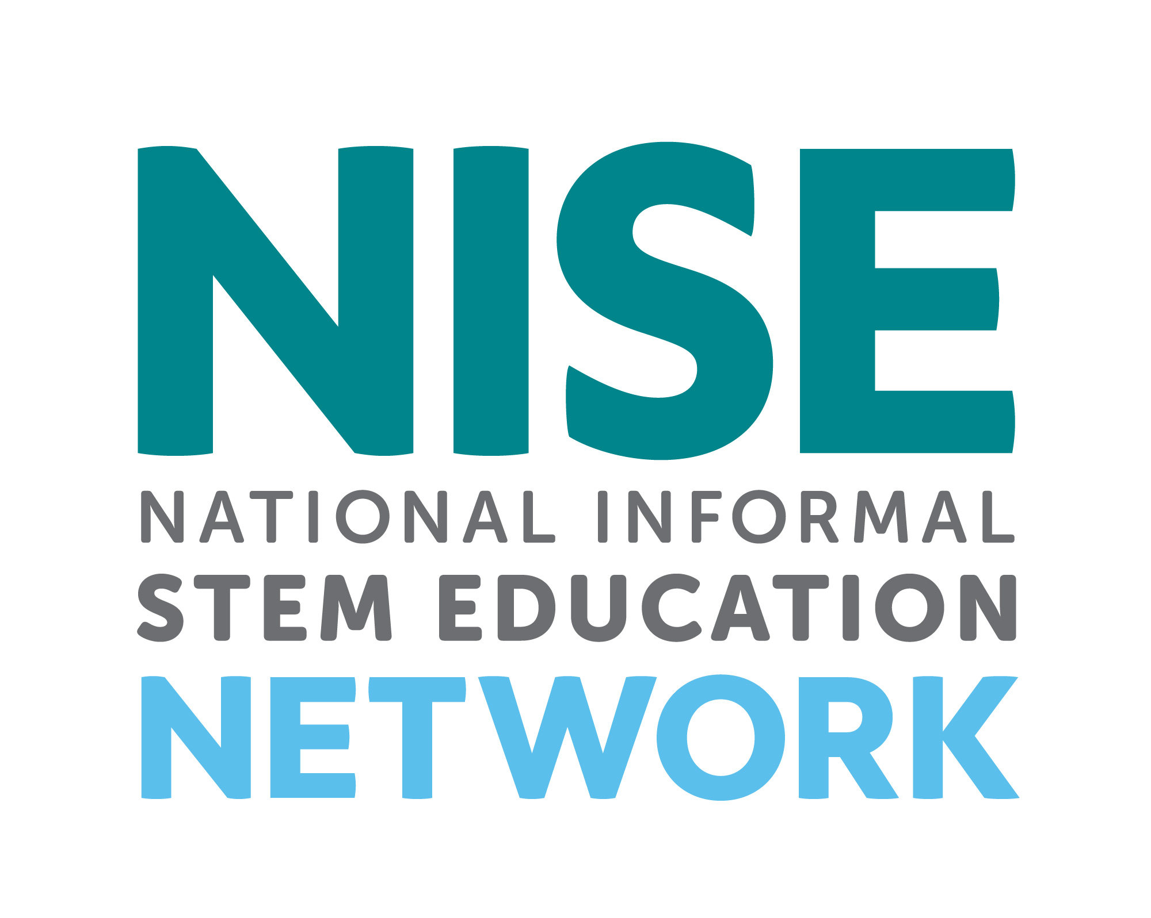

Distributed in collaboration with the National Informal STEM Education Network: nisenet.org



This project was supported by the National Science Foundation under Grant Number 1516684. Any opinions, findings, conclusions, or recommendations expressed in this program are those of the authors and do not necessarily reflect the views of the Foundation.

This is a common activity that exists in many variations. The Frankenstein200 version was adapted fromArt-O-Matic Intelligence, developed by the Museum of Science and Industry, Chicago. Retrieved from: https://www.msichicago.org/fileadmin/assets/online_science/summer_brain_games/activity_PDFs/SBG15_space_bot.pdf

Instruction and promotion photos by the Science Museum of Minnesota for Frankenstein200.

Illustration from an early edition of *Frankenstein* from Wikimedia Commons. Retrieved from: https://commons.wikimedia.org/wiki/File:Frankenstein,_pg_7.jpg

Photograph of Honda Motor Corporation’sASIMO humanoid robot from Wikimedia Commons. Retrieved from: https://en.wikipedia.org/wiki/File:ASIMO_Conducting_Pose_on_4.14.2008.jpg

Photograph of Boris Karloff as Frankenstein’s monster from Wikimedia Commons. Retrieved from: https://commons.wikimedia.org/wiki/File:Frankenstein%27s_monster_(Boris_Karloff).jpg

Photograph of Boston Dynamic’sAtlas humanoid robot from Wikimedia Commons. Retrieved from: https://commons.wikimedia.org/wiki/File:Atlas_from_boston_dynamics.jpg